***ABC Tuition Center System Documentation***

*REPORT BY: Nandita Dhanda*



**Course Name:** Web Project

**Course Code:** TCS3224

**Lecturer’s Name:** Dr Ahmad Faiz Bin Ghazali

**Due Date:** 20th April 2020

# ABSTRACT

EXECUTIVE SUMMARY

ABC Tuition Centre has been experiencing an increased rate of dissatisfaction among students who have reported to undergo an extremely time-consuming and frustrating experience during their subject registration process which requires them to stand in long queues at the registration counter while waiting their turn in order to manually register for the subjects they wish to enrol in. Additionally, the tuition centre does not have a central management system that allows them to update courses offered as well as keep a record of and maintain student records and track their performance. The overall system is inefficient.

Digitizing ABC Tuition Centre’s student registration and record management system will eliminate the waiting time involved in the current subject registration process as well as improve front desk service efficiency by allowing the staff to manage and maintain overall student and course records online.

PROPOSAL

To address the issue presented, we propose to design a website with a centralized database with the following inclusions:

1. Registration of new students
2. Enrolment for courses or subjects for existing students
3. Lecturers to capture attendance and maintain progress record
4. Administration control:
   1. To manage, control and monitor student records.
   2. Create, update, delete course offerings
   3. Assign courses to lecturers

Table of Contents

ABSTRACT 2

CHAPTER 1 – INTRODUCTION 7

1.1 Background 7

1.2 Aims and Objectives 8

CHAPTER 2 – LITERATURE REVIEW 9

2.1 Introduction 9

2.2 Data Collection 9

2.2.1 Primary Investigation 9

2.2.2 Secondary Investigation: 12

2.3 Conclusion 15

CHAPTER 3 - METHODOLOGY, ANALYSIS AND DESIGN 18

3.1 Methodology and Planning 18

3.1.1 Methodology 18

3.1.2 Project Planning 20

3.2 Analysis 22

3.3.1 Requirement Specification 22

3.2.2 Functional Requirements 23

3.2.3 Non-Functional Requirements 24

3.3 Design 25

3.3.1 Use Case Diagram 25

3.3.2 Use Case Description 27

3.3.3 Activity Diagram and Flow Chart 36

3.3.3 Class Diagram 41

3.3.5 Database Architecture 42

3.3.6 Story Board 44

CHAPTER 4: WEBSITE PROTOTYPE 49

4.1 Essential PHP Files and Functionalities 49

4.1.1 header.php 49

4.1.2 footer.php 51

4.1.3 server.php 51

4.1.4 aside.php 51

4.1.5 courses.php 53

4.1.6 viewcourse.php 56

4.2 Supporting PHP Files and sub-functionalities 68

4.2.1 index.php 68

4.2.2 setid.php 68

4.2.3 errors.php 70

4.2.4 session.php 71

4.2.5 status_check.php 71

4.3 Main Pages – Before Log In 72

4.3.1 Homepage 72

4.3.2 Registration - Student 75

4.3.3. Registration Success 80

4.3.3 Log in 82

4.3.4 Staff Sign In 86

4.3.5 Logout Function 90

4.4 Main Pages - Lecturer Portal 91

4.5 Main Pages – Admin Portal 93

4.5.1 Admin Dashboard 93

4.5.2 Manage Lecturers 94

4.5.3 Update Lecturer Account 100

4.5.4 Add Lecturer Account 104

4.5.5 Manage Students 108

4.5.6 View Student 112

4.5.7 Manage Courses 118

4.5.8 Add New Course 123

4.5.9 Update Course 129

4.6 Main Pages - Student Portal 132

4.6.1. Student Account – Status Pending 132

4.6.2. Student Dashboard – Status Approved 133

4.6.3. My Profile 133

4.6.4. Update Profile 134

4.6.5 Courses Enrolled 137

4.6.6 Courses Offered 138

4.7 404 Error Page 140

CHAPTER 5 DATABASE 142

5.1 Admin Table 142

5.2 Course Table 143

5.3 Lecturer Table 143

5.4 Student Table 144

5.5. Course-Enrolled Table 144

Appendix A 145

Appendix B 148

Appendix C 153

Appendix D 155

Appendix F 156

Appendix G 185

Appendix H 189

Appendix I 195

Appendix J 218

Appendix K 228

References 231

# CHAPTER 1 – INTRODUCTION

## 1.1 Background

ABC Tuition Centre is Malaysia’s leading tuition academy with over 5000 students enrolled in 11 different branches located nationwide. Despite being a successful venture in the education sector, ABC Tuition Centre currently practices a tedious and inefficient student registration and progress management system that heavily relies on manual processing and record keeping. During the assessment of the current system, students reported that they spend a significant amount of time standing in queues and a long processing time at the front desk in order to complete their subject registration process. The staff working at the front desk, in turn, also has to manually input the information of each student into the system which further increases the overall processing time. Furthermore, it is relatively difficult for students to obtain information about the latest offerings and course schedules. Additionally, at present, the lecturers are also required to keep a record on attendance and student performance manually. Overall, ABC Tuition Centre uses outdated methods which makes their system inefficient, time-consuming and inconvenient to use.

In order to address the current situation and improve the efficiency of the overall system, we recommend ABC Tuition Centre should incorporate an IT-based solution in order to automate and digitize the student enrolment and progress management system. This can be achieved by implementing a dedicated website or web application which will operate as a central platform; featuring current course listings, allow new students to register, enrol students for courses and allow lecturers to maintain attendance and student performance records. The administration will be able to monitor and maintain records of students through a central database and will have authority over approval or rejection of students and course enrolment. The administration will also be able to control lecturer profiles and assign subjects.

Incorporating this strategy will make the system more user-friendly and oriented towards providing the students and staff an enhanced user-experience with improved services and overall learning experience, leading to an increase in student satisfaction rate. Students will be able to access latest listings as well as register and enrol for courses at their convenience through the internet on desktop or mobile devices. Moreover, front office services will become more efficient and in-turn reduce the burden from the staff making it easier to maintain records of students and monitor their progress as lecturers will be able to capture student attendance and maintain progress records through the system.

## 1.2 Aims and Objectives

AIM:

The aim of the project is to improve efficiency and increase student satisfaction by digitizing ABC Tuition Centre’s system to facilitate subject registration, student progress[1] record management and course management, making the tuition academy more student oriented with enhanced front office services.

OBJECTIVES:

1. To create a web application with a centralized database to digitize ABC Tuition Centre’s system in order to enhance the overall learning experience and improve efficiency
2. To improve front-office services by allowing administrator to monitor, maintain and control student records online, create and update course listings and allocating courses to lecturers through the admin panel
3. To eliminate the waiting time at the registration counter and improve the student subject enrolment process by allowing students to enrol courses online through the institution’s student portal.
4. To allow lecturers to capture attendance and maintain academic performance records online

# CHAPTER 2 – LITERATURE REVIEW

## 2.1 Introduction

The modern world has come to accept the fact that organizations in all sectors of industries require a digital strategy if they are to achieve their business objectives; and academic service providers are no exception. This means, in order to stay neck-in-neck with competitor institutions and provide students with complete satisfaction of facilities and services they receive in their study environment, it is crucial for ABC Tuition Centre to incorporate a digital strategy to streamline the process of subject registration and maintain a progress record of students enrolled in each subject. In order to achieve this, we recommend ABC Tuition Centre to build a web application which will act as a centralized platform that will allow students, administrative staff and lecturers to access data relevant to them, depending on the account type of the user, easily and efficiently. This web application will act as a portal for the respective user. The web application will be built using HTML5, CSS3 and Javascript for client-side scripting and PHP for server-side. MySQL will be used for data storage and database facilities in this project. Thorough research and analysis has been conducted in order to justify why it is important for ABC Tuition Centre to implement this new system, and how it will impact the centre in the long run. The data retrieved from the investigation can be found in the next section of this chapter.

## 2.2 Data Collection

We conducted primary and secondary investigations to identify the importance of an online registration and performance system for ABC Tuition Centre and to conclude how the implementation of such a system will impact the institution as a whole. The findings of the research have been provided below:

### 2.2.1 Primary Investigation

A survey was conducted with a focus group of 45 people. The survey consisted of 11 questions assessing areas that included a brief background of participants and their experience, opinion and expectations of both online and paper-based enrollment systems respectively. The survey questions may be referred in **Appendix A** and the subsequent responses and graphs of figures can be referred in **Appendix B**

#### 2.2.1.1 Background

The survey was answered online by a group of participants and was accessible by a shared URL. This means that the survey reached out to people globally irrespective of their geo-location.

The respondents of the survey ranged between the age groups of 15 to 30. Majority of the participants, fell under the age bracket of 20-25 years accounting for 66.7% of the total group, while just above a quarter fell under the age brackets of 15-20 (13.3%) and 26-30 (15.6%) respectively. Only a handful of the participants were above the age of 30. This means that focus group primarily consisted of millennials - a generation known to be well acquainted with the concepts of digitization and who stay in the loop with the advancements of technology.

Additionally, the selection of the group of participants was based on the criteria that they had interacted with the subject enrollment system of any form of academic institution either at present or within the past decade. 71% percent of the 45 participants reported to be currently enrolled in some form of an academic institution which includes primary, secondary, tertiary levels of education institutions or any form of private tuition centres while of the remaining participants reported to have pursued at least some form of education and interacted with some form of an education center within the past decade. This means that all the participants have had experience in some form or the other with subject registration systems and performance records in accordance to the system followed by their academic service provider. This factor makes this focus group ideal participants for our investigation owing to the fact that they are able to share their opinion and knowledge with experience in interacting with the subject enrollment and management systems practiced across various institutions dating back no further than 10 years. This facilitates a critical evaluation on what participants may have encountered during modern times and what their expectations are towards the system.

#### 2.2.1.2 Experience and Opinion

It was observed that online subject registration was practiced in over a quarter of the participants’ institutions while a significant portion of the respondents reported to be still registering manually through paper-based forms. Upon further evaluation it was found that only a small fraction of the group actually preferred manual or paper-based registration methods. The remainder of the group was either neutral towards the notion or showed an inclined preference towards digitized registration methods. In other words, 48.9% of the participants stated that they were okay with any form of registration while 44.4% strongly preferred online registration methods. Regardless of this, over 75% of the total group responded that they were keen towards the idea of switching from paper-based methods to online methods if the option was available.

The surveyees were asked questions in relation to their opinion about both paper-based methods and online registration methods respectively. When it comes to paper-based methods over half of the participants reported to like the concept of face-to-face interactions that is offered by filling up forms and submitting them to registration counters manually and over a quarter of the participants also find paper-based methods to be trustworthy. It can be assumed that this may be due to the fact that interacting with front-desk personnel may allow the student to clarify any doubts they may have during filling out the forms on-the-go. Moreover, a human-touch can have a positive psychological impact on an individual which can help in building trust. Face-to-face interaction along with trust can attribute to providing personal satisfaction to the student, which has been observed by a third of the respondents. While these are a few positive factors offered by paper-based methods of subject registration, around 50% of the participants have agreed that these methods are time-consuming and require them to wait in long queues. This problem is addressed with the help of digital methods of registration. Most of the surveyees agree that online registration methods are convenient and save time. An additional benefit noted by two-thirds of the group is that digitized registration methods saves paper as well.

Apart from online subject enrollment, the institutions the participants attended used digital technology in other ways as well. The academic service providers provided their students with recorded lectures, E-libraries, student portal with access to course information, online progress reports and online discussion boards and forums. Each institute provided its own set of digital services; i.e. not every institute provided the same services. In our opinion, these are some effective methods of using digital technology to enhance a student’s learning experience and sets one institution apart from competition. These factors have been taken into consideration when designing the system.

#### 2.2.1.3 Expectations

The respondents were asked the features they look for in an online registration system to which more than 70% responded that they want the system to be user-friendly, up-to-date, mobile friendly with a fast loading time. . It is noteworthy that in previous questions a third of the participants reported that it is difficult to clarify doubts in an online system while half of them liked the ability to interact face-to-face in paper-based systems. Half of the participants expect the online registration system to be informative and provide customer service with a fast error resolution time. Providing customer service or access to help in some form like by a phone-line or email address could provide that human touch and allow the participants to clarify their doubts.

### 2.2.2 Secondary Investigation:

The results of the primary investigation helped assess the type of people who would become potential users of the system and analyze the requirements based on first-hand experience and expectations, however, secondary research is necessary to further understand the type of system that needs to be developed. Secondary Investigations for the proposed project were conducted using websites, journals and reports published by accredited sources. The results of this research defines and demonstrates the importance of digitization in the academic sector and constraints that need to be taken into account. Additionally, the findings of the investigation states the definition and demonstrates the importance of a web application and evaluates the benefits and limitations of the same along with features recommended in the system with suitable justifications.

#### 2.2.2.1 Digitization of Education Sector

Digitization can be referred to as the process that involves the conversion of information into a digital format. Digitizing information makes it easier to preserve, access and share (Rouse, 2007).

According to a journal published by Cisco, “digital technology is the name given to the newest Internet-based technologies (such as video and collaboration, social media, mobility, data analytics and embedded sensor devices) that hold the potential to transform businesses and shape people’s lives”. They define higher education institutions as a complex business and advice institutes to adapt a business-like approach in order to tackle challenges presented by the market due to rapidly evolving digital technology. And in order to achieve this, they encourage academic sector of industry to step forward and adapt a digital strategy to move forward with the modern era. The business focus for a modern university should be the use of these newest Internet-based technologies in innovative ways so creating a superior environment and a superior experience for students, researchers and staff. And, in this way, creating differentiation from other universities. (Cisco, 2019).

Another studies conducted by researchers from University of Munster, Germany involving qualitative interviews with students were conducted in order to gather information on service requirements with regards to digitization of higher education from a student’s point of view. The studies showed that the participants perceived the degree of digitization differently depending on different aspects of their student lives. With regards to online registration, online progress reports, payments and provision of lecture material, they reported to be using a Moodle-based e-learning web application, which not only shared a good reputation among them but was easy to use. However, they reported that some of their lecturers found it difficult to use due to lack of technical competence. For this reason, they preferred traditional learning methodologies (Thoring, Rudolph, & Vogl, 2017).

From the results of the interview conducted it can be concluded that students being well acquainted with the progression of the internet era find digitization of services provided by their university beneficial, however, those from previous generations may find it harder to keep up with advancements in technology and may find it more difficult to accommodate to digitization of the academic sector.

#### 2.2.2.2 Web Application

A web application, also known as a “web app” can be defined as a software program that runs on a web server. This means that unlike traditional desktop applications, web applications must be accessed through a web browser. Web applications are programmed using languages that are supported by web browsers such as HTML and JavaScript which are required to present the information to users and rely on the web browser to execute the program. Some web applications are dynamic in nature and require server-side processing through server-side scripting languages such as PHP, JSP and ASP; Server side scripting languages facilitate the storage and retrieval of information. Web applications need a web server in order to manage requests from the client, an application server which performs the tasks requested, and sometimes, a database for storage of information (Gibb, 2016).

Web applications are advantageous over desktop applications in many ways. The first advantages is that developers are not required to develop web applications for multiple platforms since the application runs directly from the web browser used by the user irrespective of the operating system or the device used by the user. This does mean, however, that a web application must be cross-browser friendly and must be responsive across various platforms / devices. Another advantage web apps have over traditional desktop applications is that updates do not have to be distributed to the users. The users have access to updated versions of the application simply by updating the application on the server itself. Furthermore, from a user’s point of view, a web application provides consistency in terms of the user interface across multiple platforms since its appearance depends on the web browser used instead of the operating system. Additionally, data entered into a web application is process and saved remotely; allowing the user to access the data from multiple devices rather than requiring them to transfer files between their computer systems, unlike a desktop app.

Although there are several benefits of building a web application over a desktop application, there are some downsides to them as well. For example, they have limited access to the user’s system resources like the memory, CPU and the file system since they do not operate directly from the operating system. For this reason, systems with high-end programs such as video production and media applications perform better as desktop apps in general terms. Also, since web apps entirely depend on the web browser, if the browser crashes, the user may lose any unsaved progress. Furthermore, any browser updates may cause incompatibilities with the application, leading to further unexpected issues. Another disadvantage web applications have is that since the run on the web browser, they rely on a steady internet connection to operate. Any interference with the internet or not being able to connect to it would result in the application being inaccessible (Christensson, 2016).

SIGNIFICANCE OF A WEB APPLICATION

The academic sector is rapidly evolving with the advancements in technology. Web applications and online portals are now commonly used in various educational institutions which include colleges and universities where prompt information and necessary updates need to be readily available to a large number of students. Portals can be used to direct students to educational resources or make information more accessible and readily available to them (Windsor, 2020).

## 2.3 Conclusion

In summary, implementing a web application with a student portal, admin panel and lecturer panel is a suitable solution to digitize ABC Tuition Centre’s subject registration system. Since ABC Tuition Centre will be mainly dealing with textual forms of data and require the system to be easily accessible across all platforms, building the system as a web application instead of a desktop application is more advisable. The institution will have to take the limitations into consideration as well while building the application, including (but not limited to) upgrades in web browser, errors from the server side or any problems encountered due to internet access.

The web application should be built using PHP and MySQL for server side scripting and database integration respectively and HTML, CSS and Javascript for front end and client side scripting. The application must be user-friendly and cross-browser compatible. It should be student-oriented in nature offering students access to updated course listings, online registration, online subject enrollment and online progress tracking facilities while lecturers should be able to see which courses have been assigned to them and should be able to update student performance and attendance records. The administration staff should have rights and access to all information available on the system.

When any service in the education section is digitized, it will affect all the potential users of the system which includes both students and lecturers, in the case of ABC Tuition Centre. Hence it is important to take into account that while providing maximum satisfaction for students, the burden of transition on lecturers needs to be minimized as they may find it more difficult to accommodate to the new system. For this reason, we recommend the new system to limit the lecturer’s interaction with the system to recording attendance and updating student performance for courses assigned to them by the administration. On the other hand, students will be able to, update their own information on the system view updated course listing, enrol for new courses and track their progress of the courses they have enrolled for. Although at this point in time and considering our time constraints, incorporating an online payment strategy and other online facilities such as an e-library and online resources for students may not be feasible, however with future developments and iterations of the system (post implementation) incorporating an online payment strategy as well as other strategies can also be considered; Hence the system must also be built in a manner to offer scalability.

As it can be observed from the investigations conducted, students are more inclined towards online registration methods as it saves time, offer flexibility and are accessible round the clock. The studies have indicated that since a web application is accessible over the internet through a web browser, the users will not have to download the application and launch it on their devices making it more convenient for the user. Furthermore, the studies have outlined that the web application must be user friendly, intuitive and easy to understand and navigate through. The system should also facilitate record keeping in a central database which can be easily accessed and updated to help students, admin and lecturers keep track of student’s progress. All in all, this will increase student satisfaction and improve efficiency in the overall system.

However, it is also important to remember that it is important for the institution to incorporate a backup strategy for times when the system is not accessible or when it is under maintenance. We suggest ABC Tuition Centre to not completely eliminate their paper-based registration methodologies and to keep it as a back-up. Additionally, the concept of human interaction should not be fully eliminated. Although, the results of the investigation suggests that the system should be digitized, human interaction through phone helpline and email should be provided to allow the users to receive a fast response if they are facing any problems with the system or if they have any queries.

RISKS – Post Implementation

1. Overall operational costs of the business will need to be revised to include a recurring annual fees of domain name and dedicated web-hosting services
2. Measures will need to be taken post the prototype stage in order to ensure data security
3. It may take some time for the users (students, administrative staff and teaching staff alike) to get accustomed to the new system. Training may be required in the initial stages of implementation.

POSSIBLE IMPACT

1. *Student Satisfaction* – Students will be able to register to the institution as a new student or enroll for subjects at their convenience
2. *Improved Learning Experience* – all records of student’s attendance and progress will be recorded in the system making it easier to access and maintain
3. *Administrative Efficiency* – Administration will be able to efficiently manage their tasks online rather than rely on outdated manual data-entry and record maintenance methods.

# CHAPTER 3 - METHODOLOGY, ANALYSIS AND DESIGN

## 3.1 Methodology and Planning

### 3.1.1 Methodology

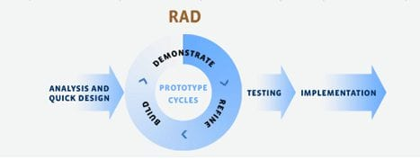

Figure 1: Rapic Application Development

For the development of this web project we will be using the Rapid Application Development model, also known as RAD. Rapid Application Development consists of a condensed development process suitable for the production of high-quality systems with low investment costs. This process allows developments to make quick adjustments to shifting requirements in a fast-paced and constantly evolving market. This method allows for flexibility in making adjustments to the system on an as-needed basis, which also facilitates lower investment costs (Singh, 2019).

RAD methodology is suitable for ABC Tuition Centre’s system because although the requirements have been thoroughly thought out and planned in the initial phases of the production, it is important to note that flexibility in the development of such types of systems is crucial to allow room for changes and adjustments in the system based on user and company feedback during the time of development. Unlike the waterfall model, Rapid Application Development emphasizes the use of the system prototype and user feedback over rigid planning and requirement recording; hence allowing changes to be made and features to be added during the time of development based upon any new requirements that may emerge during the prototyping phases. Having a visual prototype in front of the user will help the user understand what the system encompasses and what it will offer which in turn will allow them to provide better feedback.

Not only will this development methodology keep overall costs low but this methodology is also suitable for projects on a tight timeline. Since ABC Tuition Centre has proposed their final system demonstration to be held around 14 April 2019, giving the development team approximately 8 weeks to complete the development of this project, Rapid Application Development is the most suitable methodology to design and deploy the system on a low budget and within the proposed timeline.

Figure 1 demonstrates the flow of steps in the RAD model. There are 5 main steps in Rapid Application Development methodology. A brief breakdown of the steps and what development process involved in each step has been provided below:

Step 1: Analysis and Requirements Planning

The first step involves the stakeholders, which in our case are ND consultancy’s development team and ABC Tuition Centre’s management, coming together to define and finalize the project requirements such as project goals, expectations, timelines and budget. During the requirement phase, further analysis and investigations can be conducted to further define the system requirements. Once the project requirements and scope have been clearly defined, the management can be consulted for approval before proceeding to the next step of development.

Step 2: Building the Prototype

Once the requirements of the project have been planned and defined, the next step involves beginning the development of the project. During this phase, our team will work closely with the management of ABC Tuition Centre to create and improve the system until the working prototype is ready. This stage will begin with designing the system’s architecture and structure with the help of UML design, Use case design, Flow charts, Activity Diagrams, Class diagrams, etc. If necessary, before proceeding to the programming stage, photoshop mockups or wireframes can be designed - the requirement of this will be determined after designing the system’s architecture.

Step 3: Gather user feedback

This step involves converting prototypes and beta systems into working models so that we can gather feedback from the users to tweak and improve prototypes and create the best possible product.

Step 4: Testing

The system will be tested to ensure that it is functional and running according to ABC Tuition Centre’s expectations. The client’s feedback will be continued to be incorporated as the code is tested, refined and retested for smooth functioning.

Step 5: Cutover and Presentation

The system will be presented and will be prepared for launch. This stage would also involve providing training to stakeholders that will be interacting with the system to familiarize them - including students, administrative staff and lecturers.

### 3.1.2 Project Planning

Task Allocation:

ND Consultancy will be assigning the project as a solo project to Nandita Dhanda. She is a full-stack developer with experience in project planning, designing prototypes and development of the system and will be an ideal candidate to take on this project considering its tight deadlines. The project will be developed under the supervision of Dr Ahmed Faiz, the head supervisor of ND Consultancy’s development team. Please refer to the Gantt chart in **Appendix C** for task breakdown, effort allocation and the timeline of the project.

Software and Technologies:

The following technologies and software will be used for the development of this project:

Figure 2: Softwares and Technologies

## 3.2 Analysis

### 3.3.1 Requirement Specification

The system should be in the form of a web application and must have a dedicated landing page. The main website will provide course listings, information about the institution and testimonials from old students. The system will have the option for users to log in and access content their account is authorized to.

A student with an existing account will be able to log into the system and access their student portal. The student portal will provide access to courses or subjects the student can enroll in and allow them to enroll for subjects they wish to take. Upon enrollment, they will be able to track their attendance record and their performance in the course.

New students will be able to register to open an account. Before they are allowed to enroll in subjects/courses offered, their account will require approval from the admin. The student will be required to submit their documents to the administration counter in the institution and after the documents have been vetted and verified, the admin will approve or reject a student’s request for registration. A student whose account has been approved will then be able to enroll for courses offered by logging into their student portal.

Admin will have majority of rights and privileges in the system. An admin account will be pre-programmed in the system which means a new admin account cannot be created. After logging into the admin panel, the admin will be able to manage student accounts; this means they will be able to approve new students, view the attendance records and performance of each student and delete student accounts. The admin will also be able to create, update and delete courses/subjects and allocate lecturers to the respective courses. The admin will be able to create new lecturer accounts.

Since the system is primarily student-oriented, the lecturers will have least privileges in the system.A lecturer’s account can only be created by the admin and they will be provided with the login details. A lecturer will be able to log into the lecturer panel and view courses assigned to them. They will be able to update the attendance records and progress of students that are taking courses assigned to them. A lecturer will not be able to create a new account.

In addition to the functionalities mentioned above, the system must be user friendly and easy to navigate through. Furthermore, appropriate validations must be added to ensure that only authorized personnel can access data according to the rights and privileges of the user account type.

### 3.2.2 Functional Requirements

|  |  |
| --- | --- |
| **FR Number** | **Description** |
| **FR1** | New students should be able to register and create a new account |
| **FR2** | User should be able to log into the system according to account type, i.e. Lecturer, Student or Admin |
| **FR3** | Admin should be able to manage student accounts; including approve new student accounts, view and delete student accounts |
| **FR4** | Admin should be able to manage all lecturer accounts; including creating new account, view and delete lecturer account |
| **FR5** | Admin should be able to manage course listings; including creating new courses and viewing, updating and deleting existing courses. |
| **FR6** | Admin should be able to assign a lecturer to a course |
| **FR7** | Lecturer should be able to view his account details |
| **FR8** | Lecturer should be able to view all courses he has been assigned to |
| **FR9** | Lecturer should be able to view all students enrolled courses assigned to him |
| **FR10** | Lecturer should be able to update student’s course performance; including taking attendance and updating progress report. |
| **FR11** | Student should be able to view his account details |
| **FR12** | Student should be able to view updated course listing and enrol in courses |
| **FR13** | Student and Admin should be able to view courses that student has enrolled in including performance record of each course |
| **FR14** | All users should be able to log out of the system. |

Table 1: Functional Requirements

### 3.2.3 Non-Functional Requirements

|  |  |
| --- | --- |
| **NFR Number** | **Description** |
| **NFR1** | The system should be able to operate on any web browsers |
| **NFR2** | The system should be user-friendly, intuitive and easy to navigate through. It should be designed in a way that even non tech-savvy personnel can use it without facing difficulty |
| **NFR3** | The system’s user interface and user experience must comply by modern day web standards. |
| **NFR4** | The system should be available and accessible at all times – 24 hours a day, 7 days a week, all year round. |
| **NFR5** | The system should be able to take the load of excessive amounts of users trying to access it at the same time. |
| **NFR6** | The system should be able to load within 5 seconds |
| **NFR7** | Only authorized users should be able to log into the system |
| **NFR8** | Only authorized administrative staff can view personal details of students and lecturers. |
| **NFR9** | The data must be kept up-to-date. |
| **NFR10** | System must be flexible and scalable so that it can be easily maintained and so that it can be expanded to accommodate additional features and functionalities in the future. |
| **NFR11** | System should provide customer support service if students or users encounter any problems or if they have any queries. This can be done by providing a phone-helpline or an email address, for example. |
| **NFR12** | System should be portable in nature. |

Table 2: Non-Functional Requirements

## 3.3 Design

### 3.3.1 Use Case Diagram

#### 3.3.1.1 User Use Case Diagram

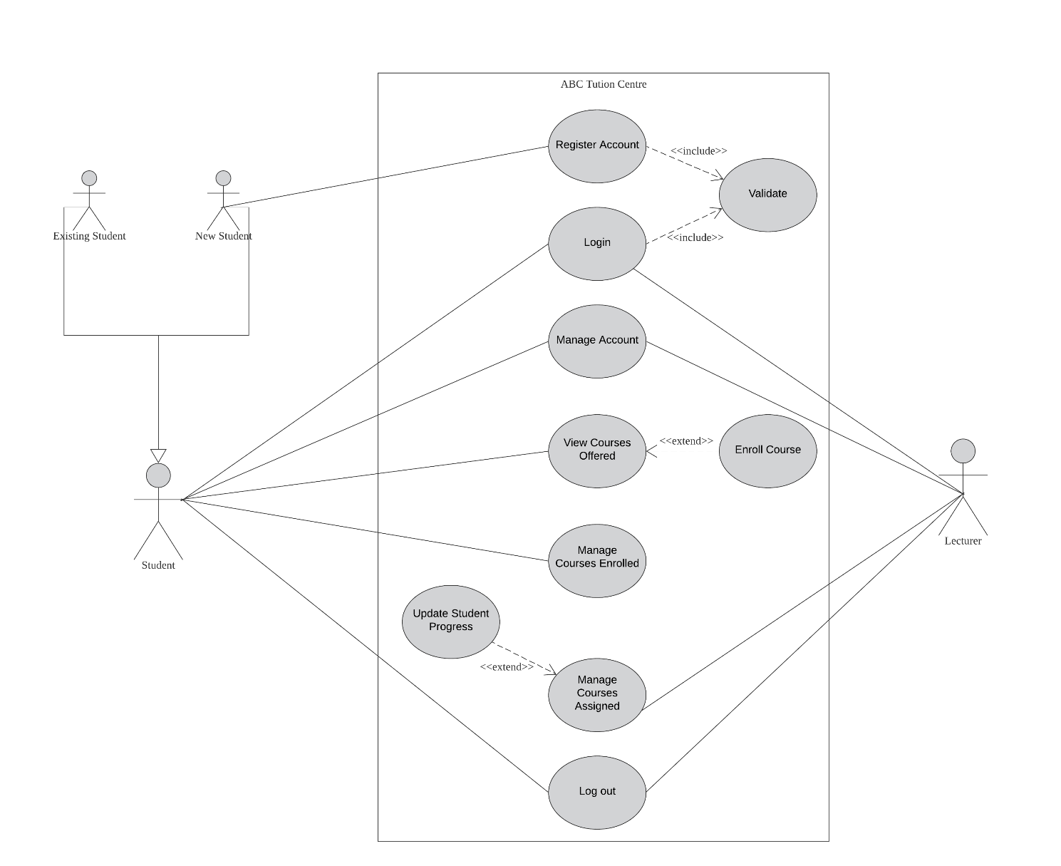

Figure 3: User - Use Case Diagram

#### 3.3.1.2 Admin Use Case Diagram

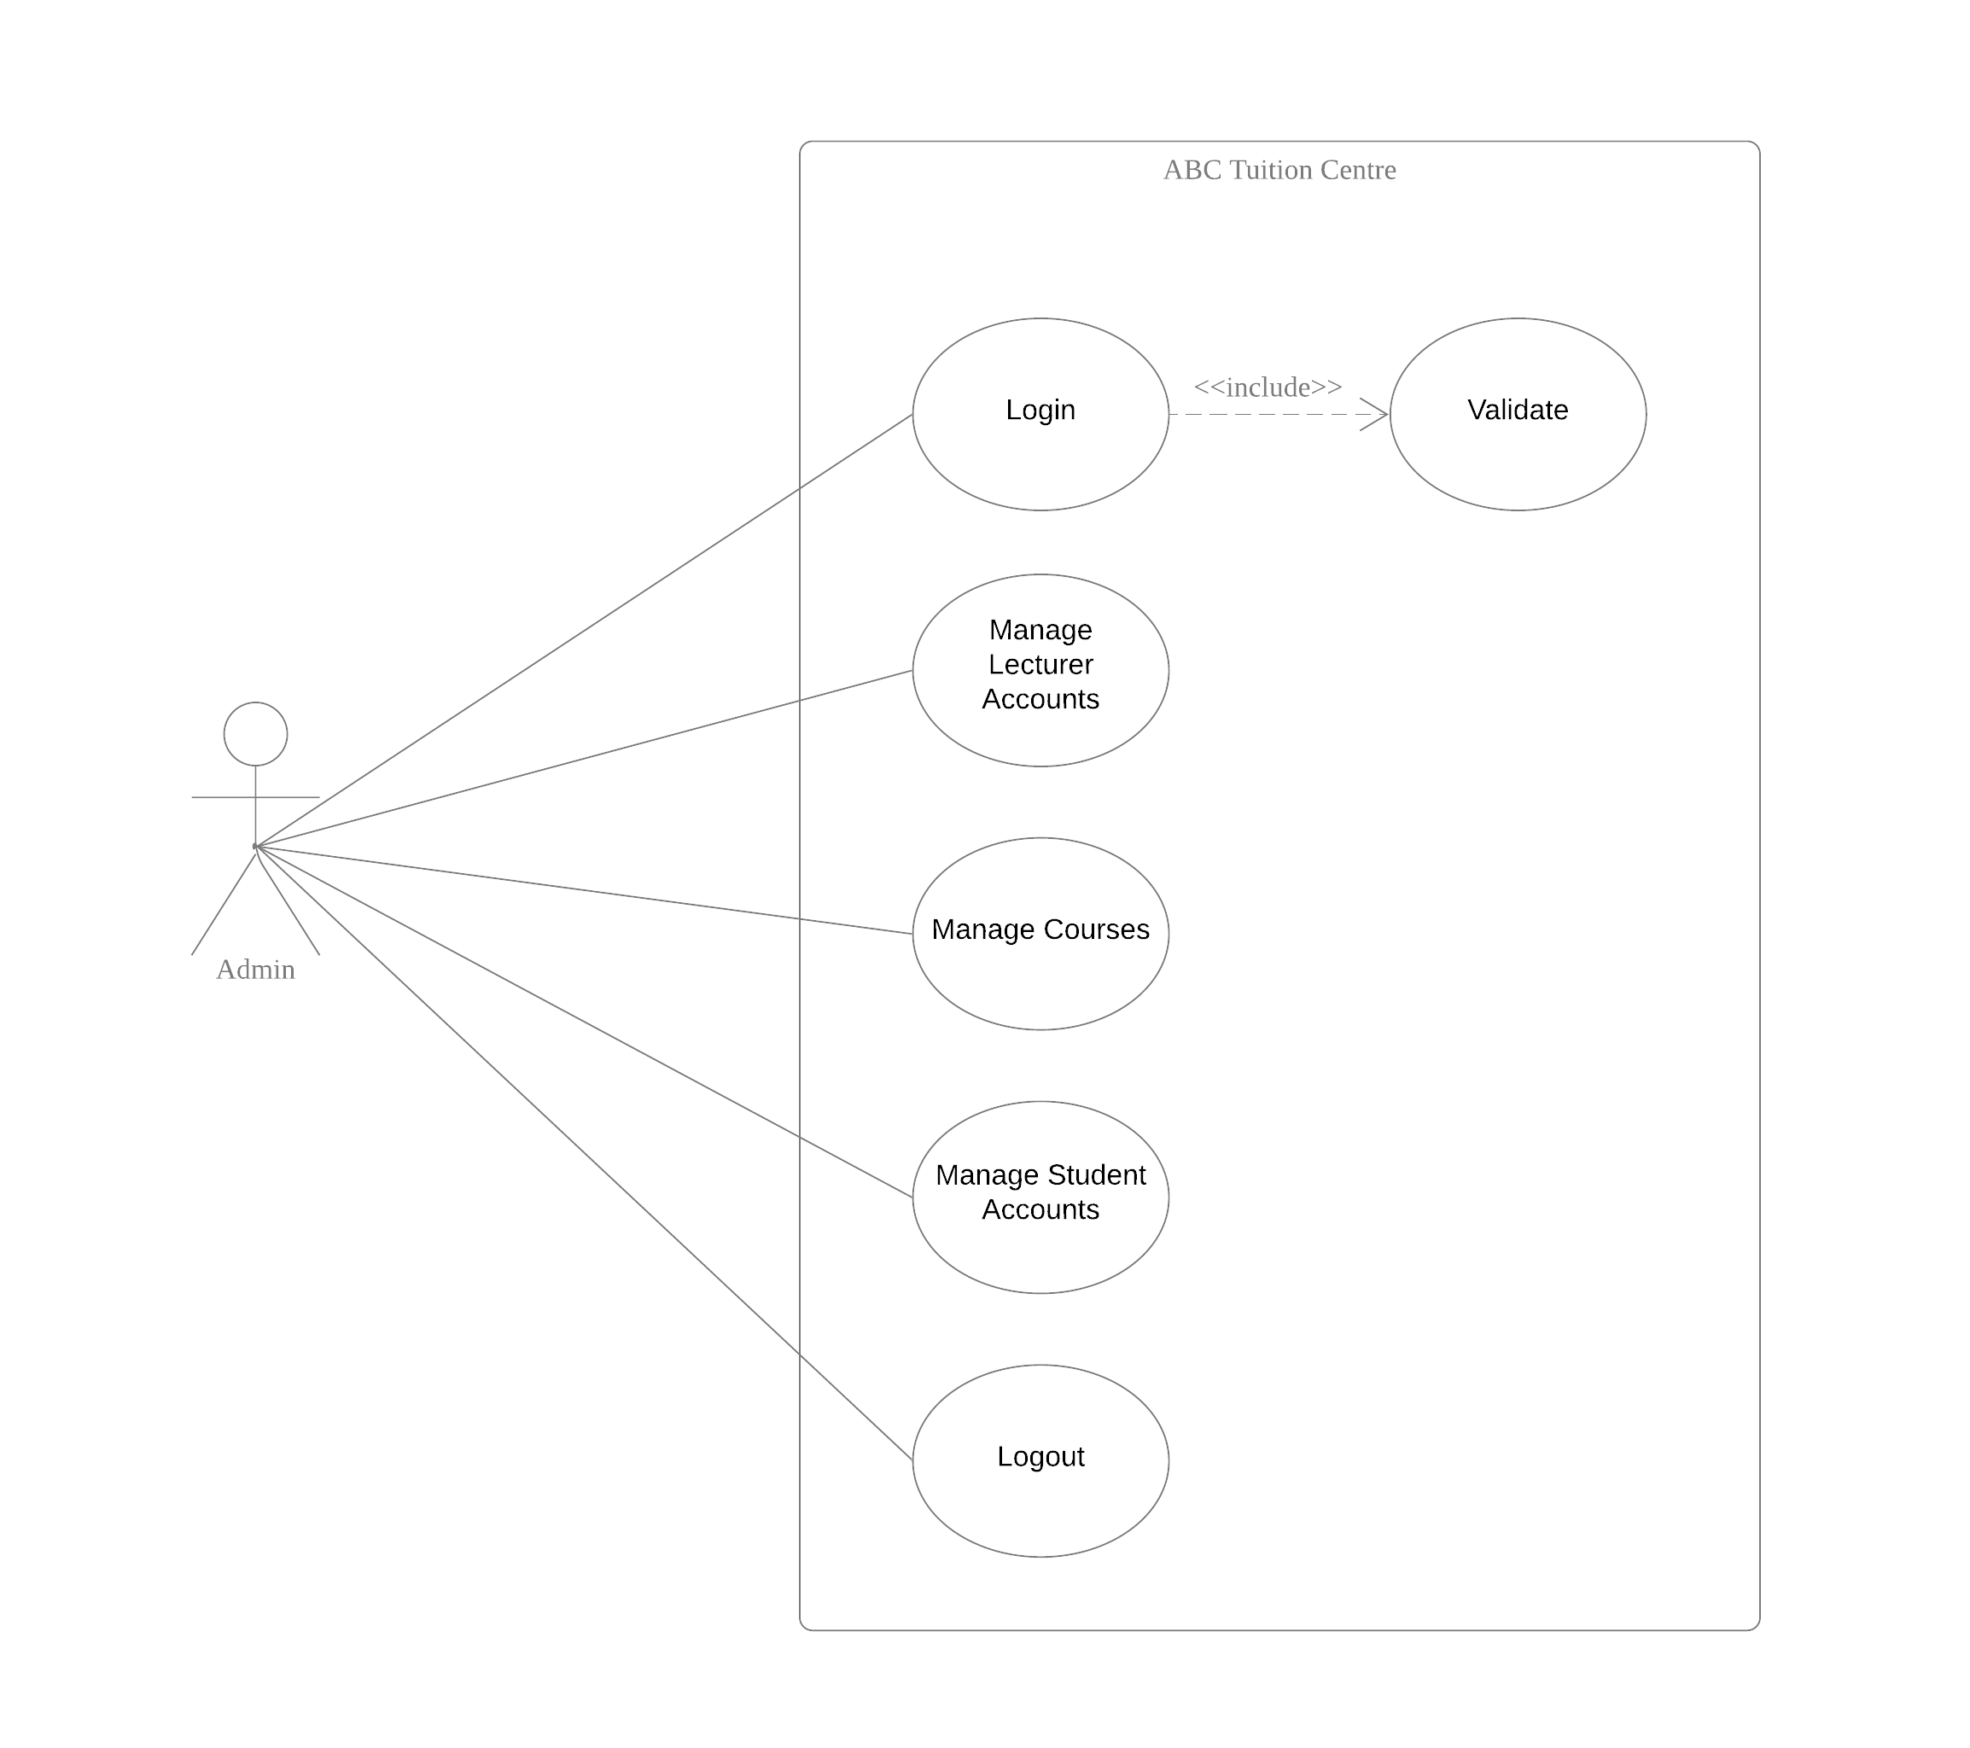

Figure 4: Admin Use Case Diagram

### 3.3.2 Use Case Description

#### 3.3.2.1 Register Account

|  |  |
| --- | --- |
| Use Case Name | Register Account |
| Use Case Description | Student registers new account with ABC Tuition Center |
| Actors | Student |
| Trigger | New student who wants to enrol in a course or have an account |
| Pre-Condition | Student does not have existing account.  Student is redirected to register page from clicking on “Register” link on menu |
| Successful Scenario | 1. Screen displays the register page with register form 2. Student fills out details in registration form 3. Student submits form 4. System displays a message of success |
| Unsuccessful scenario | 1. Existing User or email in database   1. Display an error message and deny access |
| Extension/Include | Include🡪Validate |
| Post Condition | 1. Screen displays registration successful message and gives user the option to be redirected to log in page 2. Screen displays Login Page |

#### 3.3.2.2 Login Account

|  |  |
| --- | --- |
| Use Case Name | Login |
| Use Case Description | Student, Lecturer and Admin able to access their respective profile and use Systems functionality and services fully |
| Actors | Student, Lecturer, Admin |
| Trigger | 1. Student wants to access student portal to view courses, enrol and track progress 2. Admin wants to manage courses, student listing or courses 3. Lecturer wants to update student progress in course |
| Pre-Condition | Screen displays home page with “login” icon on the navigation bar |
| Successful Scenario | 1. Screen displays Login Page with “Username field”, “Password field” and “Submit button” 2. User types in Username 3. User types in Password 4. IF username and password is correct, then system will check account type of user    1. **IF user is admin,**       1. Login user as admin    2. **Else IF user is a student**       1. Login user as a student    3. **Else IF user is a lecturer**       1. Login user as lecturer |
| Unsuccessful scenario | 1. If username or password is incorrect,    1. Display an error message and deny access to system |
| Extension/Include | Include🡪Validation |
| Post Condition | 1. Screen Display admin dashboard if user is admin 2. Screen Display student portal if user is student 3. Screen Display lecturer panel if user is lecturer |

#### 3.3.2.3 Manage Account

|  |  |
| --- | --- |
| Use Case Name | Manage Account |
| Use Case Description | User can view or update account details depending on account type |
| Actors | Student or Lecturer |
| Trigger | 1. Student wants to view or update account details 2. Lecturer wants to view account details |
| Pre-Condition | User is logged into respective account |
| Successful Scenario | 1. Screen displays profile page 2. **IF user is Student**    1. To View       1. Screen displays all student’s account details on profile page    2. To Update       1. Screen displays account details in editable form       2. Student can edit details on the form       3. Student clicks “Save” button       4. Student details are successfully updated 3. **IF user is Lecturer**    1. To View       1. Screen displays all lecturer’s account details on profile section |
| Unsuccessful scenario |  |
| Extension/Include |  |
| Post Condition | Successfully viewed or updated account details depending on account type and authorized functionality. |

#### 3.3.2.4 View Courses Offered

|  |  |
| --- | --- |
| Use Case Name | View Courses Offered |
| Use Case Description | Student can view courses listing |
| Actors | Student |
| Trigger | To view updated list of courses offered and decide about enrolling |
| Pre-Condition | Student account has been approved by admin |
| Successful Scenario | 1. Screen displays course listing page with all the courses offered 2. Student can click on “learn more” button on each course to view course details 3. Screen displays description of course with an option to enrol |
| Unsuccessful scenario |  |
| Extension/Include | Extend 🡪 Enrol Course |
| Post Condition |  |

#### 3.3.2.4.1 Enrol Course

|  |  |
| --- | --- |
| Use Case Name | Enrol Course |
| Use Case Description | Student can enrol for a course offered |
| Actors | Student |
| Trigger | To enrol for a course offered |
| Pre-Condition | Student has not already enrolled in course |
| Successful Scenario | 1. **Course Listing Page:**    1. Screen displays a list of all courses offered    2. Screen displays an “enrol” button    3. Student clicks on enrol button on course listing page without opening to view course details    4. Course is added to student’s enrolled courses in the database 2. **Course Details Page:**    1. Student opens course detail page by clicking on “learn more” button on course listing page    2. Screen displays course details with enrol button    3. Student clicks on “enrol” button    4. Course is added to student’s enrolled courses in the database |
| Unsuccessful scenario |  |
| Extension/Include |  |
| Post Condition | Student has successfully enrolled for course |

#### 3.3.2.5 Manage Courses Enrolled

|  |  |
| --- | --- |
| Use Case Name | Manage Courses Enrolled |
| Use Case Description | Student can view courses he/she is enrolled for and track progress |
| Actors | Student |
| Trigger | To view courses enrolled in and track progress |
| Pre-Condition | Student has already enrolled in course |
| Successful Scenario | 1. Screen displays list of courses student is enrolled in 2. Student can click on “learn more” button on each course to view course details 3. Student can view progress details |
| Unsuccessful scenario |  |
| Extension/Include |  |
| Post Condition | Screen displays details of course enrolled in |

#### 3.3.2.6 Manage Courses Assigned

|  |  |
| --- | --- |
| Use Case Name | Manage Courses Assigned |
| Use Case Description | View courses assigned to lecturer |
| Actors | Lecturer |
| Trigger | To view courses assigned |
| Pre-Condition | Course has been assigned to lecturer by admin |
| Successful Scenario | 1. Screen displays list of courses assigned to lecturer 2. Lecturer can click on “learn more” button on each course to view course details 3. Screen displays course details and list of students enrolled in course 4. Lecturer can update the progress of students enrolled in the course |
| Unsuccessful scenario |  |
| Extension/Include | Extend 🡪 Update Student Progress |
| Post Condition | Screen displays details of course assigned to lecturer |

#### 3.3.2.6.1 Update Student Progress

|  |  |
| --- | --- |
| Use Case Name | Update Student Progress |
| Use Case Description | Update attendance records and student progress in courses |
| Actors | Lecturer |
| Trigger | To update student progress for courses |
| Pre-Condition | Screen displays course details |
| Successful Scenario | 1. Screen displays course details and list of students enrolled in course 2. List of student enrolled in course has an option to update attendance records and add marks for assignments 3. Lecturer updates attendance of students 4. Lecturer enters marks for assignments 5. Lecturer clicks “save” button 6. Student progress is updated on the system |
| Unsuccessful scenario |  |
| Extension/Include |  |
| Post Condition | Student progress is updated on database |

#### 3.3.2.7 Manage Lecturer Accounts

|  |  |
| --- | --- |
| Use Case Name | Manage Lecturer Accounts |
| Use Case Description | View, Add, Update, Delete lecturer accounts |
| Actors | Admin |
| Trigger | To manage lecturer accounts |
| Pre-Condition | Screen displays the “Manage Lecturer” button on the navigation bar OR admin dashboard |
| Successful Scenario | 1. **Add:**    1. Admin clicks on “Add New” button    2. Screen displays a registration form to create new lecturer account    3. Admin enters lecturer details in form    4. Admin clicks “Submit” button    5. New lecturer account is added to the system 2. **View:**    1. Screen displays a list lecturers added to the system    2. Admin can view the details of all lecturers 3. **Update:**    1. Admin clicks on “edit” button next to lecturer details    2. Screen displays lecturer’s details as a form    3. Admin updates details on the form    4. Admin clicks “save” button    5. Lecturer details are updated on the system 4. **Delete:**    1. Screen displays list of lecturers on the system    2. Admin clicks on “Delete” button next to the lecturer account details    3. Lecturer account is deleted from the system |
| Unsuccessful scenario |  |
| Extension/Include |  |
| Post Condition | Screen displays updated list of lecturers |

#### 3.3.2.8 Manage Courses

|  |  |
| --- | --- |
| Use Case Name | Manage Courses |
| Use Case Description | View, Add, Update, Delete course listing |
| Actors | Admin |
| Trigger | To manage courses offered |
| Pre-Condition | Screen displays the “Manage Lecturer” button on the navigation bar OR admin dashboard |
| Successful Scenario | 1. **Add:**    1. Admin clicks on “Add New” button    2. Screen displays a registration form to create new course    3. Admin enters course details in form    4. Admin assigns lecturer to course    5. Admin clicks “Submit” button    6. New course is added to the system 2. **View:**    1. Screen displays a list courses added to the system    2. Admin can click on “learn more” button to view details of each course    3. Screen will display details of course    4. Screen will display list of students enrolled in course    5. Screen will also display progress report of all students enrolled in course 3. **Update:**    1. Admin clicks on “edit” button next to update course details    2. Screen displays course details as a form    3. Admin updates details on the form    4. Admin clicks “save” button    5. Course details are updated on the system 4. **Delete:**    1. Admin clicks on “Delete” button next to the course details    2. Course is deleted from the system |
| Unsuccessful scenario |  |
| Extension/Include |  |
| Post Condition | Screen displays updated list of courses |

#### 3.3.2.9 Manage Student Accounts

|  |  |
| --- | --- |
| Use Case Name | Manage Student Accounts |
| Use Case Description | View, Approve , Delete students |
| Actors | Admin |
| Trigger | To manage students registered in ABC tuition centre |
| Pre-Condition | Student has created an account on system |
| Successful Scenario | 1. **Approve:**    1. Screen displays list of students registered on the system    2. Admin views and verifies the details of new student registered in the system    3. All details are correct and student is eligible to register in ABC Tuition Centre    4. Admin clicks on “approve” button to approve student registration    5. Student status is updated on system    6. Student is now able to enrol for courses offered 2. **View:**    1. Screen displays a list of students registered in the system    2. Admin can click on “view more” button to view details of each students    3. Screen will display details of student registered    4. Screen will display list of courses student is enrolled in    5. Screen will also display progress report of student for each course 3. **Delete:**    1. Admin clicks on “Delete” button next to the student details    2. Student account is deleted from the system |
| Alternate scenario | 1. **Approve:**    1. Screen displays list of students registered on the system    2. Admin views and verifies the details of new student registered in the system.    3. Admin finds some details to be untrue or fraudulent OR student is ineligible to register with ABC Tuition Centre    4. Admin clicks on “reject” button to reject student registration    5. Student account is deleted from the system |
| Extension/Include |  |
| Post Condition | Screen displays updated list of student |

#### 3.3.2.10 Logout

|  |  |
| --- | --- |
| Use Case Name | Logout |
| Use Case Description | Student, Lecturer or Admin signs out of his account |
| Actors | Student, Lecturer and Admin |
| Trigger | User Wants to log out of his account for security reasons |
| Pre-Condition | User is logged in |
| Successful Scenario | 1. Screen displays any page with header having the logout icon 2. User clicks the icon 3. User is logged out 4. Screen display Login page |
| Unsuccessful scenario |  |
| Extension/Include |  |
| Post Condition | Screen display Homepage |

### 3.3.3 Activity Diagram and Flow Chart

#### 3.3.3.1 Flow Chart - Register Account

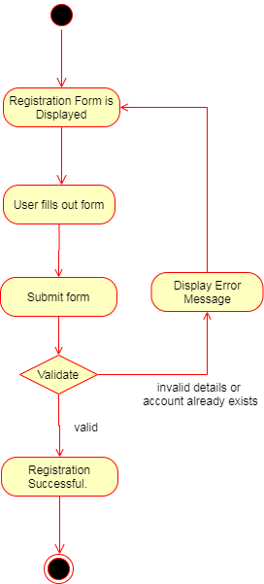

Figure 5: Flowchart: Register Account

#### 3.3.3.2 Flow Chart - Login Account

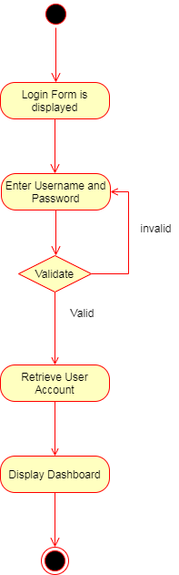

Figure 6: Flowchart - Login Account

#### 3.3.3.3 Activity Diagram Student Portal

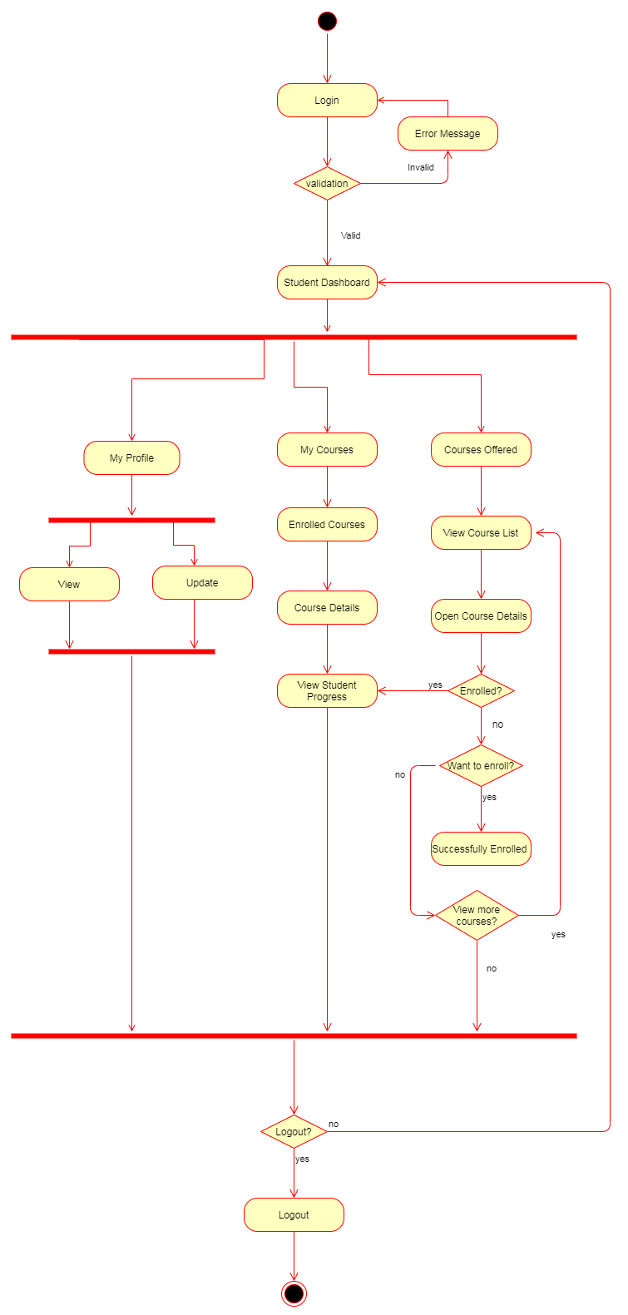

Figure 7: Activity Diagram - Student

#### 3.3.3.4 Flowchard – Lecturer Panel

Figure 8: Flowchart - Lecturer

#### 3.3.3.5 Activity Diagram Admin

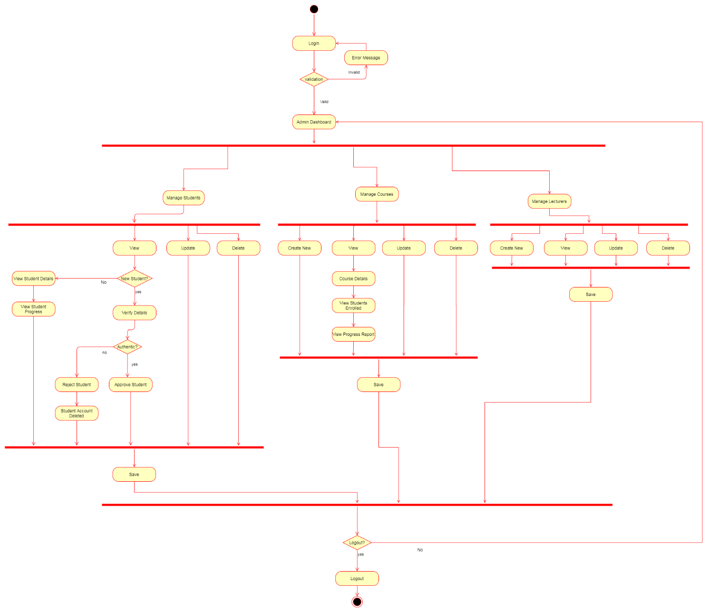

Figure 9:: Activity Diagram - Admin

### 3.3.3 Class Diagram

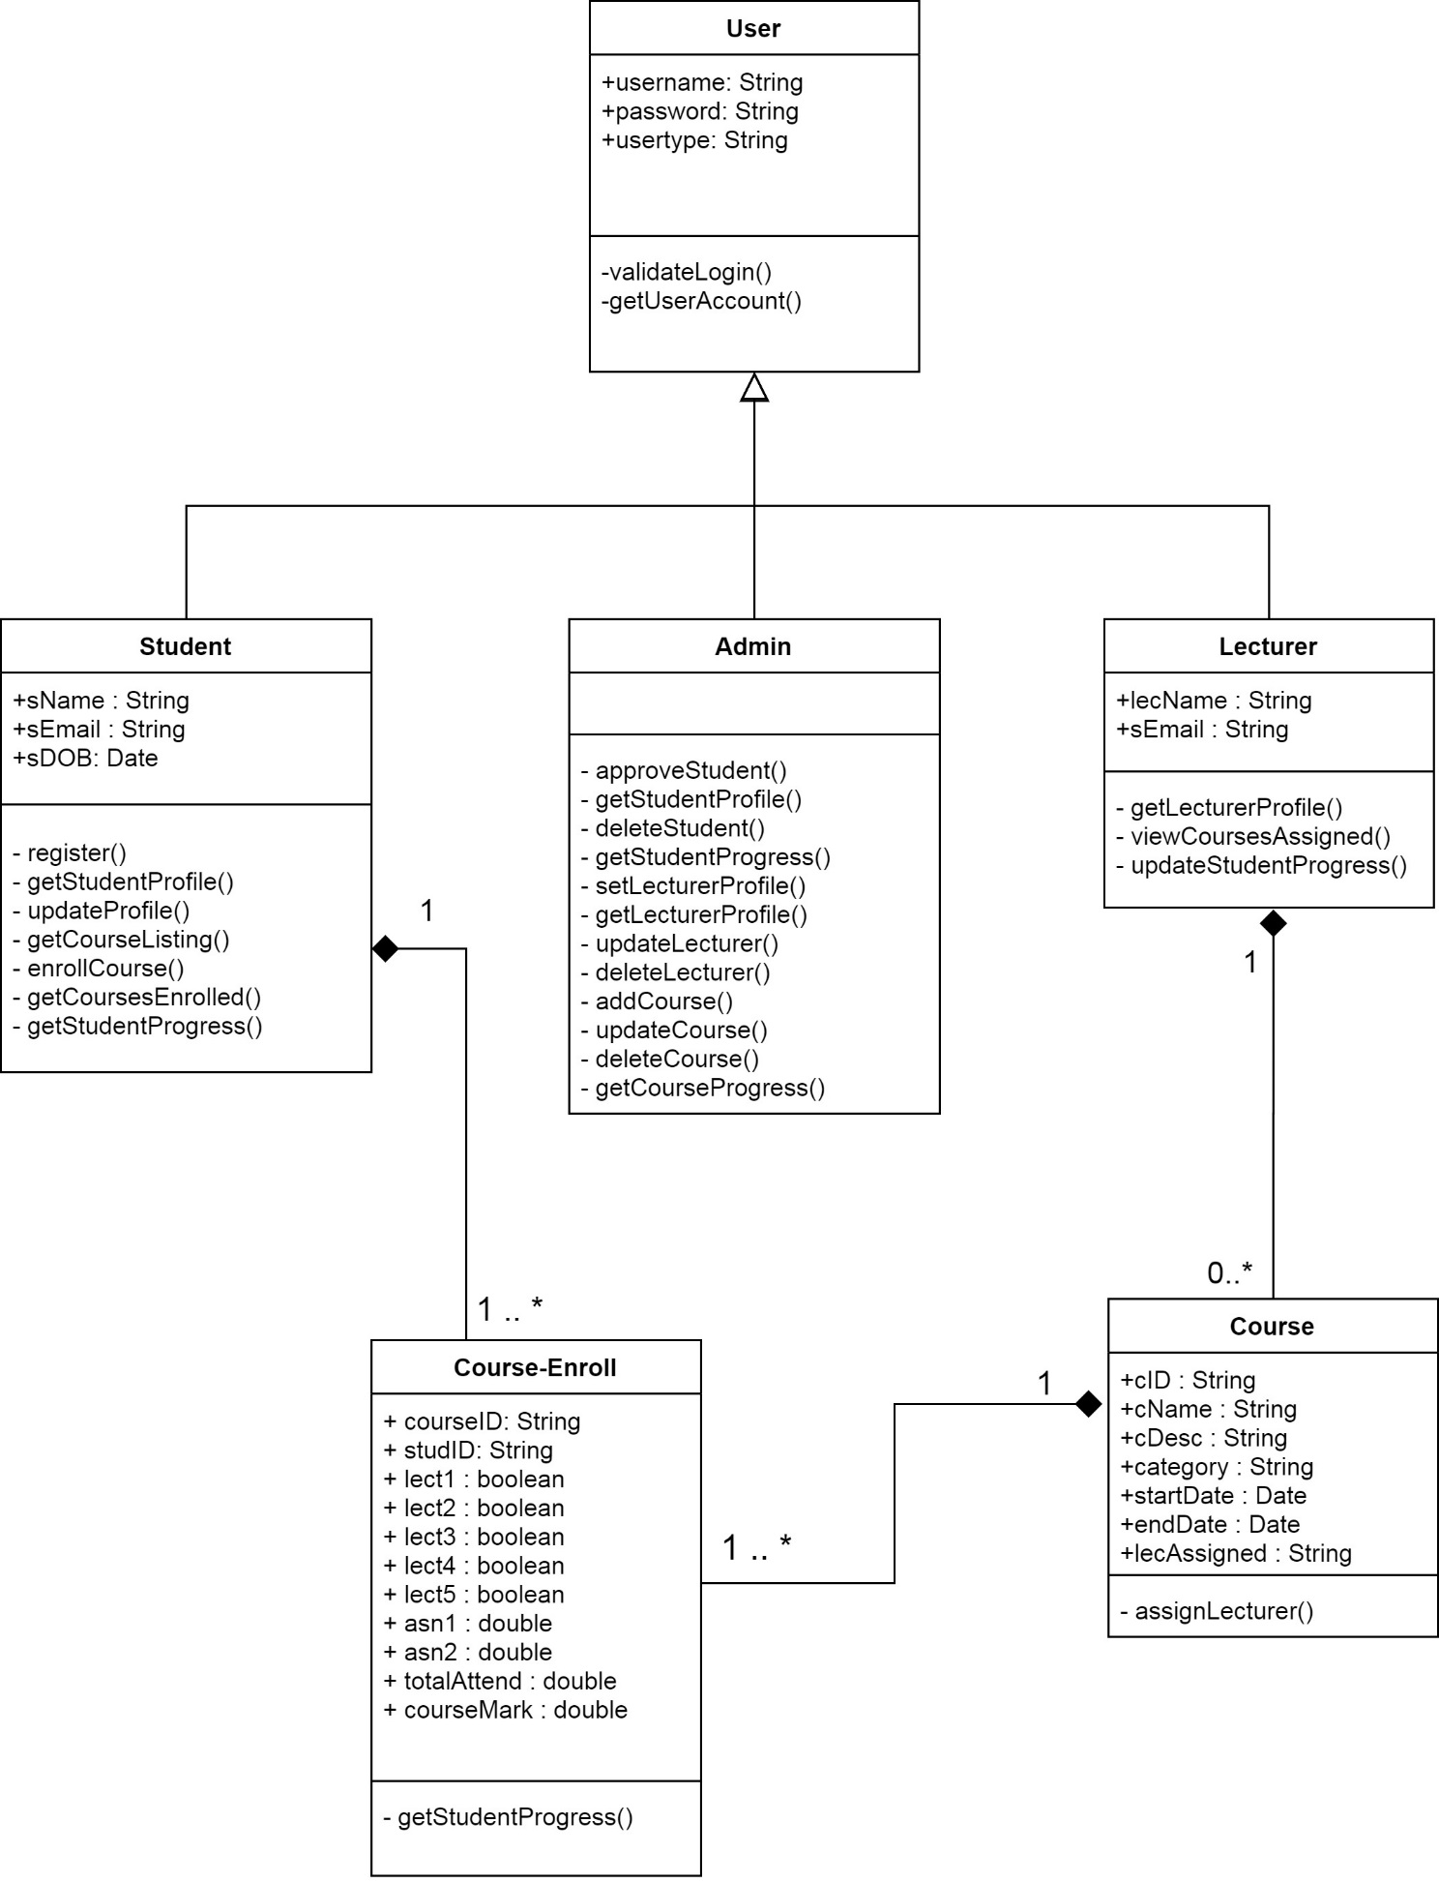

Figure 10: Class Diagram

### 3.3.5 Database Architecture

#### 3.3.5.1 Database Schema

|  |  |  |  |  |
| --- | --- | --- | --- | --- |
| Entity | Attribute | DATA TYPE | Constraint | Comment |
| Student | sID | CHAR(7) | Primary Key |  |
| sName | VARCHAR (75) |  |  |
| sPassword | VARCHAR(75) |  |  |
| sEmail | VARCHAR(75) |  |  |
| sDOB | DATE |  |  |
| usertype | VARCHAR(8) |  |  |
| Lecturer | lecID | CHAR(7) | Primary Key |  |
| lecName | VARCHAR (75) |  |  |
| lecPassword | VARCHAR(75) |  |  |
| lecEmail | VARCHAR(75) |  |  |
| usertype | VARCHAR(8) |  |  |
| Admin | adID | CHAR(7) | Primary Key |  |
| adPassword | VARCHAR(75) |  |  |
| usertype | VARCHAR(8) |  |  |
| Course | cID | CHAR(7) | Primary Key |  |
| cName | VARCHAR (75) |  |  |
| category | VARCHAR(15) |  |  |
| cDesc | TEXT |  |  |
| startDate | DATE |  |  |
| endDate | DATE |  |  |
| lecAssigned | CHAR(7) | Foreign Key |  |
| Course-Enroll | courseID | CHAR(7) | Primary Key | Composite Key |
| studID | CHAR(7) | Primary Key |
| lect1 | BOOLEAN |  |  |
| lect2 | BOOLEAN |  |  |
| lect3 | BOOLEAN |  |  |
| lect4 | BOOLEAN |  |  |
| lect5 | BOOLEAN |  |  |
| asn1 | DOUBLE |  |  |
| asn2 | DOUBLE |  |  |
| totalAttend | DOUBLE |  |  |
| courseMark | DOUBLE |  |  |

Table 3: Database Schema

#### 3.3.5.2 ERD Diagram

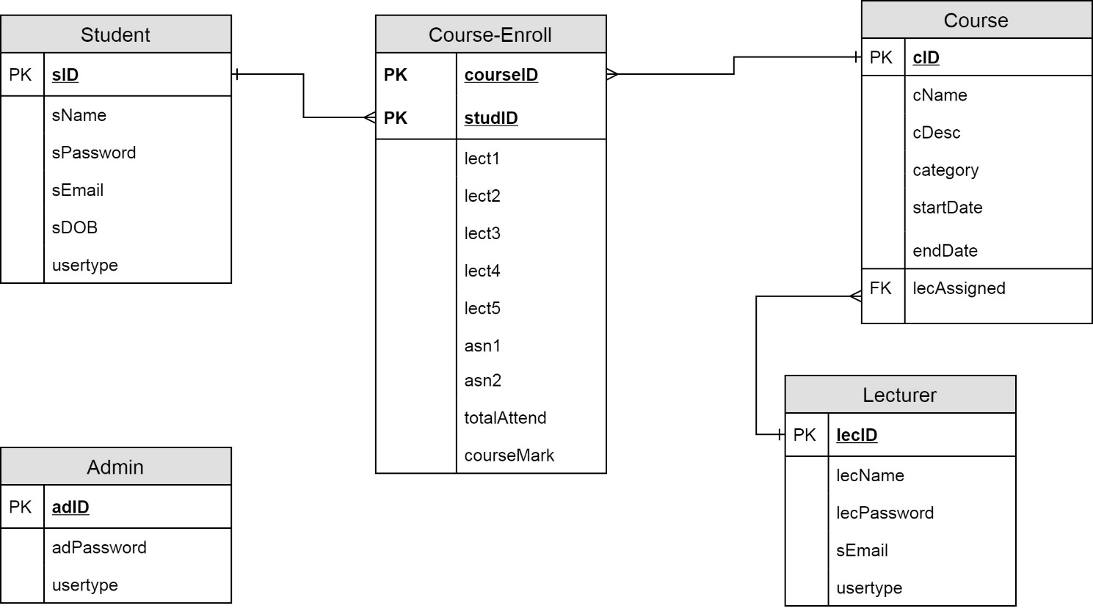

Figure 11: Entity Relationship Diagram

### 3.3.6 Story Board

Figure 12: Hierarchical Story Board

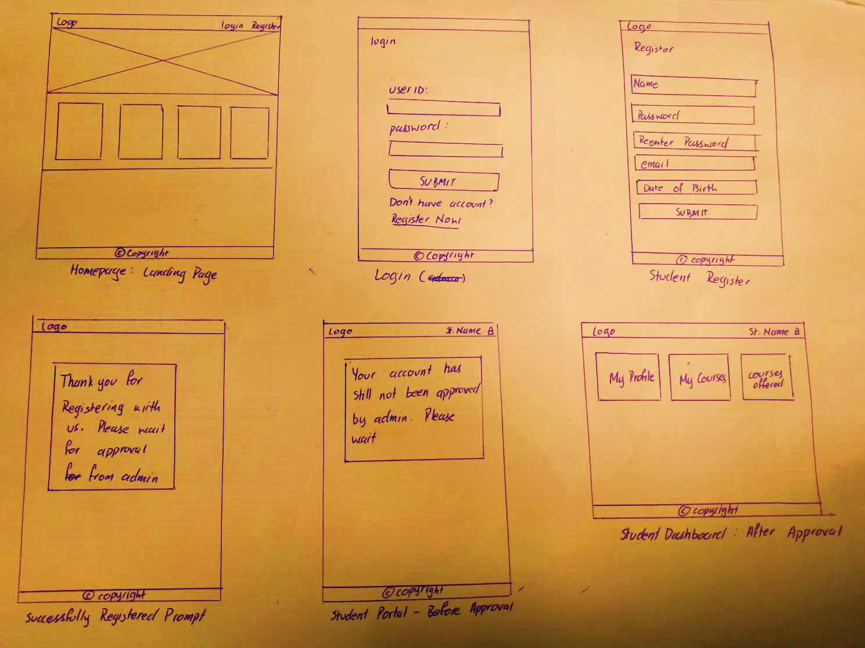

Figure 13: Story Board - Pre-login pages and Student Dashboard

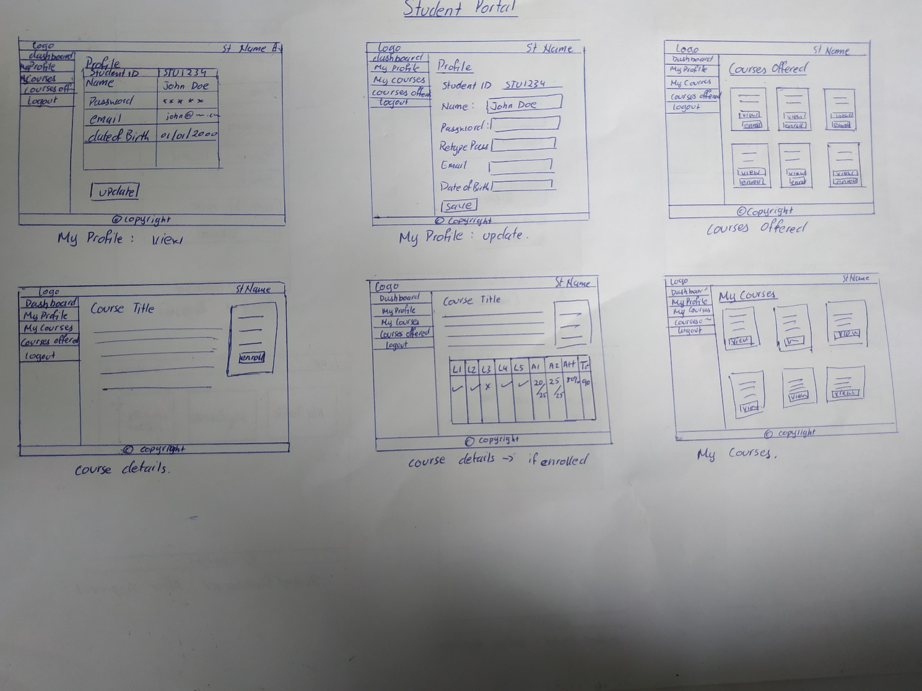

Figure 14: Story Board - Student Portal

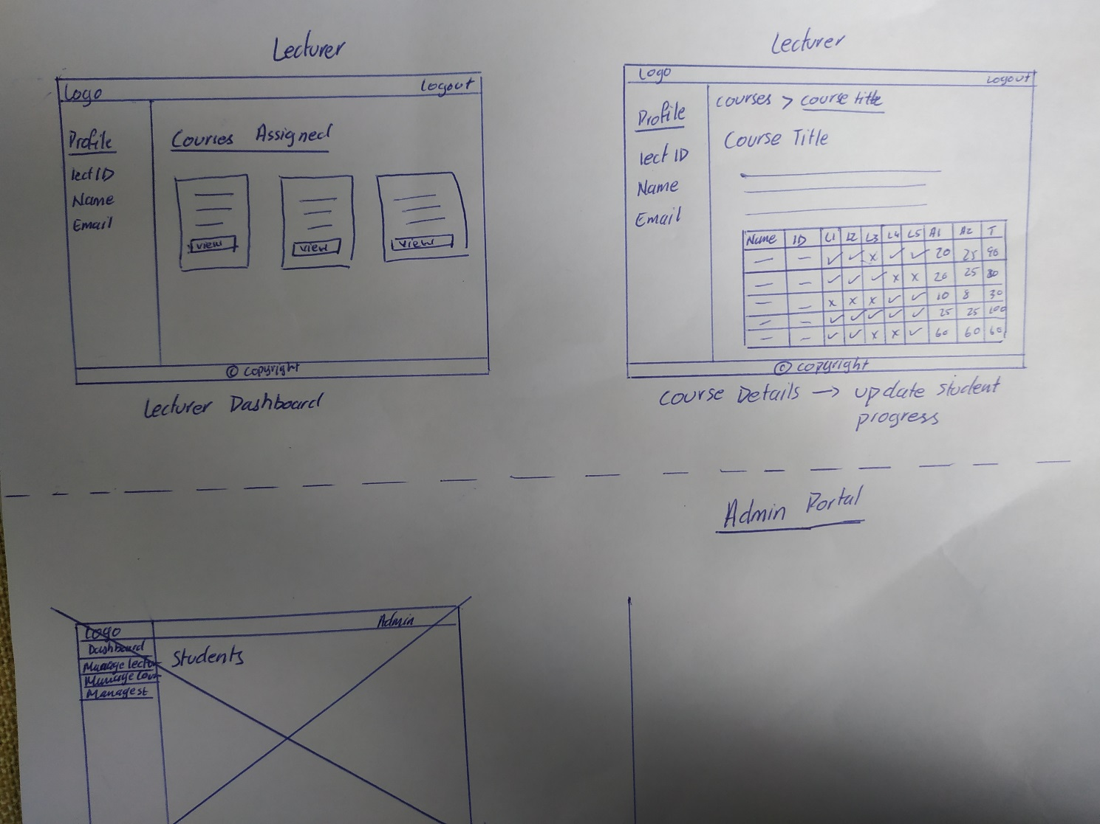

Figure 15: Story Board - Lecturer Dashboard and Course Details

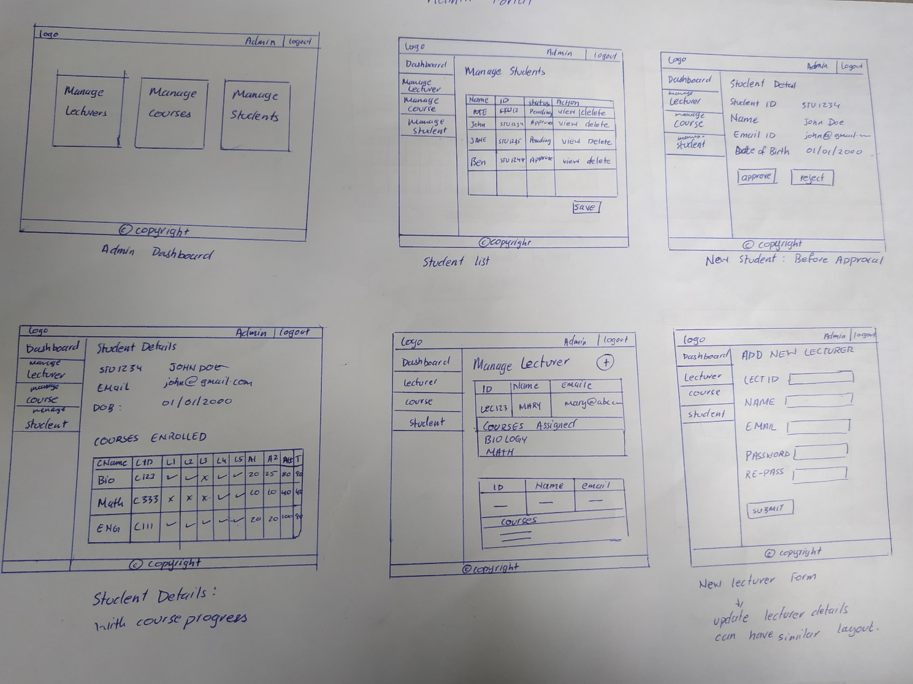

Figure 16: Story Board - Admin Panel

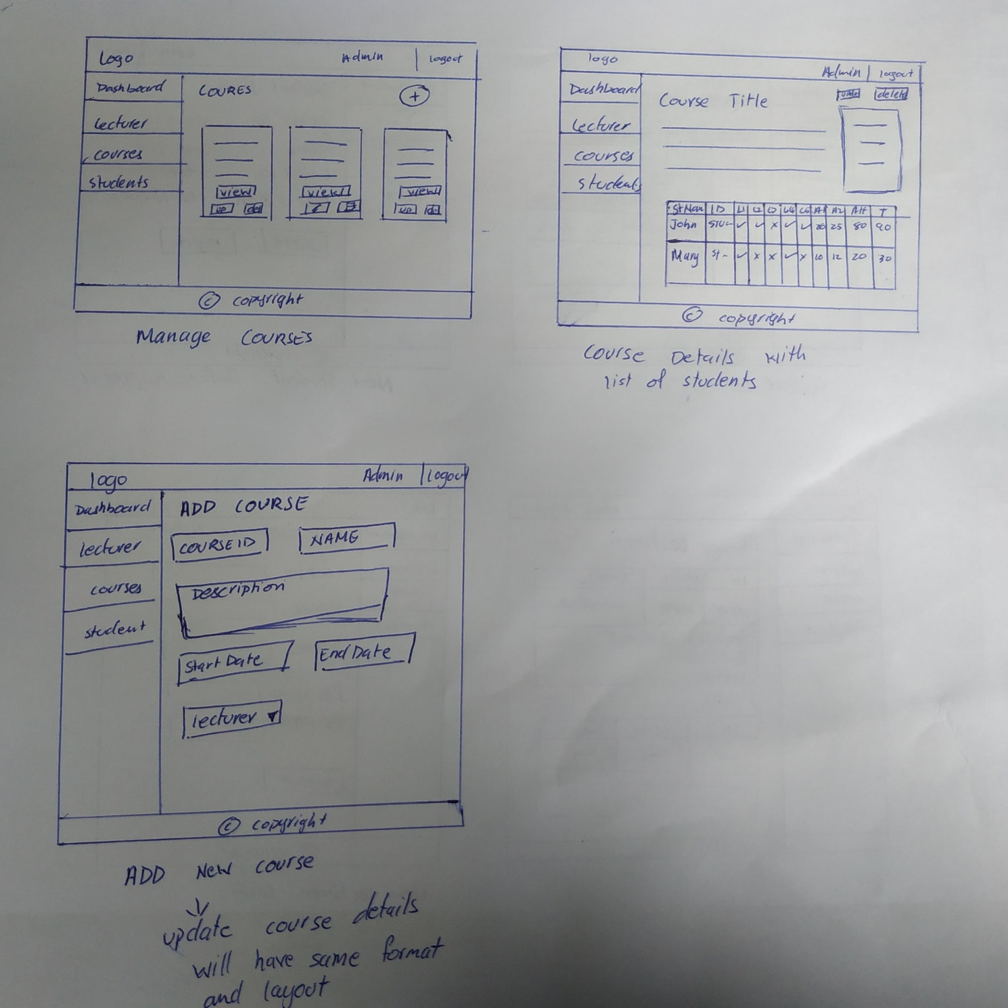

Figure 17: Story Board - Admin Panel

# CHAPTER 4: WEBSITE PROTOTYPE

The user interface of all page have been designed in accordance to Material Design Standards with the help of the Materialize framework, material icons, font awesome icons and pure CSS3 features. The interface is semi-responsive and is suitable for Desktops, Laptops and Tablets.

Before going into each individual page and their associated functionality, we would like to explain a few supporting “.php” files that are programmed to support major features or functionalities of the main pages.

## 4.1 Essential PHP Files and Functionalities

PHP allows certain repetitive elements or functionalities to be written in independent files and called in the main files of a web applications using the *include(‘FILENAME.php’ ); , include_once(‘FILENAME.php’ ); , require(‘FILENAME.php’ ); , require_once(‘FILENAME.php’ );* functions. These help break major chunks of repetitive codes allowing the developer to write them only once. Not only does this make it efficient for the application but also makes it easier to make changes that are universally applied across all the pages that call the code written in these sub-files using the include or require php functions making maintenance of the application easier.

### 4.1.1 header.php

The header element is universally applied across all the pages of the website. In order to make it more efficient to apply the header throughout the web application, the header code has been written in the header.php file. To refer to the entire code of the header.php file, please refer to **Section 1a header.php in Appendix F**

The header.php file consists of the php and html code required on all pages across the website not limited to the header element, i.e. navigational bar of the actual user interface. At the very top of the the header.php file, another supporting php file called server.php is called which consists of the main server side php functionality required on all pages of the website. The header.php file also consists of the Author information and it starts the html code of the website, i.e. the <!DOCTYPE html> element, it includes the entire <head></head> tag and their associated elements. The header.php file also starts the <body> tag of the html code.

Finally, since the navigational header of the user interface is consistent throughout the website, it has also been included in the header.php file. The navigational header is different for a user who has not logged into the system.



Figure 18: Header Navigation - user not logged in



Figure 19: Header Navigation - user logged in

The different UI for the header for a user who is logged in vs a user who is not logged in is accomplished using the PHP IF( ){ } condition. Please refer to the image below for a reference of the code.

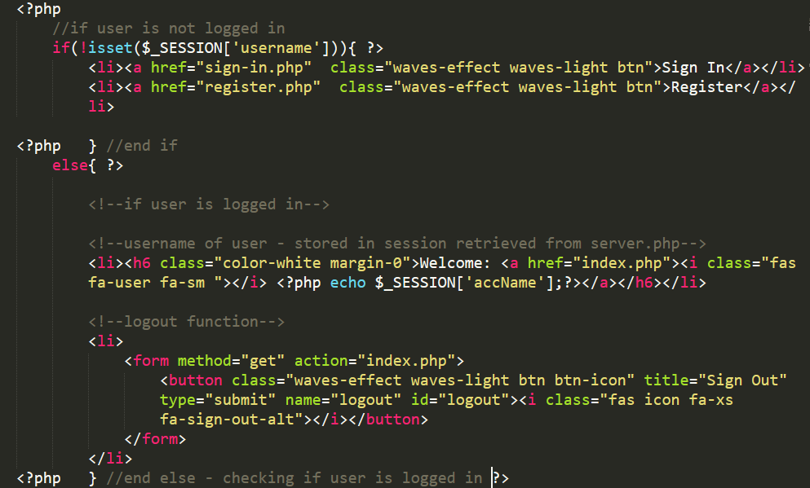

Figure 20: PHP header condition

For more details on how the PHP SESSION variable is used to accomplish this, please refer to **4.1.3 server.php** and **4.3.3 Log In**

### 4.1.2 footer.php

footer.php file is included at the end of all the main pages of the interface except the homepage. The homepage has its own independent footer. The footer.php file consists of the footer element of the user interface of the web application, jquery and materialize.js function calls and initializations, and the closing of the html <body> and <html> tags respectively. To refer to the complete code of the footer.php file, please refer to **Section 1b footer.php in Appendix F**

### 4.1.3 server.php

The **server.php** file consists of all major server side functionalities such as:

* Starting a session
* Establishing a connection with the database
* Initializing universal variables
* User sign in function – student, lecturer and admin
* Add new course
* Registration – student and lecturer
* Update function – student, course, lecturer
* Delete function
* Update student progress function

To refer to the entire code of the **server.php** file, please refer to **Section 1c. server.php** in **Appendix F.** Each of the individual functions will be discussed in detail in the remaining sections of the report.

### 4.1.4 aside.php

The **aside.php** is mainly a user interface element consisting of the sidebar navigation that appears on the user interface after the user logs in. A single file is used for student, lecturer and admin pages and the sidebar design and content will change depending on the user type. To refer to the entire code of the **aside.php** file, please refer to **Section 1d. aside.php** in **Appendix F.**

 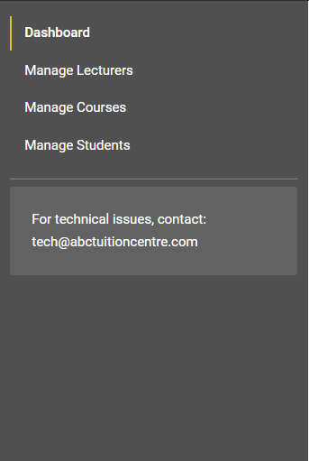 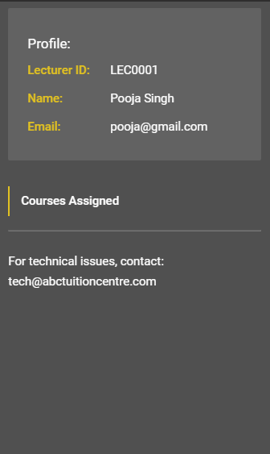

Figure 21: Sidebar – Student Figure 22: Sidebar – Admin Figure 23: Sidebar – Lecturer

The active page will be highlighted with a thick yellow line towards its left. This UX features is achieved by applying the “active” CSS Class with the help of JQuery to the active page. The active page is identified through a variable with the associated ID of the side-navigation bar link initialized on the respective pages they represent.

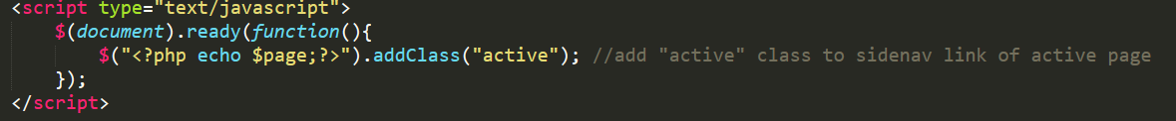

Figure 24: Sidebar JQuery functionality

For example:



The above image represents the student-dashboard.php sidebar link. The ID of the anchor tag is stored in the variable $page in the student-dashboard.php file as can be seen below.

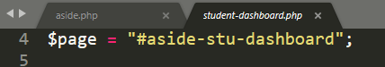

### 4.1.5 courses.php

The **courses.php** file consists of the front-end layout of the courses. The file is included on the homepage, and within the student portal under the “Courses Offered” sections respectively. To refer to the entire code of the **courses.php** file, please refer to **Section 1f. courses.php** in **Appendix F.**

#### 4.1.5.1 Default Course Layout

By default, a user will see the courses populated on the homepage in the following layout and design:

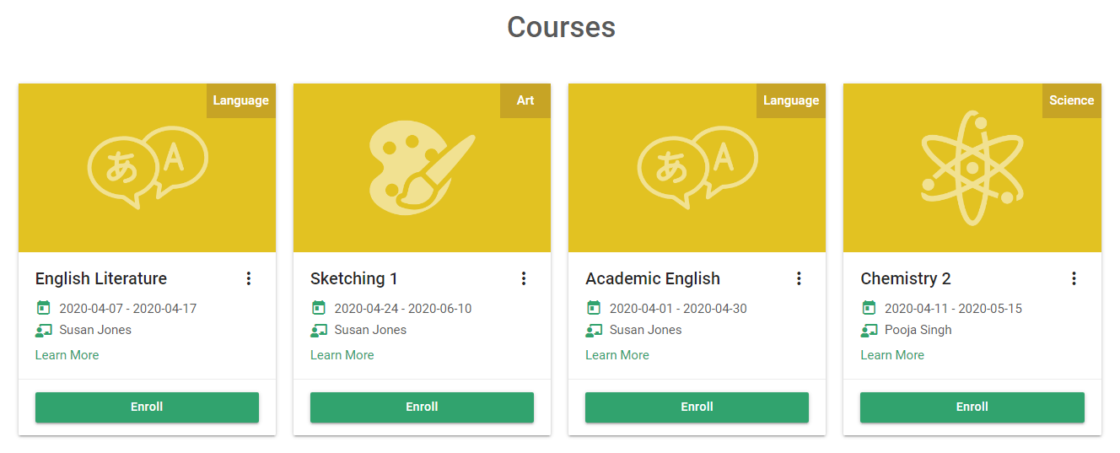

Figure 25: Courses Default Layout

Upon clicking the icon with the vertical-dotted-circles , the user will be able to view more information about the course. This will appear as an overlay on the card without redirecting the user to another page. The “card-reveal” feature from materialize.js has been used to make this interaction:



Figure 26: Course card user experience

If the user still wishes to gain more information on the course on a separate dedicated page, they may click the “Learn More” anchor text and they will be redirected to the “View Course” page. Please refer to **4.1.6 View Course Details** for more information on this.

The “card action”, i.e. the call-to-action button in the card design will change if the user is logged in depending upon the user type and other conditions.

#### 4.1.5.1 Course Card - Student

The course card layout is different depending on the type of user if the user is signed in. If the user signed in is a student, the user will encounter 3 different layouts of the course card depending on whether their registration status is approved or pending and whether they have enrolled in the course or not.

##### Student Status Pending

A student whose registration status is still pending will not be allowed to enroll in the courses offered until their registration status is changed. By default they will not be allowed to access the “Courses Offered” and “Courses Enrolled” sections in their student dashboard, however they will still be able to view the courses on the homepage due to the nature of the homepage layout. In order to ensure that a student who is logged into the system and has their registration status as pending does not cheat the system and enroll into the course anyways, the enrollment button has been disabled for them in the following manner:

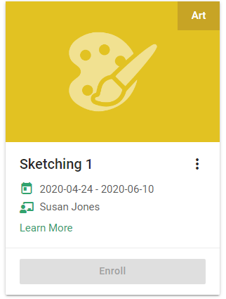

Figure 27: Course Card - Disabled Button

##### Student Status Approved

If a student is approved, they will be able to enroll for a course. Once they have enrolled for a course, the “enroll” button will change to “enrolled” and the button will become disabled. The two layouts of a course that is not enrolled and a course that is enrolled have been provided below:

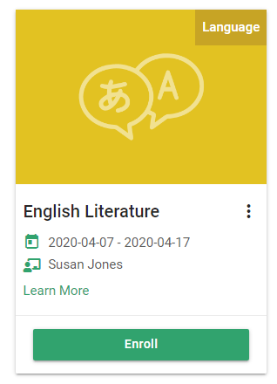 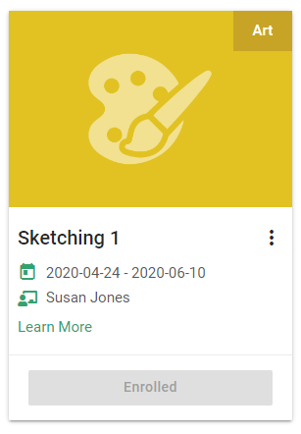

Figure 28: Course Card – Enroll Figure 29: Course Card - Enrolled

#### 4.1.5.2 Course Card – Lecturer and Admin

The courses assigned to a lecturer will be populated in their “Courses Assigned” section on their dashboard. In order to simplify the system, the courses assigned to the lecturer in the “Course Assigned” page are not populated from the **courses.php** file but rather programmed directly in the **lect-dashboard.php** file. To refer to the layout and coding, please refer to the section **4.5.1 Lecturer Dashboard**.

Although lecturers will not have direct access to courses assigned to other lecturers, they will still be able to view the courses assigned to other lecturers through the courses populated on the homepage. The admin will also be able to view the courses populated on the homepage in the same manner:

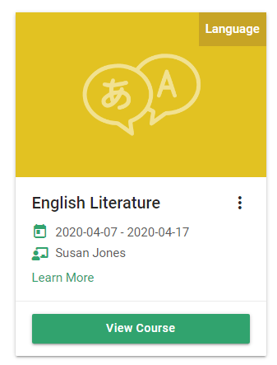

Figure 30: Course Card Homepage- Admin or Lecturer

### 4.1.6 viewcourse.php

The View Course page is a single page that can be accessed by all the different users, i.e. a user who is not signed in, a student, lecturer and admin. The roles each user plays on the page and the information they are authorized to view and interact with differs based on their user type and other conditions. To view the source code of the viewcourse.php page, please refer to **Appendix F** **Section 1e.**

The system retrieves the ID of the respective course the user would like to view with the GET method retrieving “id” attribute set on the anchor tag on the courses.php page:

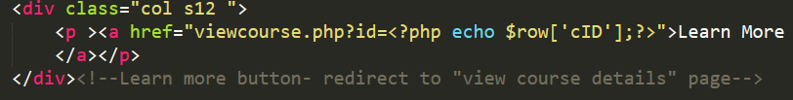

Figure 31: GET method set on anchor tag - courses.php



Figure 32: viewcourse.php URL

#### 4.1.6.1 User Not Signed In

For a user who is not logged in, the view course detail page appears like the image below. Similar to the enrol button on the course card on the homepage, upon clicking on the “enrol button” without logging in, the system will prompt the user to log in first in order to enrol for the course.

#### 

Figure 33: View Course Page - No user signed in

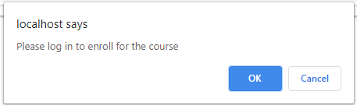

Figure 34: Log in Prompt

#### 4.1.6.2 Student – Pending Status

A student whose status is pending will not be allowed to enroll for a course. To prevent the student from cheating the system and enrolling for the course, if they access the view course page through the homepage, the “enroll” button is disabled preventing them from attempting to enroll in the program until their status is approved.

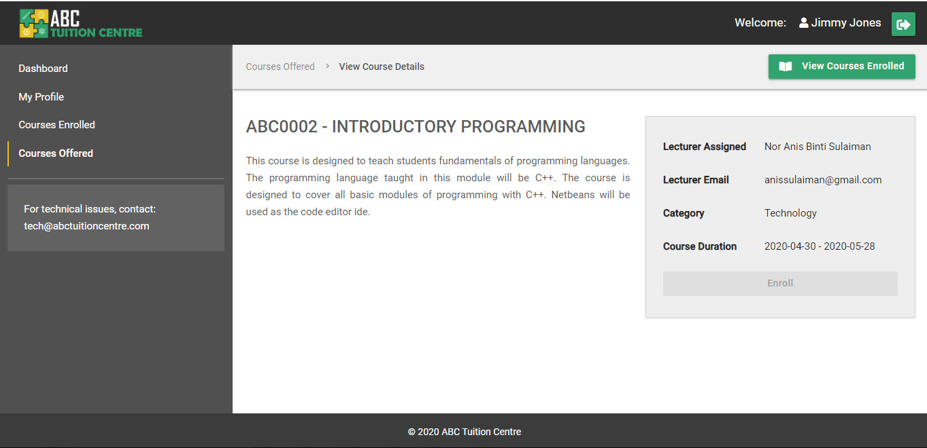

Figure 35: View Course Details - Student (Pending Status)

#### 4.1.6.3 Student – Active Status

If the student status is not “pending” the student is able to enroll for the course.

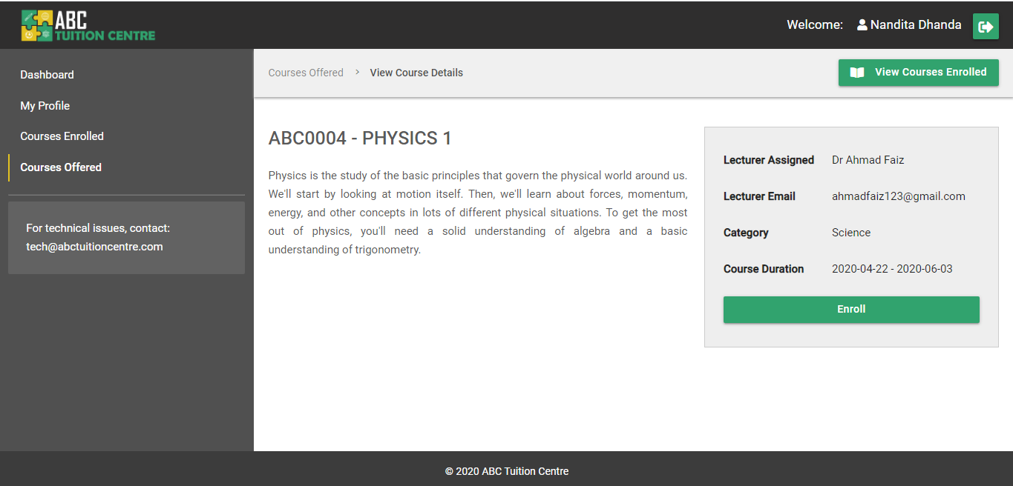

Figure 36: View Course Details - Student (Active)

Upon clicking on the “enroll button” the system displays a prompt confirming if the student would like to enroll for the course selected:

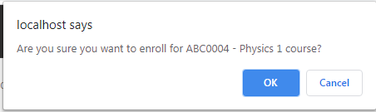

Figure 37: Enroll Course Confirmation Prompt

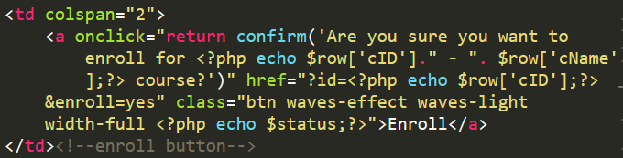

Figure 38: Enroll Course Button HTML and JQuery

After confirming that the student would like to enroll for the course, the student’s details are inserted into the “course-enrolled” SQL table and the enrollment is successfully completed.

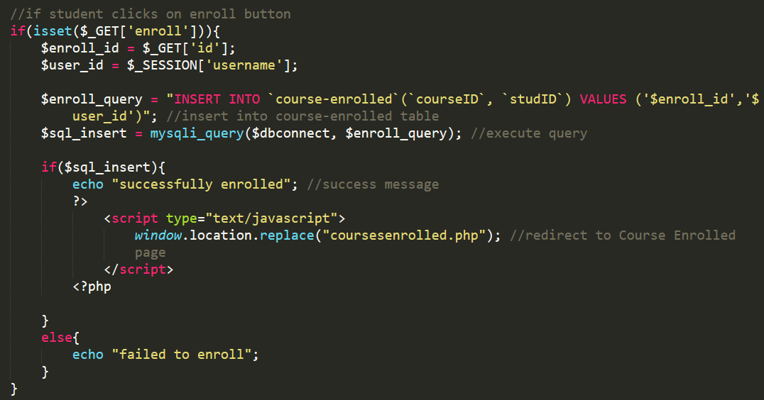

Figure 39: Enroll Course

#### 4.1.6.4 Student – Course Enrolled

After a student has enrolled for a course, they are able to review their progress when they visit the course detail page:

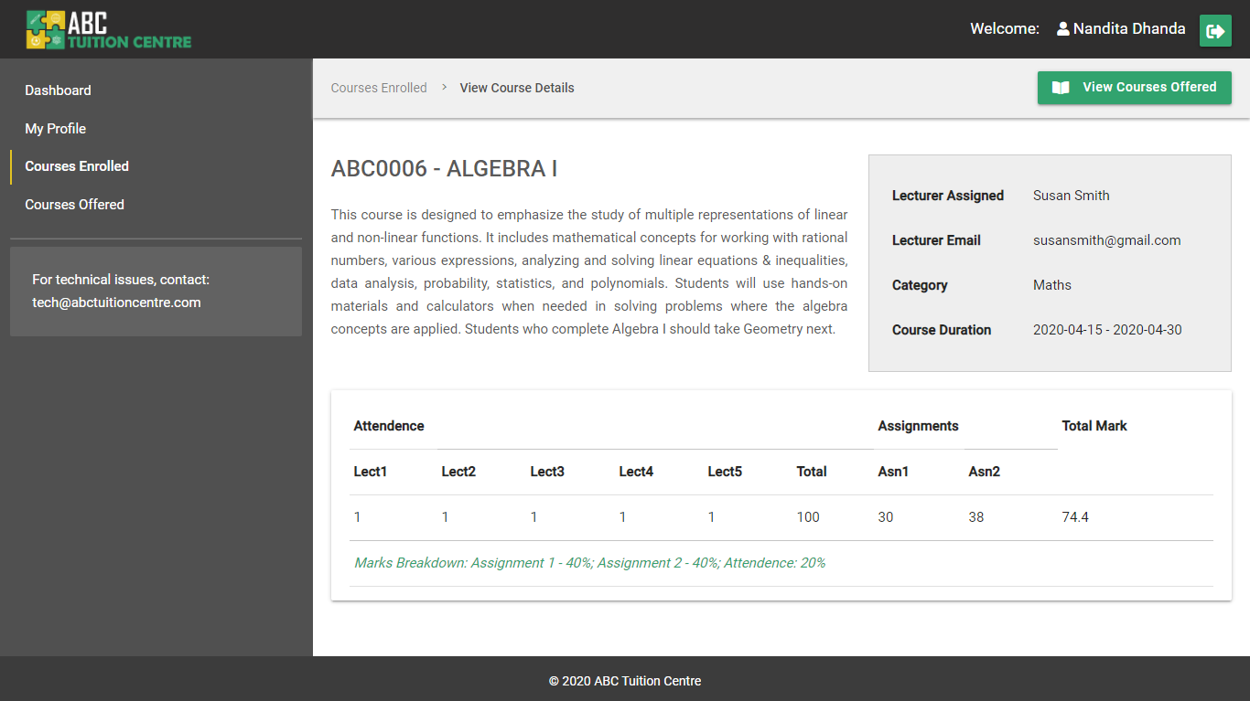

Figure 40: Student - Course Enrolled

Please note, since the data on student attendance is stored as boolean values, “1” represents that the student attended the class while “0” represents that the student did not attend the class.

To view the source code of how the student’s course progress was retrieved from the database and displayed on the screen, please refer to **Appendix F** **Section 1e.**

#### 4.1.6.5 Admin – No Students Enrolled

If no students are enrolled in the course, i.e. no rows were retrieved from the “course-enrolled” table, the Student Progress table will appear with no values populated and it will contain the text “No students enrolled in the course”.

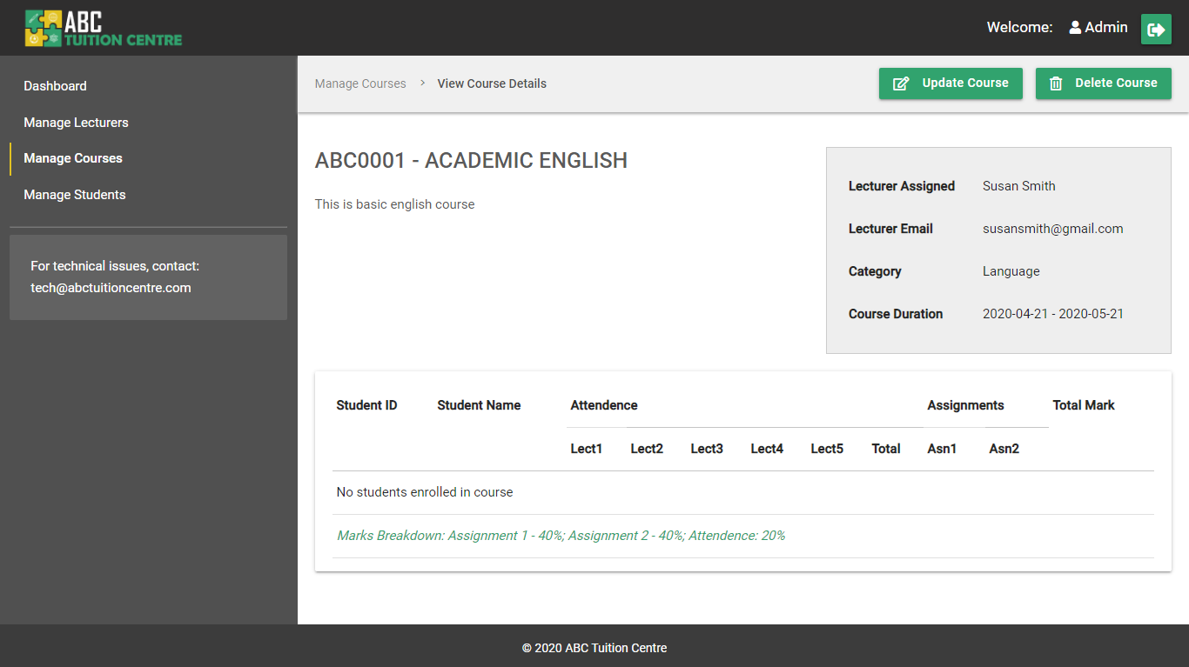

Figure 41: View Course - Admin (No Students Enrolled)

#### 4.1.6.6 Admin –Students Enrolled

If students are enrolled in the course, the list of students enrolled and their progress report will be populated in the table on the course page. To view the source code of how the student’s course progress was retrieved from the “course-enrolled” table in database and displayed on the screen, please refer to **Appendix F** **Section 1e.**

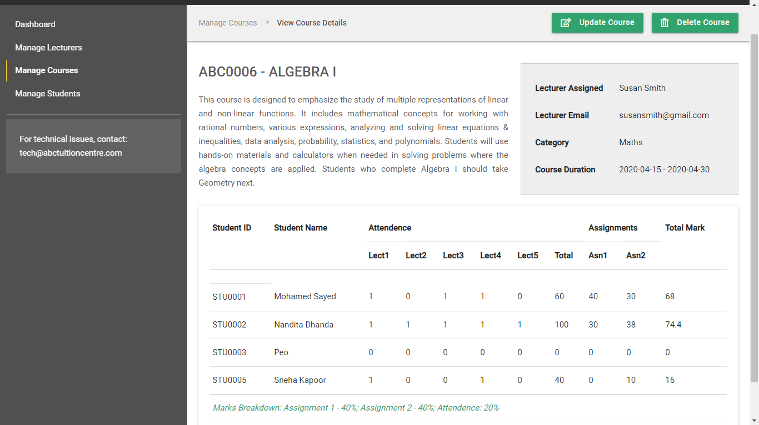

Figure 42: View Course Details (Admin - With Students Enrolled)

#### 4.1.6.7 Lecturer – Course Not Assigned

If a lecturer is not assigned to a course and they try to access the course details of a course through the course card on the homepage, the layout of the View Course Page will be as follow:

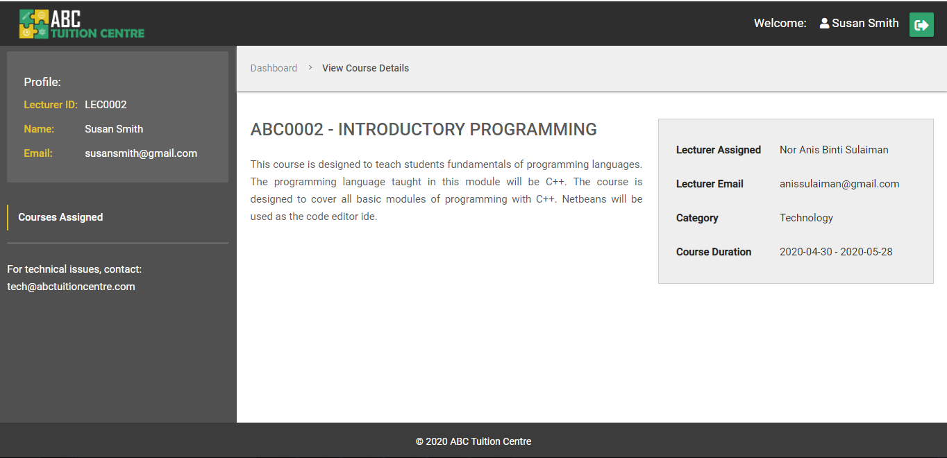

As it can be observed, a lecturer who has not been assigned to the course cannot view information on the students enrolled for the course or their progress.

#### 4.1.6.7 Lecturer – Course Assigned

**No Students Enrolled**

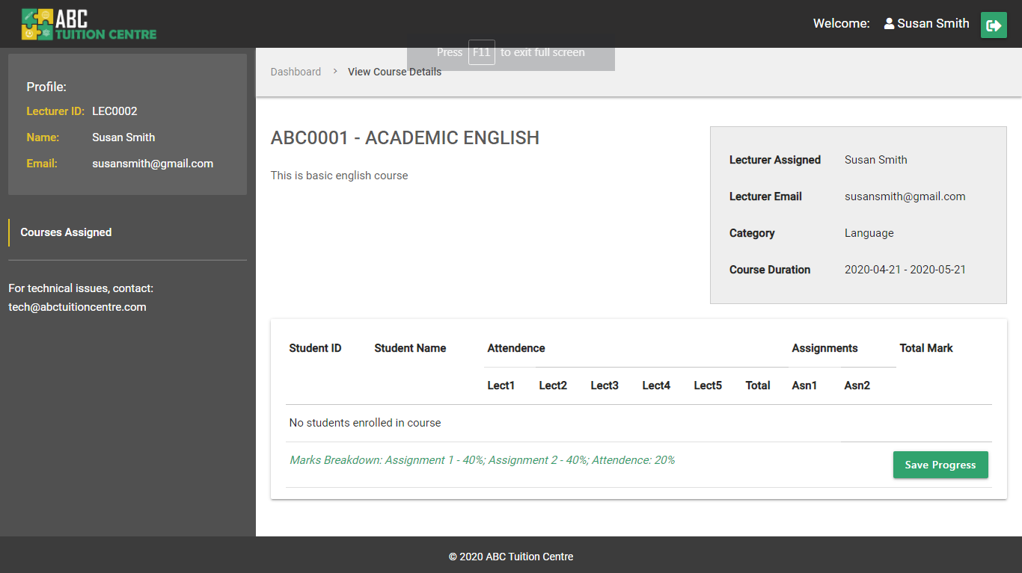

Figure 43: View Course Details - Lecturer (No students)

**Students Enrolled**

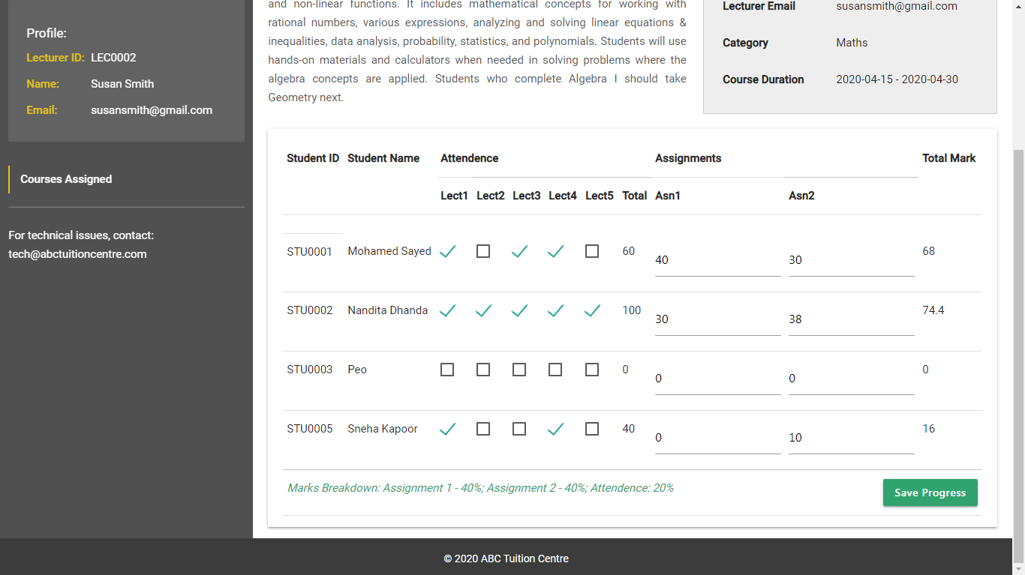

Figure 44: View Course Details - Lecturer (Update Progress)

If students are enrolled for a course, the lecturer is able to update the progress of the student. The Attendance column is represented in the form of checkbox. If the student attends the class, the lecturer can “tick” the box indicating that the student was present. The marks for the two assignments can be entered in by the lecturer. Once the lecturer updates the progress of the students, he/she can click on the “Save Progress” button which will update the values of the respective fields in the “course-enrolled table on the database.

**Please review the HTML and PHP code for the editable fields below:**

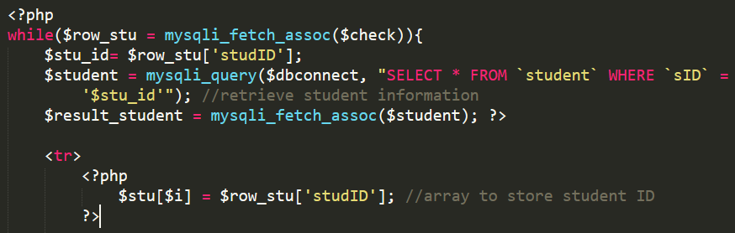

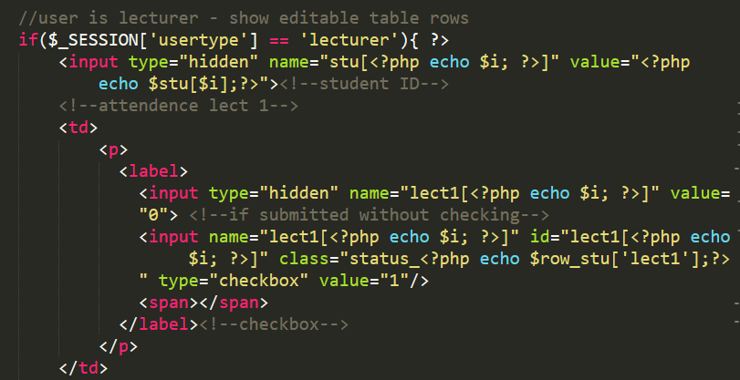

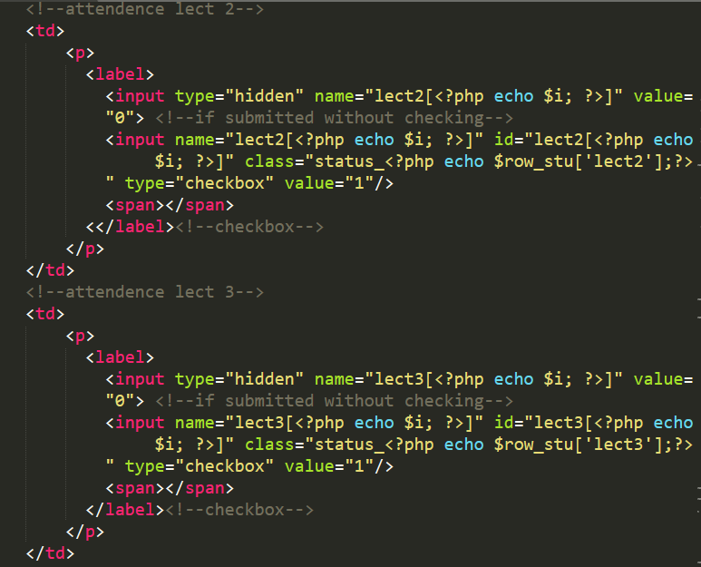

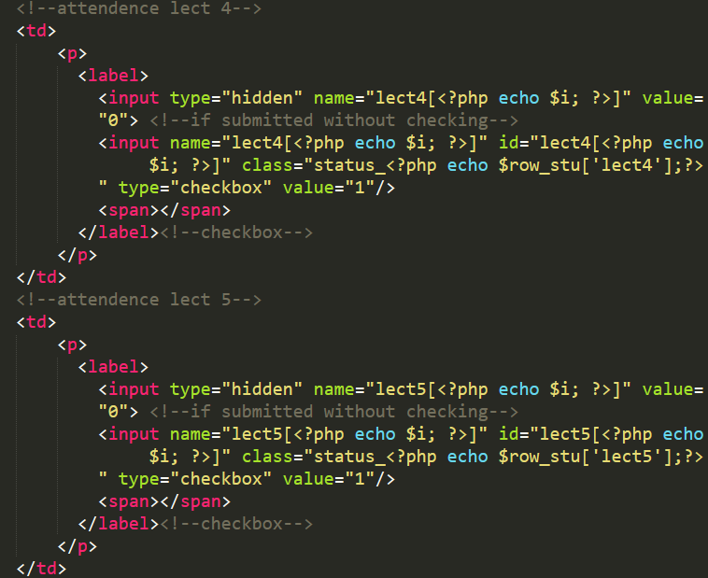

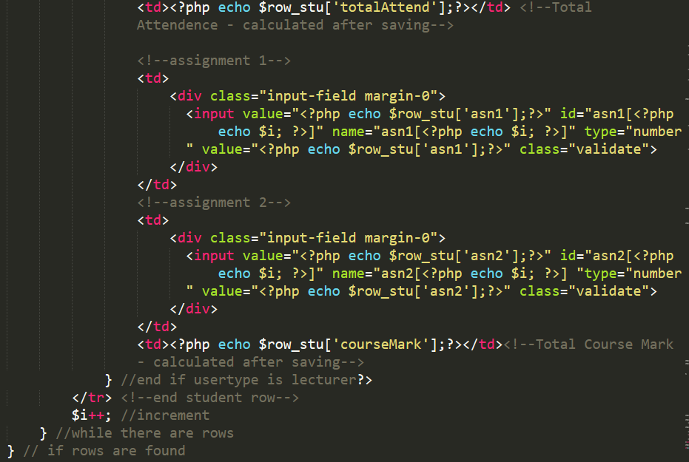

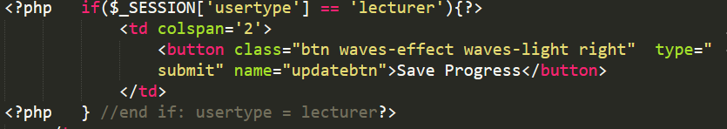

Once the lecturer clicks on the “Save Progress” button, the php method written in the **server.php** file is executed and the course-enrolled table is updated on the database. The “total attendance” and “final course mark” is calculated by the system through the **server.php** file.

**Please review the PHP code from server.php used to update the values:**

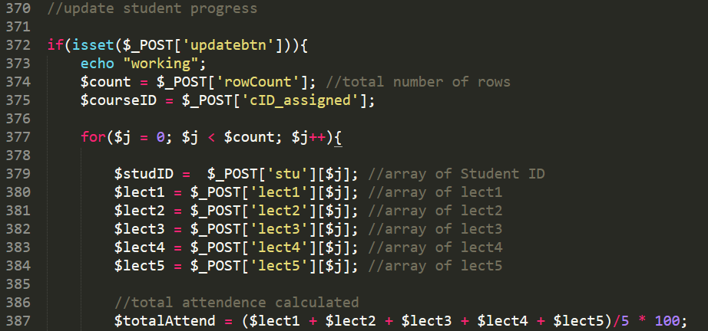

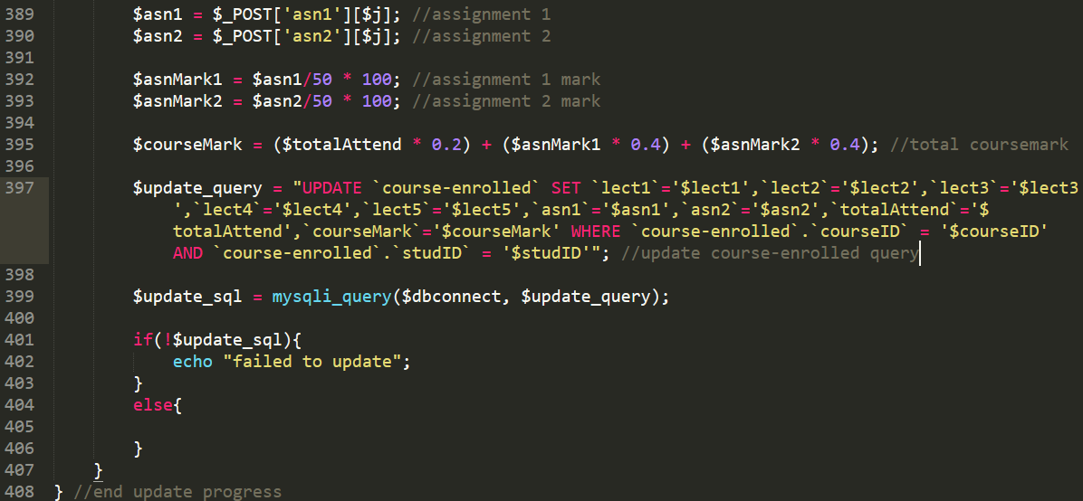

## 4.2 Supporting PHP Files and sub-functionalities

The supporting php files are sub-files that are not included in all of the main pages but they consist of small sub-functionalities that support certain major functionalities of the system.

### 4.2.1 index.php

The index.php file acts as a re-director in the web application. In any working application, the index file is the first page that is accessed by the system when the URL is typed in the browser. In our application, the index file does not have any front-end roles but helps to redirect the users to respective pages based upon whether the user is logged in or not and based on the user type. When a user logs in. The functionalities defined on **server.php** file redirect the user first to the index.php page which then further redirects the user to the respective dashboard the user is meant to access, i.e. student, lecturer or admin.

Additionally, when a user clicks the “logout” button on the header navigation, they are first redirected to the index.php page which then directs them to the homepage. And if a user is not logged in, the index.php page redirects them to the **homepage.php** page as the default landing page of the website. To refer to the entire code of the **index.php** file, please refer to **Section 2a. index.php** in **Appendix F.**

### 4.2.2 setid.php

The **setid.php** file is a supporting php file which is used to set the Student ID, Lecturer ID and Course ID respectively when inserting (adding) new data in the respective student, lecturer and course tables in the database. The Student ID, Lecturer ID and Course ID are primary keys in their respective tables, therefore it is essential to ensure that their values are unique and do not match with existing values stored in the respective fields. The **setid.php** method is programmed to retrieve the existing ID values from the selected table.

To make the program easier to understand, we will explain an example using a segment of the code below. Let us take the example that the Admin would like to add a new lecturer account. To set a lecturer ID, the **setid.php** file is included on the **newlecturer.php** page and the “$usertype” variable is assigned the value “lecturer” on the **newlecturer.php** page



Figure 45: newlecturer.php

Since the $usertype variable is assigned the value “lecturer” in the newlecturer.php file, upon including the setid.php file after the variable initialization, the following condition is executed from the setid.php program:

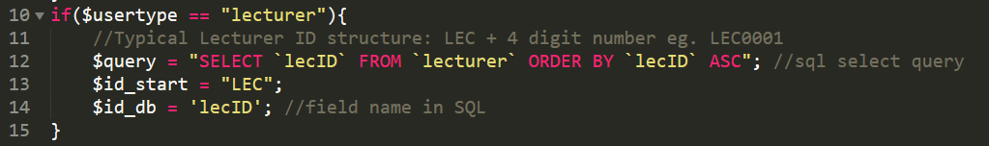

Figure 46: setid.php

From the above, it can be observed that the $query variable is assigned the “SELECT” SQL query to SELECT the lecturer ID stored in the “lecID” field from the “lecturer” table in the database. Subsequently, the $id_start variable is assigned the value “LEC” to signify that the start of the ID will consist of the value “LEC”. This is because all IDs in the system are 7 characters in length starting with the ID type followed by a 4 digit numeric value. Student IDs start with “STU”, Lecturer IDs start with “LEC” and Courses IDs start with “ABC” respectively.

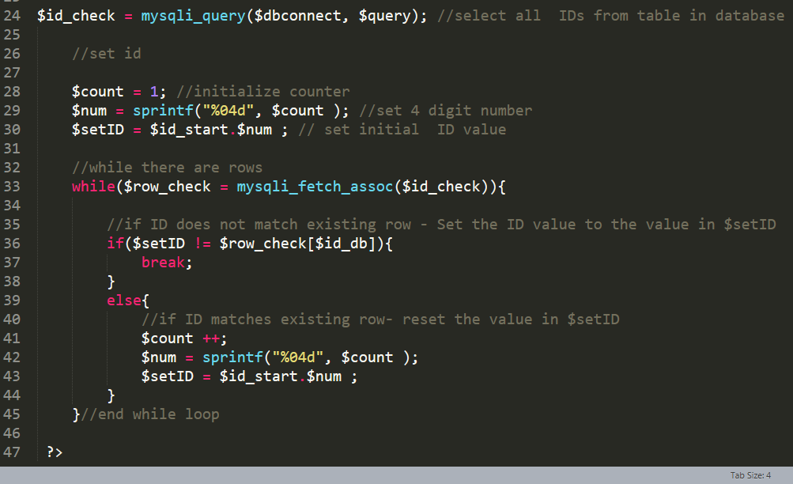

After the initial variables are initialized based on the usertype or course, the SQL query is executed. An initial id value is set and stored in the $setID variable. The initial value is set to the “ID Start” + 0001. In our example, this would be LEC0001. This value will then be used to compare with the “lecID” each row in ascending order with each ID value in the database table until no match is found. If the value in $setID matches with the lecID field in the current row, the $setID is re-set to the next value (eg. LEC0002) and the value is compared with the value of lecID field in the next row. This continues until the $setID value does not match the value in the lecID field in the row.

This method of setting the value of the ID not only ensures that the ID is unique but also makes sure that there are no gaps in the rows and that all available ID slots are taken in case the row was deleted at some point. The **setid.php** program has been included in the **newcourse.php**, **server.php and newlecturer.php** pages.

For the full program please refer to the entire code of the **setid.php** file in **Section 2b. setid.php** in **Appendix F.**

### 4.2.3 errors.php

The **errors.php** file is program written to read errors stored in an array. The file is included mainly in the **server.php** file and the error messages are stored in the array through the server.php file.

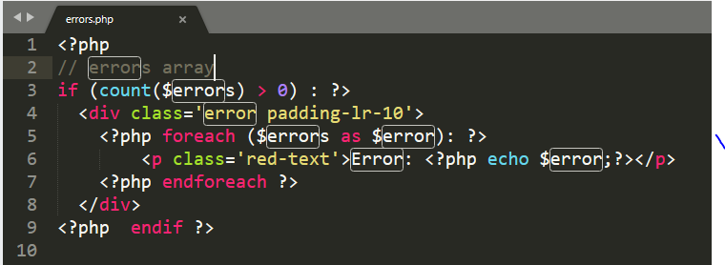

Figure 47: errors.php file program



Figure 48: $errors array initialized in server.php file

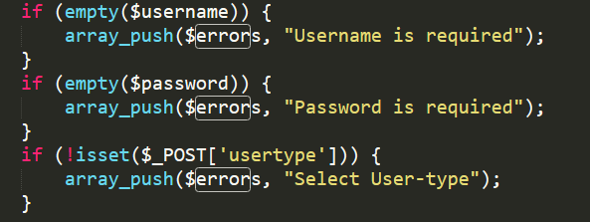

Figure 49: example of values stored in $errors array - server.php file

The messages are then displayed on the associated pages by including the **errors.php** file:



### 4.2.4 session.php

The **session.php**  file consists of a short supporting program written to check if the user is logged in order not. If the user is logged in, they are not supposed to be able to access the **sign-in.php, staff-signin.php** and **register.php** pages. To prevent that from happening, the **session.php** file is included on all three of these pages. If the user is logged in, and try to access these pages, the program redirects the user to the **index.php** page which further checks the usertype of the user and redirects him/her to his/her respective dashboard. The program can be referred below:

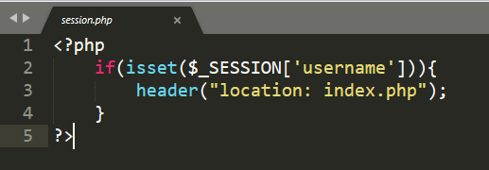

Figure 50: session.php

### 4.2.5 status_check.php

The **status_check.php** page is another short supporting program written to check if the user logged in is a student and if their registration status is still pending. If their registration status is still pending, they will be prevented from accessing certain pages which are only accessible by students who have been approved by the admin. The program can be found below:

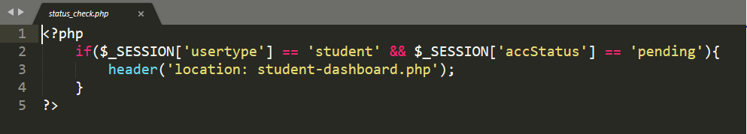

Figure 51: status_check.php program

## 4.3 Main Pages – Before Log In

### 4.3.1 Homepage

The homepage is the main landing page of the web application. It is the first page a user will land on upon typing the URL of the website. It is also the first page a user is able to access when opening the folder in the localhost server.

Since the primary goal of the web application is to facilitate student course enrollment and progress management, we have designed the website to minimize external pages keeping it limited to a single landing page that consists of the most relevant data to the target user. For the homepage code, please refer to **Appendix G: Homepage**

The homepage consist of the following elements:

1. **Header**
   1. A header bar which will be consistently seen across the website.
   2. The header consists of the institute's logo and a "sign in" and "register" button for the students
2. **Parallax Banner**
   1. An attractive banner image which will span across 100% of the screen width and height of the user with a parallax effect upon scrolling to make the website look more engaging and professional. The parallax effect is achieved using pure CSS3's background attributes with no Javascript integration. Refer to ".banner-img" class in **Appendix E : style.css** for more details
3. **Courses**
   1. The courses section will be populated with all courses offered by the institution. The data for this section is retrieved from the database. More information regarding the UI and integration of this section can be refered to in section **4.1.5 courses.php**
4. **Testimonials**
   1. The testimonial section will comprise of a touch-friendly slider element consisting of testimonies of students who had studied in ABC Tuition Centre. The element layout is designed in CSS and slider effect is achieved with the help of materialize.js carousel plugin. The data is not retrieved from the database. It is hardcoded in the homepage design. Please refer to the homepage code provided in **Appendix G: homepage** for more details
5. **Pre-Footer**
   1. **About Us:**

Instead of a having a dedicated about us page, a brief description about the company is included within the pre-footer element. The company branding has been reiterated followed by a brief description.

* 1. **Social Media:**

Links to social media pages of the institution have been provided below the description about the company

* 1. **Quick Contact:**

Contact information has been provided to allow users to be able to reach out to ABC Tuition Centre in case of any problems or inquiries

* 1. **Email Subscription:**

This section allows users to sign up for the company's monthly mailing list

1. **Footer**

This is consistent footer element that has copyright information about the company. This element will be consistently repeated across all pages in the web application

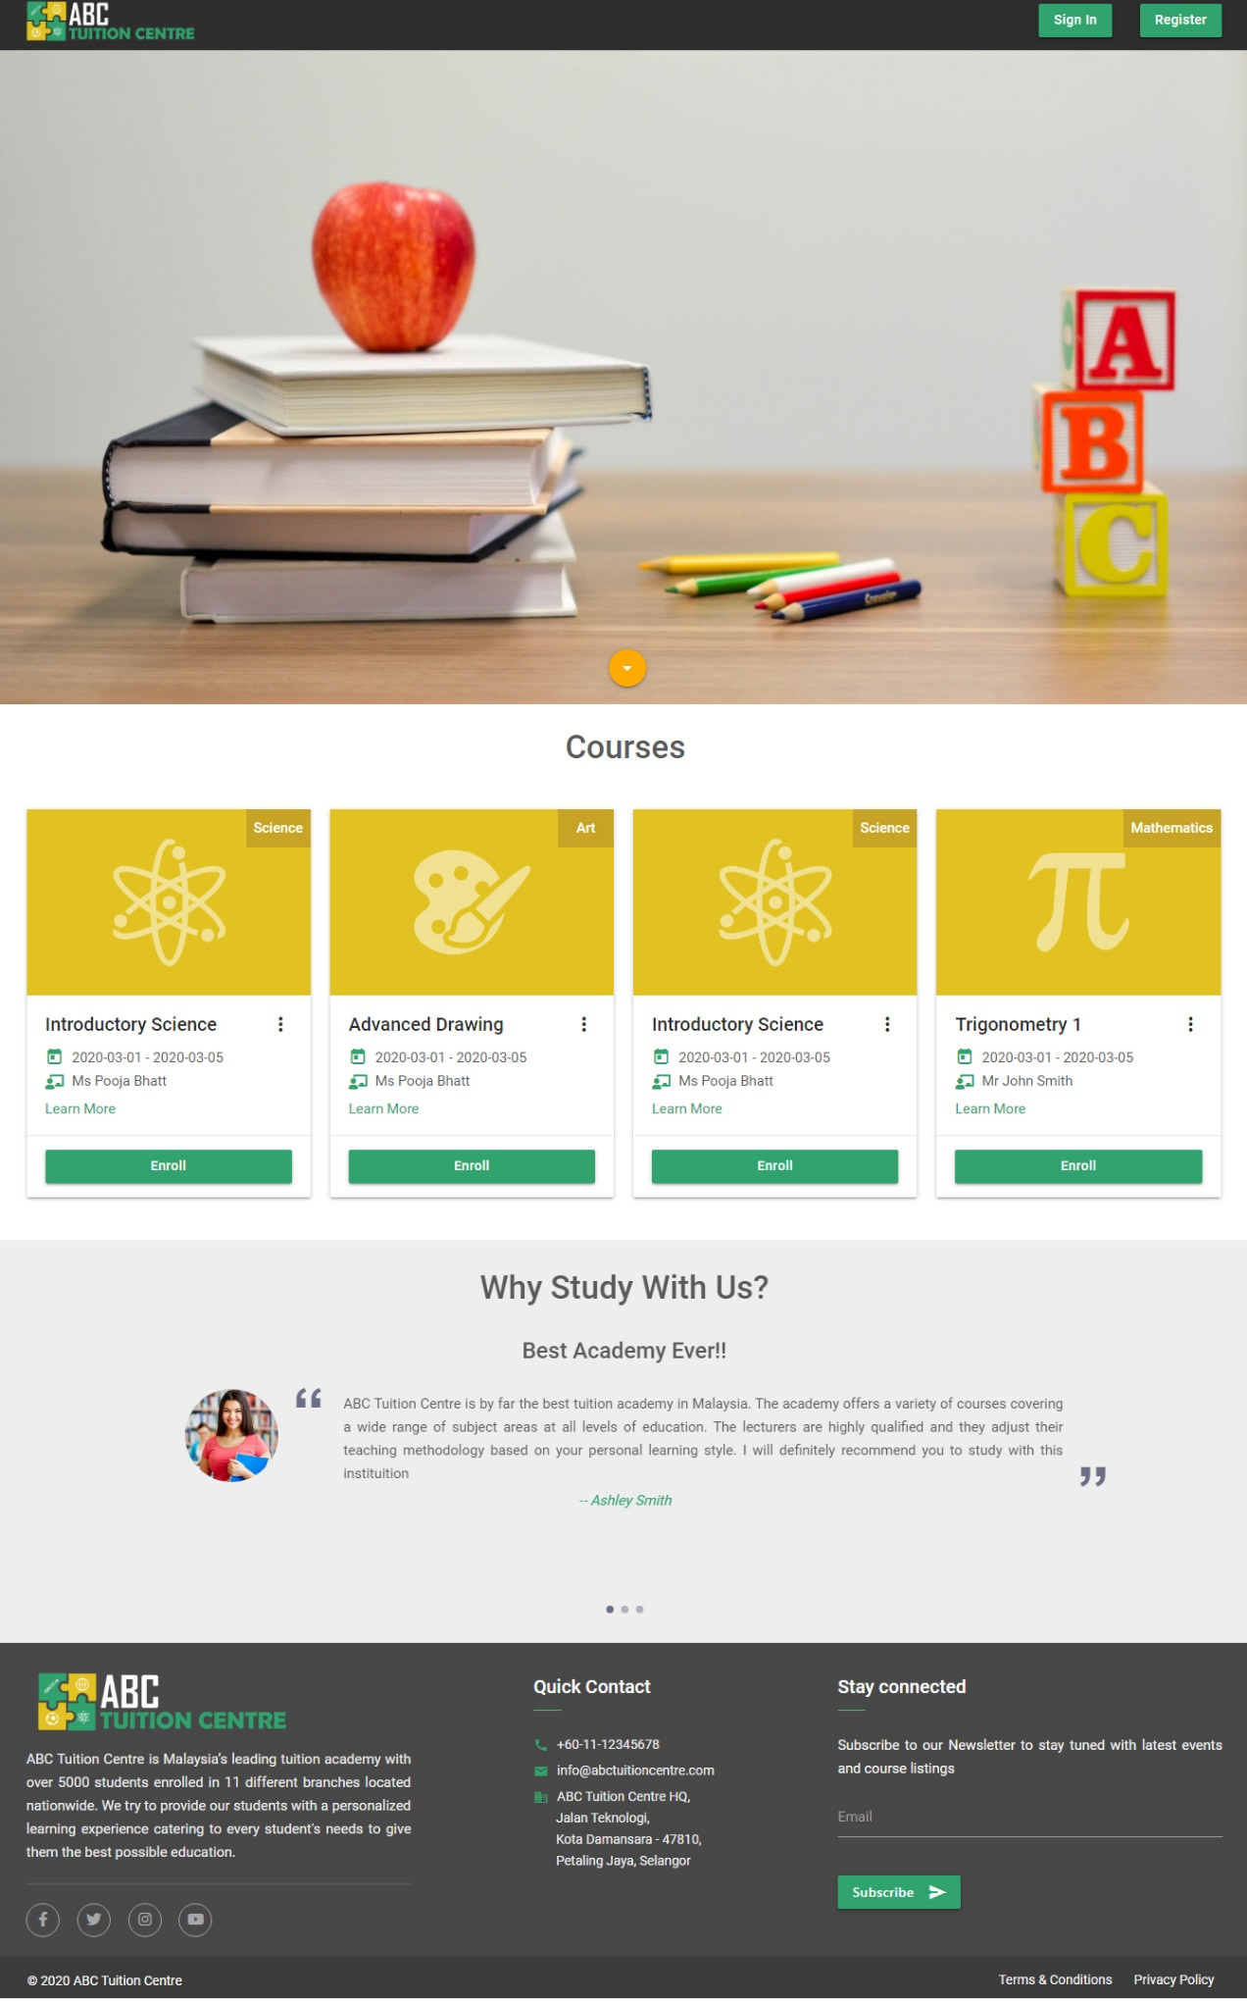

Figure 52: Homepage UI

### 4.3.2 Registration - Student

#### 4.3.2.1 Register User Interface

The user lands on the “Register” page after clicking on the register button on the header. The UI of the Register page can be referred below:

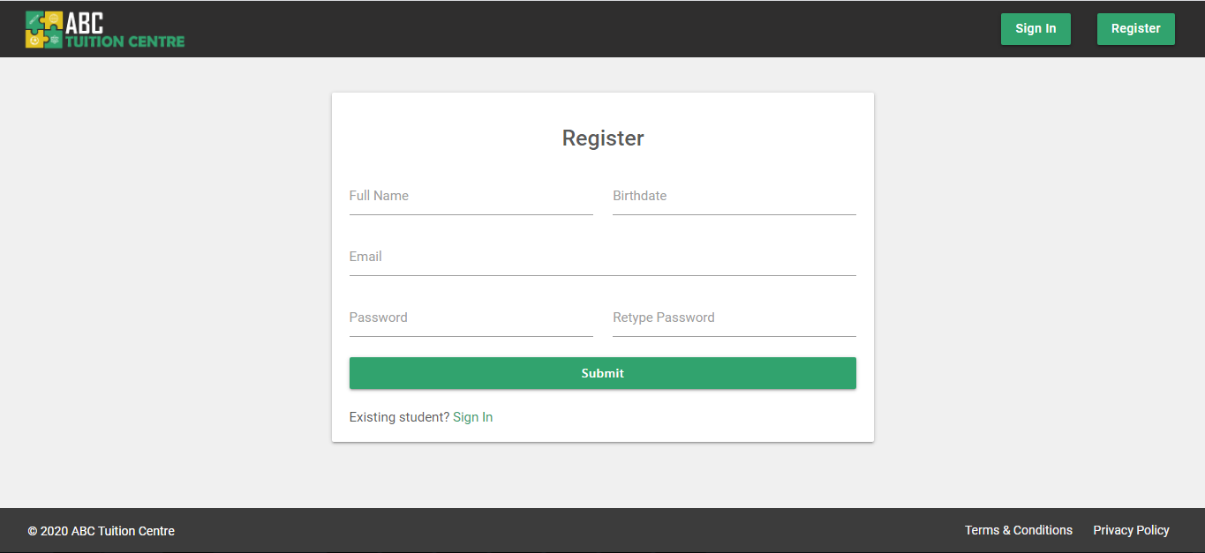

Figure 53: Student Register UI

Please refer to **Section 1a Student Registration HTML** in **Appendix H: Registration** for the complete HTML and PHP code of the **register.php** page.

#### 4.3.2.2 Register User Experience

##### Interactive UI

Instead of using the standard HTML5 <input type= “date”> field, a custom interactive date picker has been used in the web application in order to make the user experience interactive and conforming with industrially recognized material design principles. The date picker is using the date picker function from materialize.js. Please refer below for the user experience of the date picker, html integration code and jQuery function call and initialization.

Please note: since the default format for dates in MySQL is ***yyyy-mm-dd*** we have conformed to this format for all date fields used throughout the application.

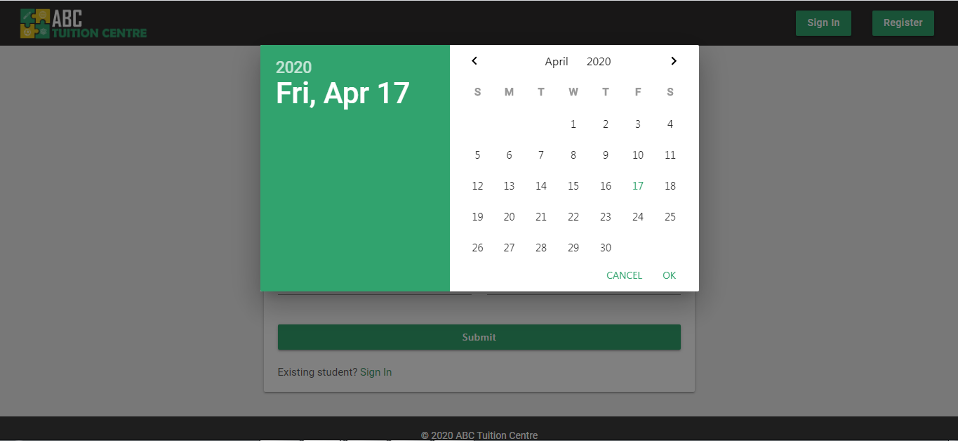

Figure 54: Custom Date picker

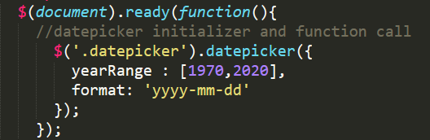

Figure 55: Date picker initialization

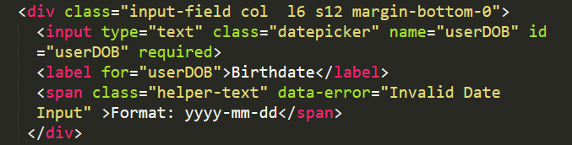

Figure 56: Customized Date picker HTML integration

##### HTML5 and JQuery Validations:

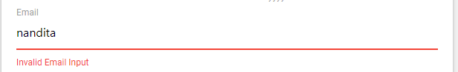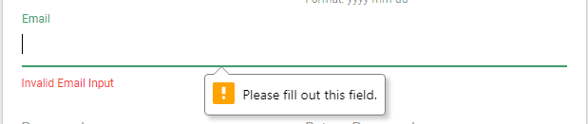

The primary validations implemented in the system are through the HTML5 “required” attribute and materialize.js’s integrated jquery validation function that is called with the “validate” class applied to the input html field. If a user leaves a required field blank or if an input value is invalid, an error message will display. The required attribute has been implemented on all the fields of the register form.

Please refer to an example of one of the input fields with the required code for reference of how this feature has been implemented.

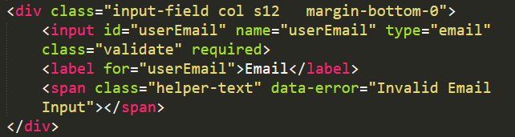

For the complete HTML and PHP code of the registration page, please refer to **Section 1** **Student Registration in Appendix H**

Note: All other forms in the application, i.e. “Add Course” and “Add Lecturer” forms, use the same validation structure

##### PHP Validations:

Any secure web application will not rely solely on HTML5 and JavaScript’s validation functionalities because the user can easily override the initial front-end programming features by either disabling JavaScript in their browser rendering all JavaScript functionalities useless or by manually removing the “required” attribute and “validate” class from the HTML tags and elements.

Hence, PHP validations have been implemented as a backup.

If the form is submitted with the HTML5 required attribute removed, PHP validations retrieved from the **server.php** will be executed. Even if the form is submitted with all fields filled out, additional validations will be carried out to check if the values entered in the corresponding fields are valid or if the passwords match. Please refer to **Section 1c server.php** in **Appendix F** for all the validations and registration functionality**.**

**Empty Field Validations:**

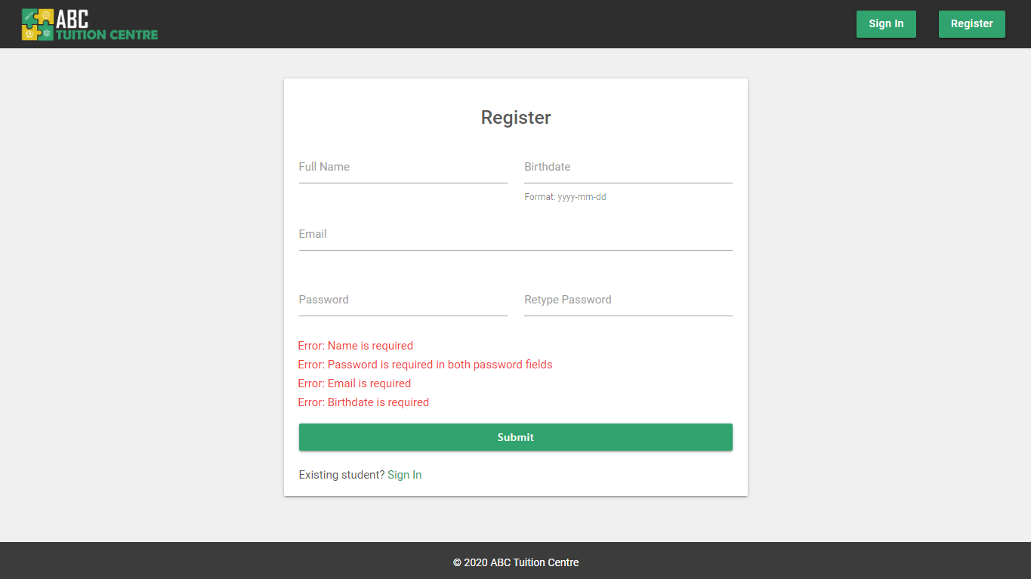

Figure 57: Register Page - PHP empty field validations

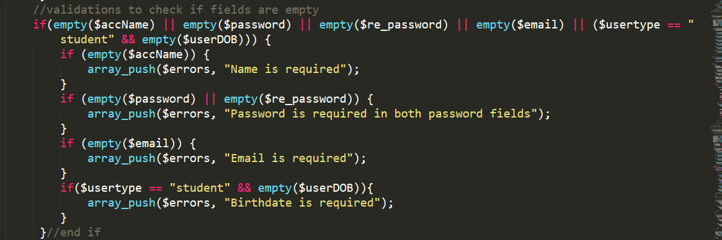

**Invalid Input Validations:**

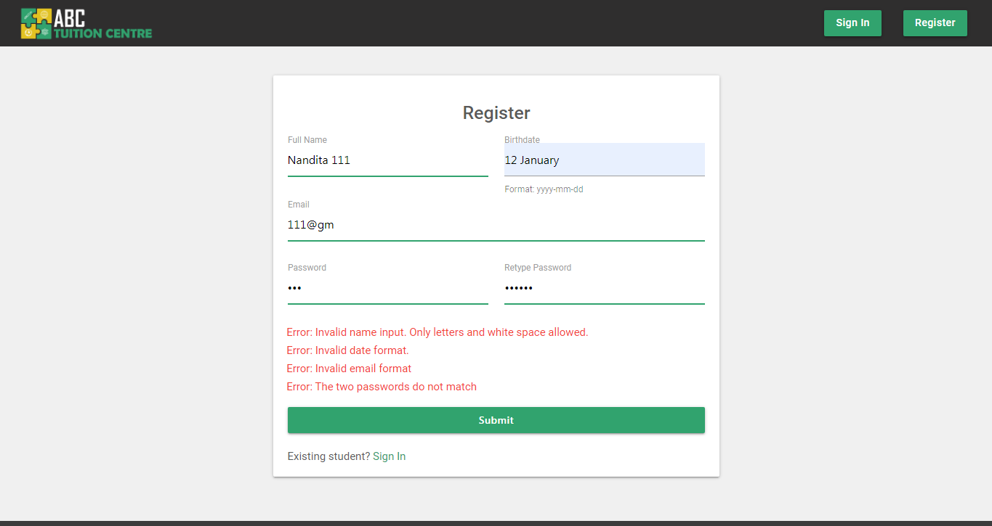

Figure 58: Register Page - PHP invalid input validations

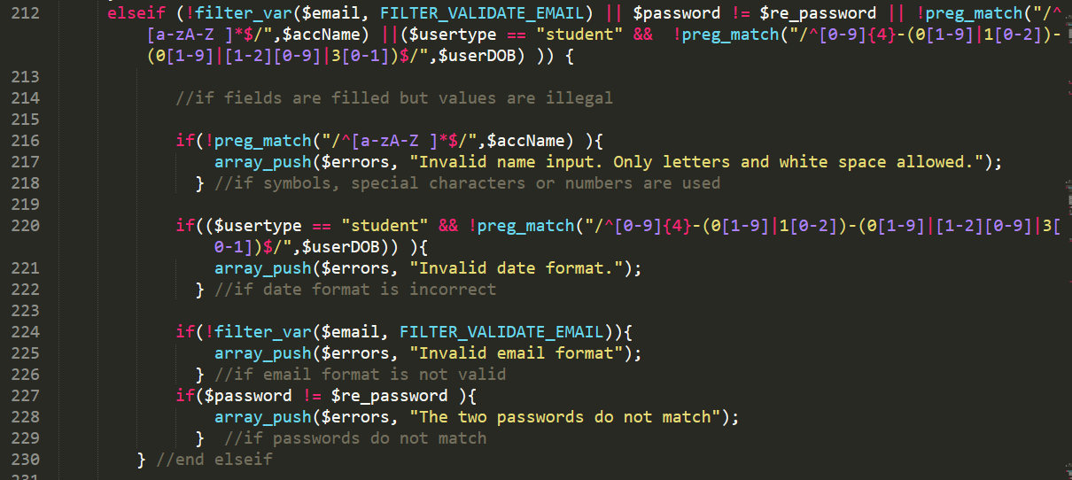

**Duplicate Email Address Validation:**

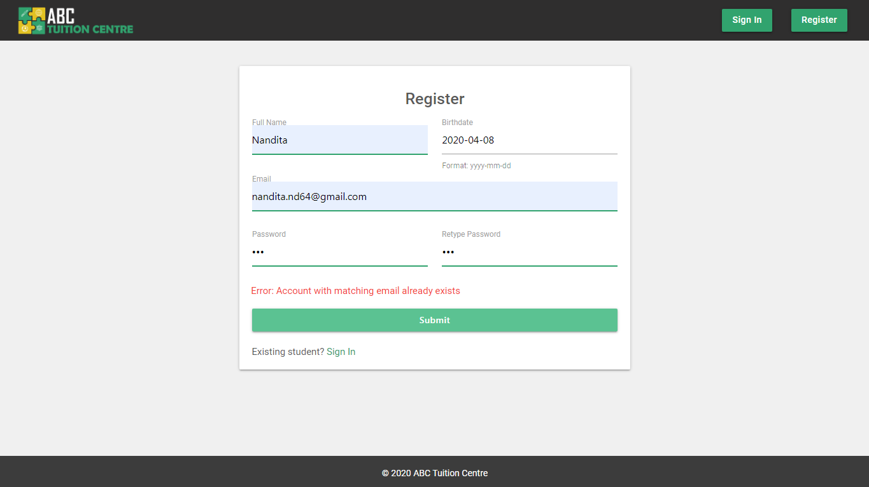

Figure 59: PHP validation if account with matching email address already exists



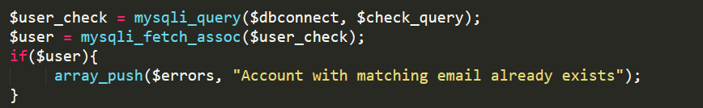

### 4.3.3. Registration Success

After a user has successfully registered, they will be redirected to a “registration success” page which will give them their student ID and inform them about some important information. Please refer to **Section** **2. Registration Success** in **Appendix H** for the HTML and PHP code of the following page:

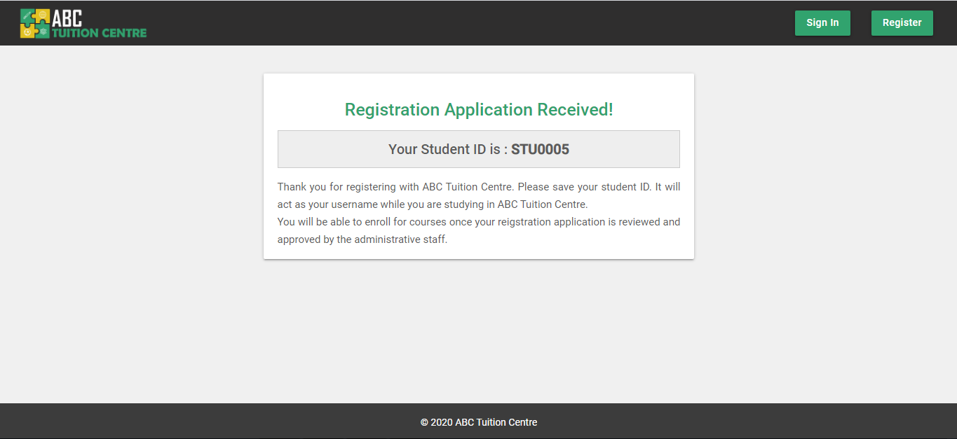

Note: Upon successful registration, the server.php stores the student ID in a $_SESSION[‘sID’] variable in order to call it in the **register-success.php** page. Once the user is directed to this page, the value stored in the $_SESSION[‘sID’] to prevent the user to be able to access this page unauthorized.

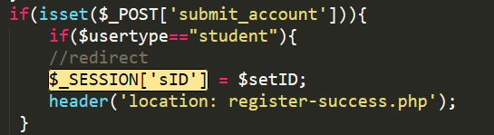

Figure 60: server.php - Upon Successful Registration

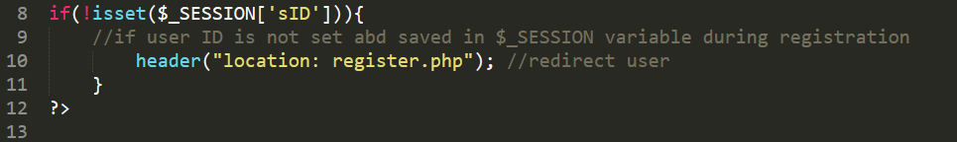

Figure 61: register-success.php

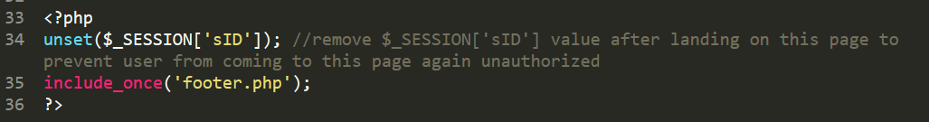

Figure 62: register.php

### 4.3.3 Log in

#### 4.3.3.1 Student Sign In

The student Sign In page is different from the staff sign in page. It can be accessed by clicking on the “sign in” button on the header.

##### User Interface

In the Username field, the system will accept the Student ID or the email address of the user. For the complete HTML code of the Sign In page’s user interface, please refer to **Section 3: Student Sign In** in **Appendix H**

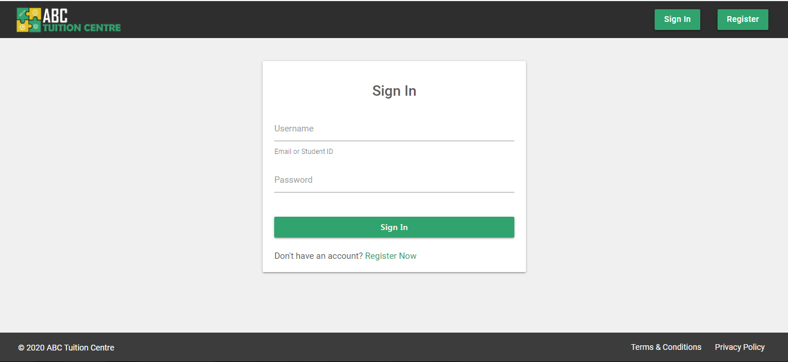

Figure 63: Student Sign in UI

#### 4.3.3.2 Student Sign In – User Experience

##### Validations

Similar to the register page, Initial validations users will encounter are HTML5 and JavaScript based. HTML5 and JavaScript validation won’t allow the user to be able to submit the form without filling out all the fields. The system also has PHP validations accessed through **server.php** file implemented to reinforce the security of the system. Please refer to **Section 1c server.php** in **Appendix F** for the entire backend programming of the Sign In function, including the php validations.

**HTML5 Validations**

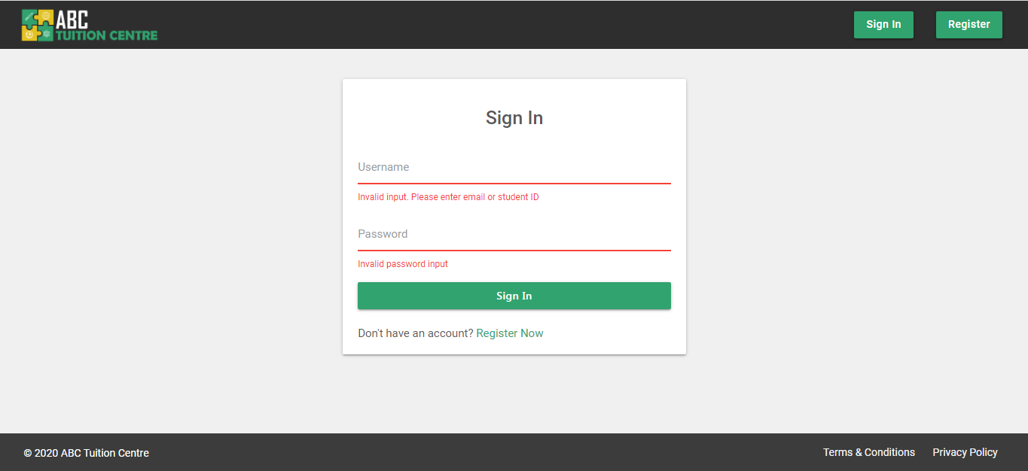

Figure 64: JavaScript Validation

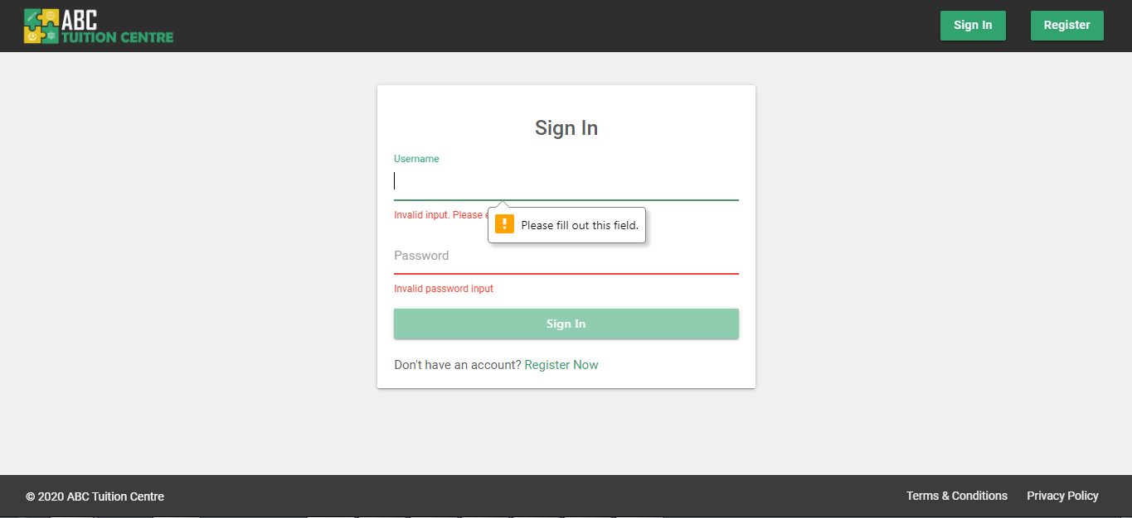

Figure 65: HTML5 Validation

**PHP Empty Field Validations**

If the user turns off JavaScript in their browser or if they amend the HTML5 “required” attributed from the console, system also has PHP validations implemented as a backup.

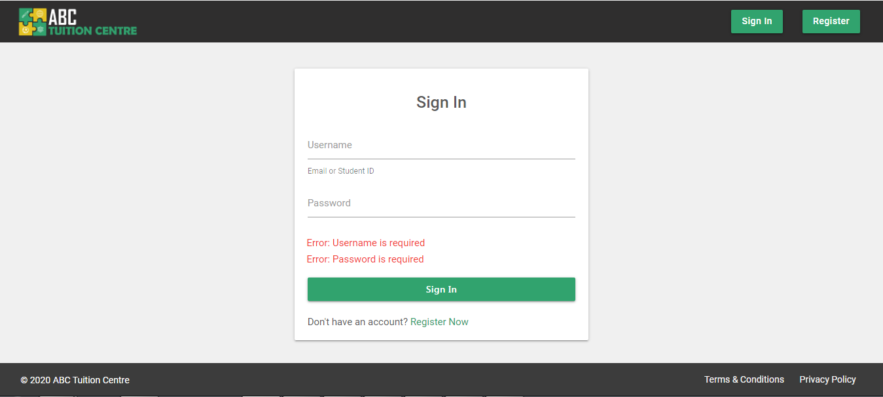

Figure 66: PHP empty-field validations

**PHP No Account Found Validations**

If user enters invalid credentials:

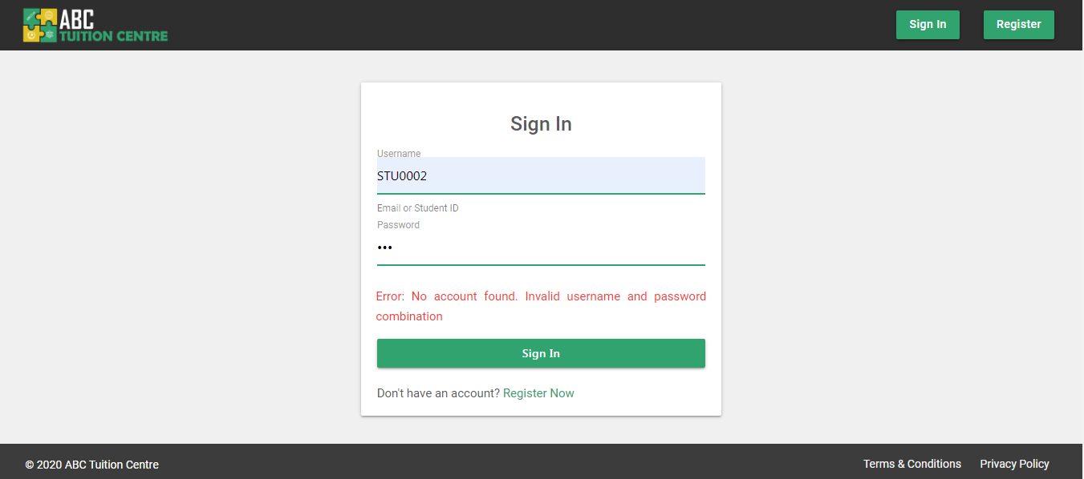

Figure 67: Account not found in database

**Sign In Success Scenario**

The system logs in a user by first searching for account in the database.

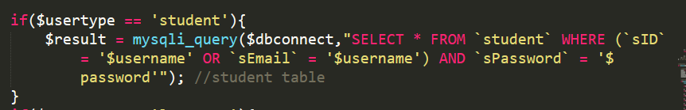

Figure 68: SQL Query to retrieve student account

If the system finds an account matching with the log in credentials provided, the system stores the relevant user information in $_SESSION[ ] variables in order to maintain the sign-in status of the user.

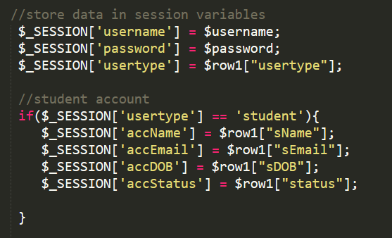

Figure 69: PHP - Session Variable

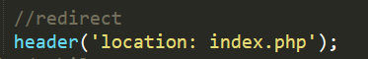

Figure 70: Redirect user upon successful login

After the session is created and stored, the system is redirected to the index.php file which checks the user type and then further redirects the student to the student dashboard.

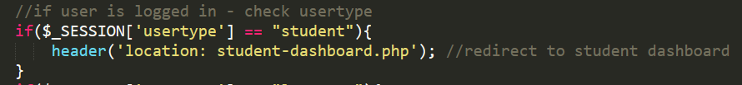

Figure 71index.php

Please refer to **Section 1c server.php** in **Appendix F** for the entire backend programming of the Sign In function.

### 4.3.4 Staff Sign In

Staff members will be given a separate login URL that won’t be available on the website navigational links. The staff sign in page can be accessed on the **staff-signin.php.** Please refer to **Section 4. Staff Sign In** in **Appendix H** for the entire HTML and PHP code for the staff-signin.php page. For the staff sign in function, please refer to **Section 1c. server.php** in **Appendix F**.

#### 4.3.4.1 Staff Sign In – User Interface

The interface of the Staff Sign in page is similar to the interface of the Student Sign in page in terms of design. An additional sign in criteria is added here to identify if the user signing in is Admin or Lecturer.

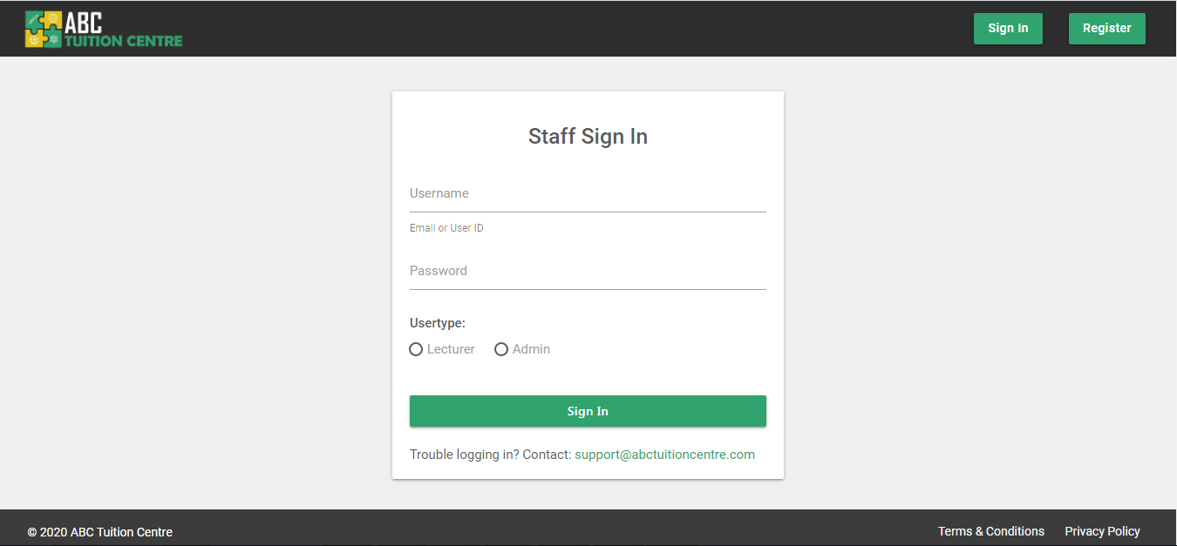

#### 4.3.4.2 Staff Sign In – User Experience: Validations

Similar to the student sign-in and register pages, initial validations users will encounter are HTML5 and JavaScript based. HTML5 and JavaScript validation won’t allow the user to be able to submit the form without filling out all the fields. The system also has PHP validations accessed through **server.php** file implemented to reinforce the security of the system. Please refer to **Section 1c server.php** in **Appendix F** for the entire backend programming of the Sign In function, including the php validations.

**HTML5 Validations**

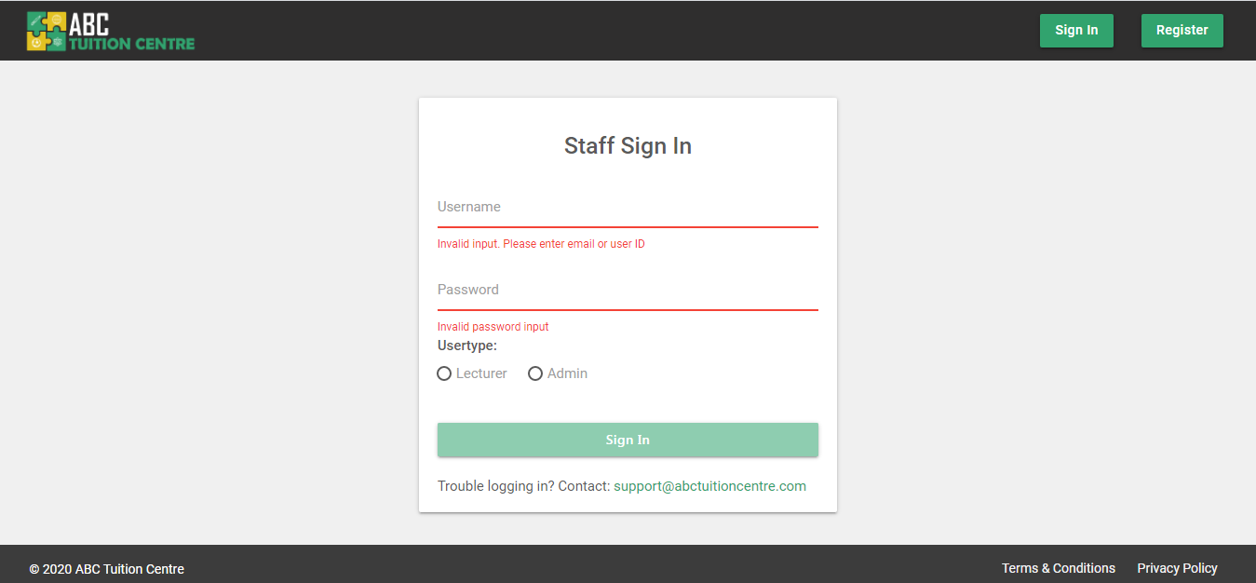

Figure 72: JavaScript Validations

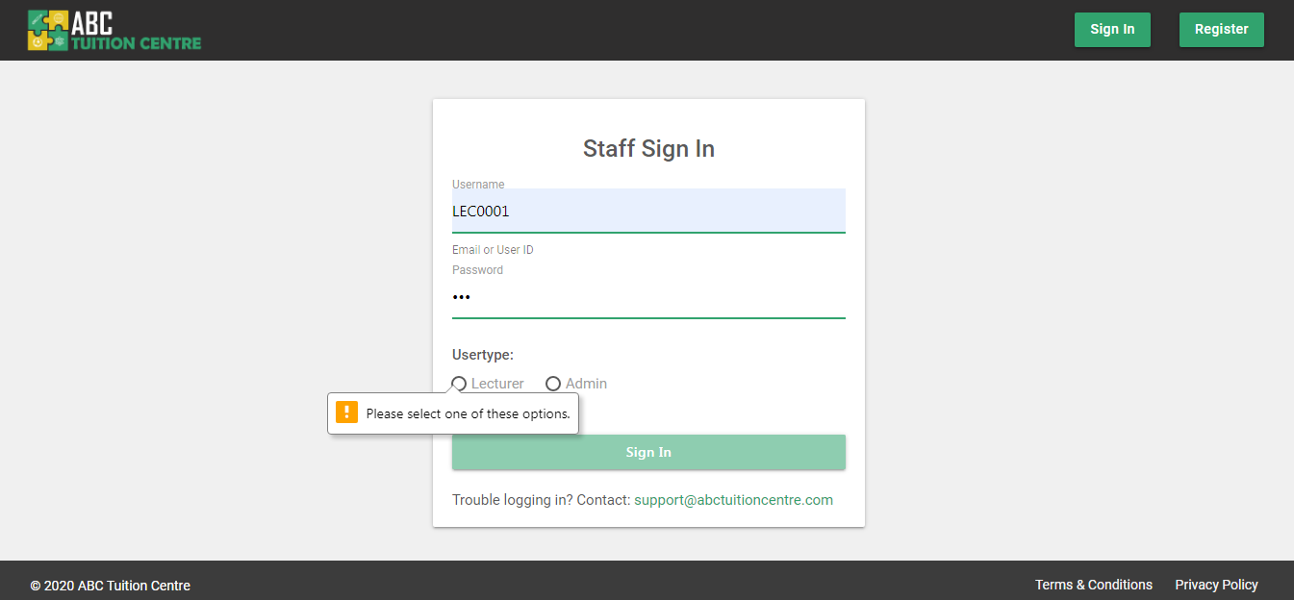

Figure 73: HTML5 Required Field Validation

**PHP Empty Field Validations**

If the user turns off JavaScript in their browser or if they amend the HTML5 “required” attributed from the console, system also has PHP validations implemented as a backup.

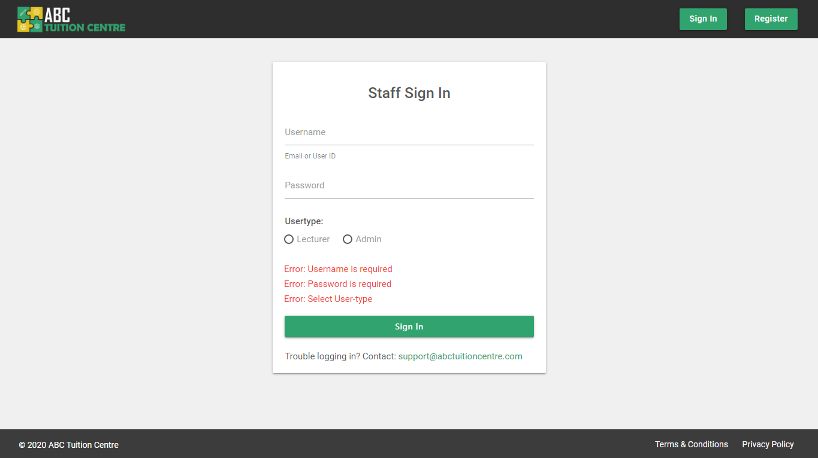

Figure 74: PHP validations

**PHP No Account Found Validations**

If user enters invalid credentials:

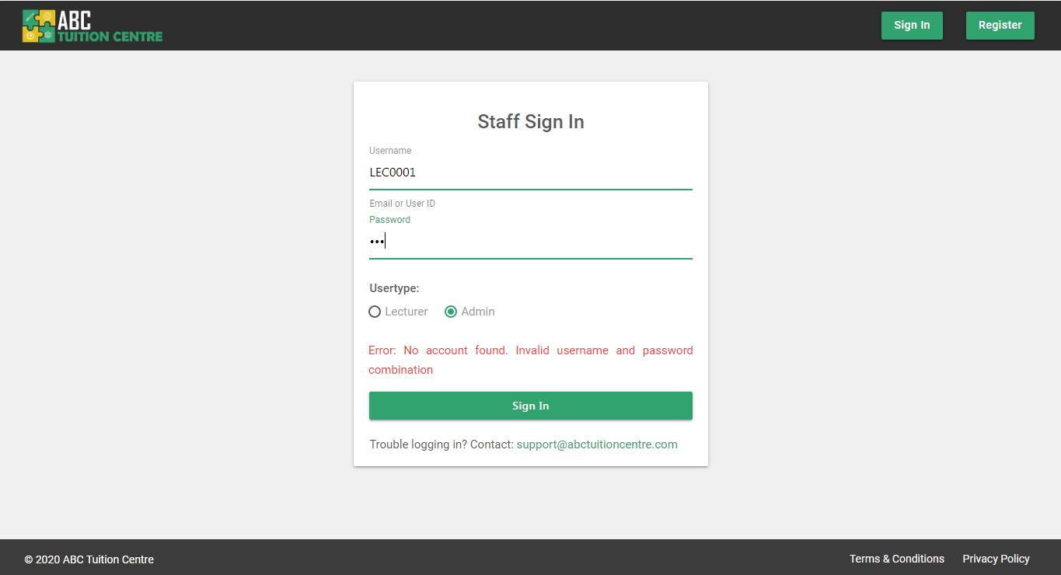

Figure 75: Invalid login details

**Sign In Success Scenario**

The system logs in a user by first searching for account in the database.

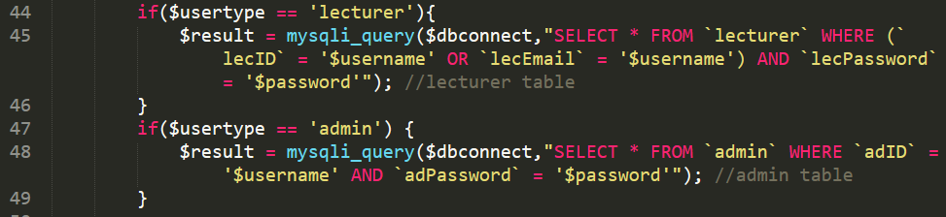

Figure 76: SQL Query to retrieve student account

If the system finds an account matching with the log in credentials provided, the system stores the relevant user information in $_SESSION[ ] variables in order to maintain the sign-in status of the user.

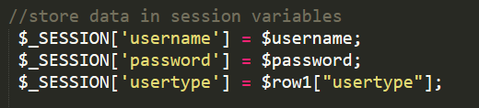

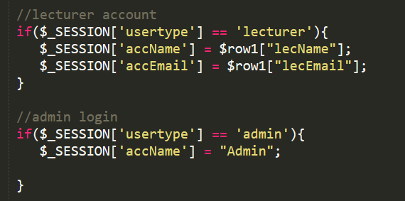

Figure 77: PHP - Session Variable



Figure 78: Redirect user upon successful login

After the session is created and stored, the system is redirected to the index.php file which checks the user type and then further redirects the student to the student dashboard.

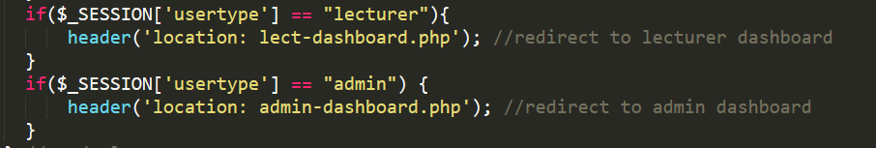

Figure 79index.php

Please refer to **Section 1c server.php** in **Appendix F** for the entire backend programming of the Sign In function.

### 4.3.5 Logout Function

If a user is signed into the system, they can sign out by clicking on the sign-out button on their navigation bar. The logout functionality can be referred below:



Figure 80: Sign Out Button

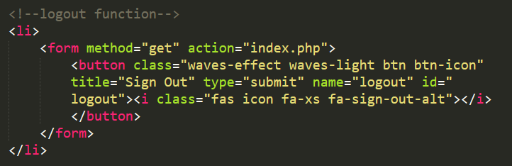

Figure 81: Sign out button in page navigational header

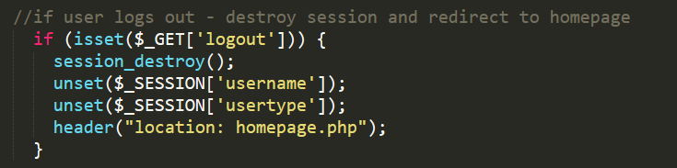

Figure 82: Sign Out function on index.php page

## 4.4 Main Pages - Lecturer Portal

The lecturer account is designed to have minimal interaction with the system. For this reason their profile information is populated within the sidenav and they do not have the permissions to update or alter their details. The lecturer dashboard will consist of the courses assigned to the lecturer rather than having them navigate to another page for the same. The lecturers are able to update the student progress by clicking on the “View Progress” button and accessing the “View Course Detail” page. To review the source code of how the courses assigned to the lecturer are retrieved from the “Course” table in the database and populated on the lecturer dashboard, please refer to **Appendix K**

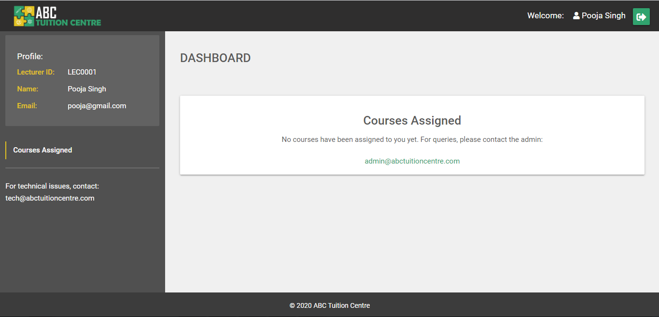

Figure 83: Lecturer Dashboard - No Courses Assigned

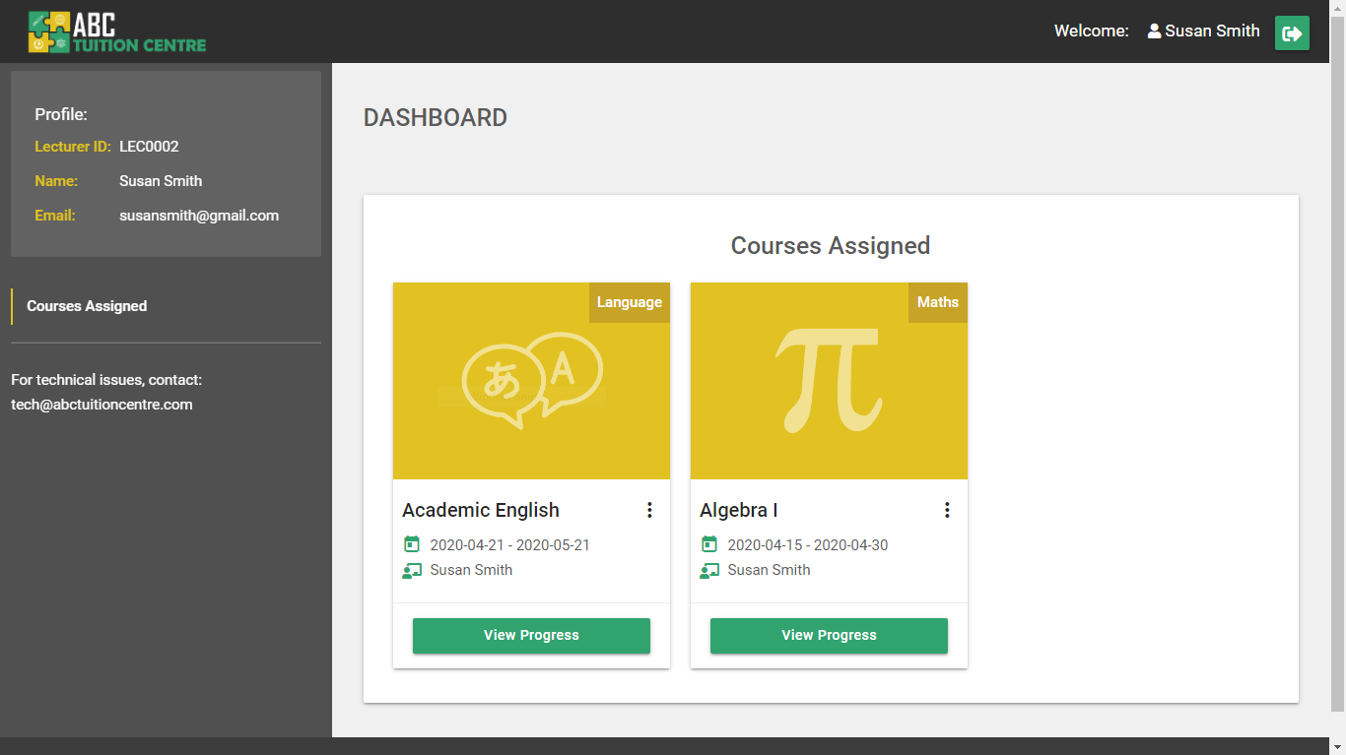

Figure 84: Lecturer Dashboard - With courses assigned

## 4.5 Main Pages – Admin Portal

Admin dashboard and all associated Admin pages under the admin portal can only be accessed by a user who logs in as the “Admin”. In order to ensure that no unauthorized users access the admin portal, the following condition has been added at the top of all pages that are supposed to be accessed by the admin only:

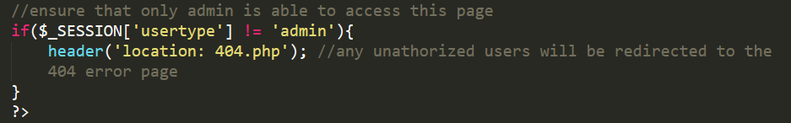

### 4.5.1 Admin Dashboard

The Admin dashboard is the page the Admin is redirected to upon logging in. The design is very simplistic and only contains essential elements. It helps the Admin navigate to other sub-pages they are authorized to access. Please refer to **Appendix I Section 1** for the entire code of the Admin Dashboard.

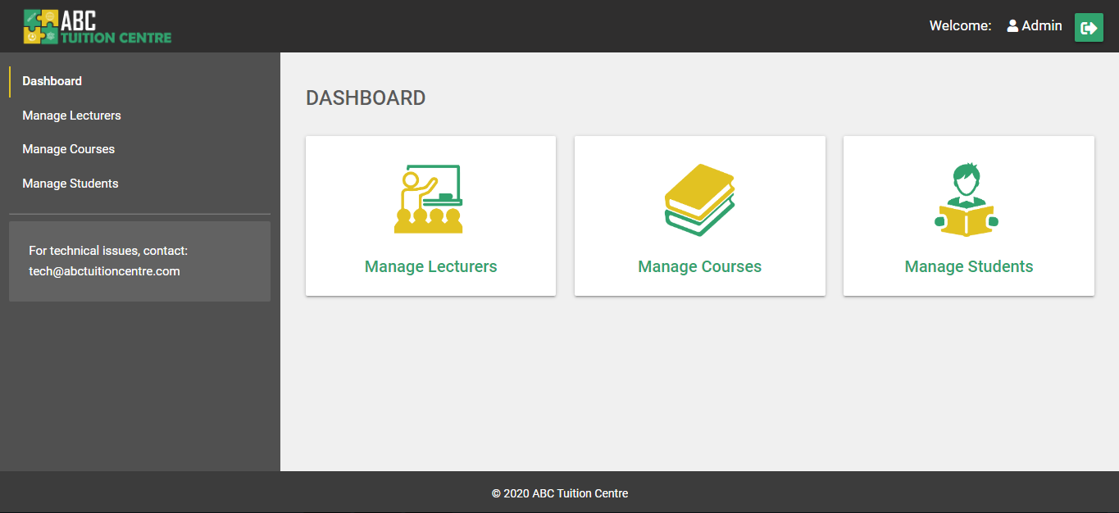

Figure 85: Admin Dashboard

### 4.5.2 Manage Lecturers

The “Manage Lecturers” page lists all lecturer accounts that are available on the system. Please refer to **Appendix I Section 2** for the complete HTML, PHP and MySQL code used to create this page.

#### 4.5.2.1 No Lecturer Accounts

If there are no lecturer accounts found in the “Lecturer” table in the database, the managelecturers.php page will appear with the following layout:

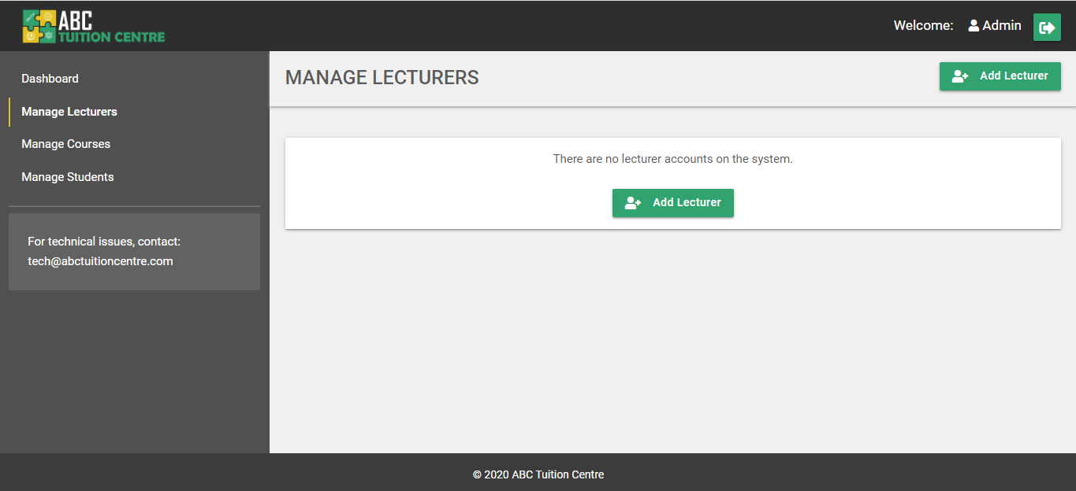

Figure 86: Manage Lecturers - No Lecturer Account Found

#### 4.5.2.2 Lecturer Accounts

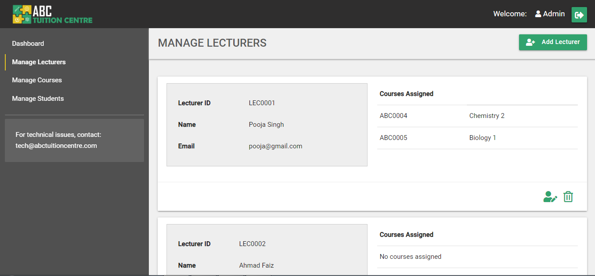

Figure 87: Manage Lecturers

The page has the following features:

**1.** **Add Lecturer Button** – The “Add Lecturer” Button redirects the admin user to the “Add New Lecturer” page (newlecturer.php).

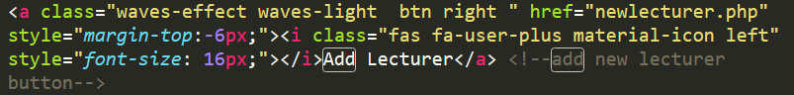

**2. Lecturer Information Card –** Each lecturer account found on the system will be displayed in its own independent card. The card will consist of the lecturer’s information such as Lecturer ID, Lecturer Name and Email. It will also list the courses assigned to the lecturer. Please refer to **Appendix I Section 2** for the entire program written to develop this layout and retrieve the information from the database.

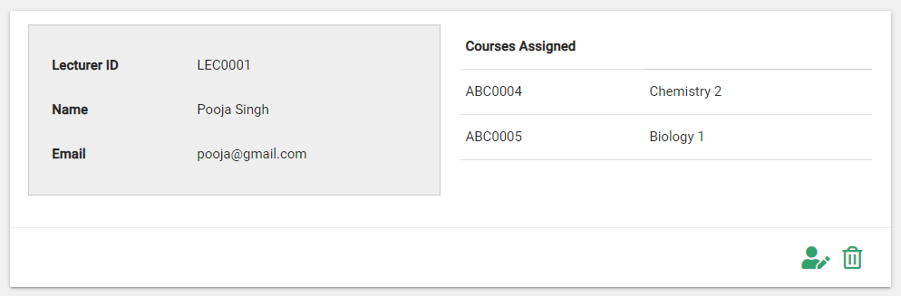

**3. Courses Assigned**

Each Lecturer information card contains a table of the courses assigned to the lecturer. Please refer to **Appendix I Section 2** for the entire program written to retrieve and display the information about courses assigned to the lecturer from the database.

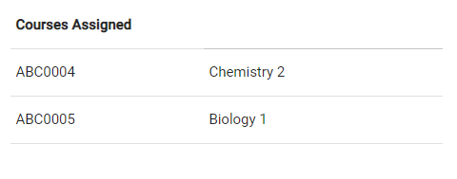

Figure 88: Manage Lecturers - courses assigned table

Each course row is clickable and it will redirect the user to the respective “View Course” page of that specific course. This feature is achieved in the following manner:

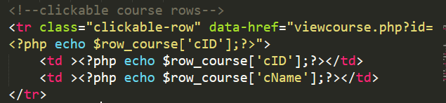

Figure 89: Clickable Course Row – HTML

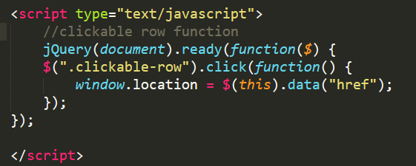

Figure 90: Clickable Course Row - JQuery Function

If no course is assigned to a lecturer, the system will display it in the following manner:

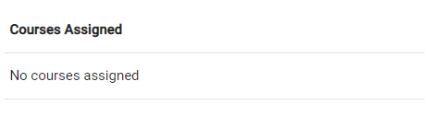

Figure 91: Manage Lecturers - No courses assigned

**4. Update Lecturer Account Button**

Each lecturer information card has an “Update” button in the bottom left corner that allows the admin to be redirected to the Update Lecturer Account page to update the information of that specific lecturer.



Figure 92: Update Lecturer Account Button

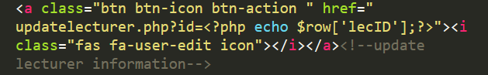

Figure 93: Update Lecturer HTML and PHP

**5. Delete Lecturer Account**

Clicking on the delete button allows the admin to delete a specific lecturer account. A common delete function has been implemented in the **server.php** file that deletes the selected lecturer account row, course row, or student row. For the complete “Delete” backend function, please refer to **Section 1c server.php** in **Appendix F**. The function is used in the Manage Lecturer page in the following manner:

a) The user first clicks on the delete icon located on the bottom left corner of the lecturer card



Figure 94: Delete Icon

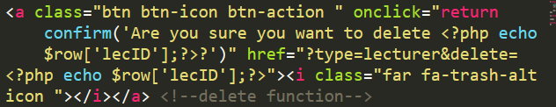

Figure 95: Delete Function HTML and PHP – managelecturers.php

b) a pop-up confirmation dialog box appears asking if the admin wants to delete the selected lecturer account:

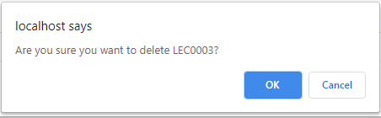

c) If the admin clicks “cancel”, nothing happens. If the admin clicks “ok”, the following program is executed from the **server.php** file and the lecturer account is deleted from the system and the page is refreshed. For the complete program please refer to **Section 1c server.php** in **Appendix F**:

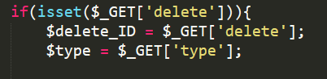

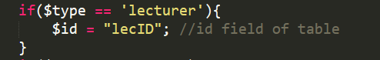

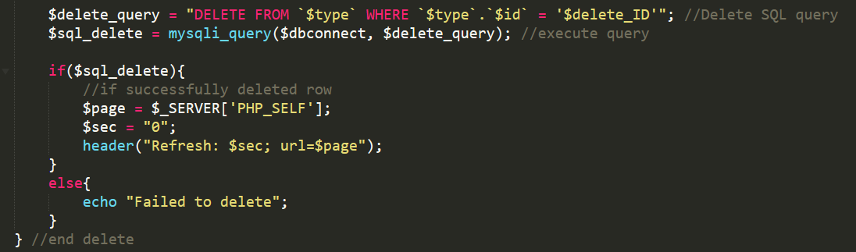

Please note, a lecturer account with courses assigned to it cannot be deleted because the lecturer ID is used as a foreign key in the course table. The admin will have to re-assign the courses to another lecturer first if they wish to delete the selected lecturer account. If a lecturer has courses assigned to them, the following error message will appear:

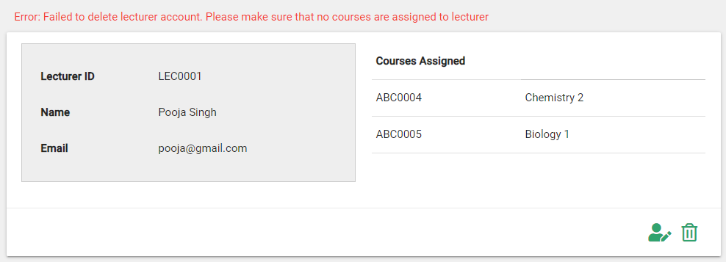

### 4.5.3 Update Lecturer Account

The Lecturer is not able to update their account details on their own. To minimize the lecturer’s interaction with the system, the Admin is in charge of setting up a lecturer’s account and updating it if required.

Clicking on the “Update” icon on a lecturer information card on the manage lecturer account page will redirect the user to the Update Lecturer Account page of the selected lecturer. The system retrieves the ID of the associated lecturer account with the GET method retrieving “id” attribute set on the anchor tag on the managelecturers.php page:



Figure 96: GET method set on anchor tag - managelecturers.php



Figure 97: Update Lecturer URL

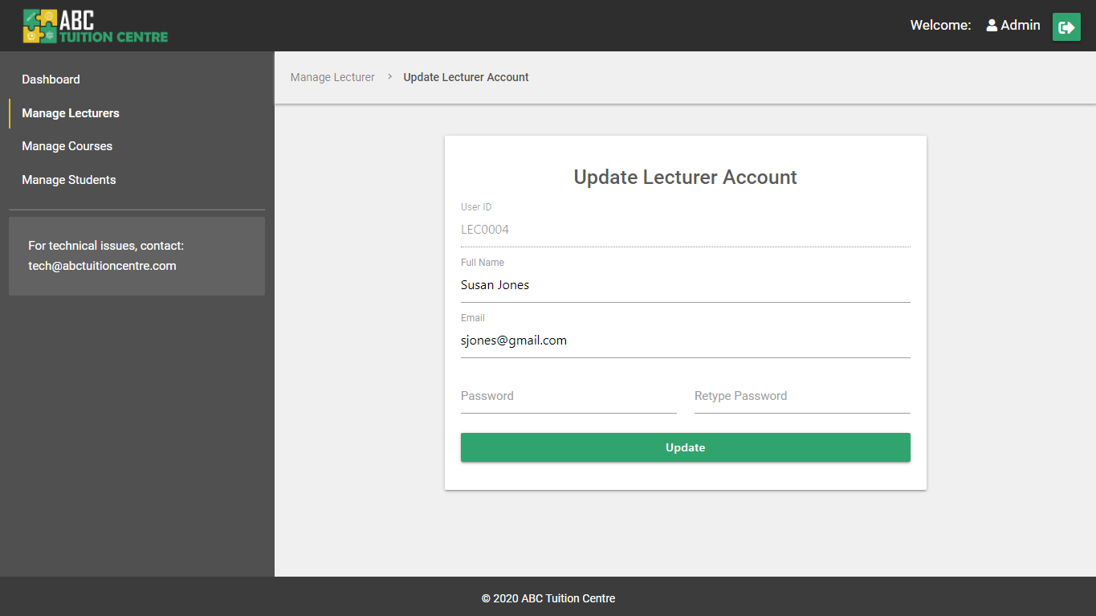

Figure 98: Update Lecturer Account page UI

The information of the selected lecturer is retrieved from the database and pre-populated in the input fields of the form based on the id. The admin may make changes to the values to update the information. For the complete code of how the information was retrieved from the database and populated in the respective input fields, please refer to **Appendix I Section 3.**

**Error – No Lecturer ID**

If the “id” is not declared in the URL, the system will redirect the user back to the **managelecturers.php** page with the help of the following condition added to the **updatelecturer.php** page code:

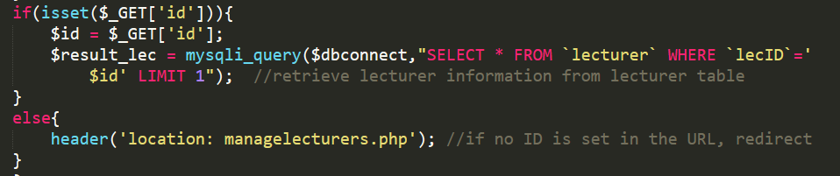

Figure 99: Update Lecturer Account - id condition

**Error – Incorrect Lecturer ID**

If an ID is declared in the URL but no associated lecturer account is found, the following error will appear on the screen:



Figure 100: Update Lecturer - Incorrect id declared

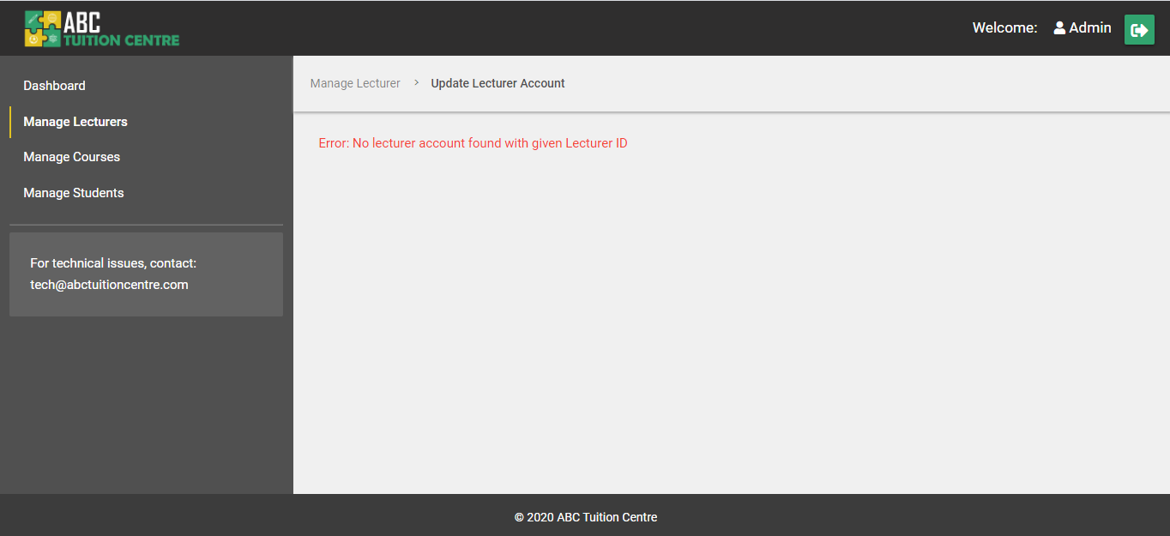

Figure 101: Update Lecturer - Lecturer Account Not Found Error

**Successfully Updated Lecturer Information**

Upon updating the account information, the admin can click on the “Update” button to update the values on the database as well. Upon clicking on the update button, the “update” program and query in the **server.php** file are executed. Upon successfully updating the account information on the database, the page is refreshed and a success message is displayed on the screen. Please refer to **Section 1c server.php in Appendix F** to review the server side program for the update query.

Please note: The lecturer ID cannot be edited or updated.

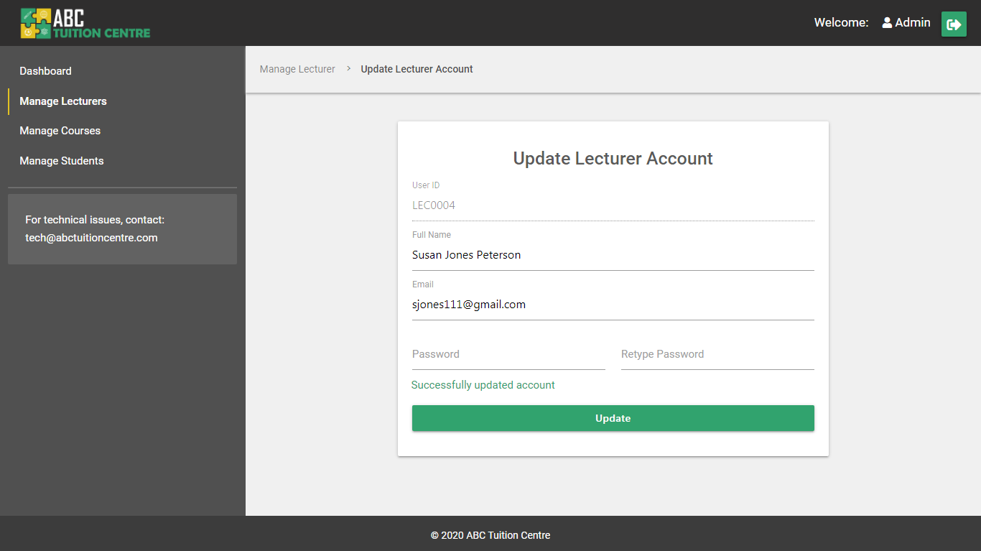

Figure 102: Update Lecturer Account - Successful

### 4.5.4 Add Lecturer Account

A new lecturer account can be added by clicking on the “Add Lecturer” button on the **managelecturers.php** page. Upon clicking on the button, the admin is redirected to the **newlecturer.php** page. The new lecturer account will allow the admin to add a new lecturer account. To refer to the entire code of the **newlecturer.php** page, please refer to **Appendix I Section 4**.

#### 4.5.4.1 Add Lecturer - User Interface

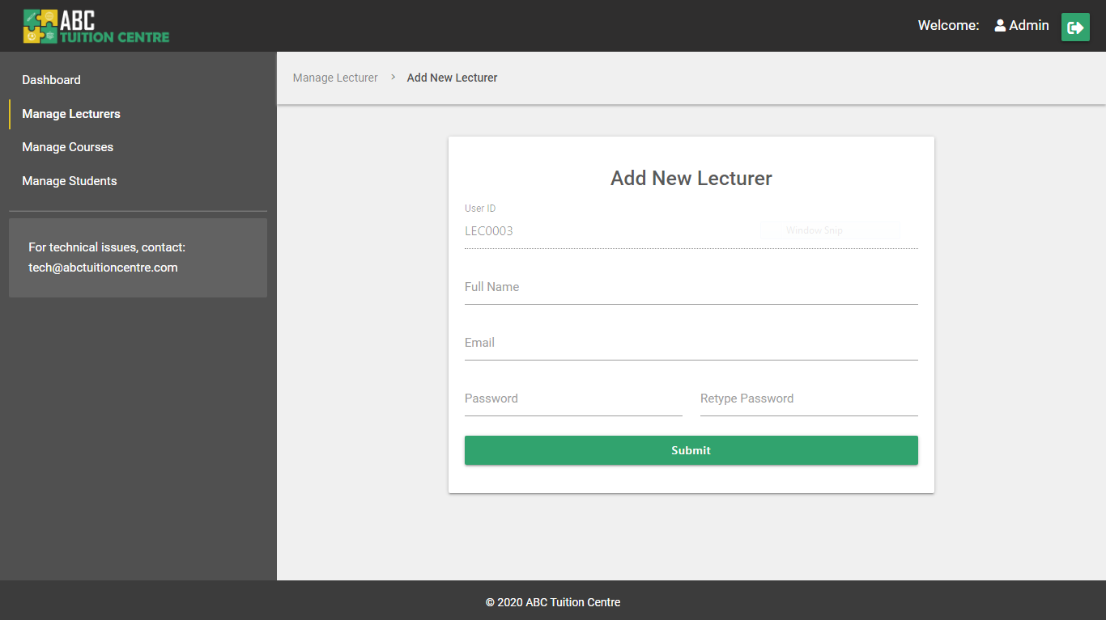

Figure 103: Add New Lecturer UI

Please note: The admin cannot change the Lecturer ID. The system will set the lecturer ID according to which ID is available with the help of the program written in the **setid.php** file. Please refer to **4.2.2 setid.php** for more information on how the system sets the Lecturer ID.

#### 4.5.4.2 Add Lecturer – User Experience

The validation structure of the newlecturer.php page is the same as the validation structure used in the Register (register.php) and New Course (newcourse.php) pages. Please refer to the detailed description provided in **4.3.2 Register** for a detailed explanation of how the validation system works. For the entire backend code of adding a new lecturer, please refer to **Section 1c server.php in Appendix F**.

**HTML5 and JavaScript Required Validations**

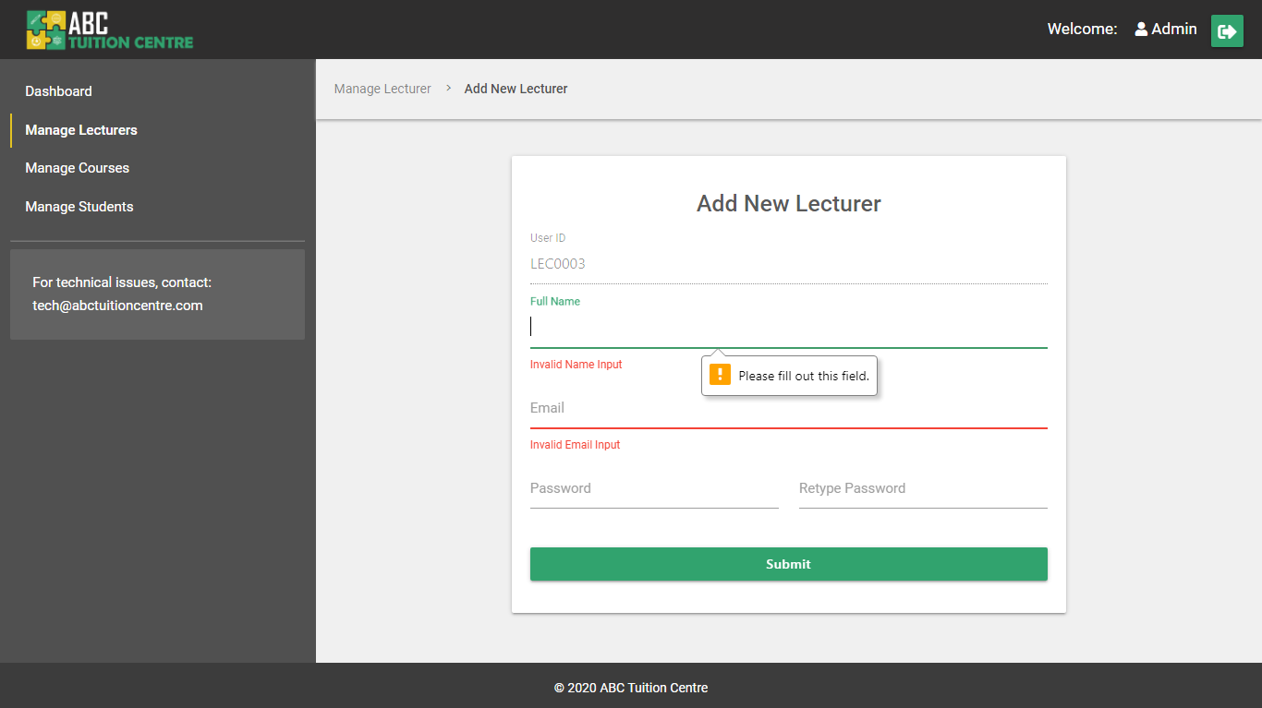

Figure 104: HTML5 Required Field Validations

**Empty Field PHP Validations**

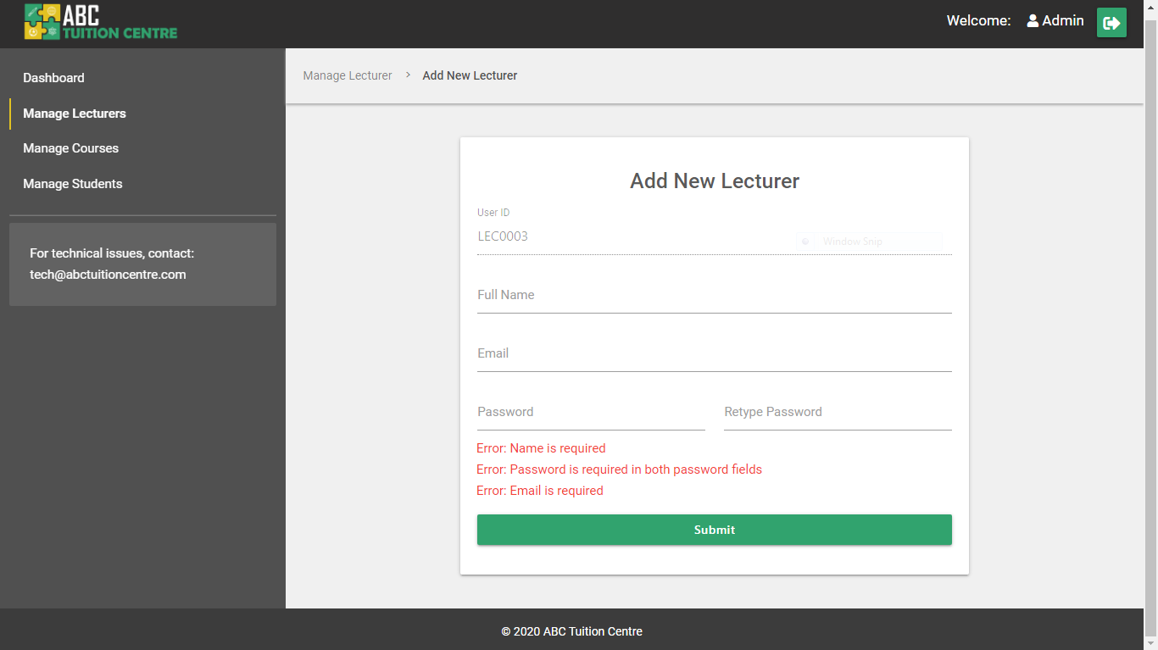

Figure 105: New Lecturer - Empty Field PHP validations

**Invalid Input PHP Validations**

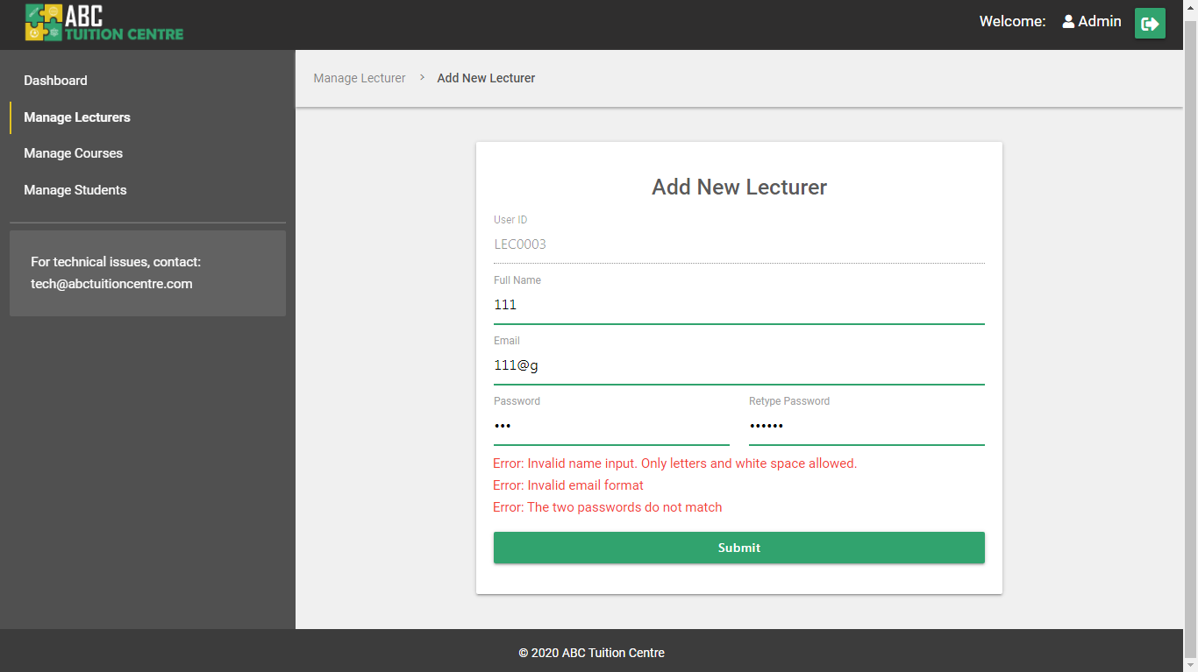

Figure 106: New Lecturer - Invalid Input PHP Validations

#### 4.5.4.2 Add Lecturer – Success Scenario

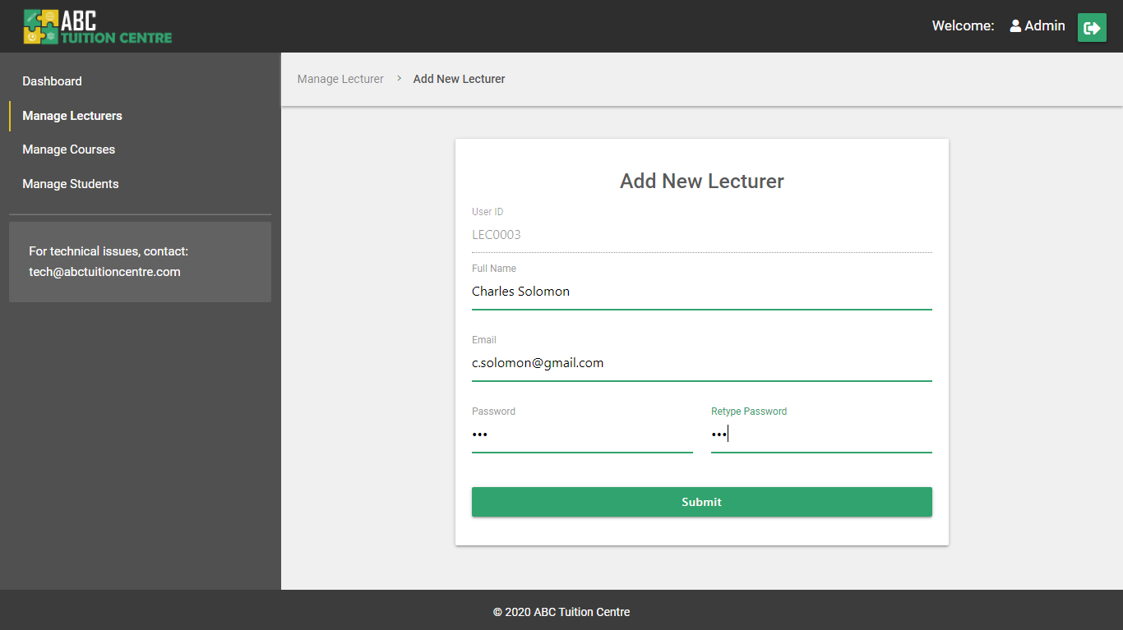

Figure 107: New Lecturer - Filled out form

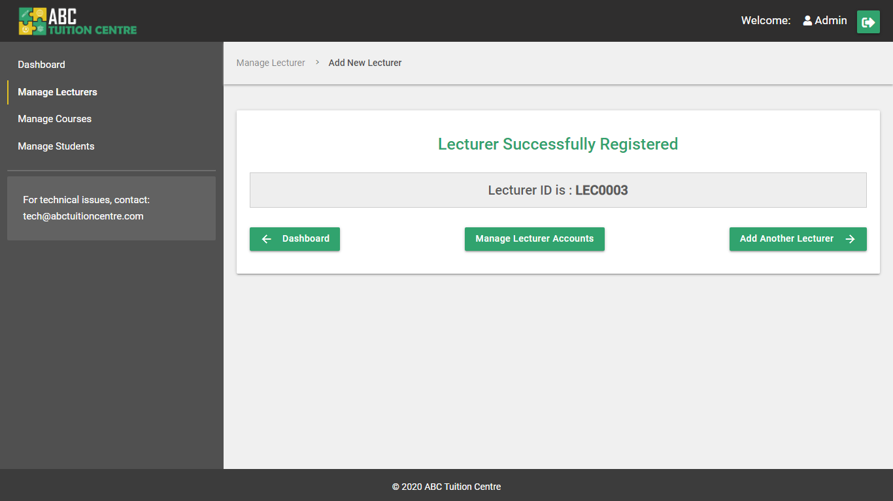

Figure 108: New Lecturer - Successfully Registered

Upon successful registration, the admin is redirected to the “Lecturer Successfully Registered” page. Please refer to **Appendix I Section 5** for the complete code of the **lecturer-register-success.php** page.

### 4.5.5 Manage Students

The Manage Students page lists all the students registered in the system. Please refer to **Appendix I Section 6** for the entire HTML and PHP code of the **managestudents.php** page and to see how all the student accounts were retrieved from the database “Student” table and displayed below.

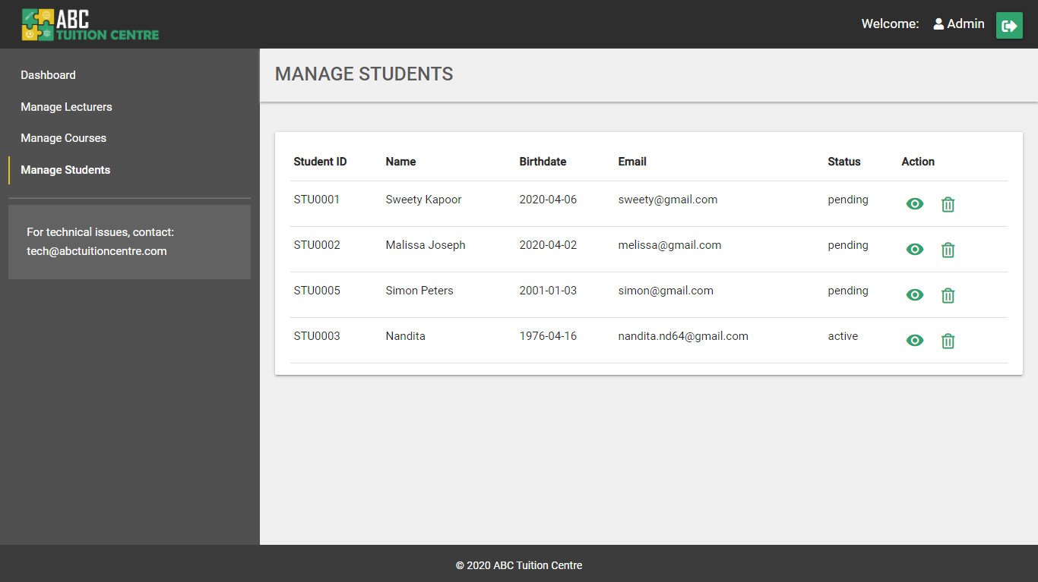

Figure 109: Manage Students

The features included on this page:

**1. Tabular View of All Students –** the student account information are retrieved from the student table in the database and displayed in tabular format. To review the complete code of how the accounts are retrieved from the database and displayed in the HTML UI, please refer to **Appendix I Section 6**

The student accounts are sorted in descending order by status and ascending order by ID. This makes all student accounts with “pending” status appear first in the list sorted according to their student IDs. This has been achieved with the help of the following SQL query:

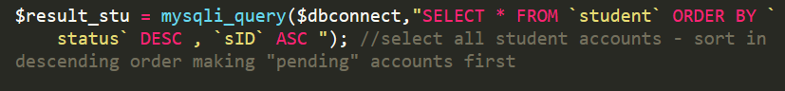

**2. View Student Account**

The student account can be viewed by clicking on the view icon under the “Action” column in the respective student row whose account the admin wishes to view. :



Figure 110: Manage Students - View Icon

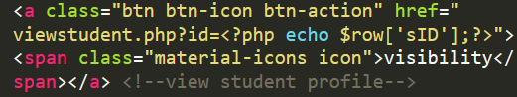

Figure 111: View Student Profile HTML code

Upon clicking on the icon, the browser window will be redirected to the viewstudent.php page and the selected student profile will be retrieved with the GET method from the “id” attribute in the URL.

**3. Clickable Row**

Similar to the rows of courses in the managecourses.php and managelecturers.php pages, the rows of student profiles are also clickable on the managestudent.php page with the help of the jquery function:

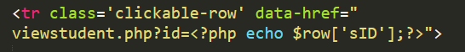

Figure 112: clickable-row HTML

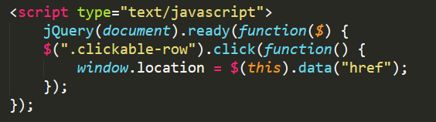

Figure 113: clickable-row JQuery

**4. Delete Student**

Clicking on the delete icon allows the admin to delete a specific student account. A common delete function has been implemented in the **server.php** file that deletes the selected lecturer account row, course row, or student row. For the complete “Delete” backend function, please refer to **Section 1c server.php** in **Appendix F**. The function is used in the Manage Student page in the following manner:

a) The user first clicks on the delete icon located in the “Action” column in the row of student that the admin wants to delete



Figure 114: Delete Icon

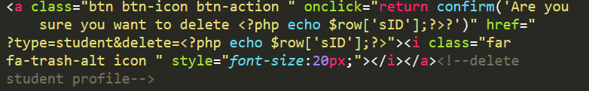

Figure 115: Delete Function HTML and PHP – managestudents.php

b) A pop-up confirmation dialog box appears asking if the admin wants to delete the selected student account:

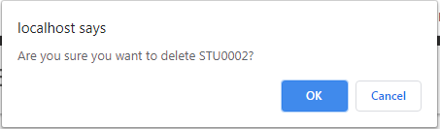

Figure 116: Delete - Popup Confirmation

c) If the admin clicks “cancel”, nothing happens. If the admin clicks “ok”, the following program is executed from the **server.php** file and the student account is deleted from the system and the page is refreshed. For the complete program please refer to **Section 1c server.php** in **Appendix F**

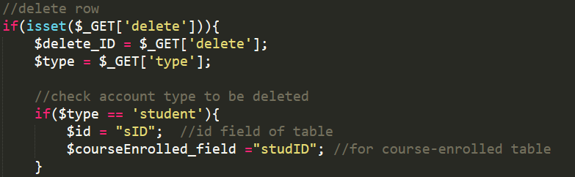

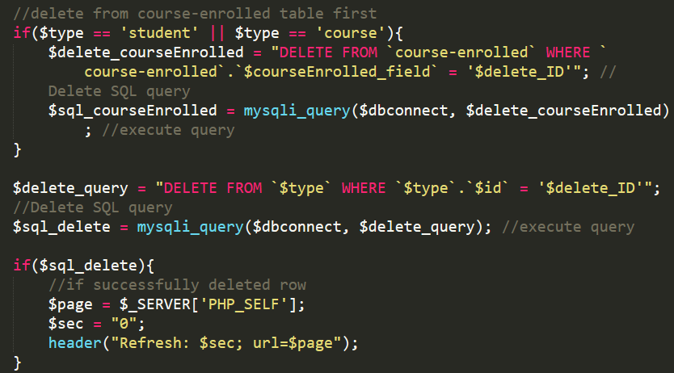

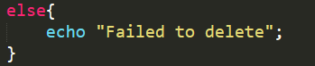

**5. If there are no students registered:**

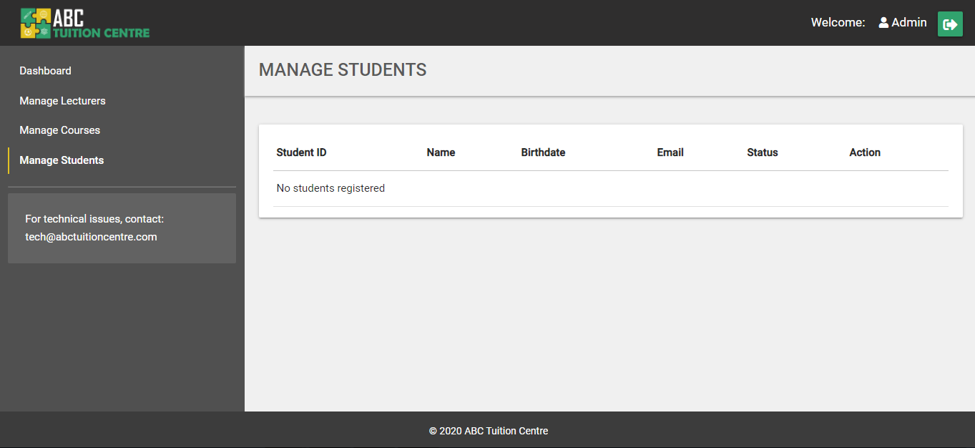

Figure 117: No Students Registered - managestudents.php

### 4.5.6 View Student

Please refer to **Appendix I Section 7** for the entire HTML and PHP code of the **viewstudent.php** page and to see how all the specific student account was retrieved from the database “Student” table and displayed. The code also includes how information related to courses student is enrolled in are retrieved from the database and displayed in the “student progress” table.

Clicking on the “view” icon on a student row in the table of students on the manage students page will redirect the user to the View Students page of the selected student. The system retrieves the ID of the associated student account with the GET method retrieving “id” attribute set on the anchor tag on the managestudents.php page:

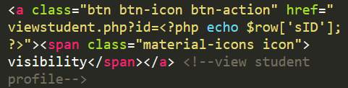

Figure 118: GET method set on anchor tag - managestudents.php



Figure 119: View Student URL

**Error – No Student ID**

If the “id” is not declared in the URL, the system will redirect the user back to the **managestudents.php** page with the help of the following condition added to the **viewstudent.php** page code:

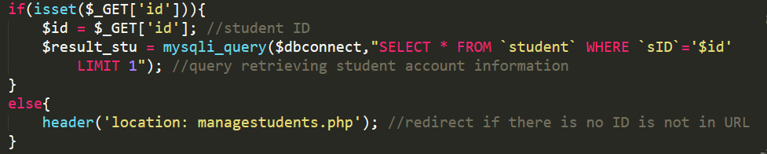

Figure 120: View Student Account - id condition

**Error – Incorrect Lecturer ID**

If an ID is declared in the URL but no student account is found, the following error will appear on the screen:



Figure 121: View Student - Incorrect id declared

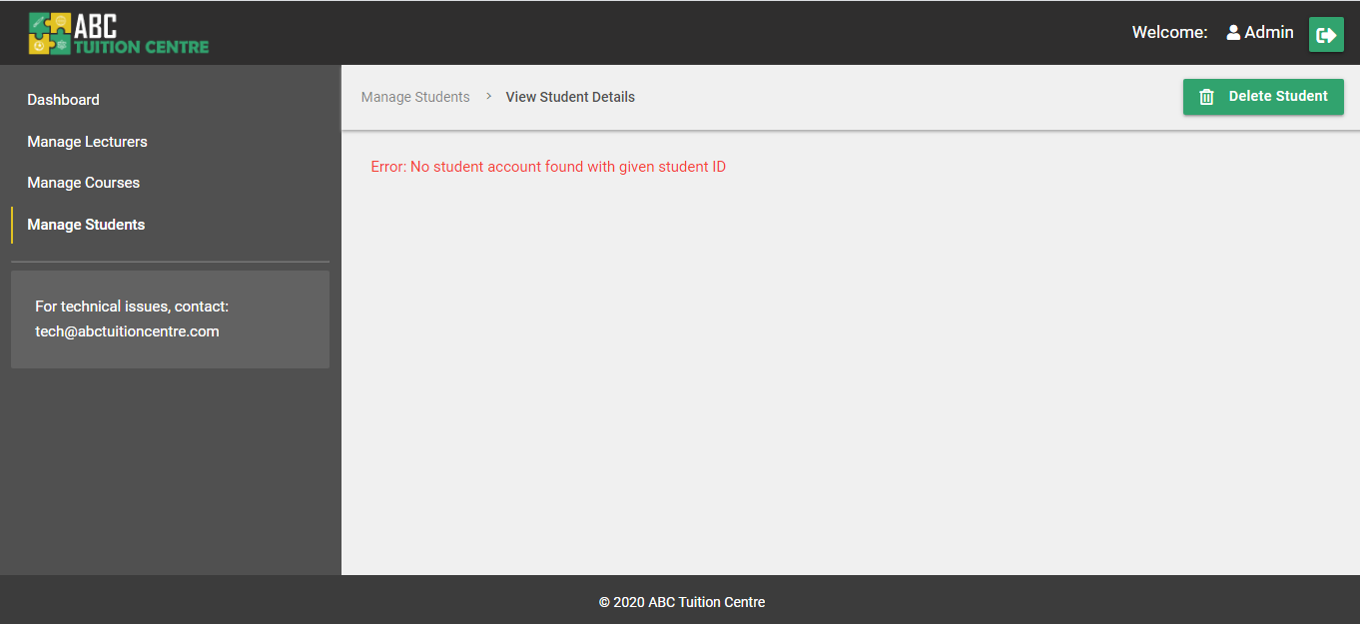

Figure 122: Incorrect Student ID in URL

#### 4.5.6.1 View Student: Status – Pending

When a student initially registers, their status is initially set to “pending” by default. The admin has to review their details and documents in person before they approve the student to be a part of ABC Tuition Academy.

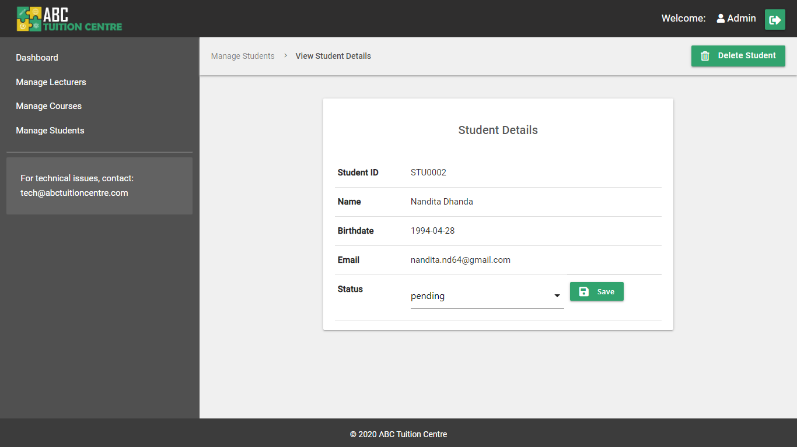

The admin can approve a student by selecting the “approve” option from the “status” dropdown menu and then click on the save button. When the admin clicks on the dropdown menu, they are presented with 3 options. The first is the current, default status, i.e. “pending. The second is “approve” and the third is “reject”. If the admin selects “reject”, the student account is deleted from the system considering they are not eligible to register in the academy and the admin user is redirected to the “Manage Students” page. If the admin selects “approve”, the page refreshes and the status is changed to “active” on the system and the student is then able to enrol for courses offered by ABC Tuition Centre.

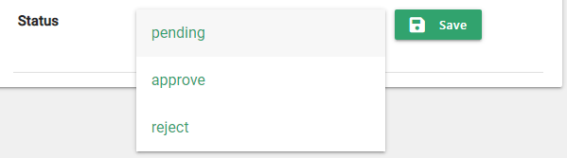

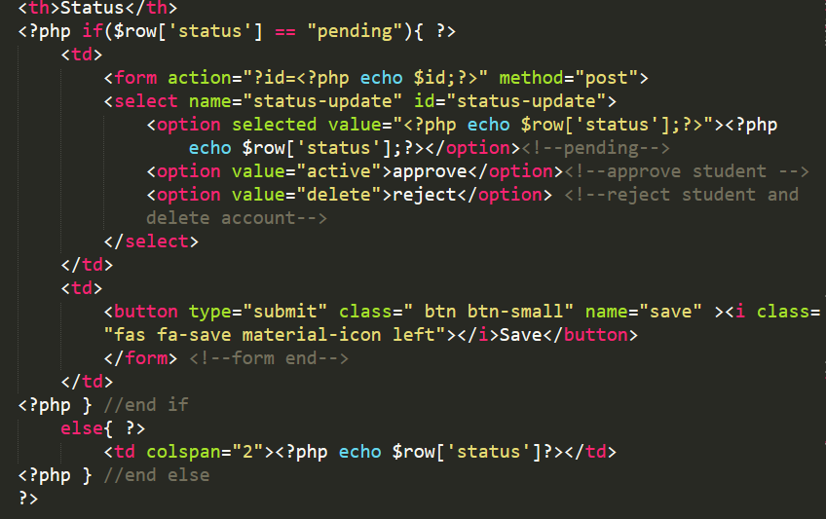

Figure 123: View Student - Update Status HTML

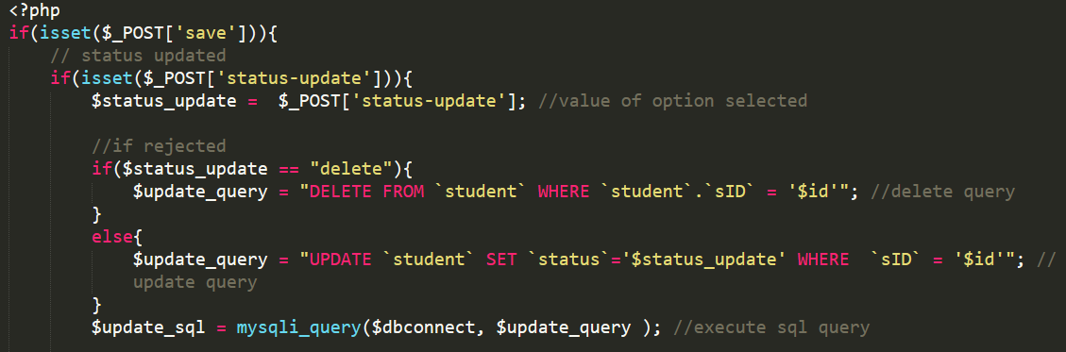

Figure 124: View Student - Status Update PHP and MySQL

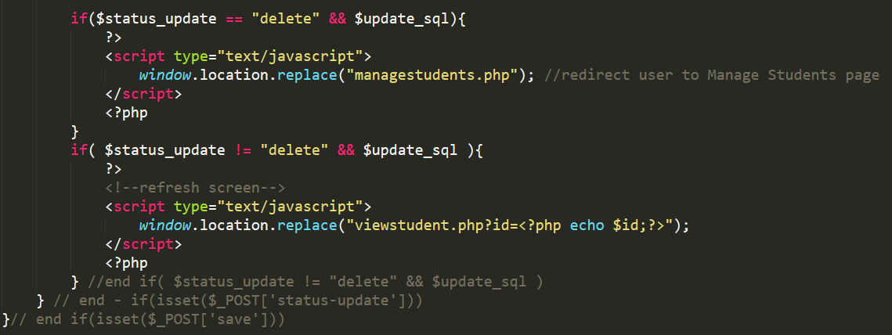

Figure 125: View Student - Status Update PHP

#### 4.5.6.2 View Student: Status - Approved

After the admin approves a student account, the status changes to “active” and the page is refreshed. Below the student details section, a table with the courses the student is enrolled in will appear and will help to keep track of the student’s progress in all the courses they are enrolled in. Since there are no courses a student is enrolled in immediately after being approved, the table states “No courses enrolled by student”. Please refer to **Appendix I Section 7** for the entire HTML and PHP code.

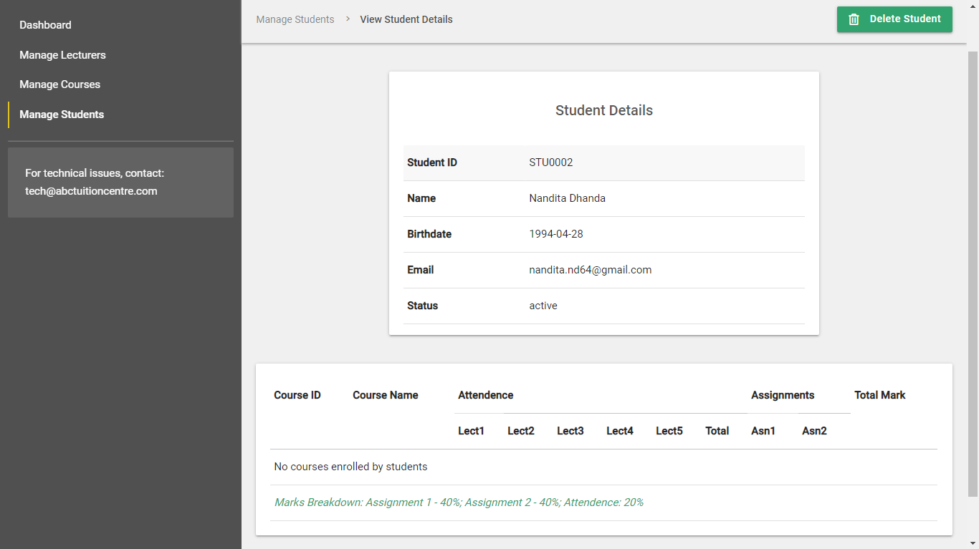

Figure 126: Admin - View Student Details (Status Active)

Once the student enrolls for courses, the course progress is populated in the table displayed below the student details. Please refer to **Appendix I Section 7** for the source code

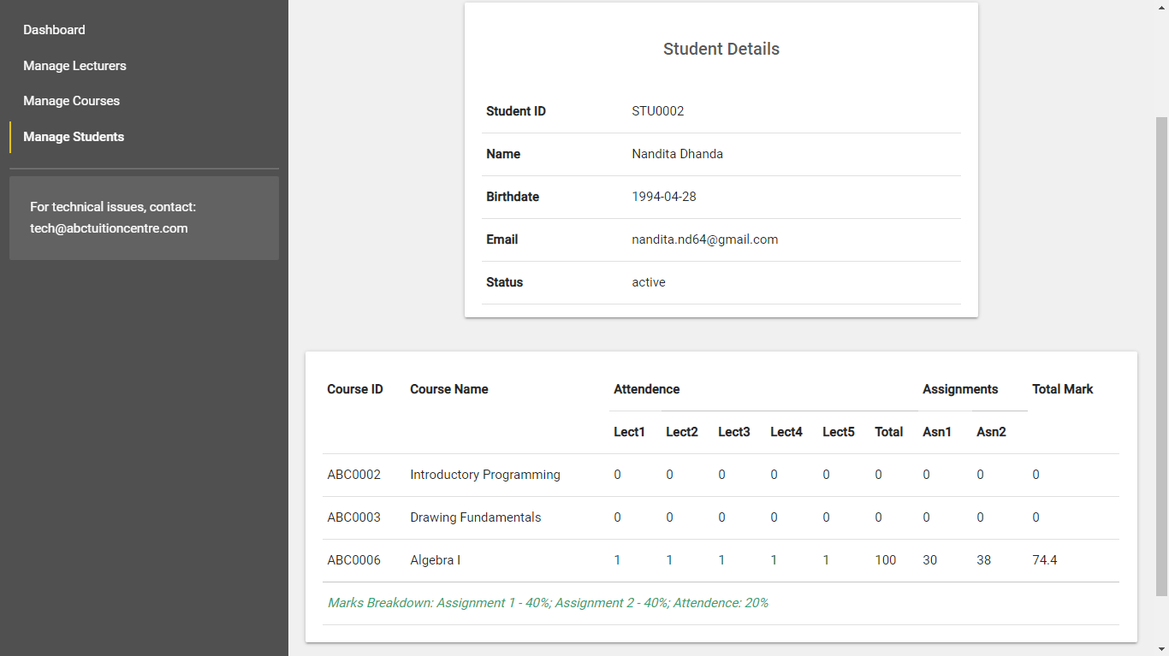

Figure 127: Admin - View Student Details (With Course Progress)

### 4.5.7 Manage Courses

The admin is able to add, remove or view courses in the system. The courses available on the system are listed in a tabular format on the Manage Course Page. Please refer to **Appendix I Section 8** for the source code of the managecourses.php page and to review how the courses are retrieved from the database and populated in the table.

**No Courses:**

Layout if there are no courses added in the system:

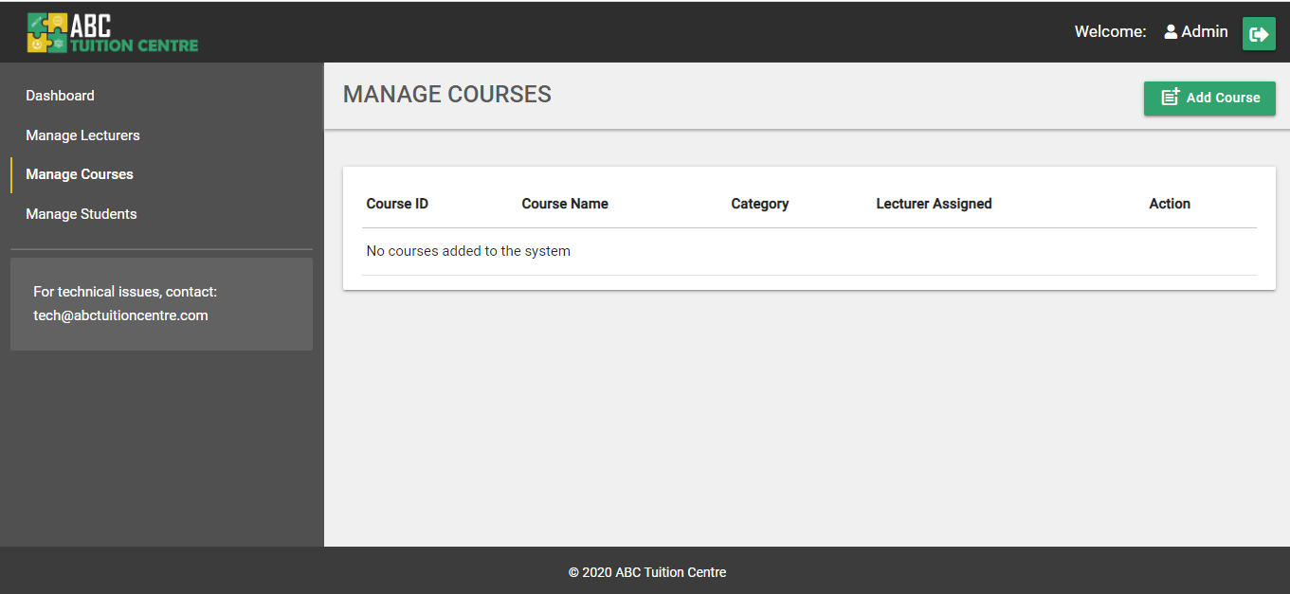

Figure 128: Admin - Manage Courses (No Courses)

**Courses Present in system**

Layout if there are courses added to the system:

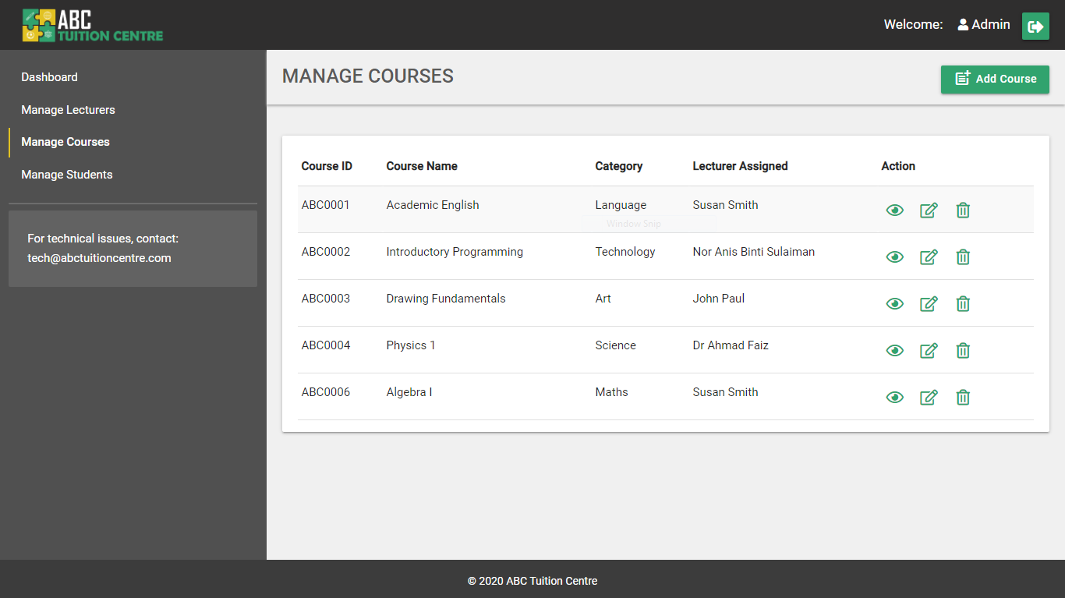

The features included on this page:

**1. Tabular View of All Courses –** the courses information are retrieved from the course table in the database and displayed in tabular format. To review the complete code of how the accounts are retrieved from the database and displayed in the HTML UI, please refer to **Appendix I Section 8**

**2. View Course**

The course details can be viewed by clicking on the view icon under the “Action” column in the respective course row whose account the admin wishes to view. :



Figure 129: Manage Courses - View Icon

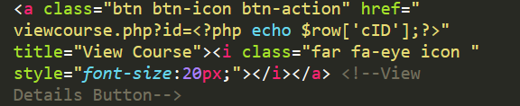

Figure 130: View Course Details HTML code

Upon clicking on the icon, the browser window will be redirected to the viewcourse.php page and the selected course will be retrieved with the GET method from the “id” attribute in the URL.

**3. Clickable Row**

Similar to the rows of students and courses in the managestudents.php and managelecturers.php pages, the rows of course detail are also clickable on the managecourse.php page with the help of the jquery function:



Figure 131: clickable-row HTML



Figure 132: clickable-row JQuery

**4. Delete Course**

Clicking on the delete icon allows the admin to delete a specific course. A common delete function has been implemented in the **server.php** file that deletes the selected lecturer account row, course row, or student row. For the complete “Delete” backend function, please refer to **Section 1c server.php** in **Appendix F**. The function is used in the Manage Course page in the following manner:

a) The user first clicks on the delete icon located in the “Action” column in the row of student that the admin wants to delete



Figure 133: Delete Icon

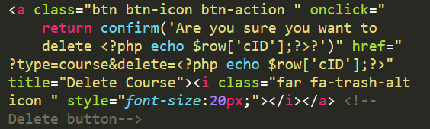

Figure 134: Delete Function HTML and PHP – managecourse.php

b) A pop-up confirmation dialog box appears asking if the admin wants to delete the selected student account:

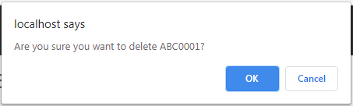

Figure 135: Delete - Popup Confirmation

c) If the admin clicks “cancel”, nothing happens. If the admin clicks “ok”, the following program is executed from the **server.php** file and the course is deleted from the system and the page is refreshed. For the complete program please refer to **Section 1c server.php** in **Appendix F**:







**6. Update Course**

Each course row has an update icon under the “Action” column. The admin can update a specific course by clicking on the icon and being redirected to the update course page.



Figure 136: Update course Button

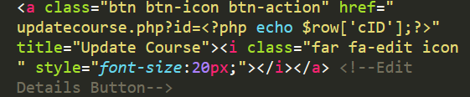

Figure 137: Update Course HTML and PHP

**6. Add New Course**

The Admin user can add a new course by clicking on the “Add Course Button”. When the admin clicks on the button, he/she is redirected to the newcourse.php page



### 4.5.8 Add New Course

A new course can be added by clicking on the “Add Course” button on the **managecourses.php** page. Upon clicking on the button, the admin is redirected to the **newcourse.php** page. The new course page will allow the admin to add a new course. To refer to the source code of the **newcourse.php** page, please refer to **Appendix I Section 9**.

#### 4.5.8.1 Add New Course User Interface

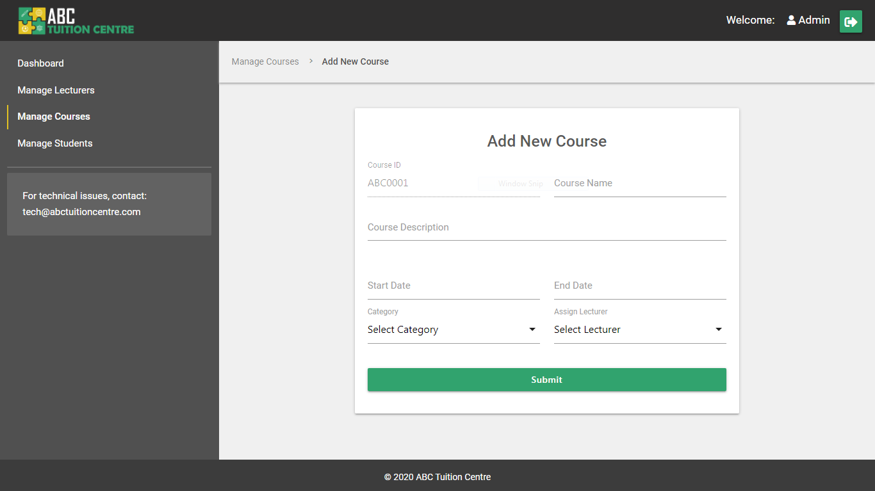

Figure 138: Add New Course UI

Please note: The admin cannot change the Course ID. The system will set the course ID according to which ID is available with the help of the program written in the **setid.php** file. Please refer to **4.2.2 setid.php** for more information on how the system sets the Course ID.

#### 4.5.4.2 Add Course – User Experience

The validation structure of the newcourse.php page is the same as the validation structure used in the Register (register.php) and New Lecturer (newlecturer.php) pages. Please refer to the detailed description provided in **4.3.2 Register** for a detailed explanation of how the validation system works. For the entire backend code of adding a new lecturer, please refer to **Section 1c server.php in Appendix F**.

#### 4.5.8.2 Add New Course User Experience

##### Interactive Elements

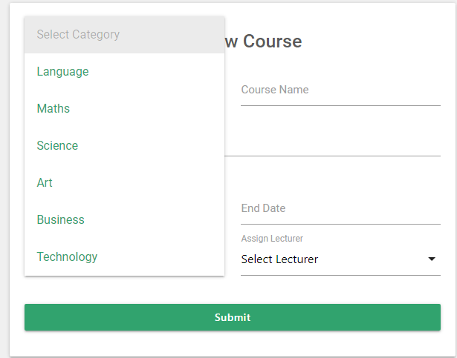

Figure 139: Add New Course - Category Dropdown Menu



Figure 140: Interactive Date Picker

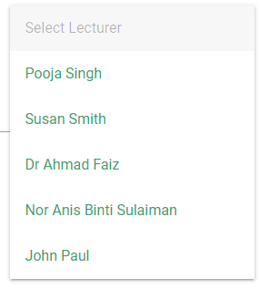

Figure 141: Interactive Dropdown Menu Populated With Lecturers

The dropdown menu to assign a lecturer to the course is populated with the names of the lecturers registered on the system. The list of lecturer names are retrieved in the following manner:



Figure 142: Lecturer query

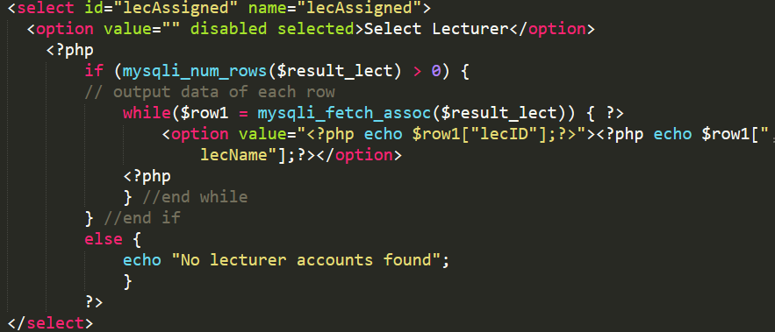

Figure 143: Populate Lecturers Found

The lecturer name is shown in the <option></option> HTML tag and the value attribute contains the Lecturer ID. This way, when the lecturer is selected and the course is added to the system, the lecturer id will be saved in the course table and not the lecturer name.

##### PHP Validations

**Empty Field PHP Validations**

Please refer to **Appendix F Section 1c server.php**  for the source code of how these validations work

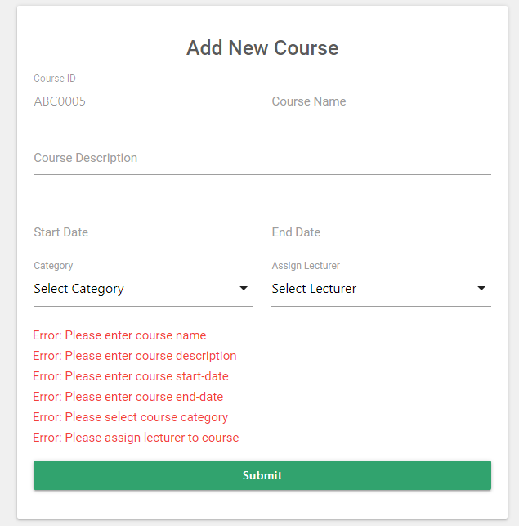

Figure 144: New Lecturer - Empty Field PHP validations

**Invalid Input PHP Validations**



Figure 145: New Lecturer - Invalid Input PHP Validations

**Duplicate Course Name**

When a new course is added, the system will check if there is any existing course with the same name. Two courses with the same name are not permitted in the system.

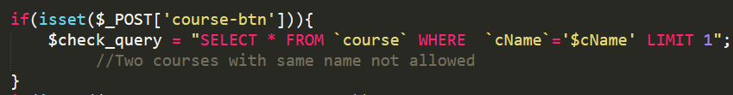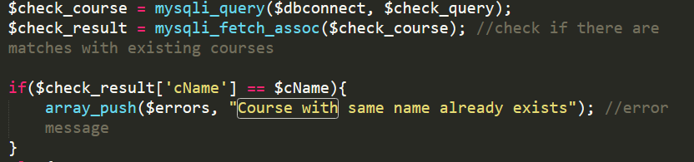

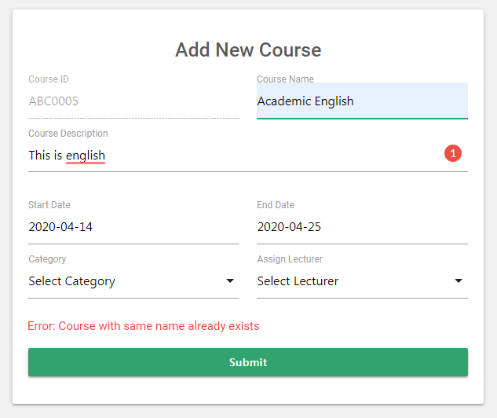

Figure 146: Duplicate Course Name

Upon successfully adding a course, a success message is displayed “Course Successfully Added” page.

### 4.5.9 Update Course

Admin is able to update the course details by clicking on the “Update” icon in the action column next to the associated course row on the Manage Courses page. They will be redirected to the Update Course page of the selected course. The admin can also access the page by clicking on the “Update Course” button on the “View Course” page where the user logged in is the Admin. The system retrieves the ID of the associated course with the GET method retrieving “id” attribute set on the anchor tag on the managecourses.php or viewcourse.php pages:

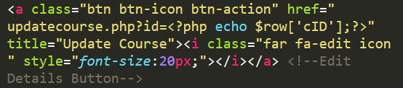

Figure 147: GET method set on anchor tag - managecourse.php

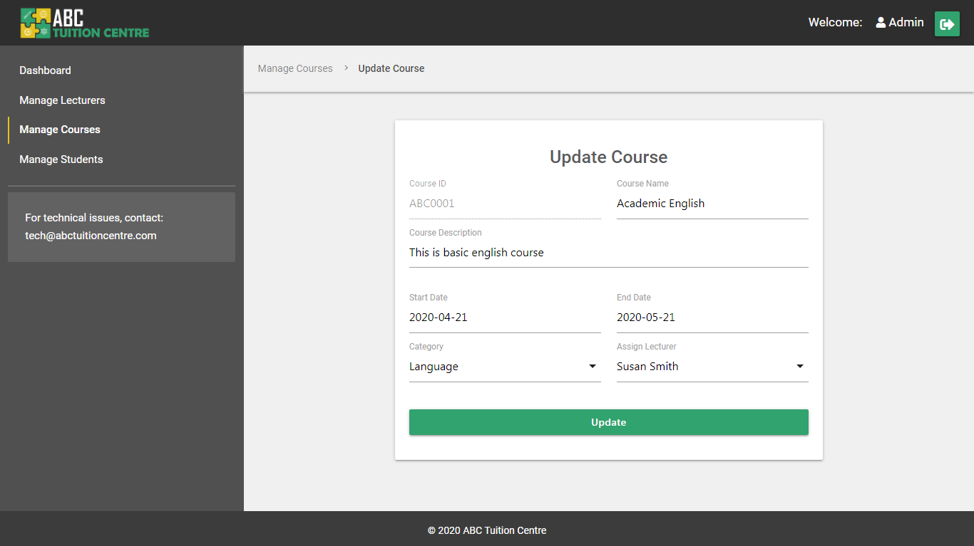

Figure 148: Update Course page UI

The information of the selected course is retrieved from the database and pre-populated in the input fields of the form based on the id. The admin may make changes to the values to update the information. For the complete source code of how the information was retrieved from the database and populated in the respective input fields, please refer to **Appendix I Section 10.**

**Error – No Lecturer ID**

If the “id” is not declared in the URL, the system will redirect the user back to the **managelecturers.php** page with the help of the following condition added to the **updatelecturer.php** page code:

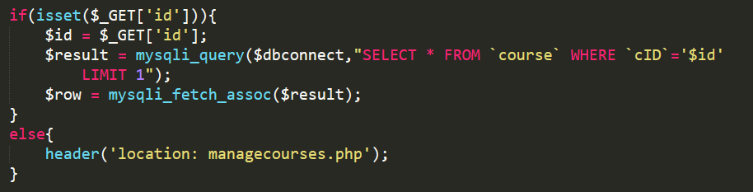

Figure 149: Update Course - id condition

**Successfully Updated Lecturer Information**

Upon updating the course information, the admin can click on the “Update” button to update the values on the database as well. Upon clicking on the update button, the “update” program and query in the **server.php** file are executed. Upon successfully updating the course information on the database, the page is refreshed and a success message is displayed on the screen. Please refer to **Section 1c server.php in Appendix F** to review the server side program for the update query.

Please note: The course ID cannot be edited or updated. Additionally, the validation structure for the Update course page is the same as the “Add New Course” page. Please refer to **4.5.8 Add New Course** for more details on how the validation structure will work. For the source code of the “update course” validations, please refer to **Section 1c server.php in Appendix F.**

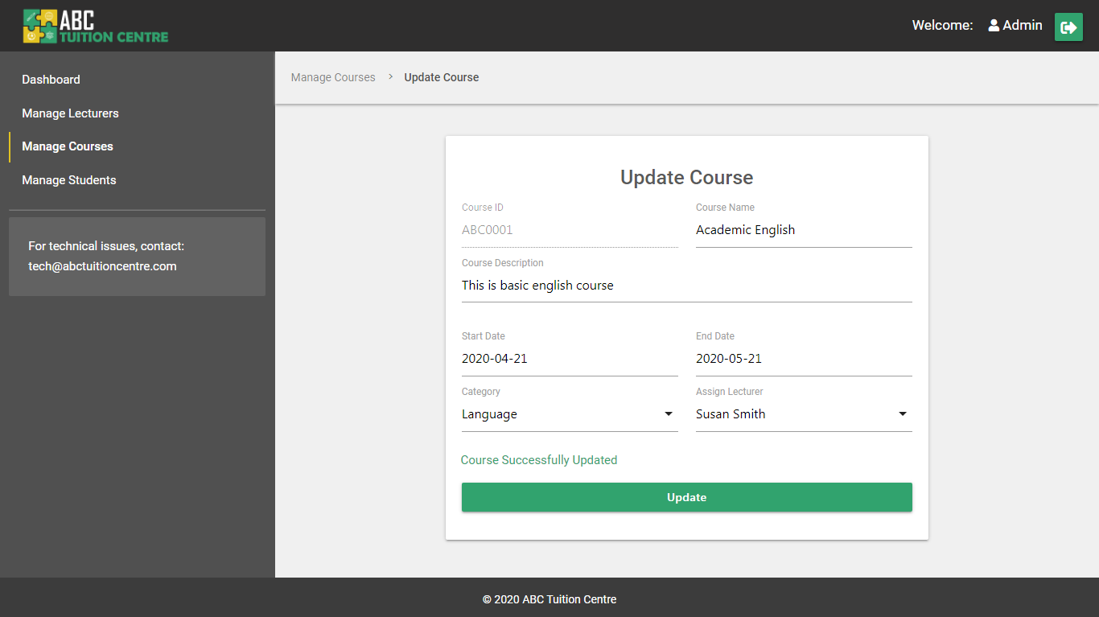

Figure 150: Update Course - Successful

## 4.6 Main Pages - Student Portal

When a student registers with ABC Tuition Centre, they have to undergo a status vetting process in which the Administration reviews the student registration details and may request to review the student’s documents in person. After the admin is satisfied with the student information and are ready to approve a student’s registration application, the student is able to enrol for courses through their student portal

### 4.6.1. Student Account – Status Pending

If a student’s status is pending, they are still able to log into their student portal, however they will not be able to enrol for any courses. The student dashboard for a student whose status is pending will appear in the following way:

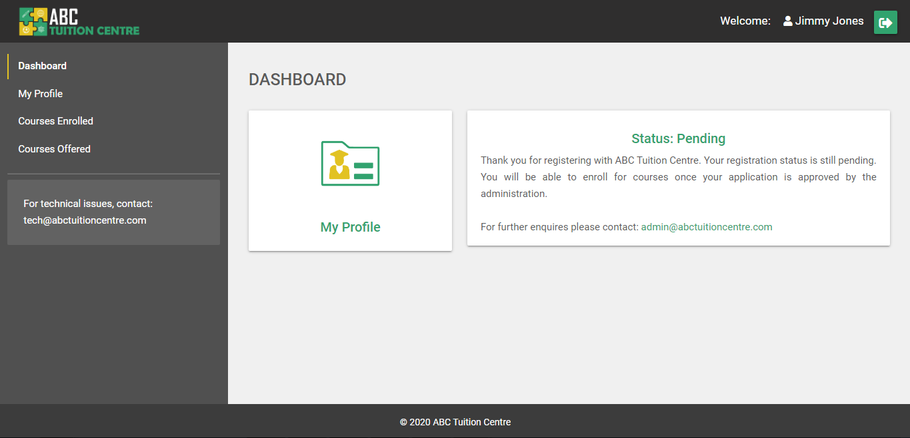

Figure 151: Student Dashboard (Pending Status)

To review the entire source code of the dashboard, please refer to **Appendix J Section 1**.

Although the links to the “Course Enrolled” page and “Course Offered” page are still available on the side navigation, the student will still not be able to access those pages due to the following condition included on both the pages, which prevents a student whose status is pending from accessing the pages:

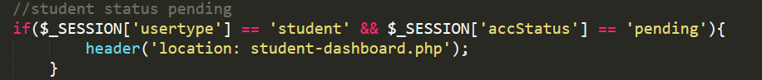

If the student tries to access these pages, he will be redirected back to the student dashboard.

The student will, however, be able to access the “My Profile” page and also edit their personal information.

### 4.6.2. Student Dashboard – Status Approved

Once the student status is approved by the admin, they will be able to enrol for courses and their dashboard layout will change. The “Course Enrolled” and “Courses Offered” thumbnails will become visible and accessible to them. To review the entire source code of the dashboard, please refer to **Appendix J Section 1**.

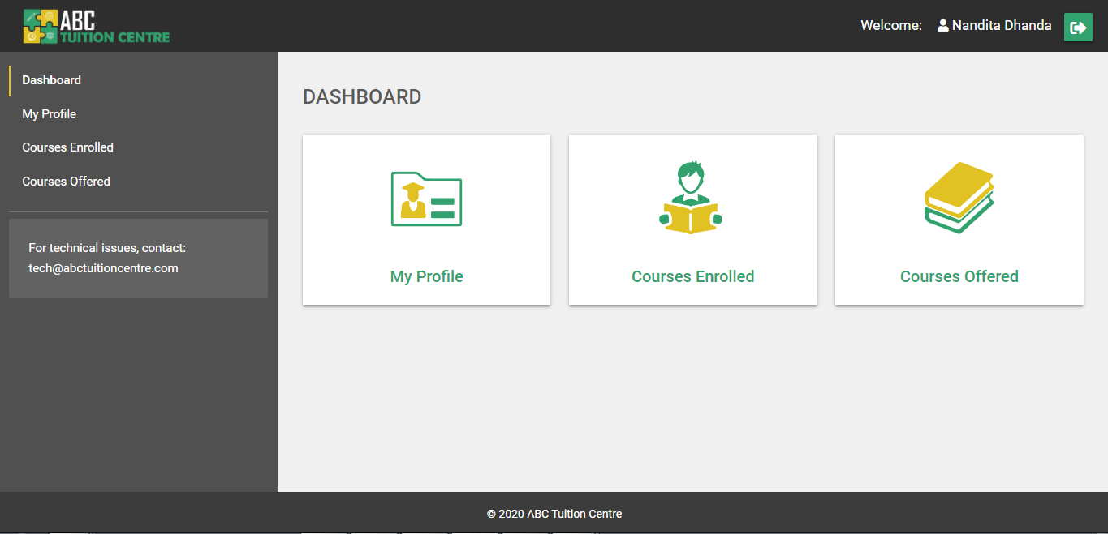

Figure 152: Student Dashboard (Active Status)

### 4.6.3. My Profile

By clicking on the “My Profile” link in the sidebar navigation menu or on the thumbnail in the student dashboard, the student is able to access the “My Profile” page which consists of student’s information. To review the source code of how the student’s information is populated on the “Profile” page, please refer to **Appendix J Section 3**.

The student will be able to update his/her profile information by clicking on the “Update Profile” Button in the sub-navigation bar of the “Student Profile” page.

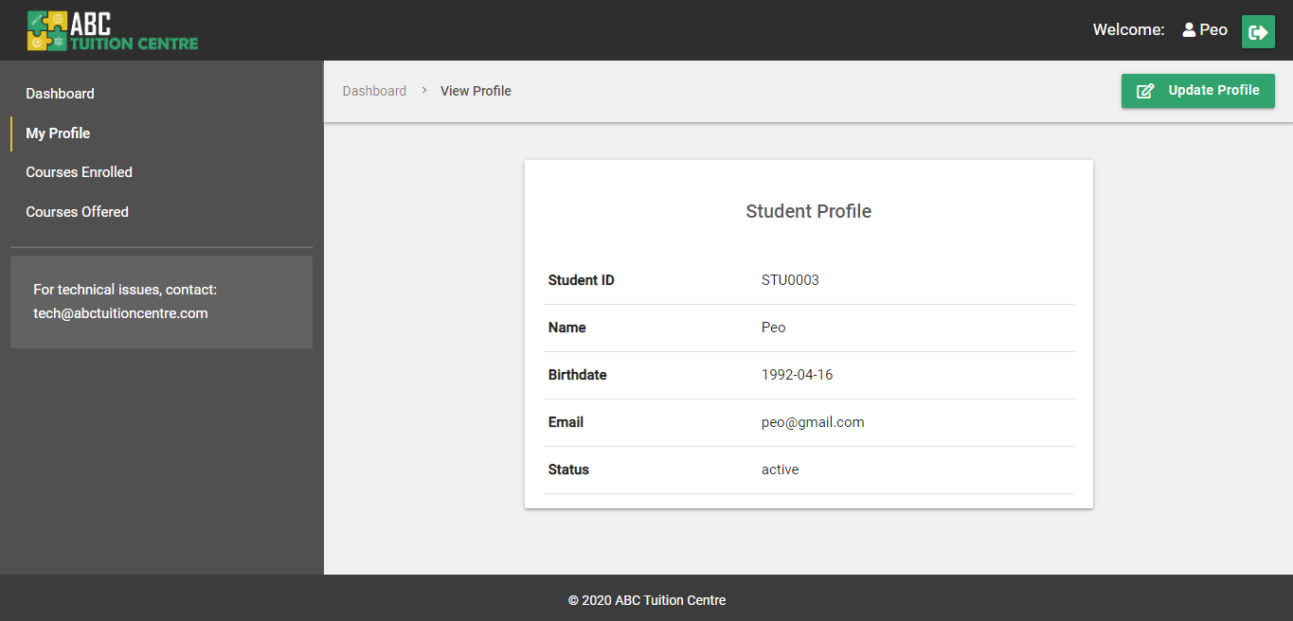

Figure 153: Student Profile (active status)

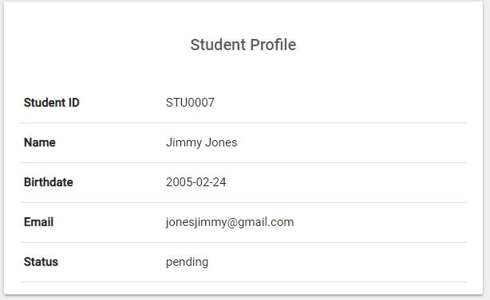

Figure 154: Student Profile (pending status)

### 4.6.4. Update Profile

The student is able to update their account details through the updatestudent.php page. Only the student is authorized to update the “Student Account” details. When the student accesses the “Update Profile” page, the form is pre-populated with existing values of the student account. In order to update the values, the student can make changes in the input boxes, retype their password and click on the “Update Button”. Please refer to **Appendix J Section 3** for the source code of the updatestudent.php page. And please refer to **Appendix F Section 1c server.php** for the source code of the “Update” function. The “Update” function follows the same structure as the “Register” student function. This means the same validation structure is also applied to the “Update Profile” page as the Register page.

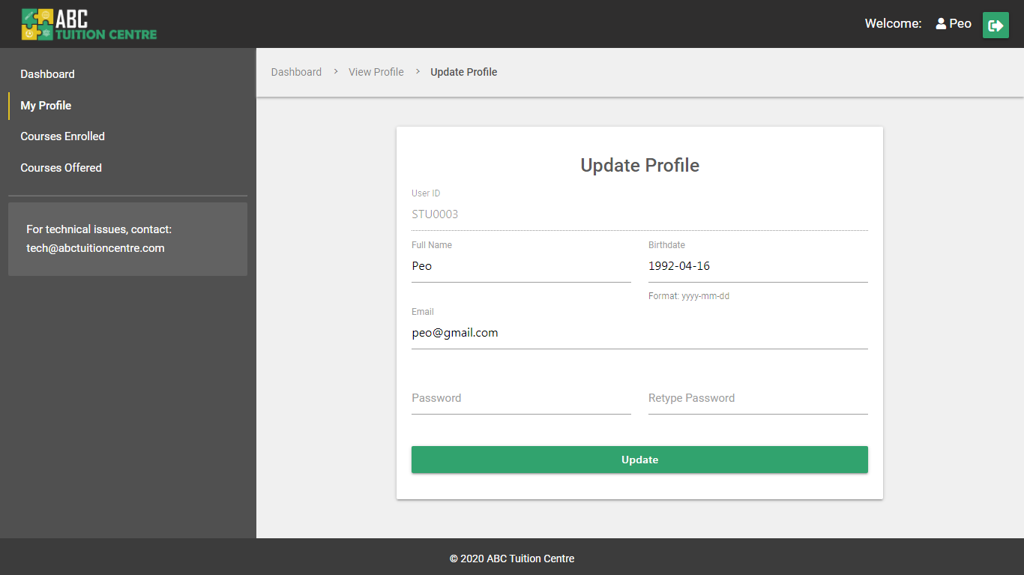

Figure 155: Student Portal - Update Profile (Pre-Populated Fields)

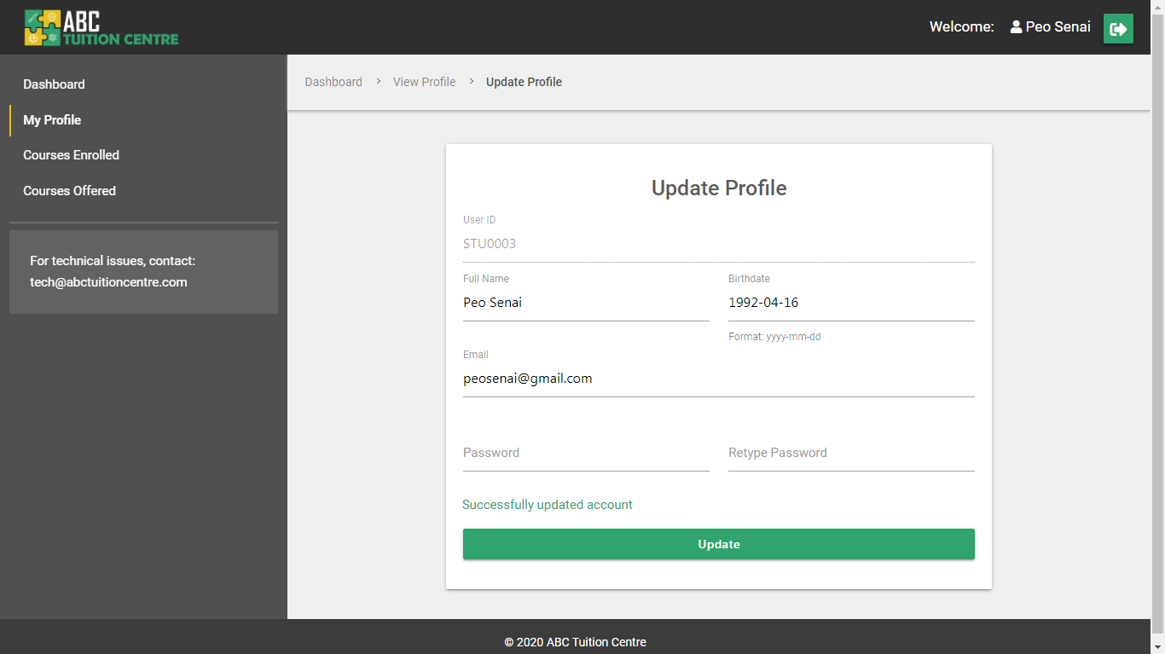

Figure 156: Student Portal - Update Profile (Successfully Updated)

Once the student makes the necessary changes and clicks on the “Update” button to update the values in the database as well, a success message is displayed and the updated values are populated in the input fields.

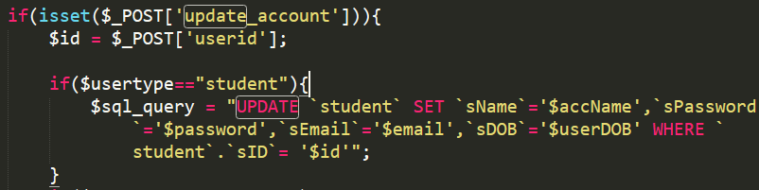

Figure 157 Student Update Query

Please Note: The Welcome text in the header displays the user’s name that is stored in a $_SESSION variable during the time of log in. If the student updates their name, the value stored in the $_SESSION[‘accName’] variable is updated as well to show the latest changes made by the student.



Figure 158: Updated Student Name in Header

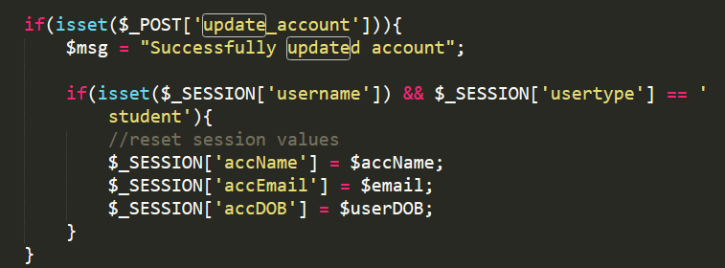

Figure 159: Updated $_SESSION variables

### 4.6.5 Courses Enrolled

Courses enrolled by students will be listed in the “Courses Enrolled” page. If the student has not yet enrolled in any courses, the system will display a call-to-action button redirecting them to the “course offered” page to allow them to enrol in courses. The system initially detects that the student has not enrolled in any course through the course-enrolled table. All courses retrieved from the course-enrolled table under the student’s account will be populated on the coursesenrolled.php page. To review the complete source code of this page, please refer to **Appendix J Section 5**.

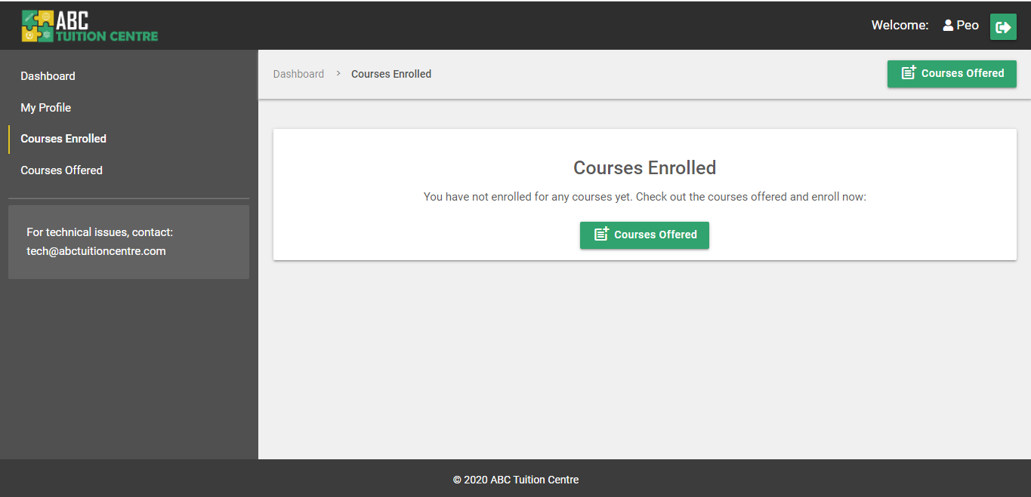

Figure 160: Courses Enrolled - no courses

If the student has enrolled in courses, the layout of the course cards change slightly. The button says “view progress” instead of enrol to allow the student to view their progress in the course and there is no learn more button since the “View Progress” button redirects the student to the Course Detail page.

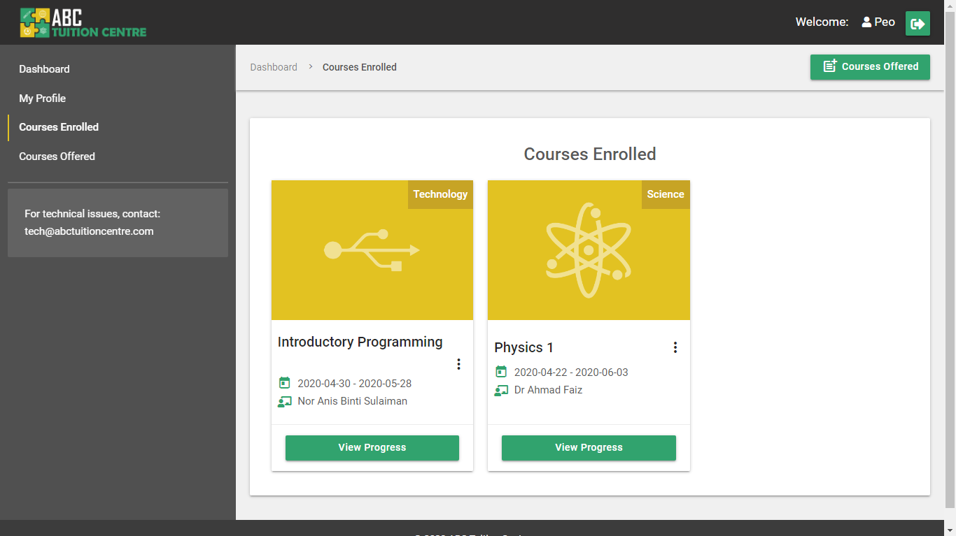

Figure 161: Courses Enrolled - Courses populated

### 4.6.6 Courses Offered

The courses offered page lists down all courses that are offered by ABC Tuition Centre. The courses are listed by including the **course.php** file in the **coursesoffered.php** file. The students are able to enroll for the courses by clicking on the “Enroll” button or by clicking on “learn more” and enrolling through the “View Course Detail” page. For the source code of the **coursesoffered.php** page, please review **Appendix J Section 4.**

If the user clicks on the “Enroll” button, a confirmation dialog box appears asking the user if they want to enroll for the selected course. If the user clicks on the “ok” button, the system will enroll them into the course and the course is listed on the “Course Enroll” page.



Figure 162: Enroll Course Confirmation Prompt

Please Note: The Courses Offered page lists down all courses offered by ABC Tuition Centre, including those that are already enrolled by the student. The courses that are already enrolled by the student will not have an “Enroll” button. Instead, the button will change to a grey disabled button with the text “Enrolled” to indicate that the student has already enrolled in the course. For the source code of this functionality, please refer to **Appendix F Section 1f courses.php**

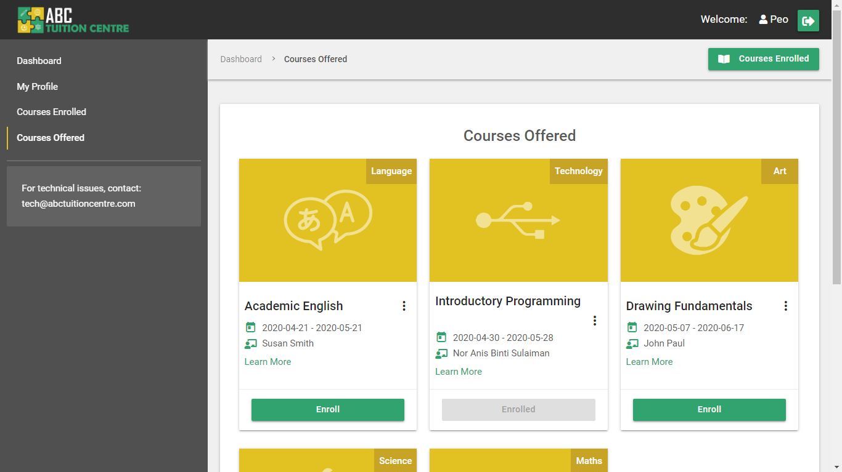

Figure 163: Courses Offered UI

## 4.7 404 Error Page

If user tries to access a page that is not authorized to them or without logging in, they will be redirected to a 404 error page. This is accomplished by the following piece of code added at the top of pages that require only authorized users to access them:

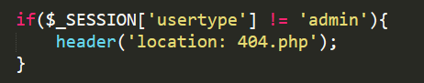

Figure 164: Authorization Check – Admin

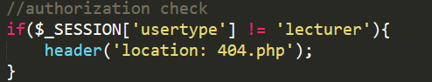

Figure 165: Authorization Check – Lecturer

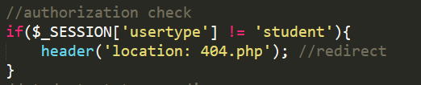

Figure 166: Authorization Check - Student

To review the source code of the 404.php page, please refer to **Appendix F Section 2c**

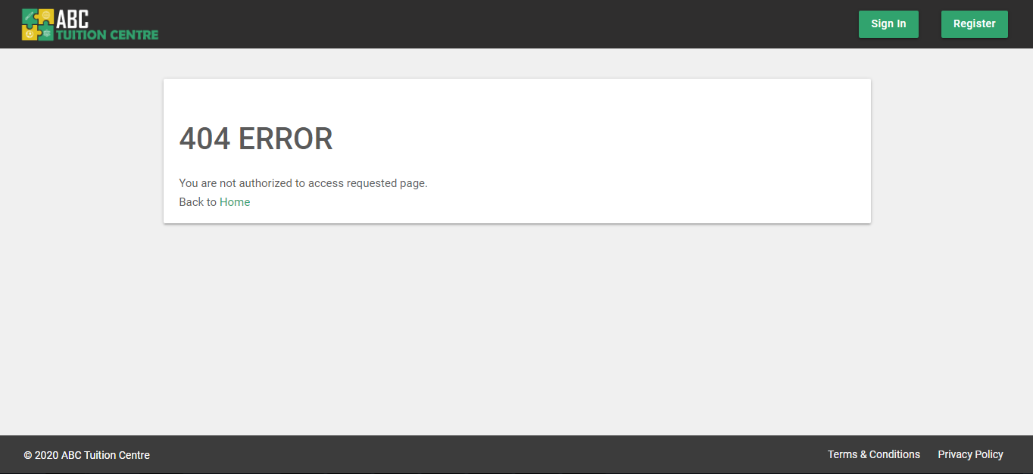

Figure 167: 404 Error Page

# CHAPTER 5 DATABASE

Database Configuration:

* + - * 1. Open your phpMyAdmin
        2. Click on "New" to create a new database
        3. In the "Database Name" input box type : abctuition
        4. Make sure the collation selected is : latin1_swidish_ci
        5. Click "Create" button
        6. The database will be created

Import Tables:

* + - * 1. Click on the database name to open it
        2. Select the "Import" tab
        3. Click on "choose file" button
        4. select "abctuition.sql" from the "database" folder
        5. Click on the open button
        6. Click on the "go" button
        7. The tables of the database will be successfully imported

## 5.1 Admin Table

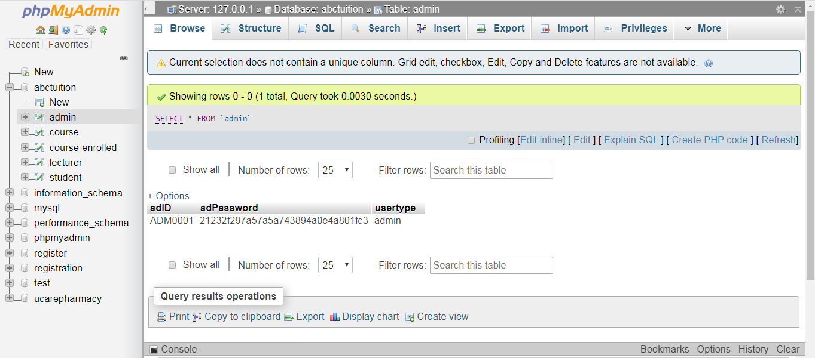

Figure 168: Admin Table

## 5.2 Course Table

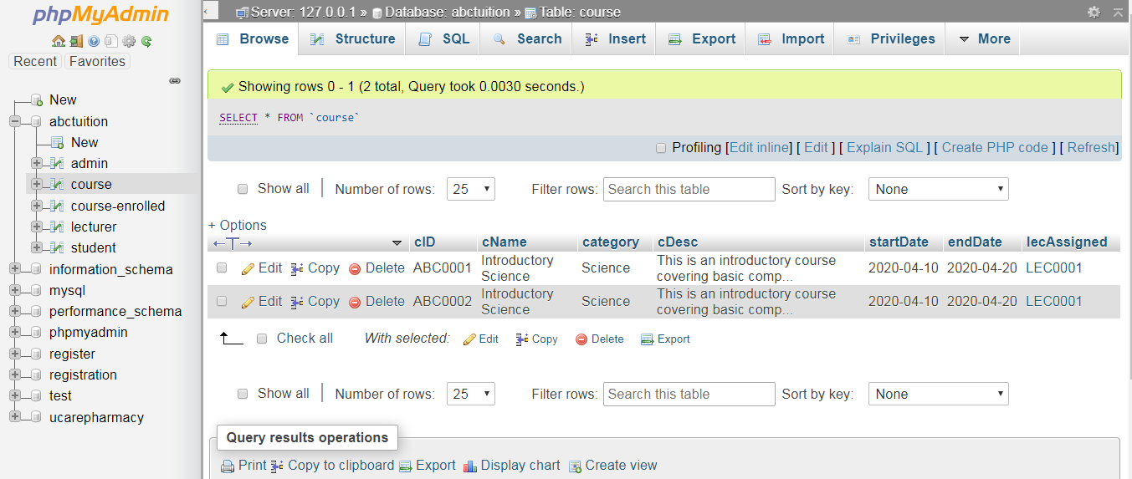

Figure 169: Course Table

## 5.3 Lecturer Table

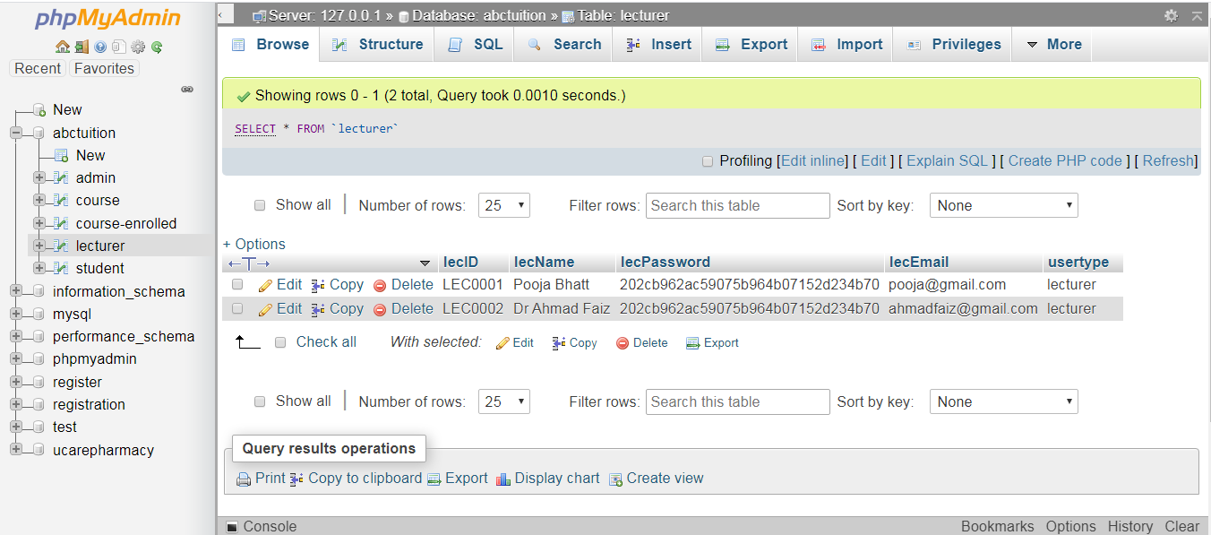

Figure 170: Lecturer Table

## 5.4 Student Table

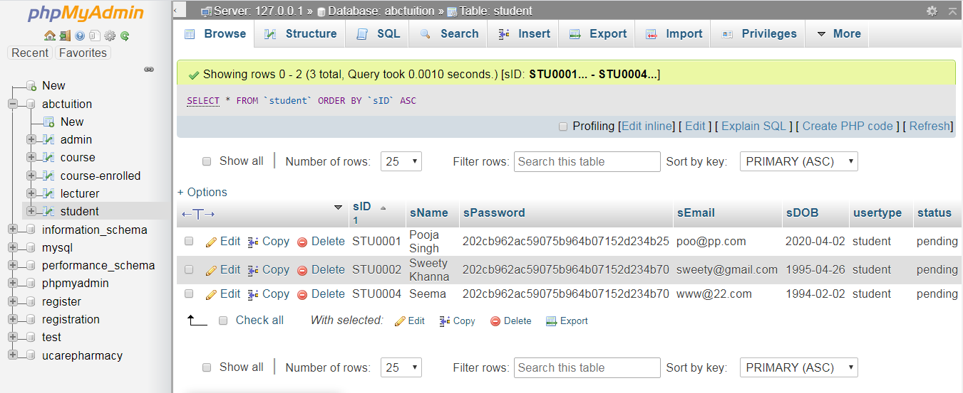

Figure 171: Student Table

## 5.5. Course-Enrolled Table

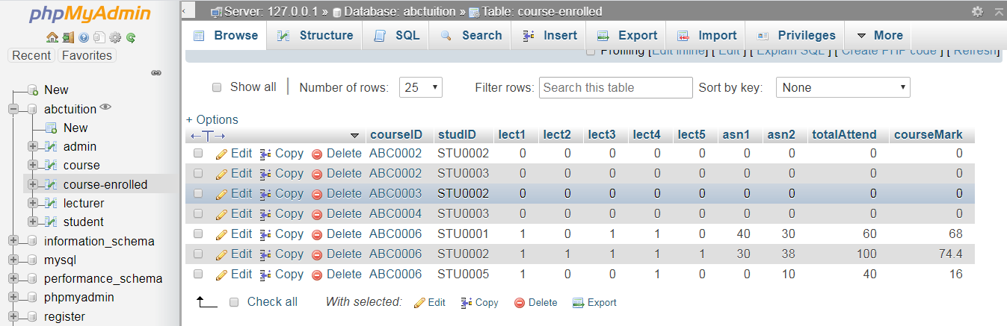

Figure 172: course-enrolled table

# Appendix A

**Online Survey**

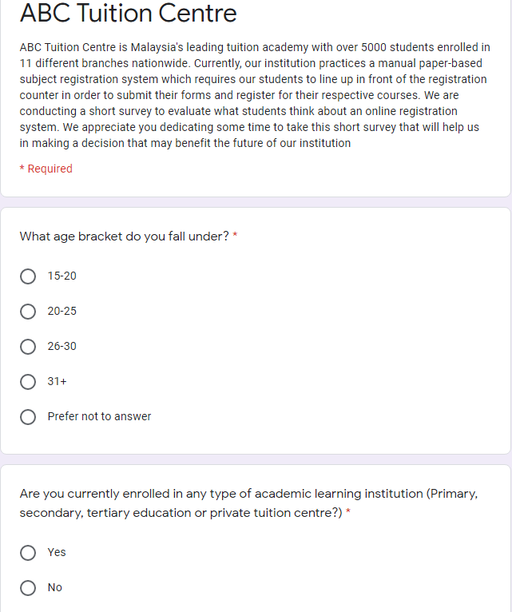

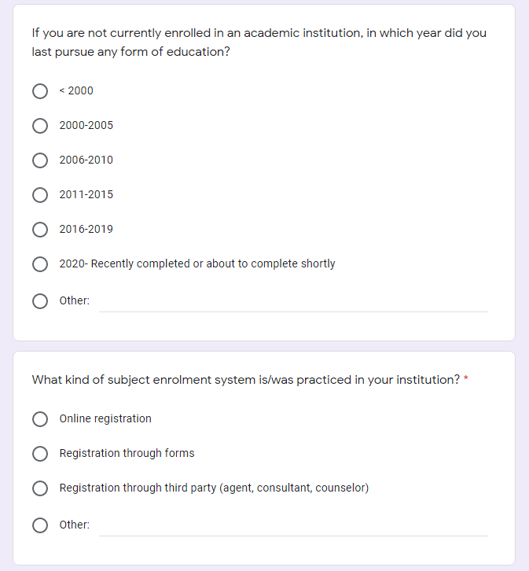

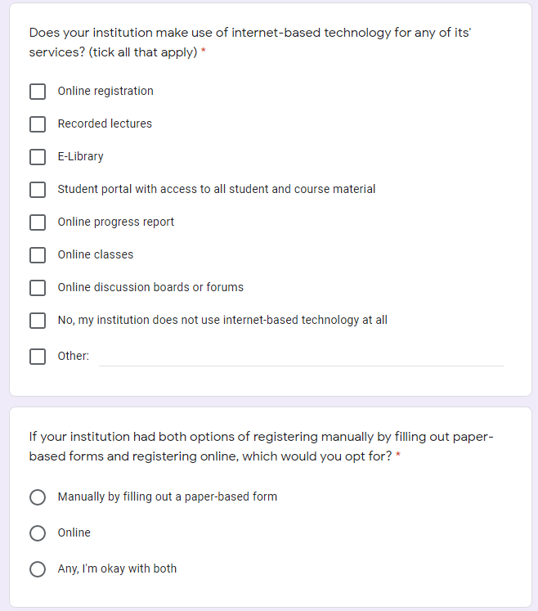

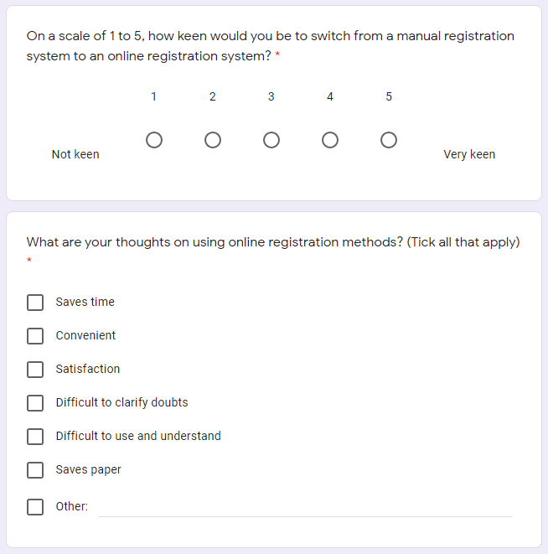

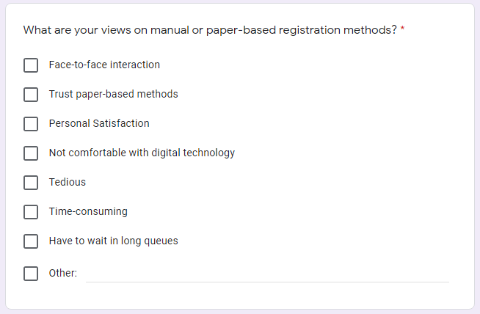

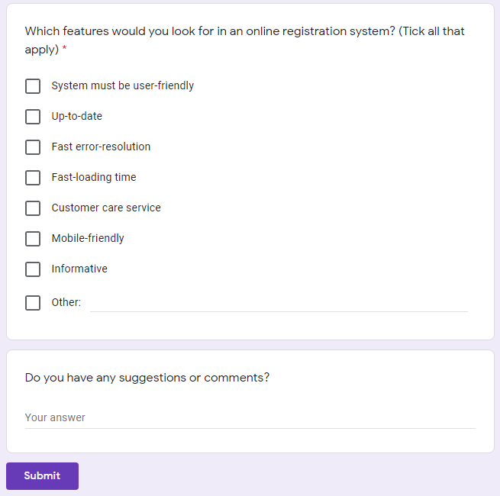

# Appendix B

**Survey Results**

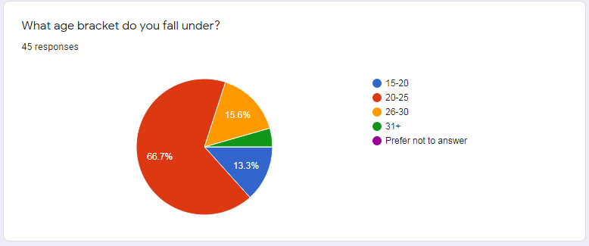

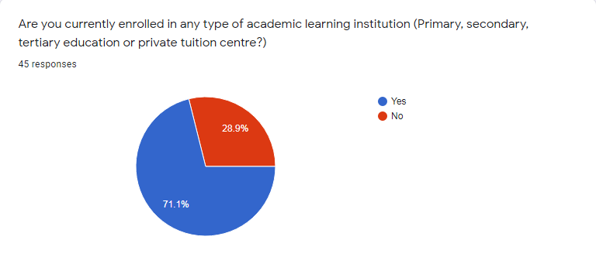

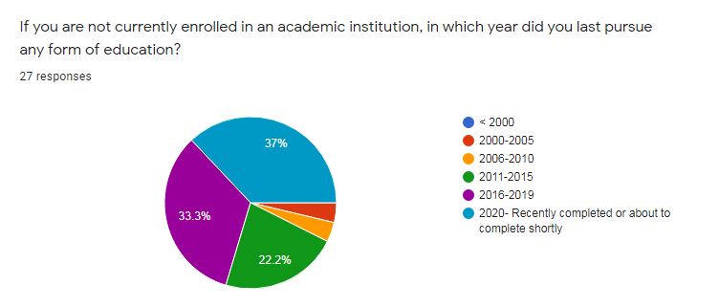

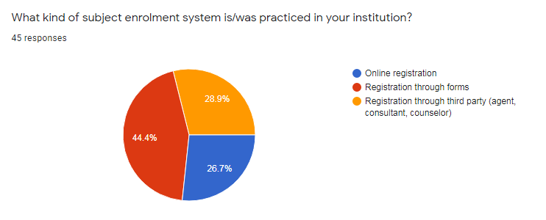

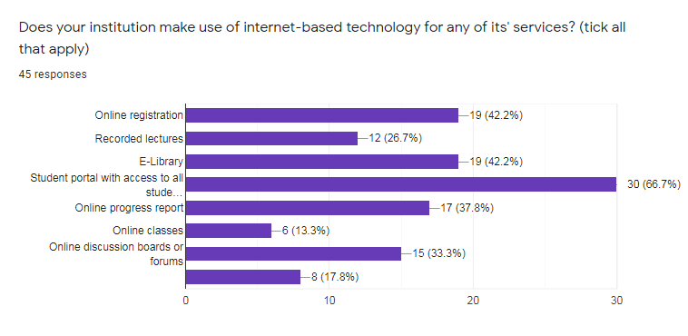

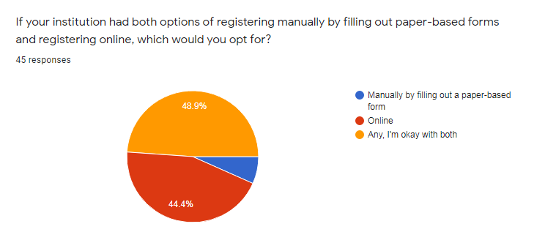

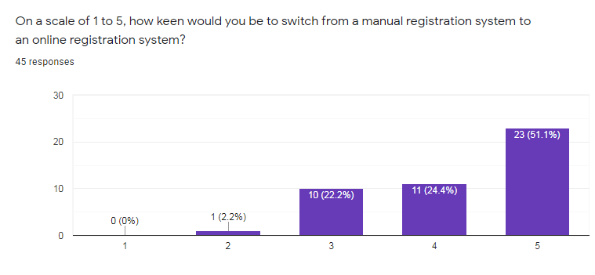

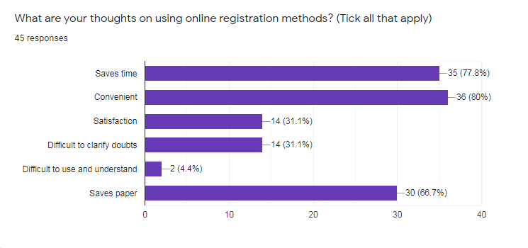

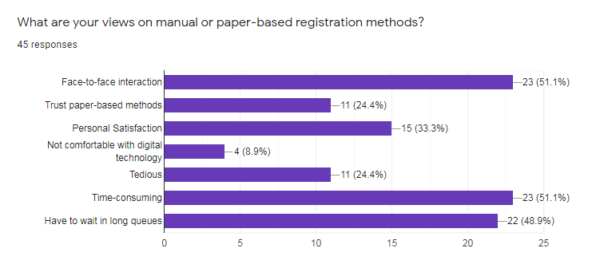

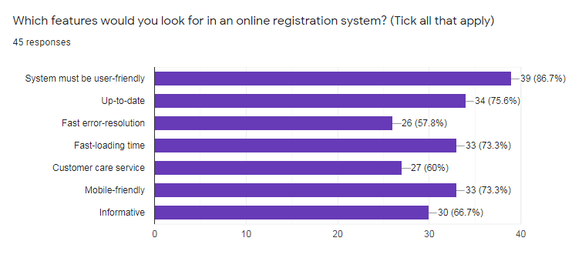

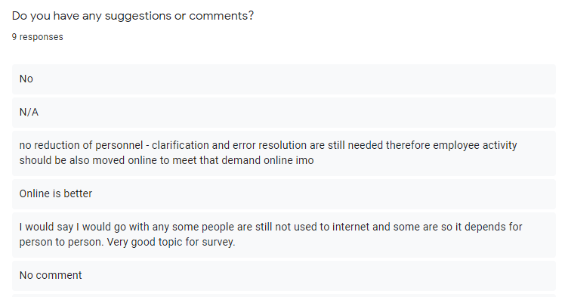

# Appendix C

**Gantt Chart**

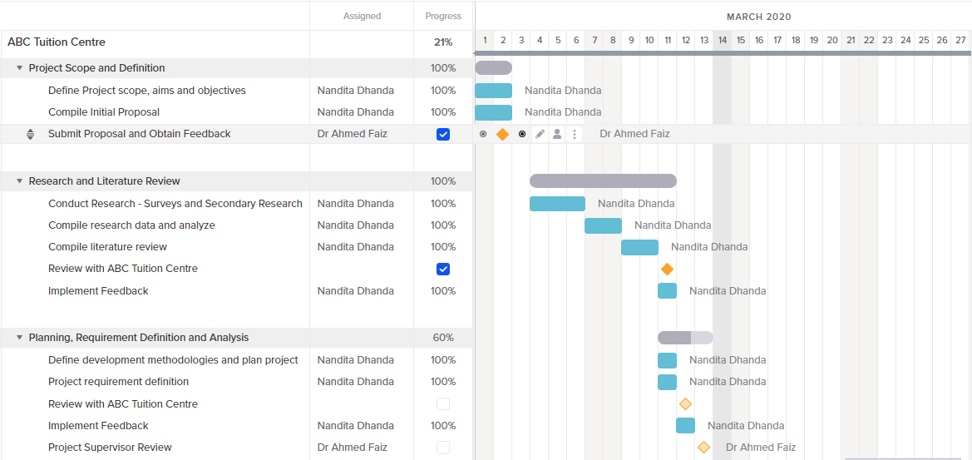

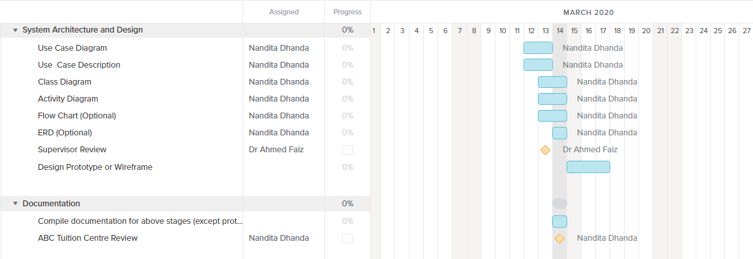

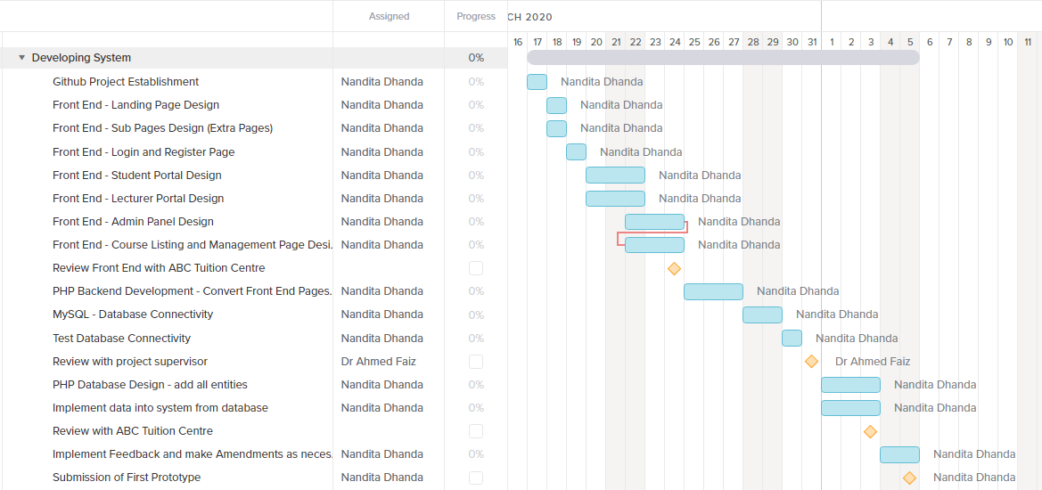

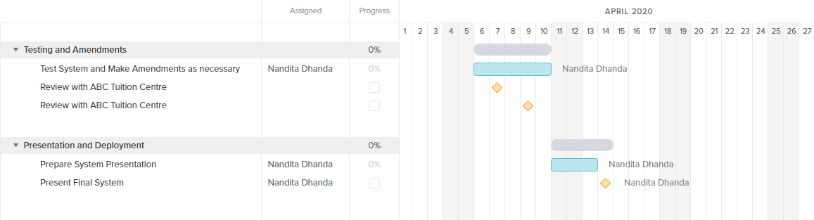

# Appendix D

**File Structure:**

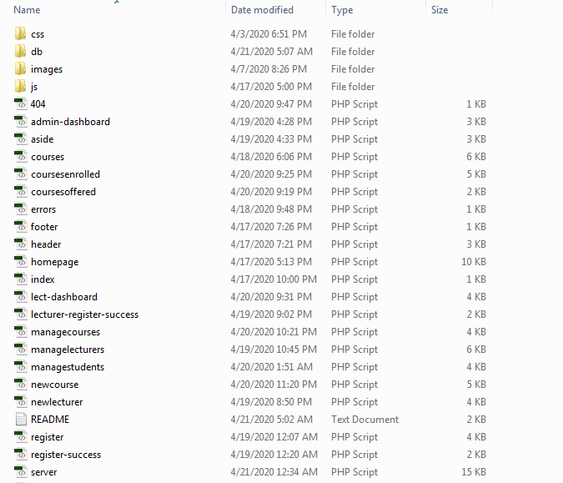

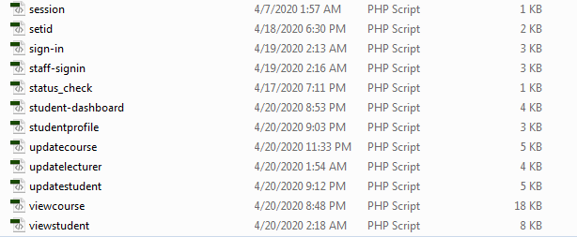

# Appendix F

**1. PHP Included or Required Files:**

**1a) header.php**

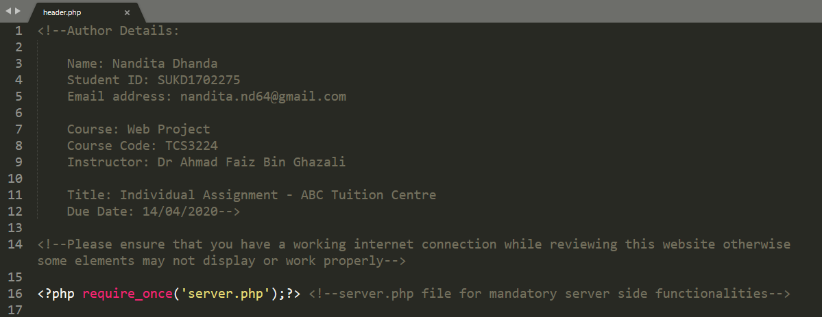

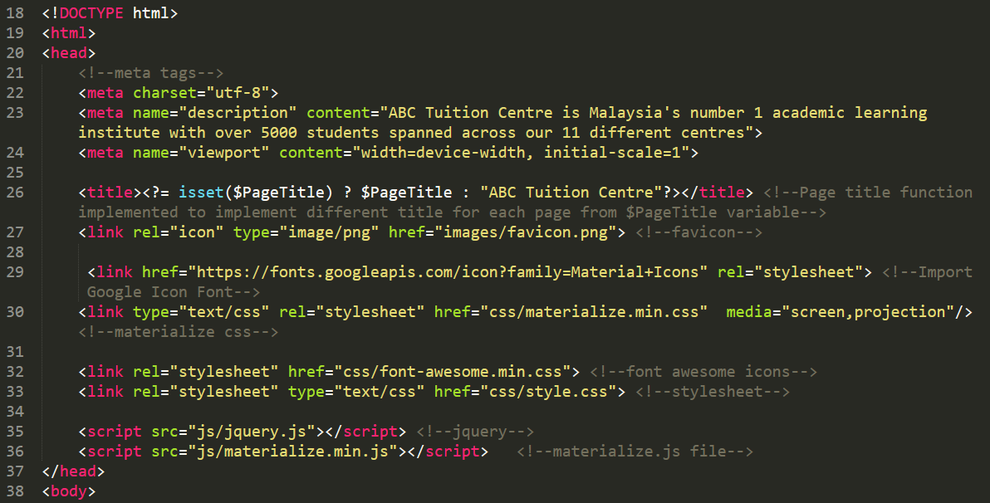

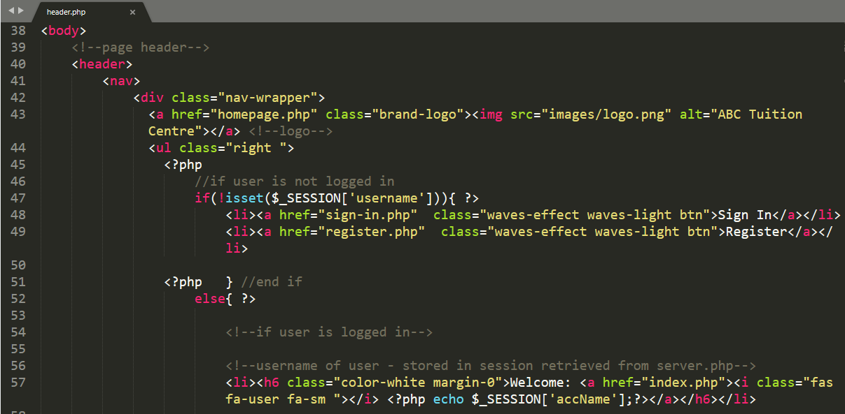

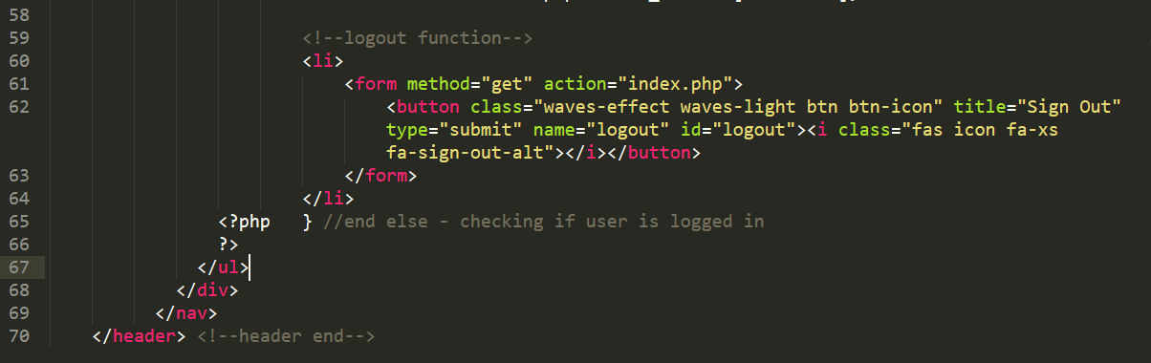

**1b) footer.php**

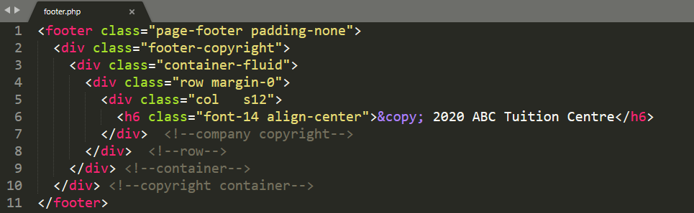

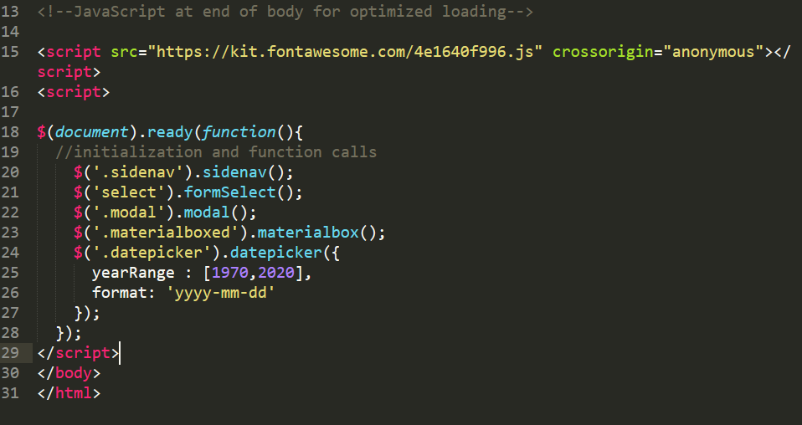

**Section 1c) server.php**

Database Connectivity and initial variable declaration

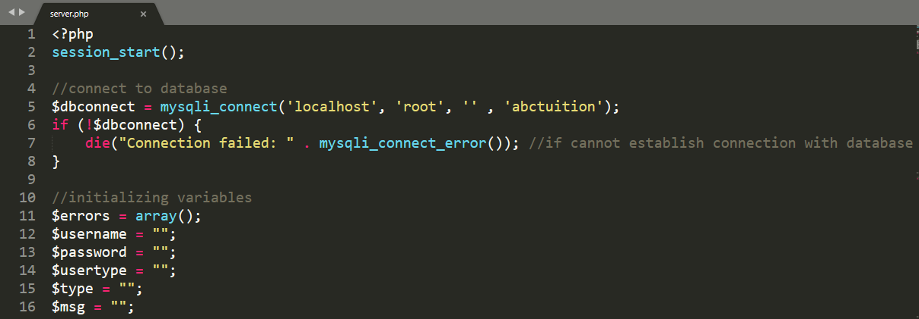

Sign In – Student, Lecturer or Admin Account

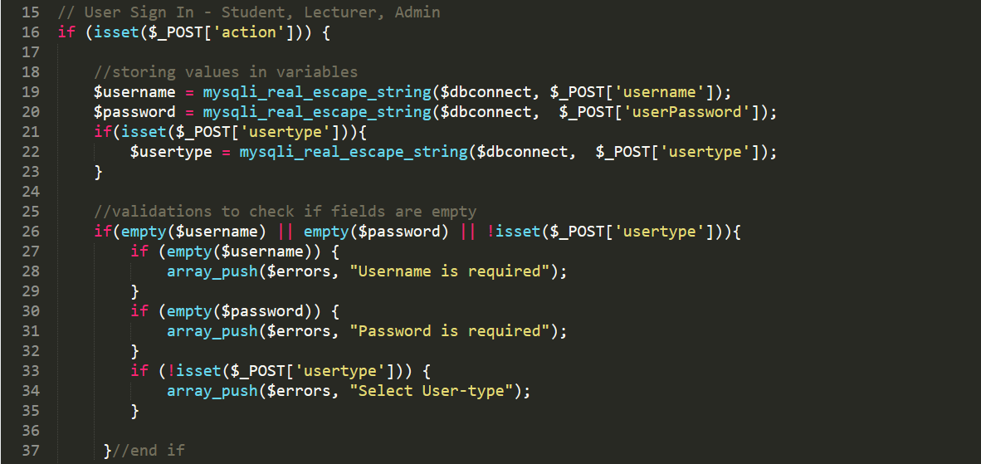

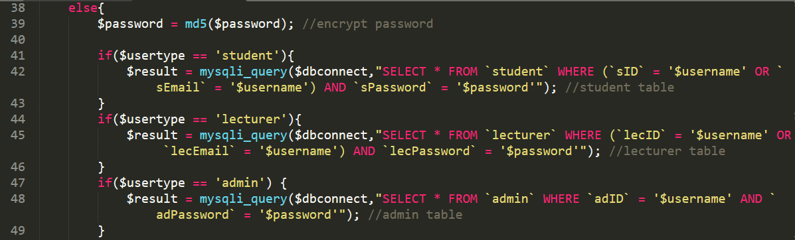

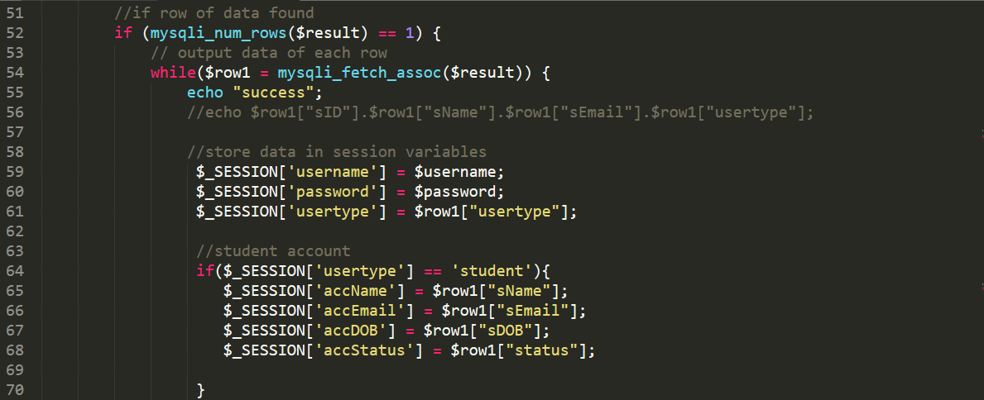

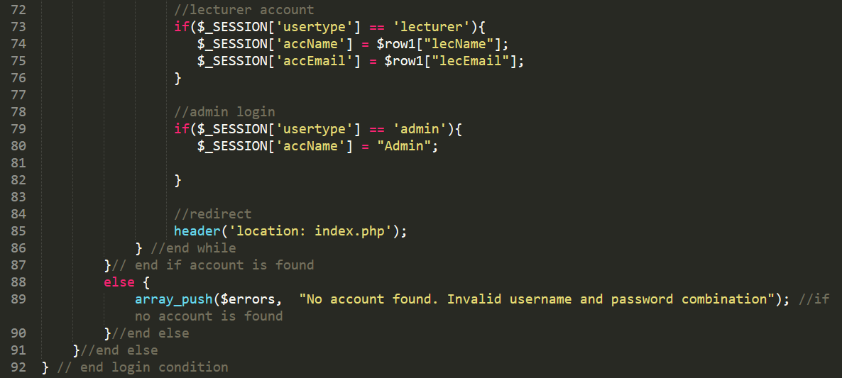

Add New Course or Update Existing Course

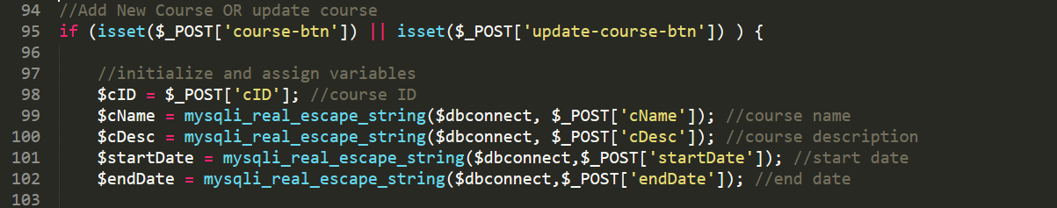

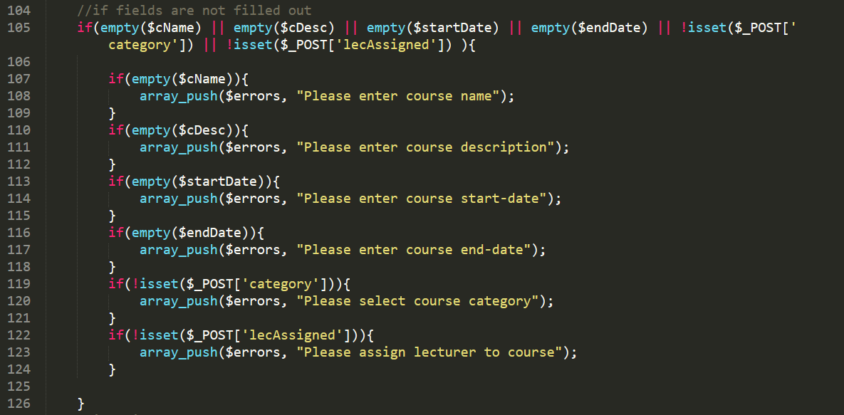

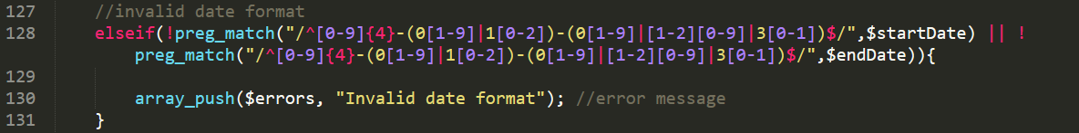

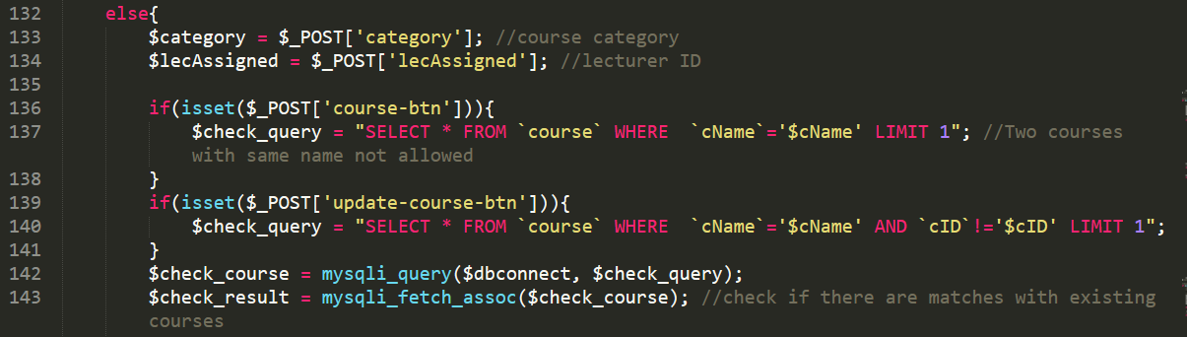

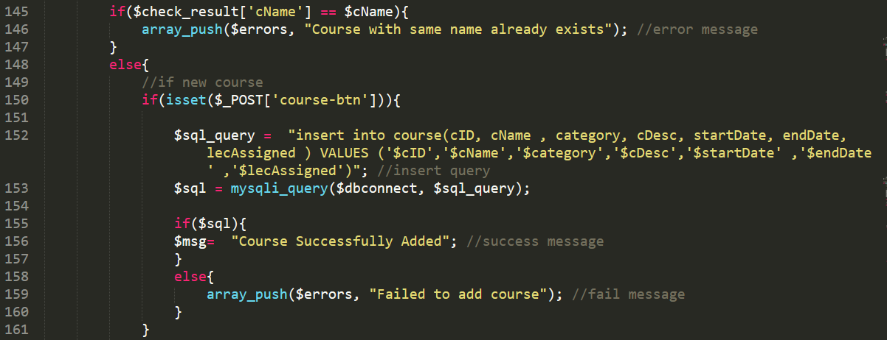

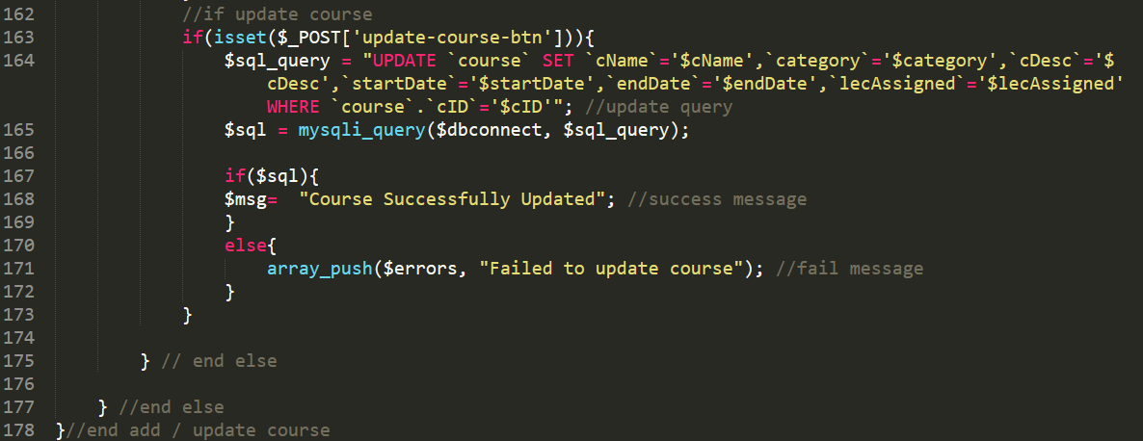

Register New or Update Student or Lecturer Account

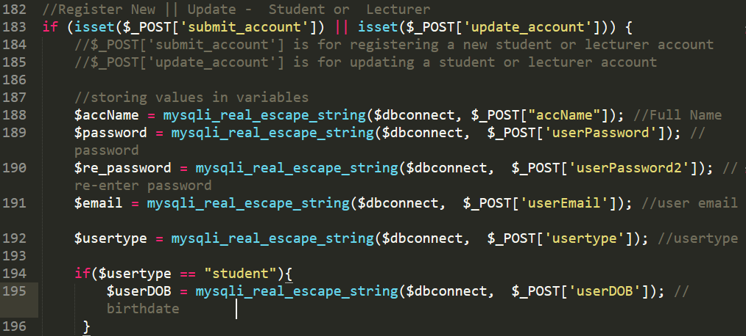

Figure 173: Register or Update (Student or Lecturer) - Variable initialization

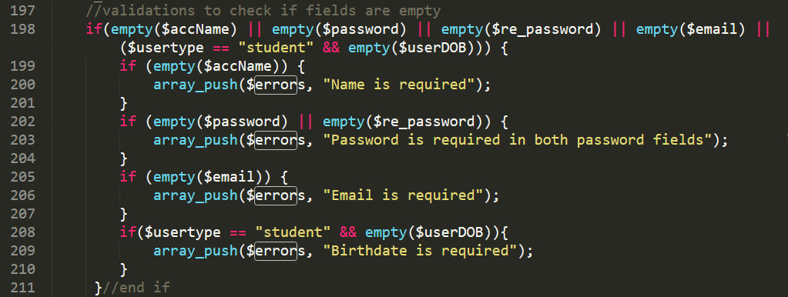

Figure 174: Validations - Check if fields are empty

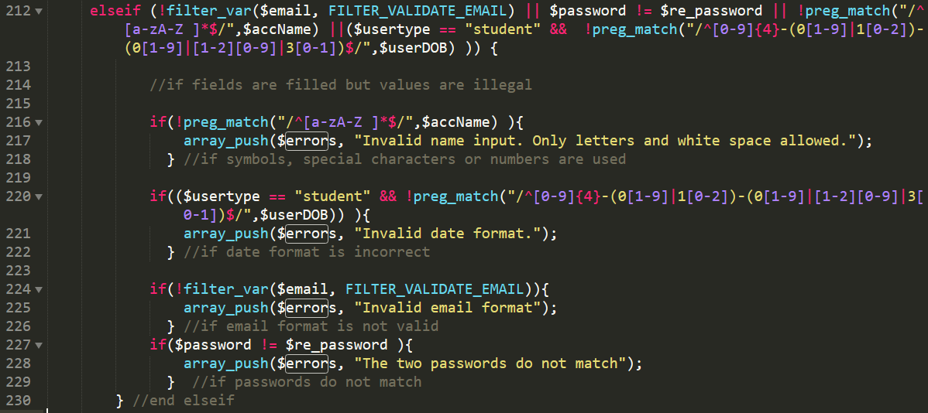

Figure 175: Validations - if values entered are not allowed

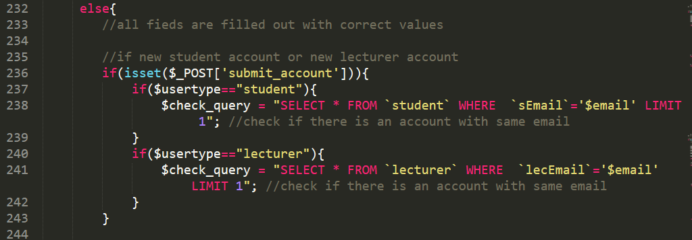

Figure 176: Validation - check if database has account with same email

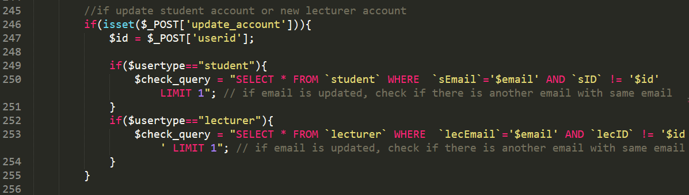

Figure 177: Validation - check if database has another account with same email during updating

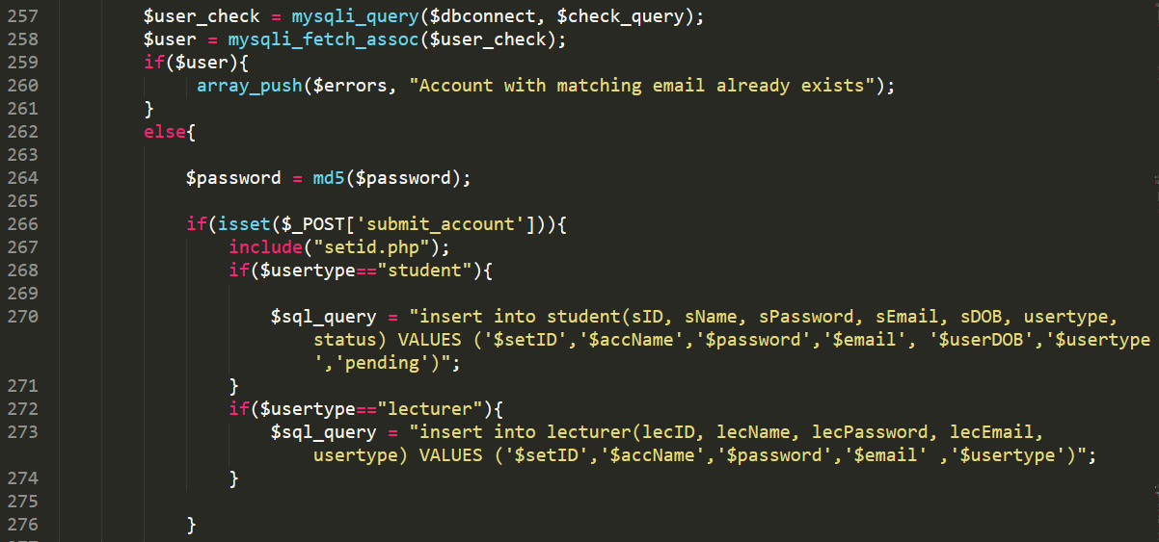

Figure 178: server.php - SQL query for new account

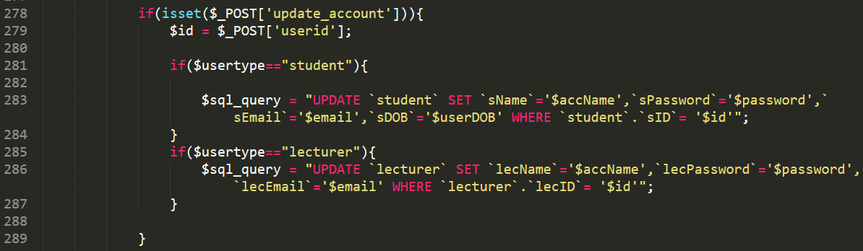

Figure 179: server.php - SQL update query

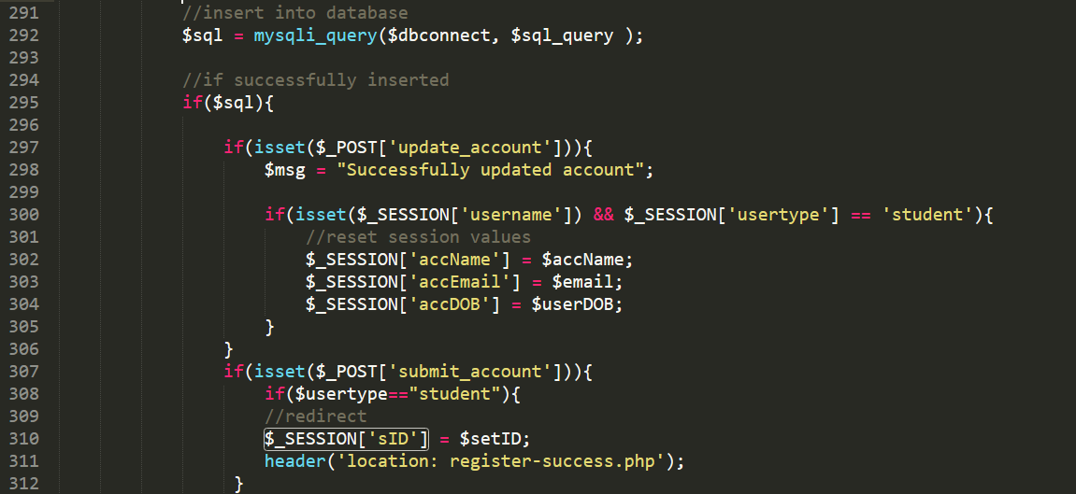

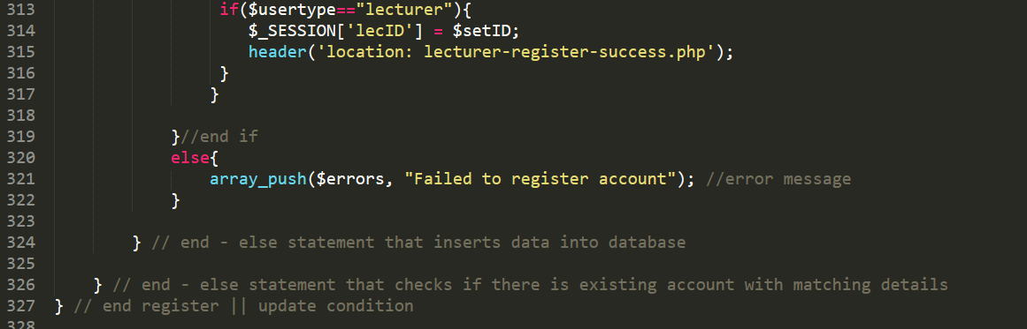

Delete Row

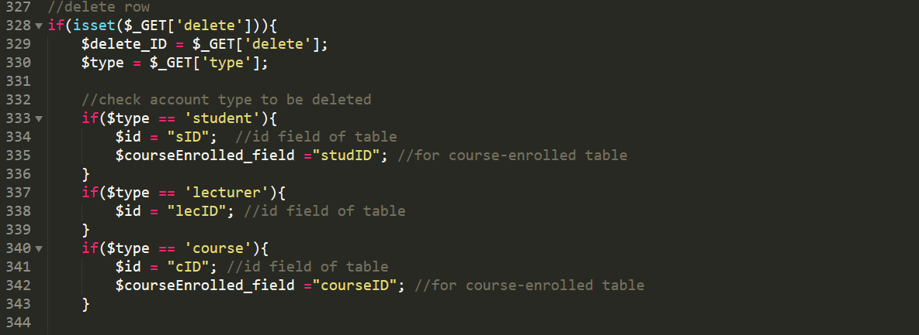

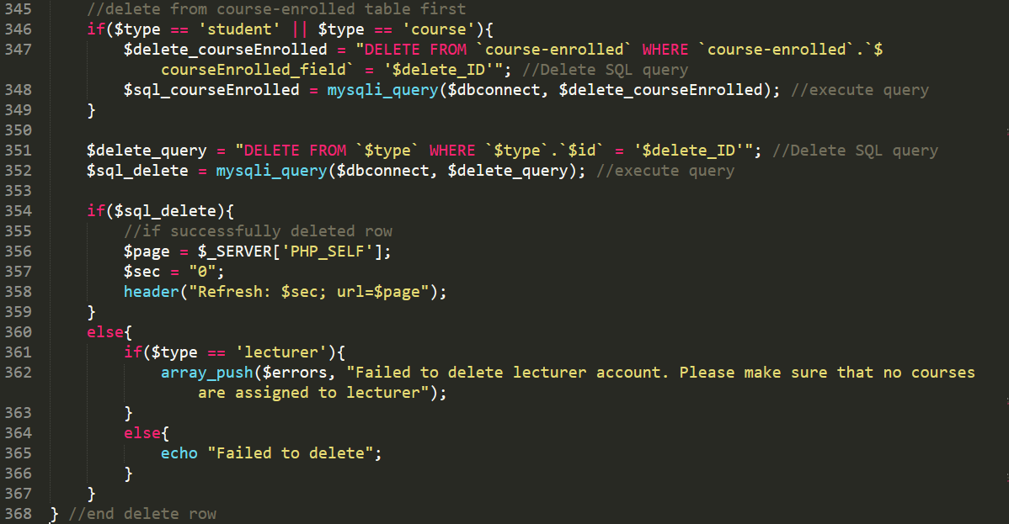

Update Student Progress:

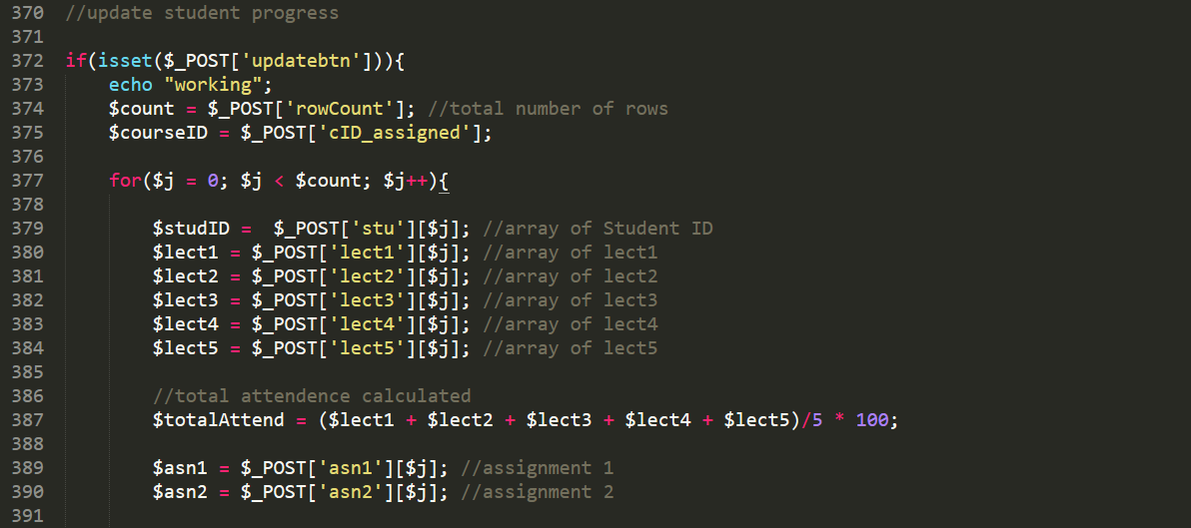



**1d) aside.php**

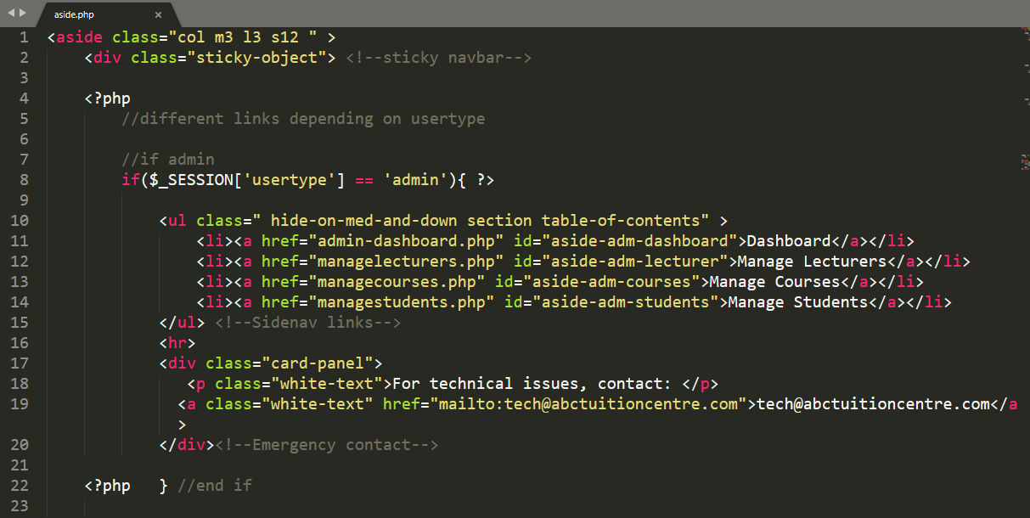

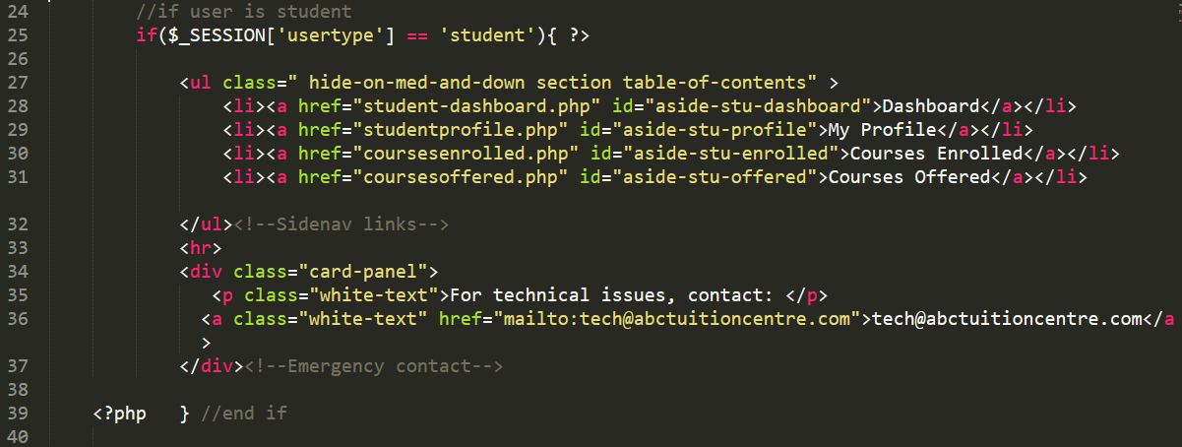

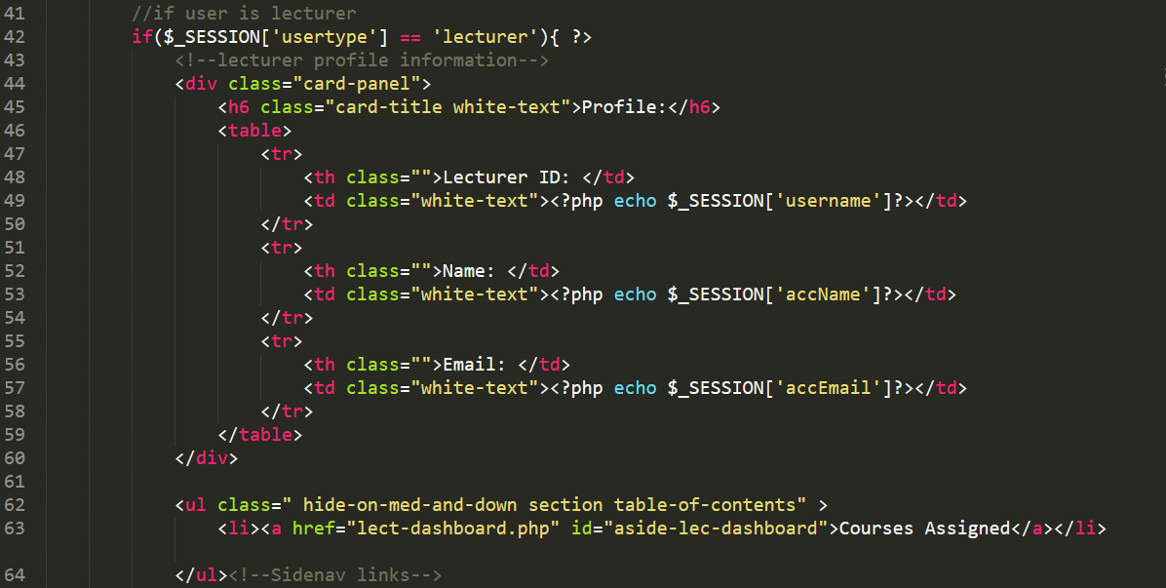

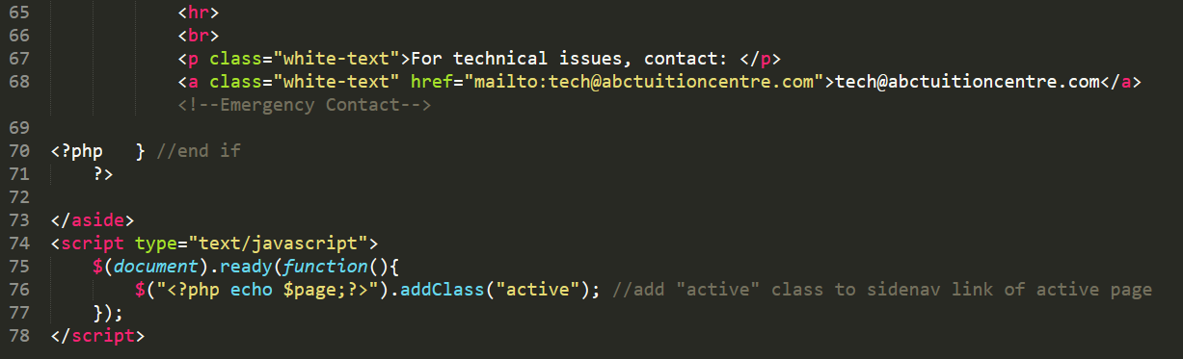

**Section 1e) viewcourse.php**

**Note: This page has multiple views, functionalities and permissions based on which user is accessing the page**

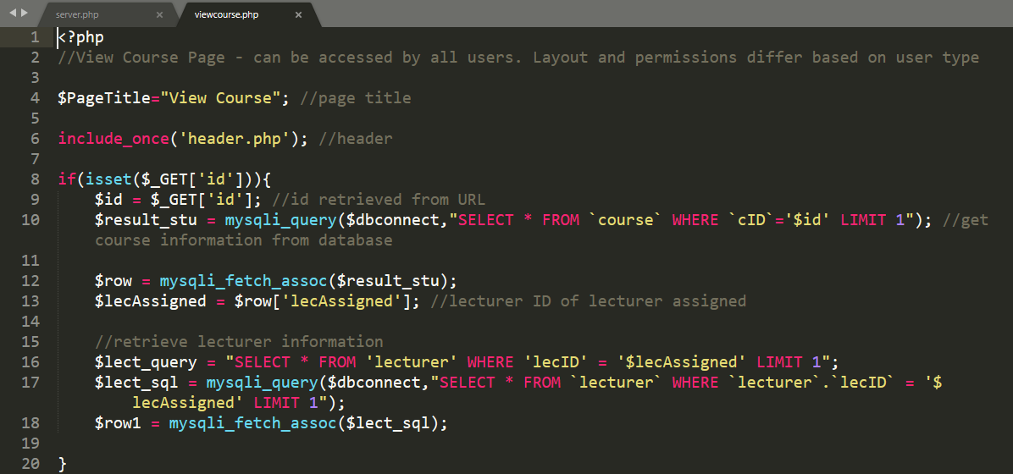

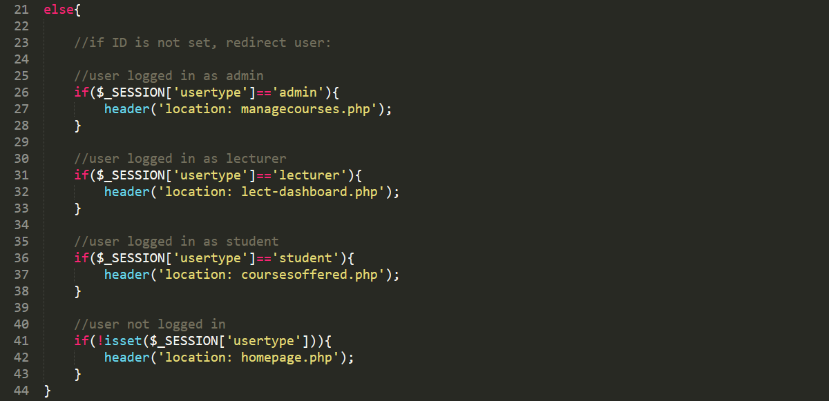

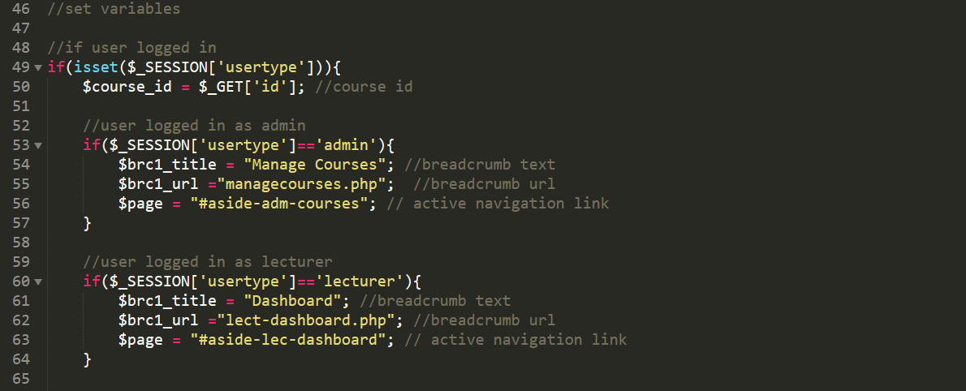

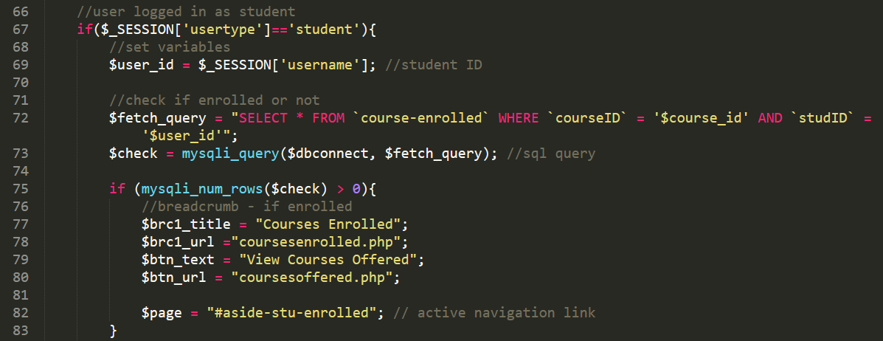

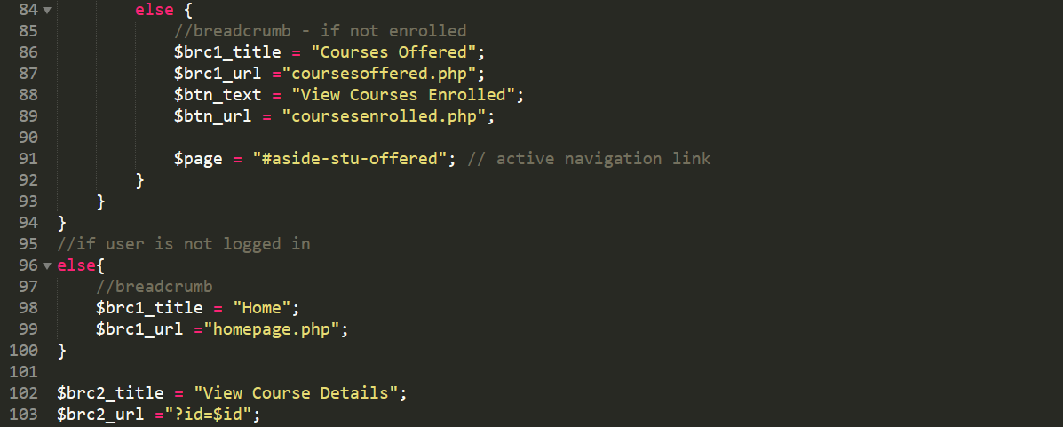

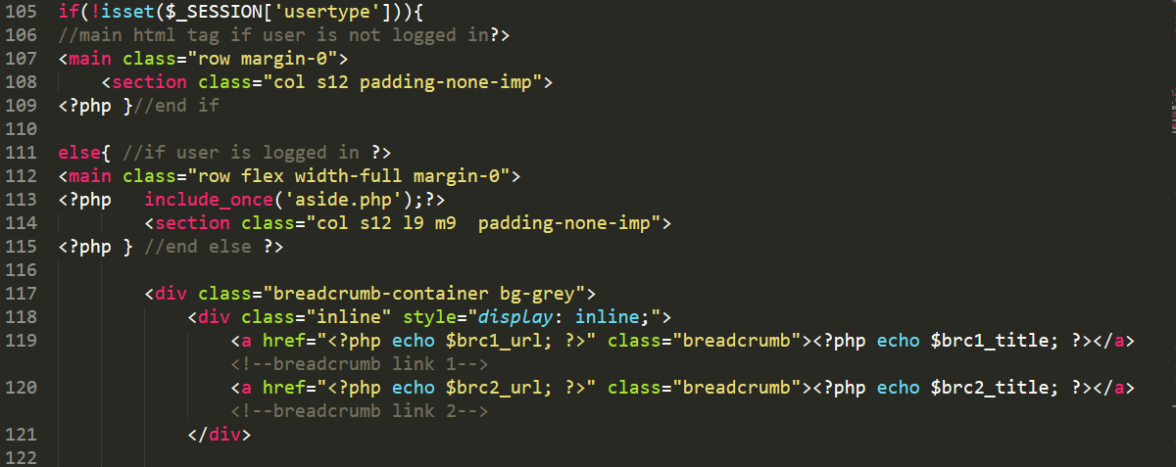

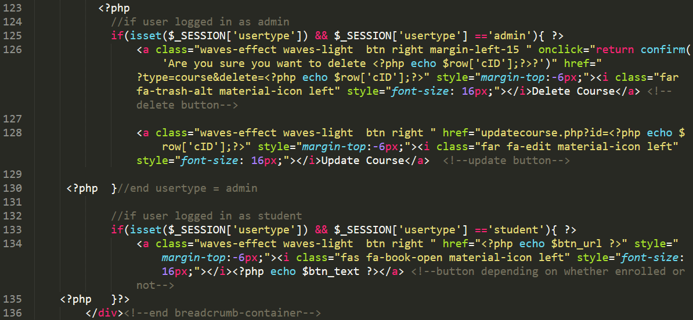

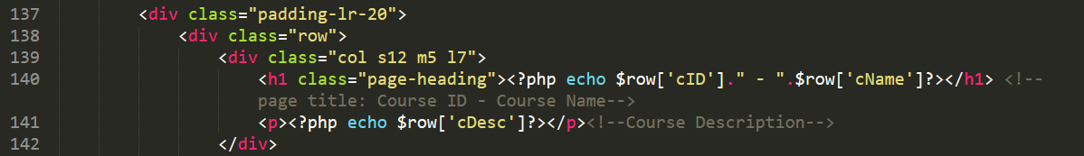

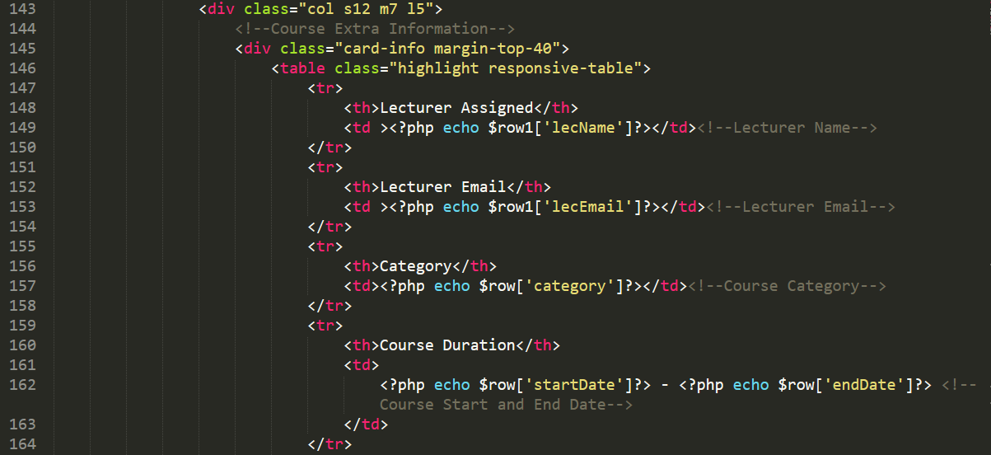

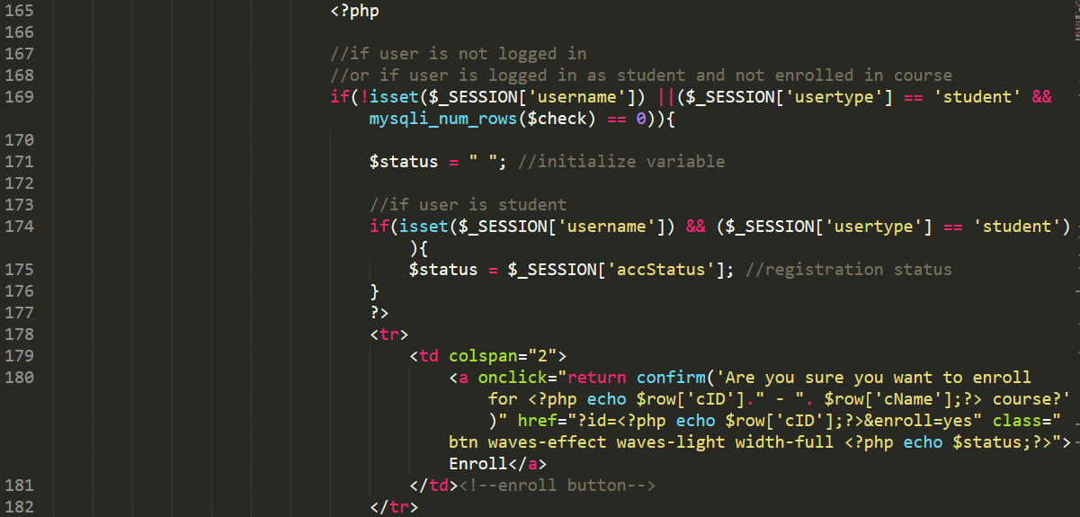

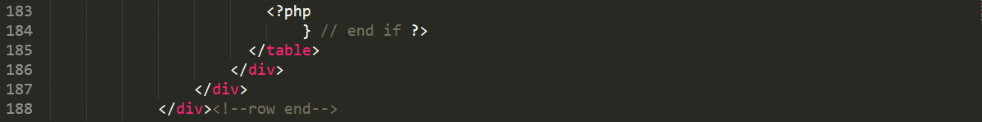

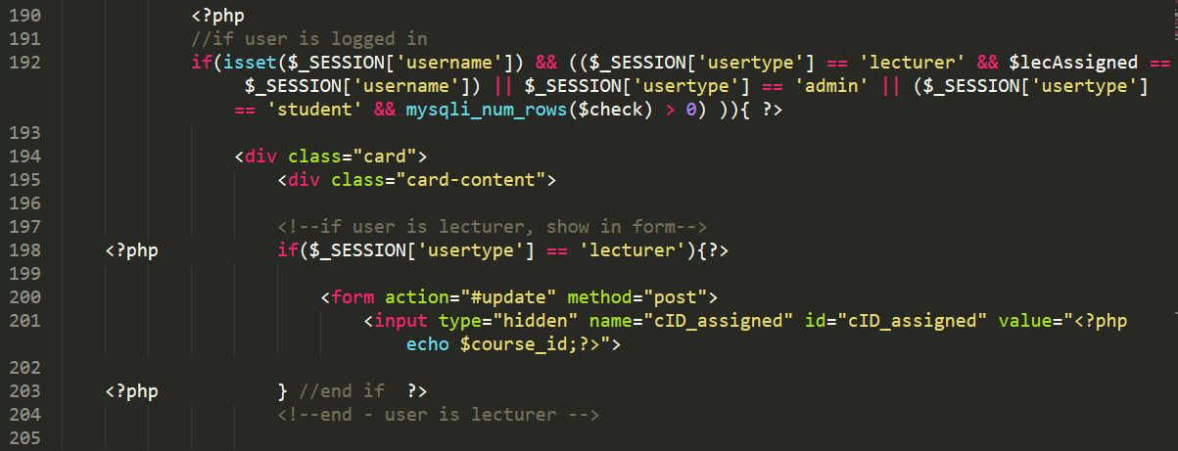

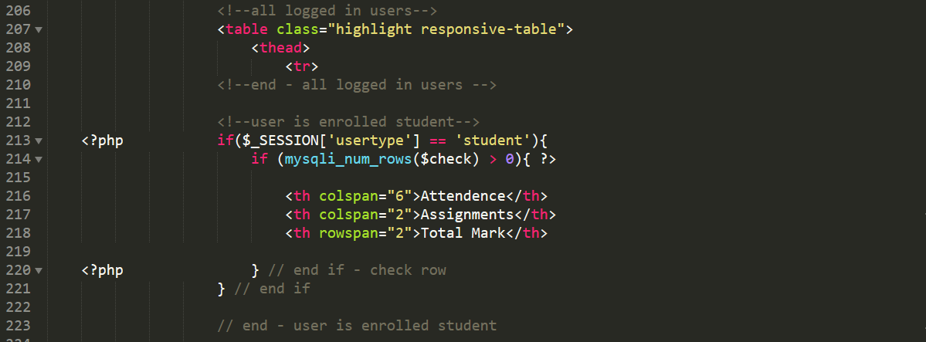

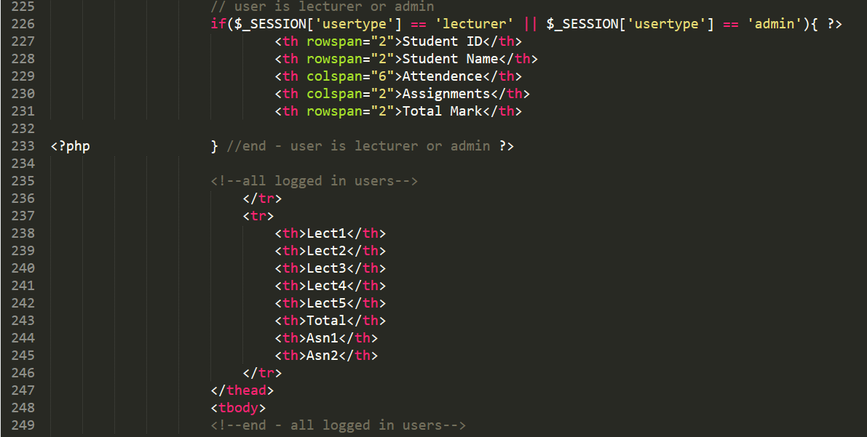

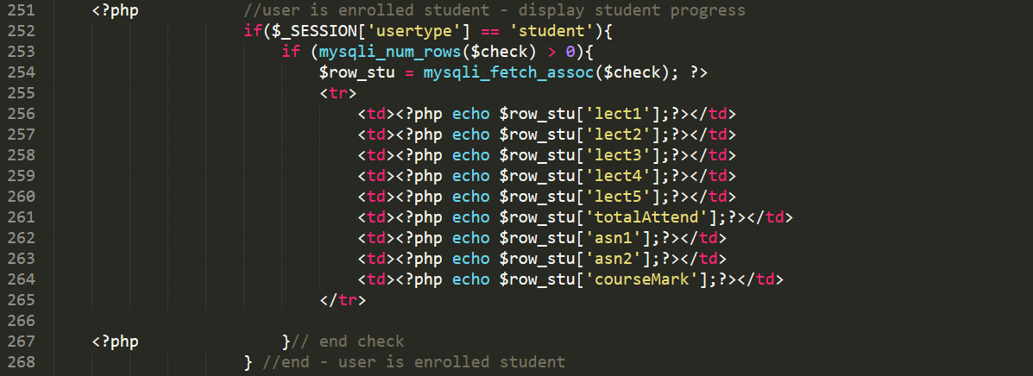

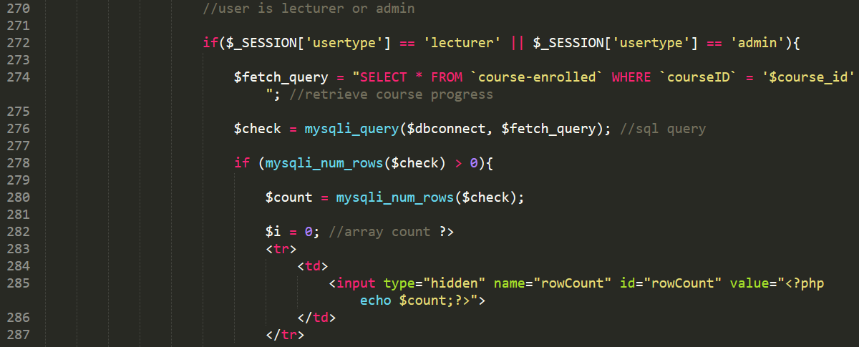

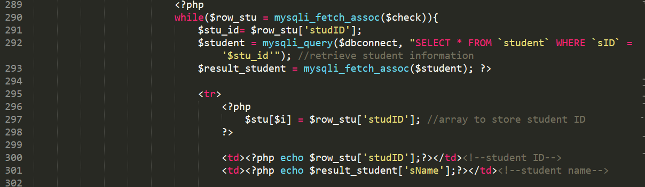

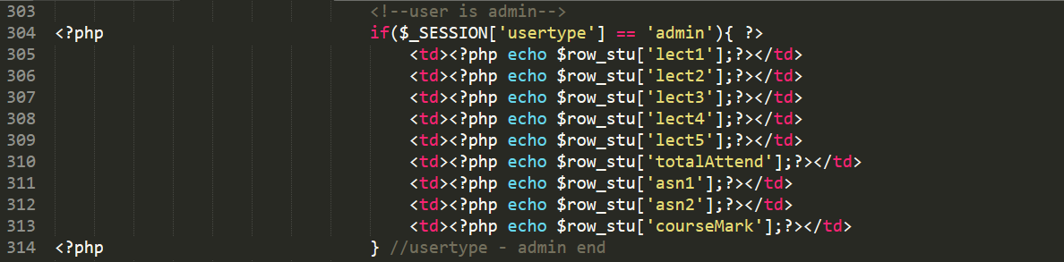

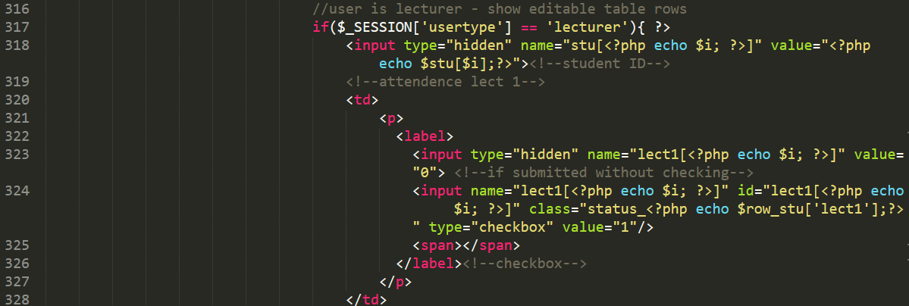

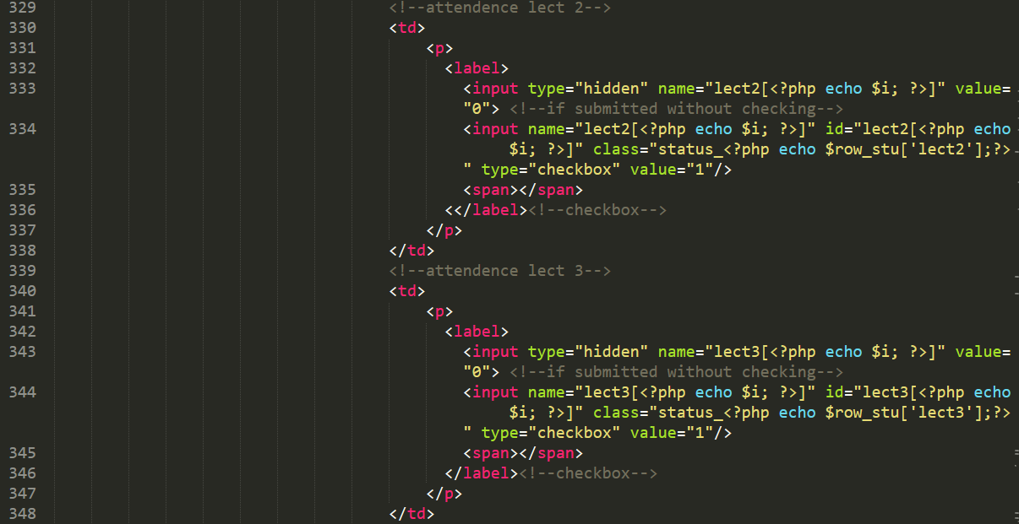

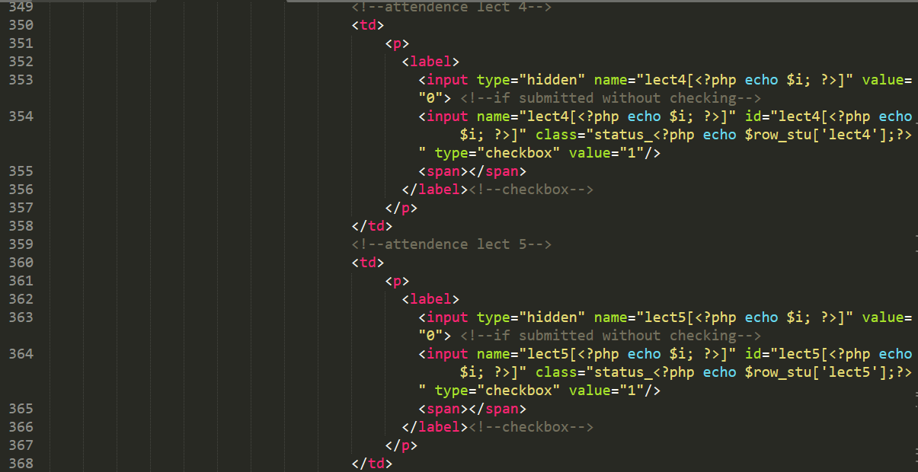

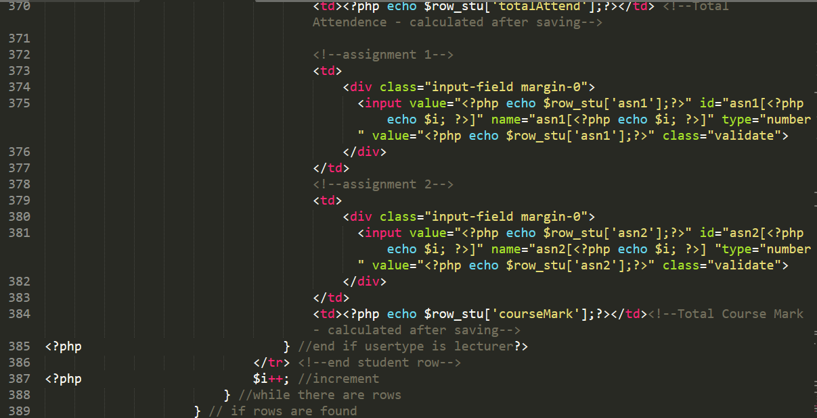

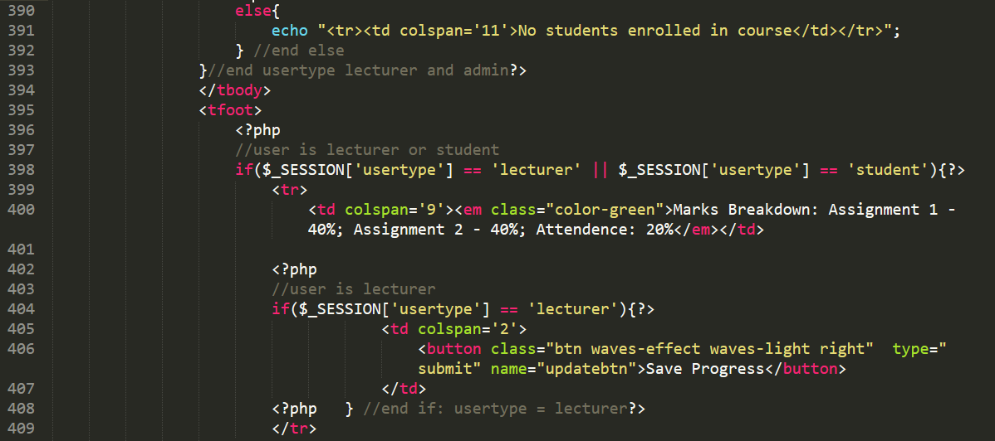

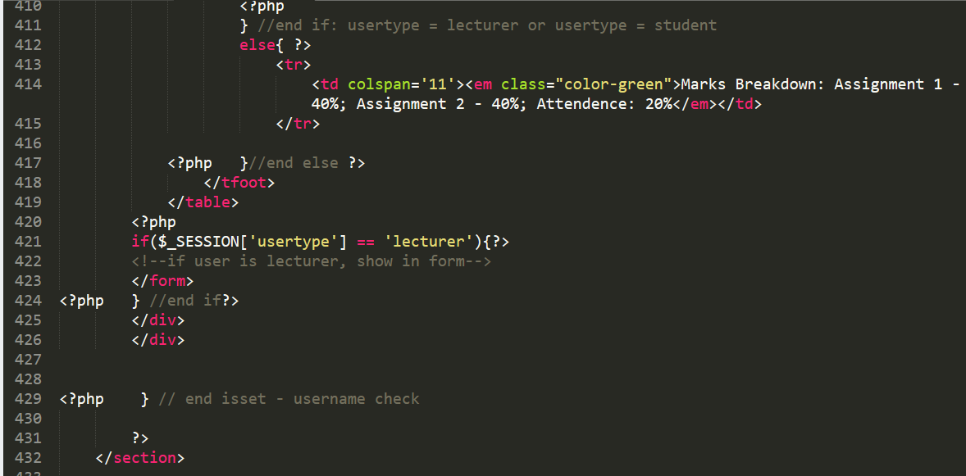

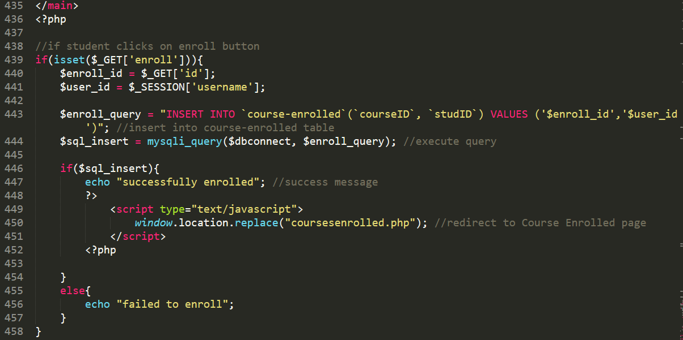

**Section 1f) courses.php**

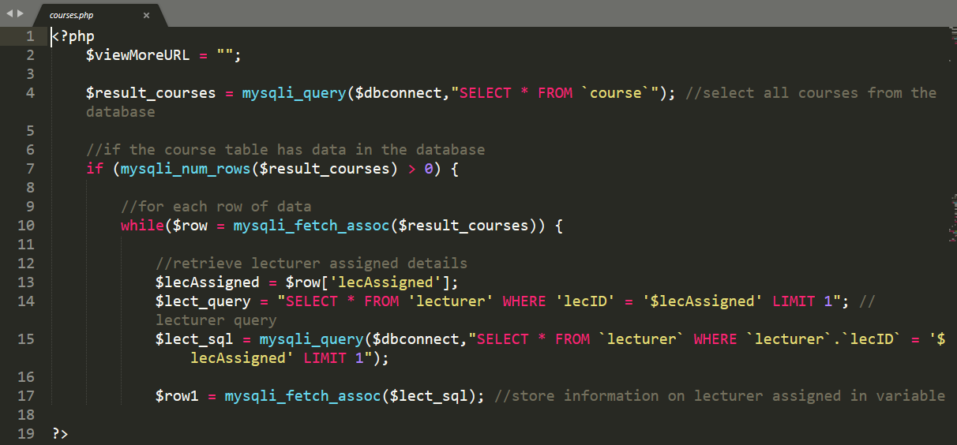

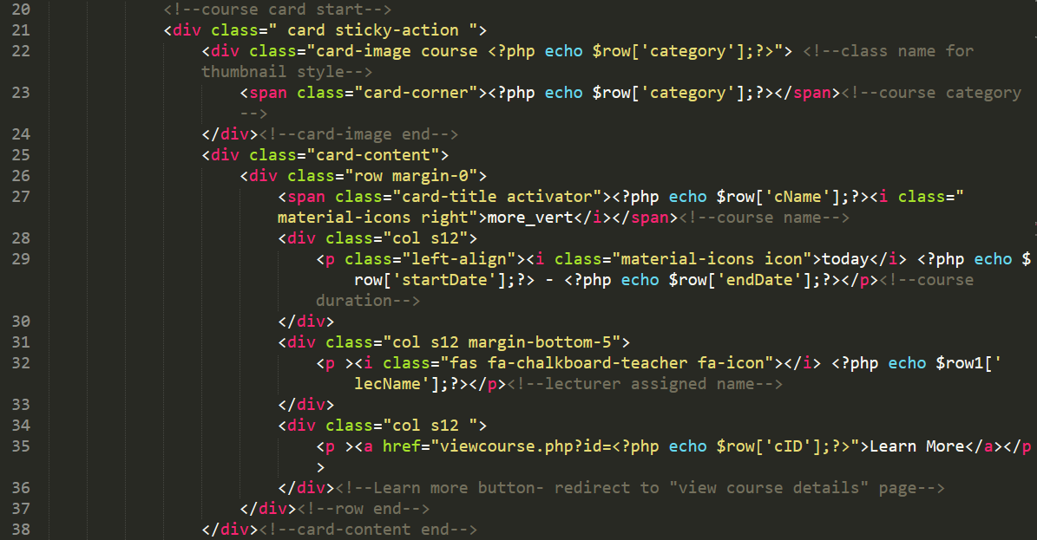

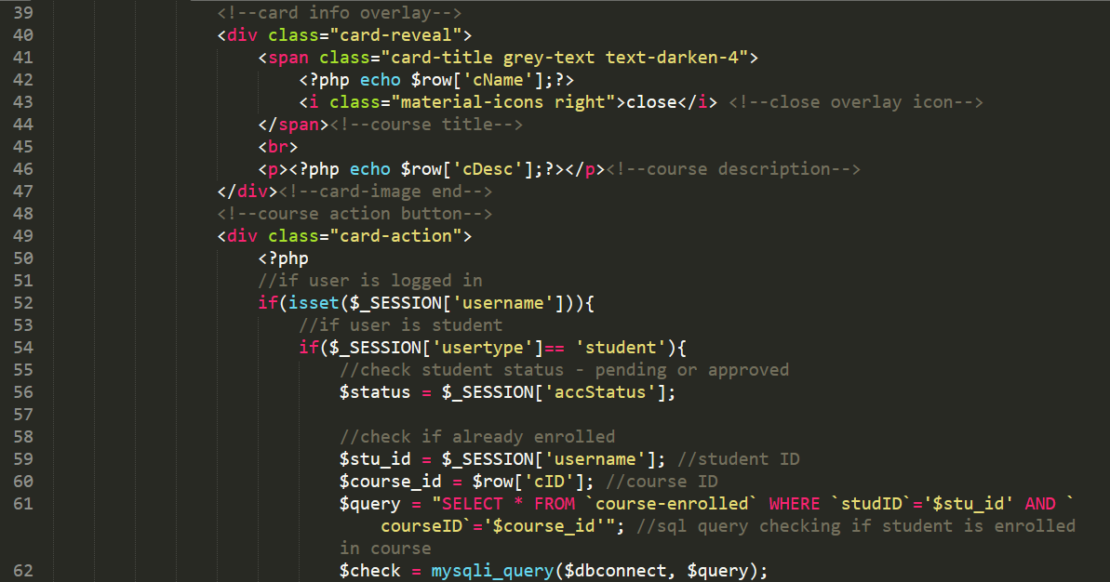 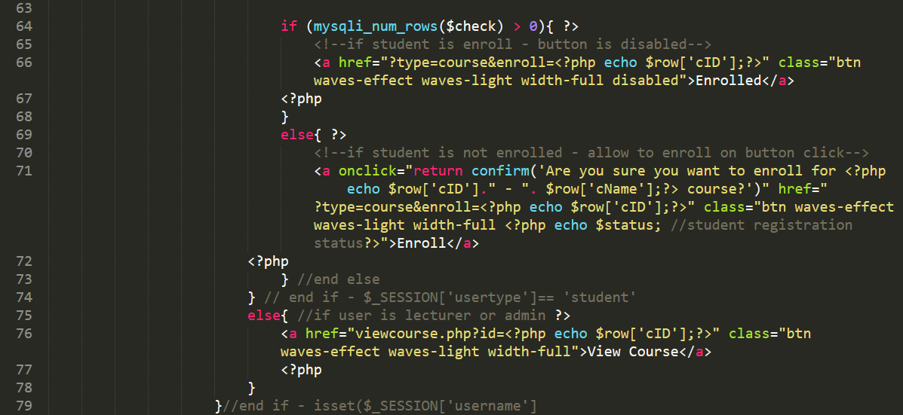

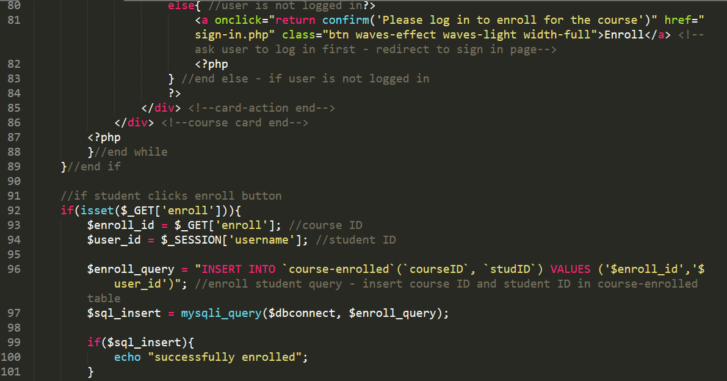

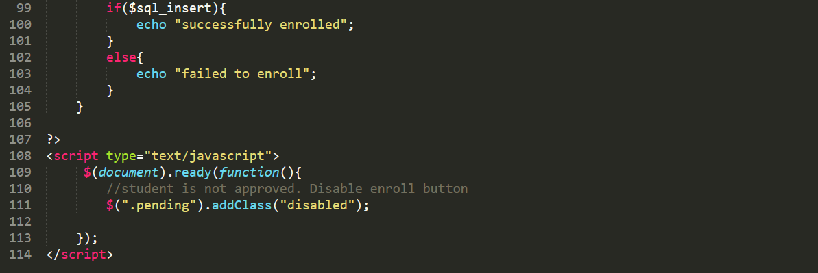

**Section 2. Supporting PHP files**

**Section 2a) index.php**

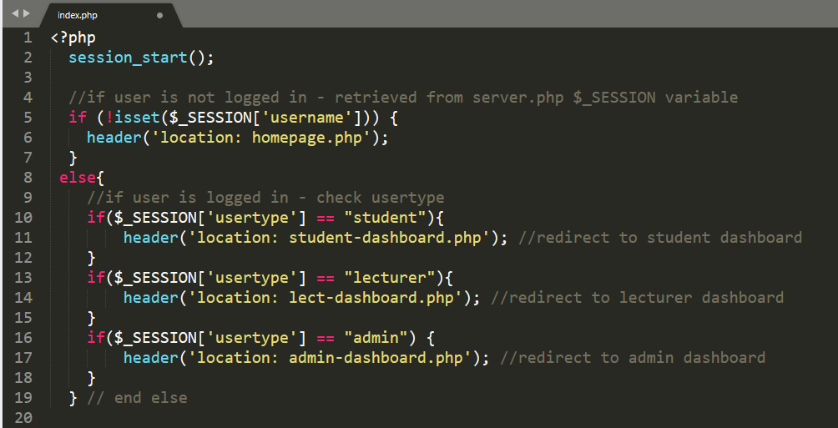

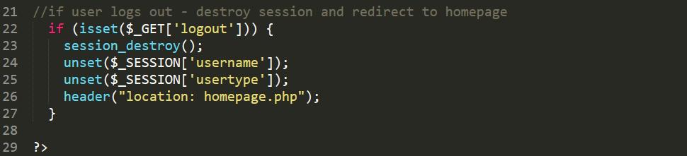

**Section 2b setid.php**

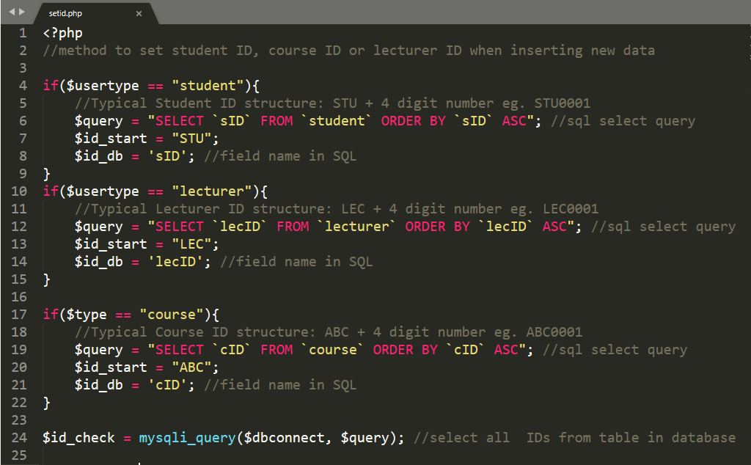

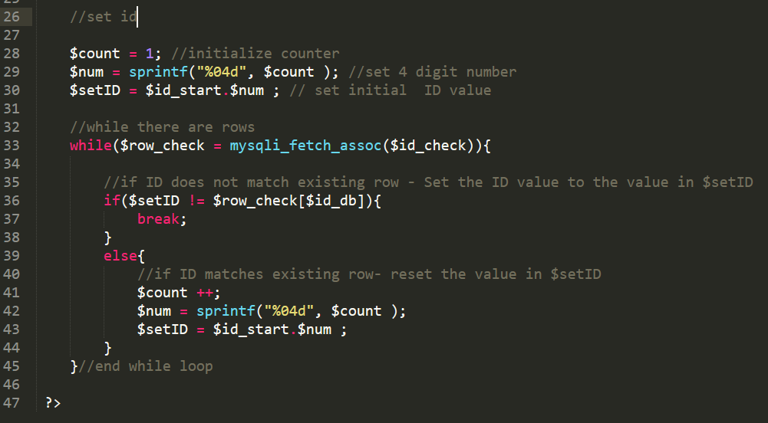

**Section 2c. 404.php**

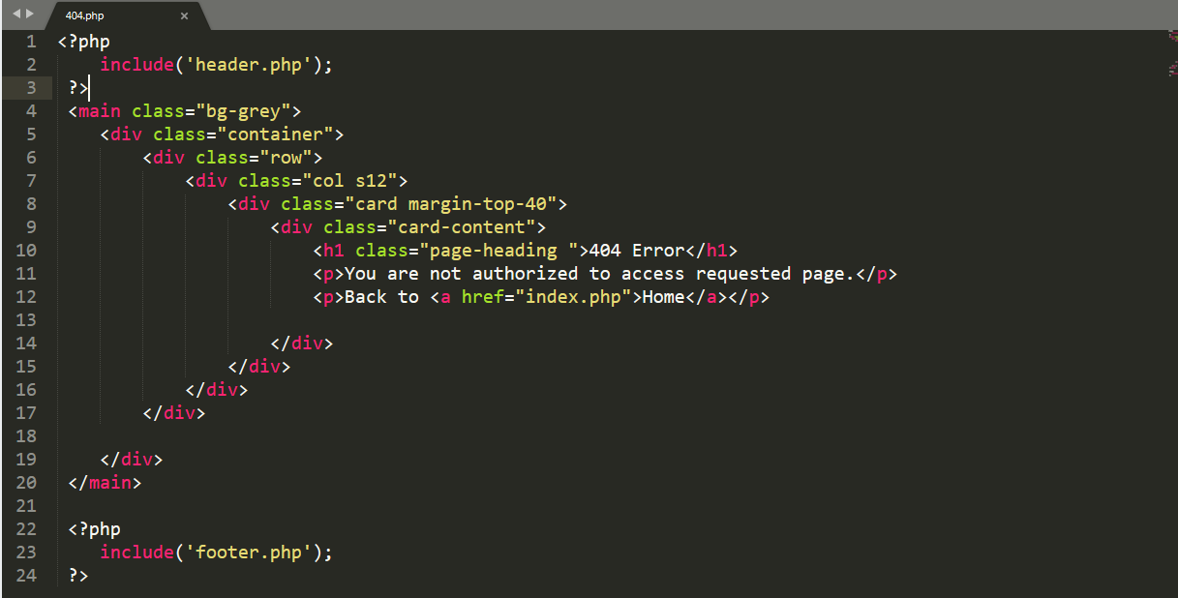

# Appendix G

**1. Homepage HTML Code:**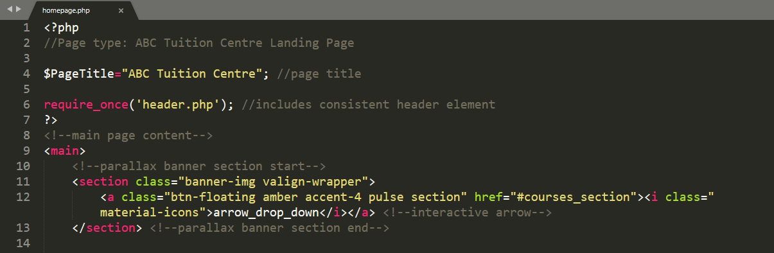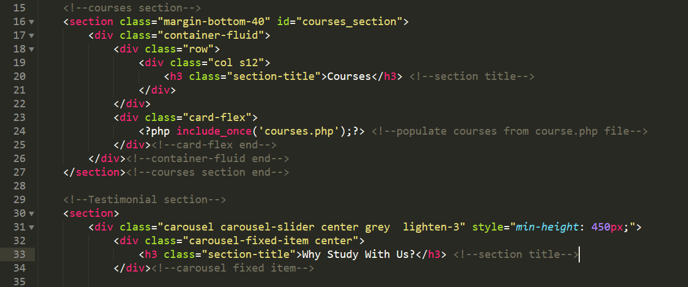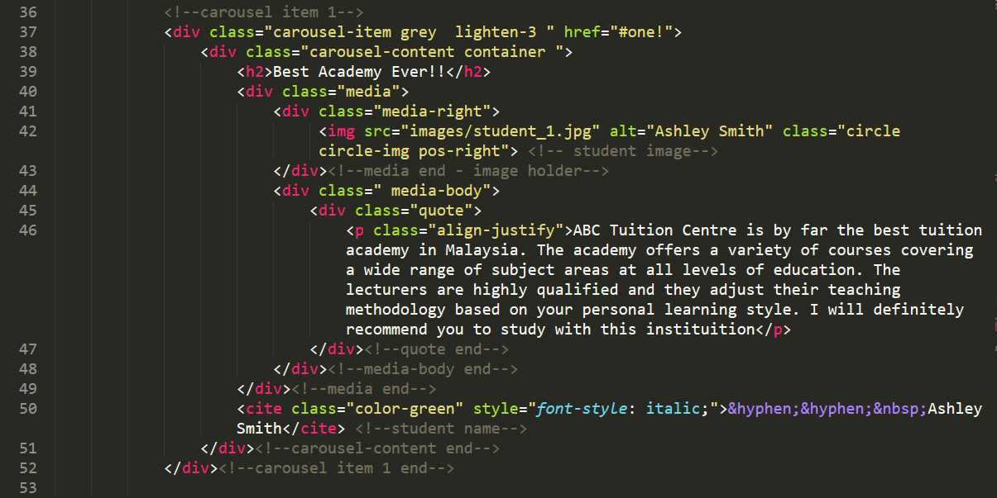

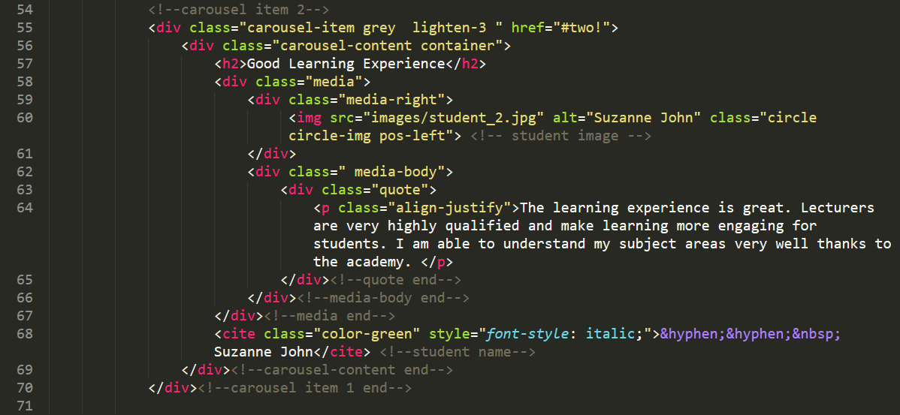

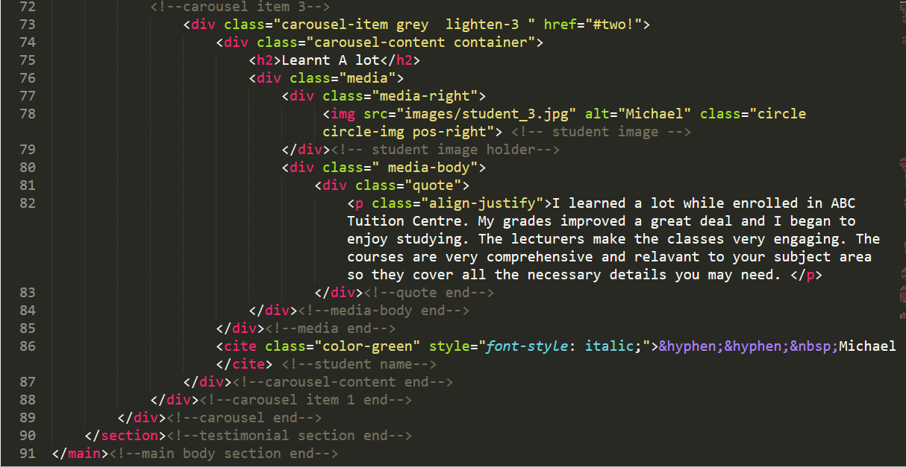

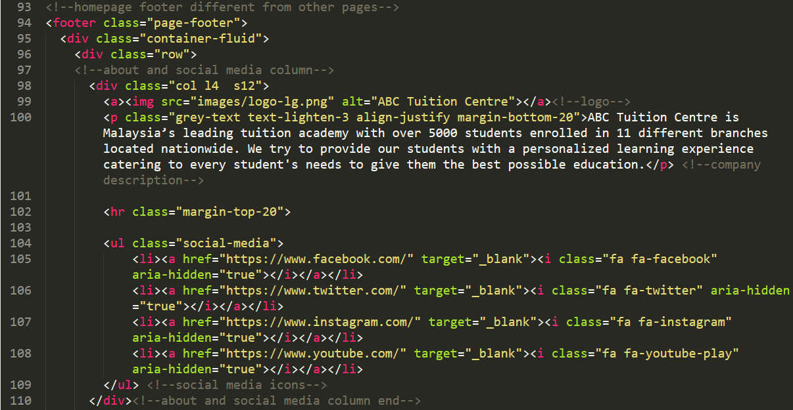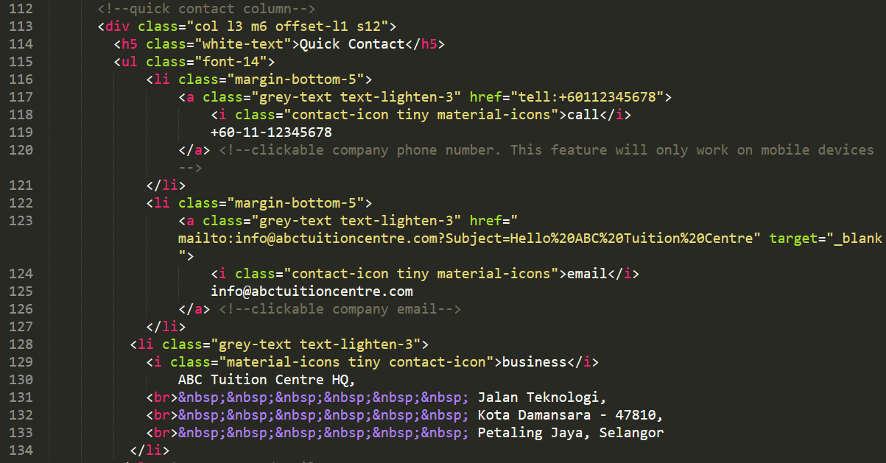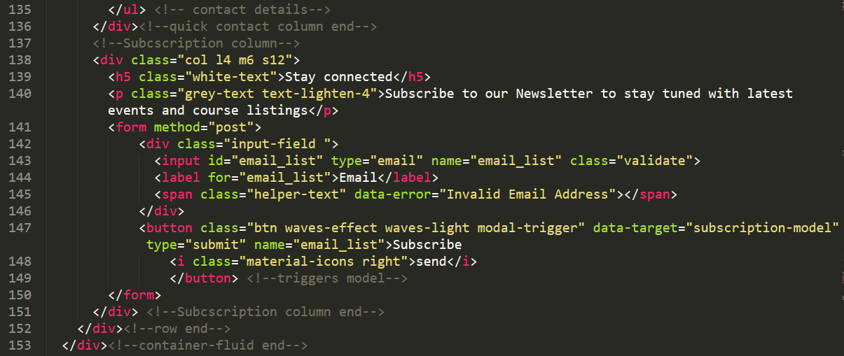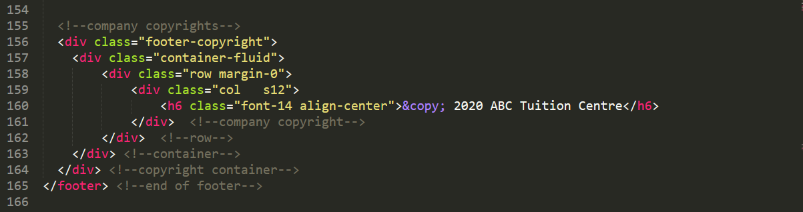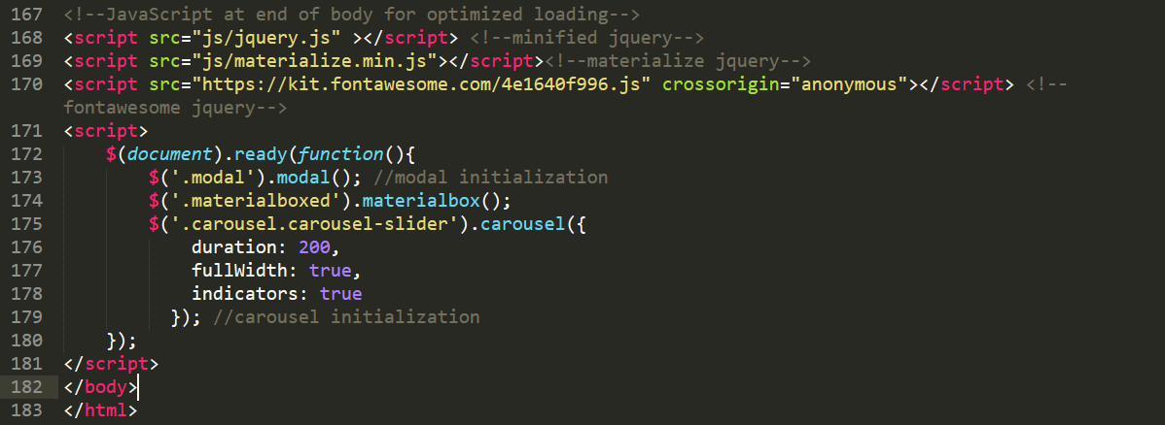

# Appendix H

Appendix H will cover the pages relevant to students and staff user type before they log in.

**1. Student Registration HTML**

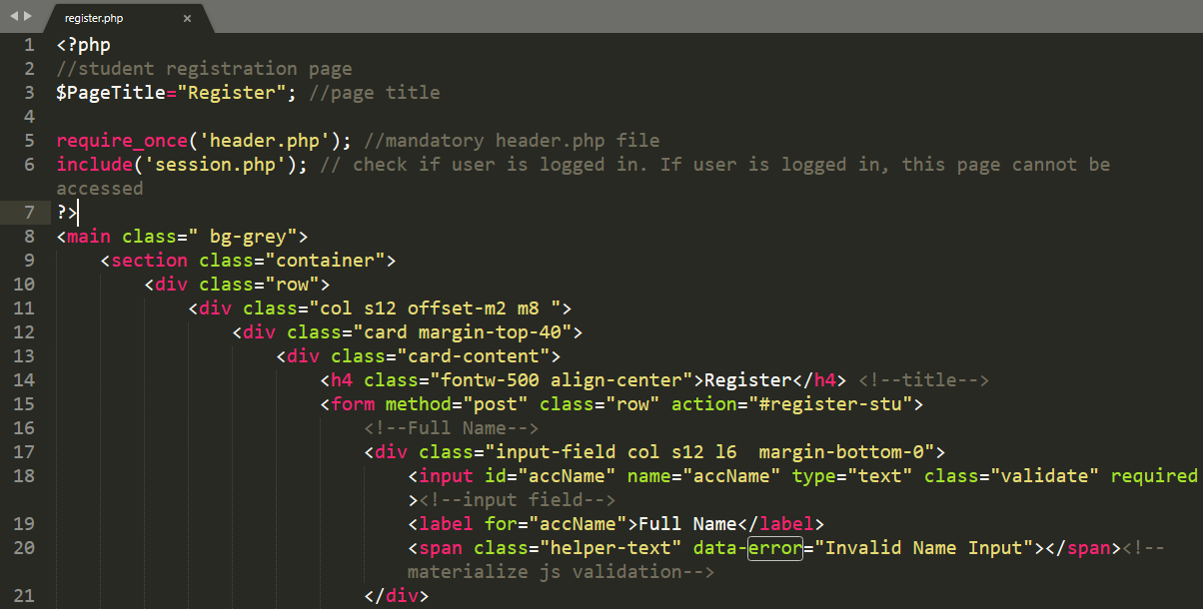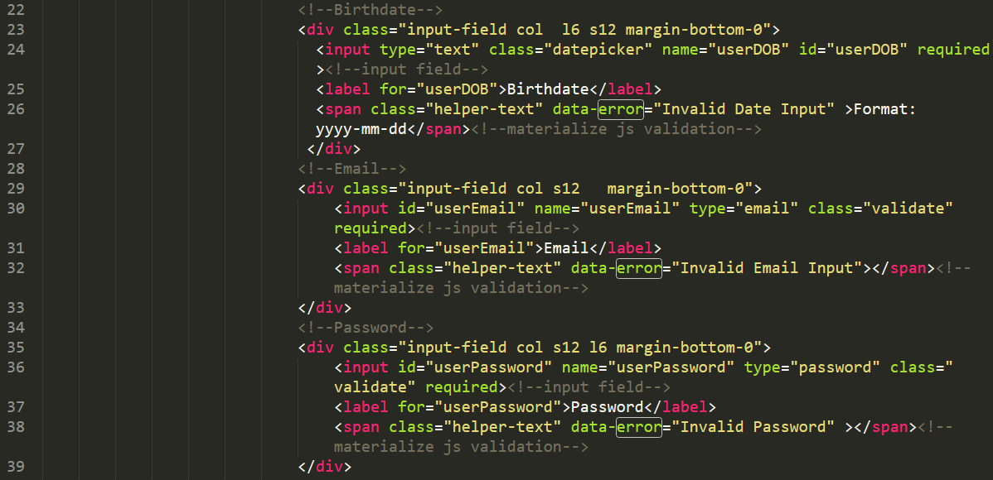

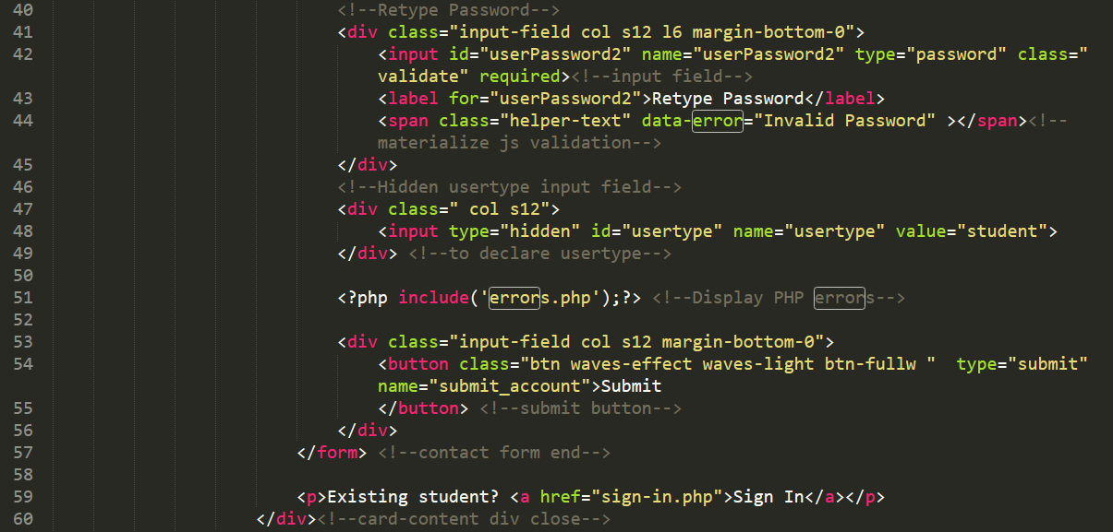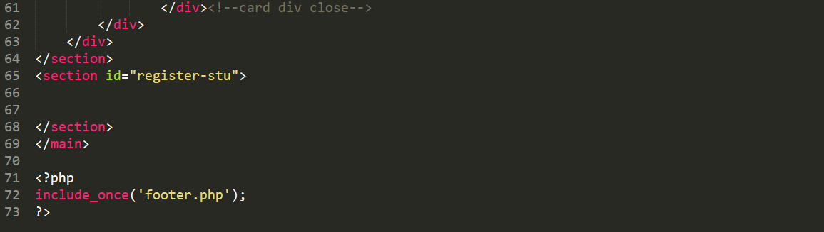

**2. Student Post Registration HTML**

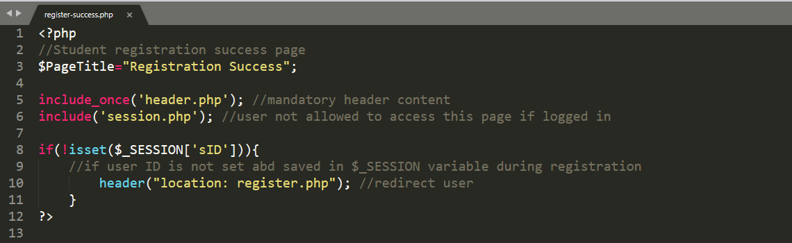

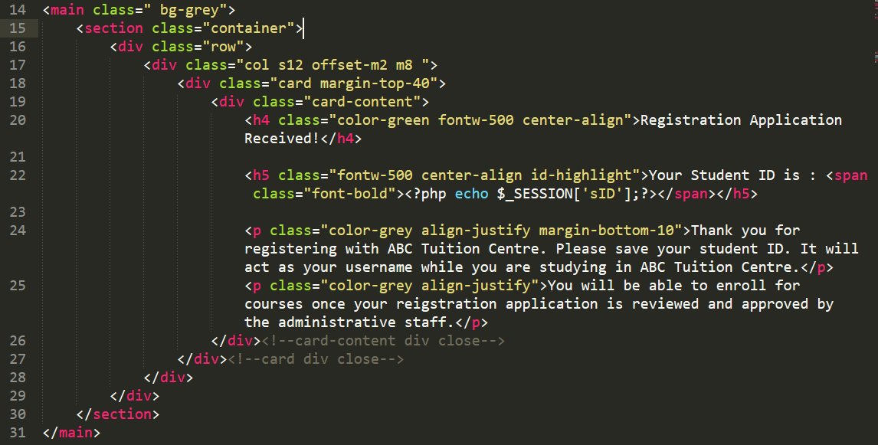

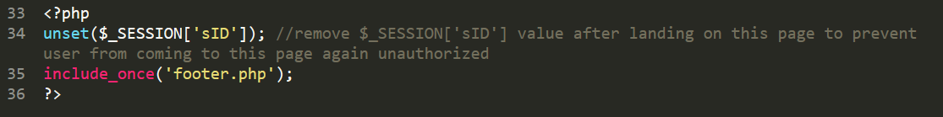

**3. Student Sign In**

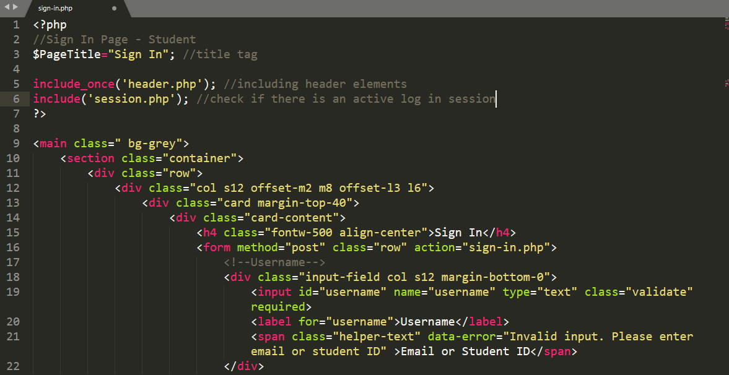

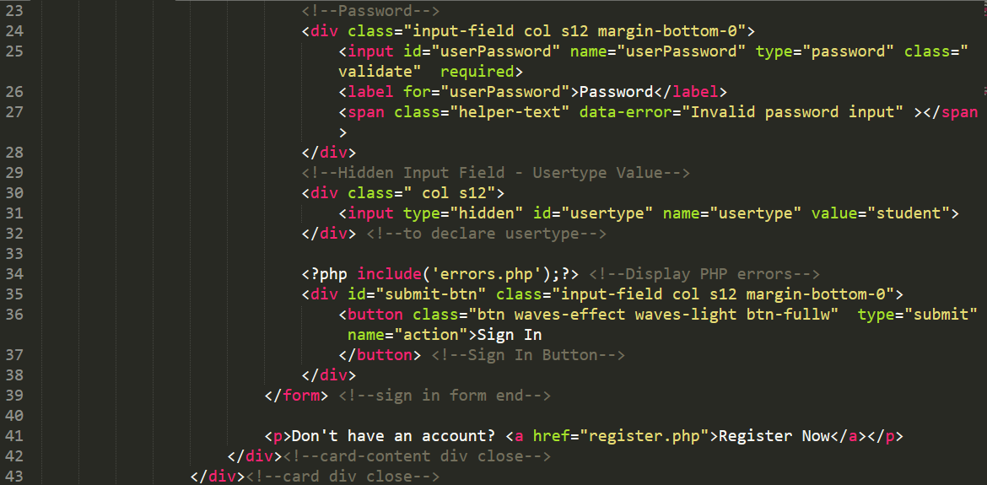

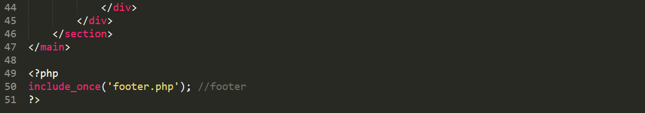

**4. Staff Sign In**

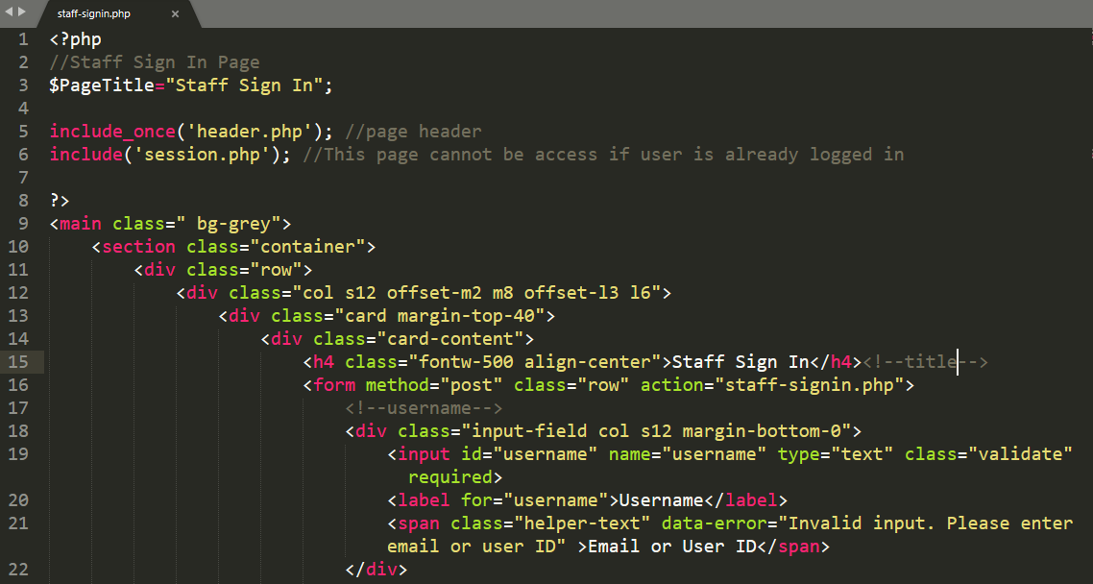

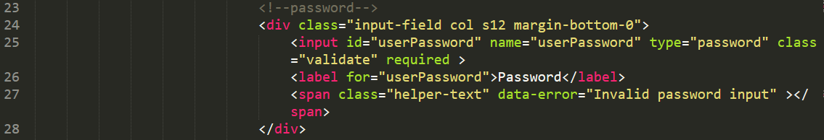

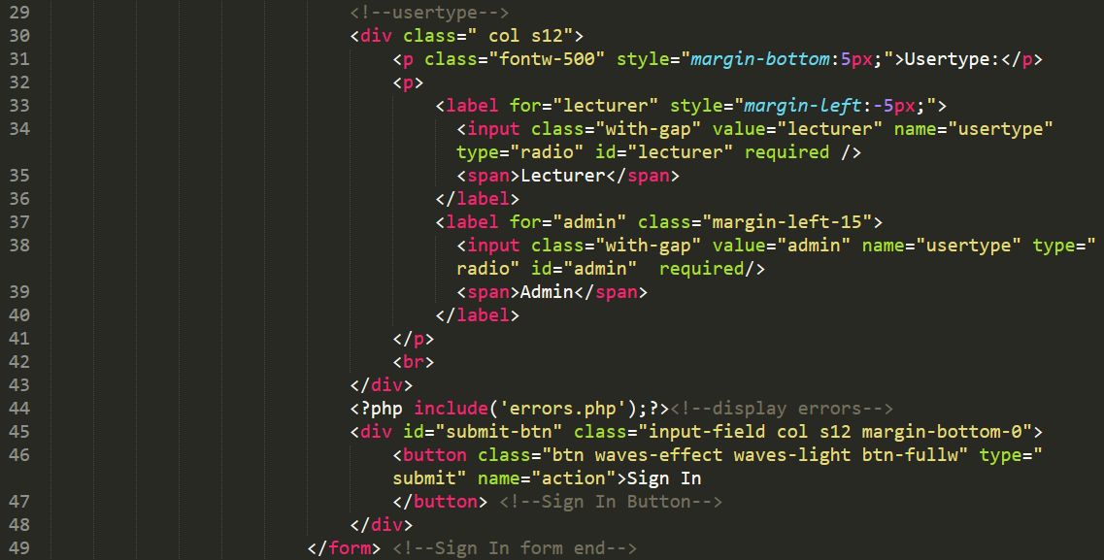

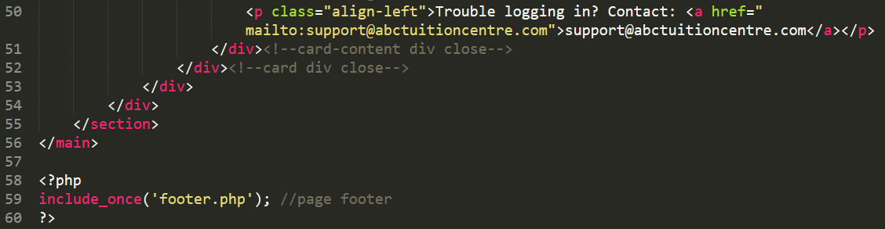

# Appendix I

All pages under the admin portal will be included in Appendix I

**1. Admin Dashboard: admin-dashboard.php**

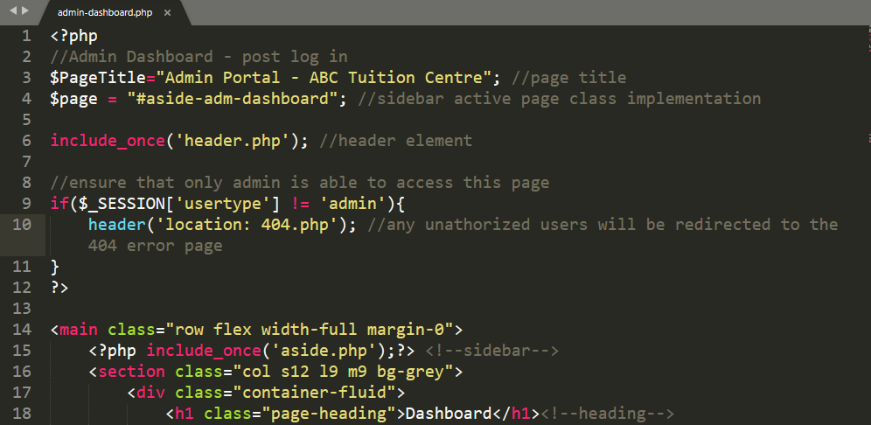 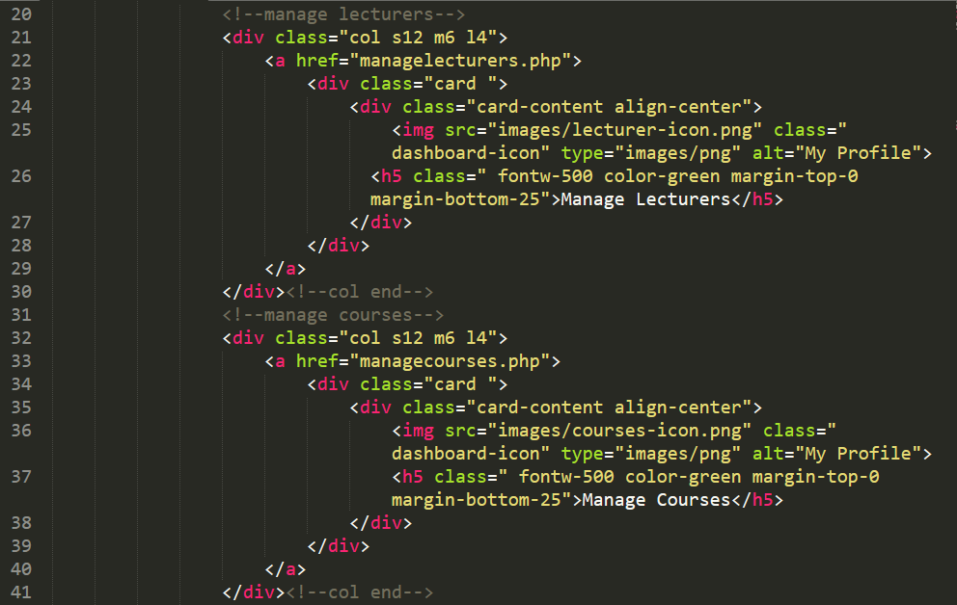 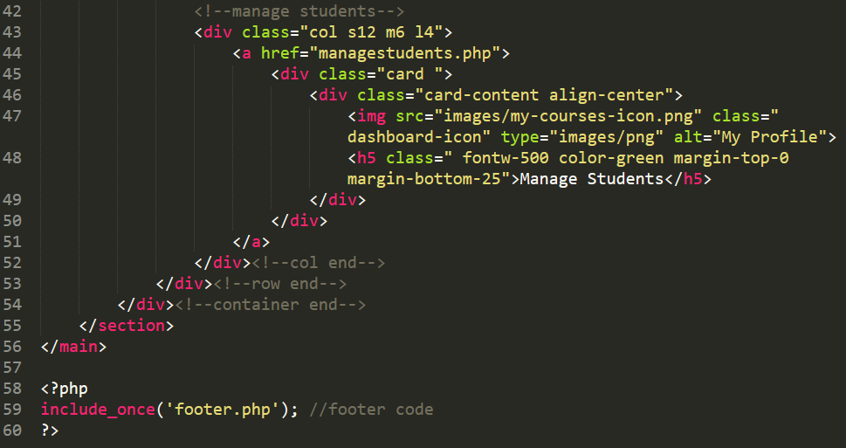

**Section 2. Manage Lecturers: managelecturers.php**

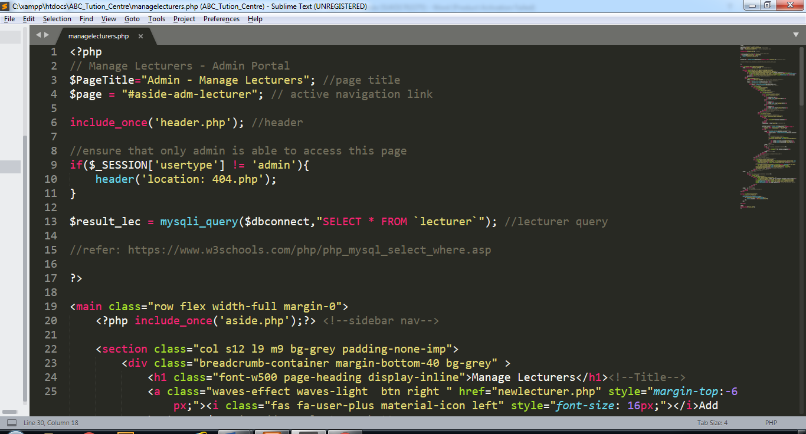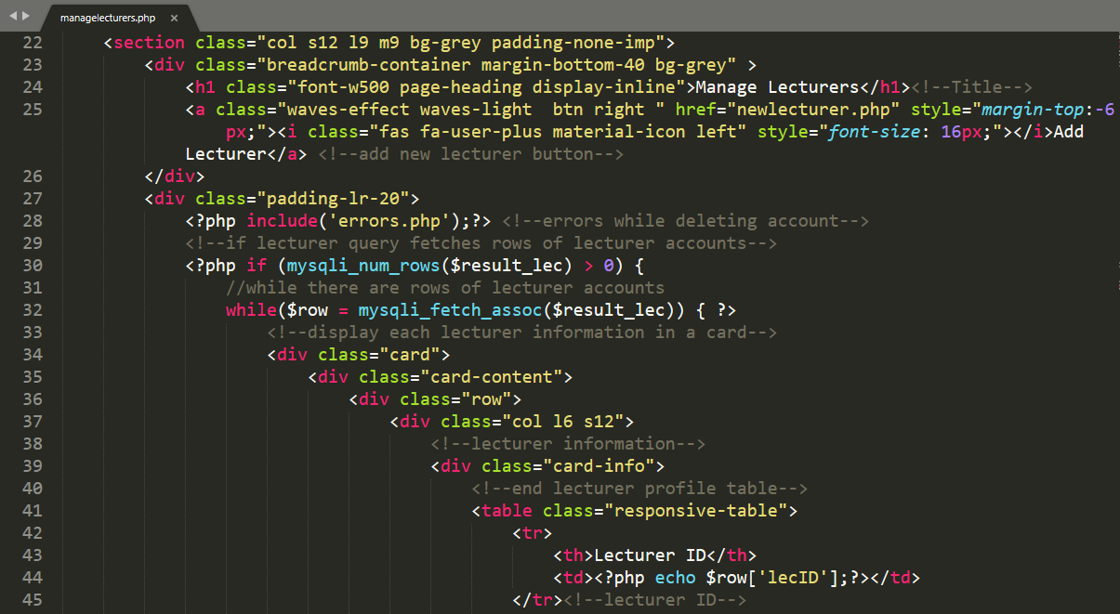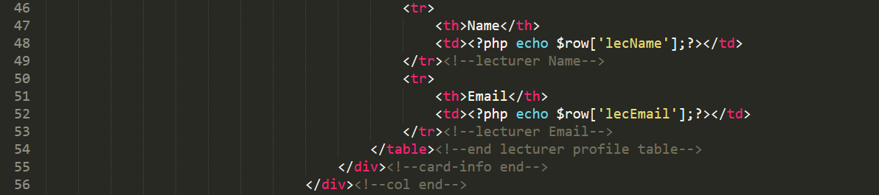

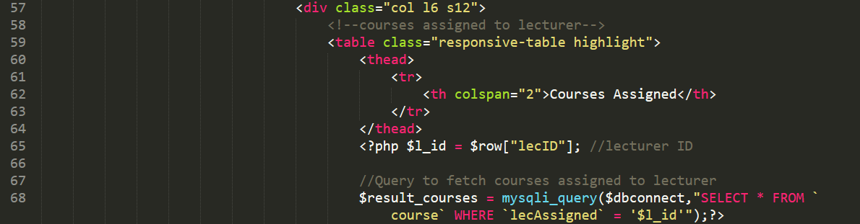

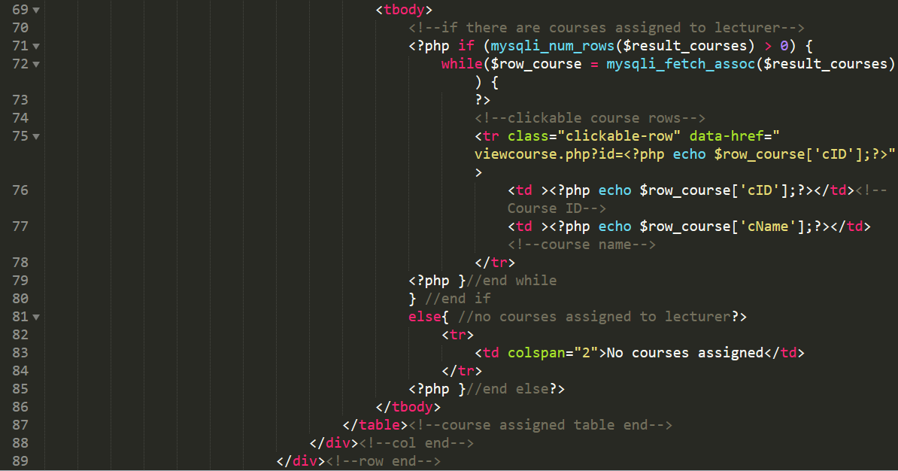

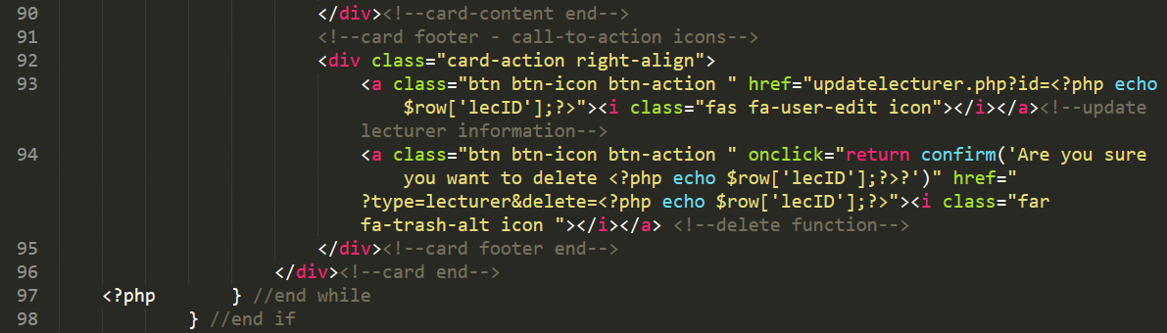

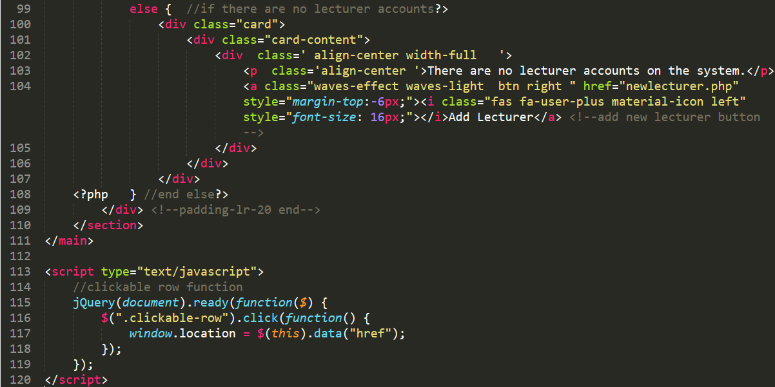

**Section 3. Update Lecturer Account**

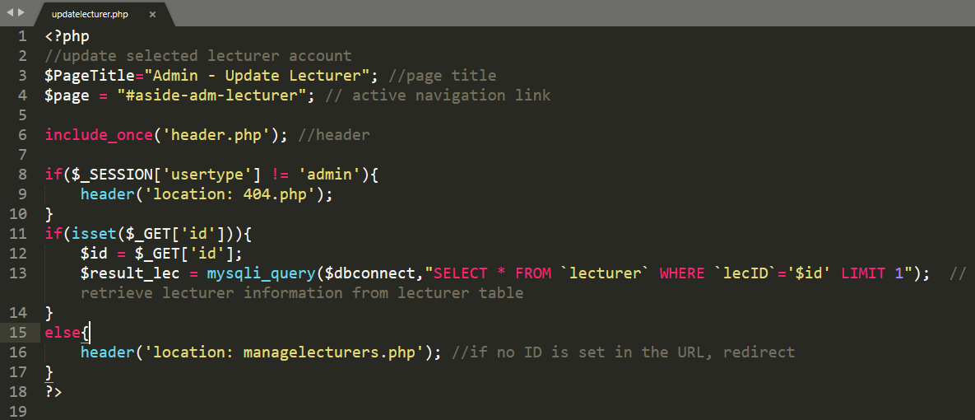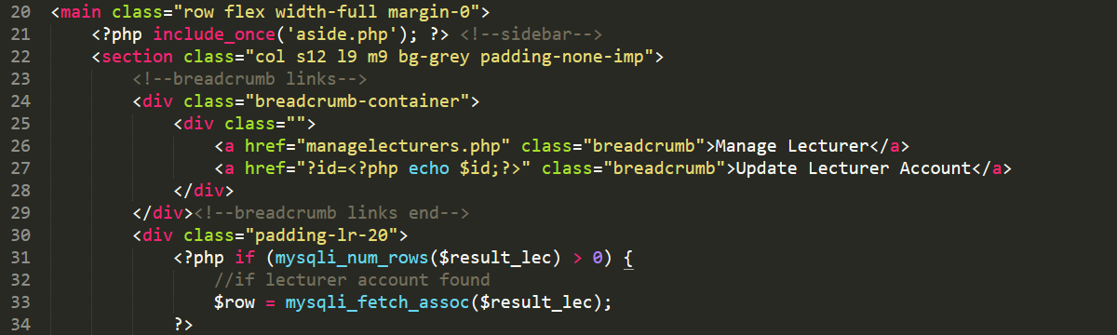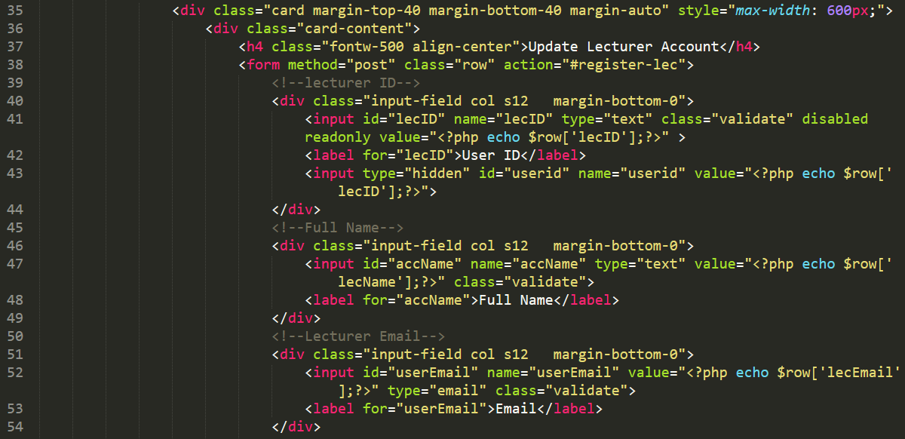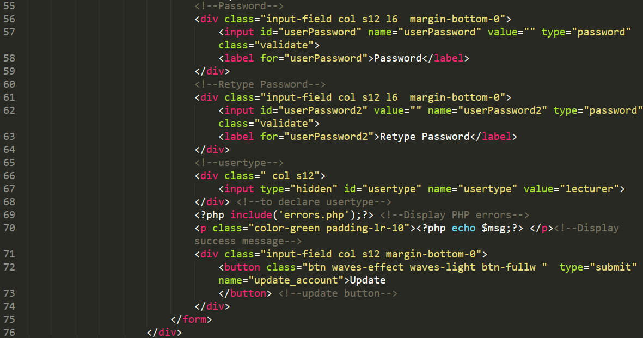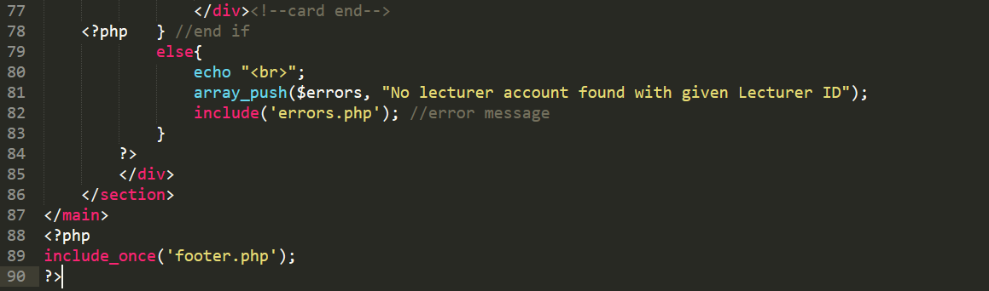

**Section 4. New Lecturer Account**

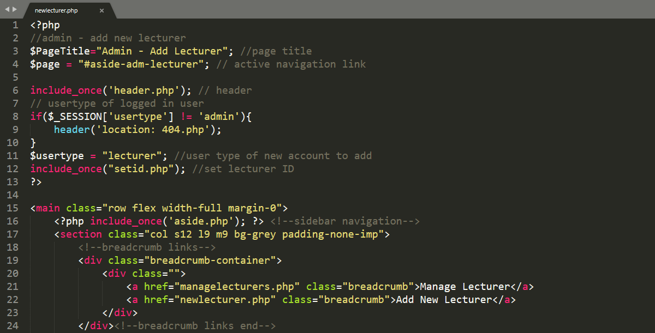 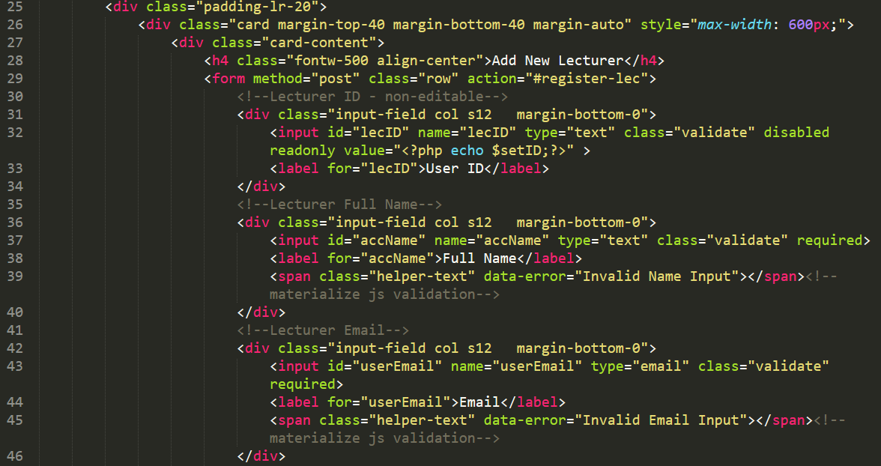 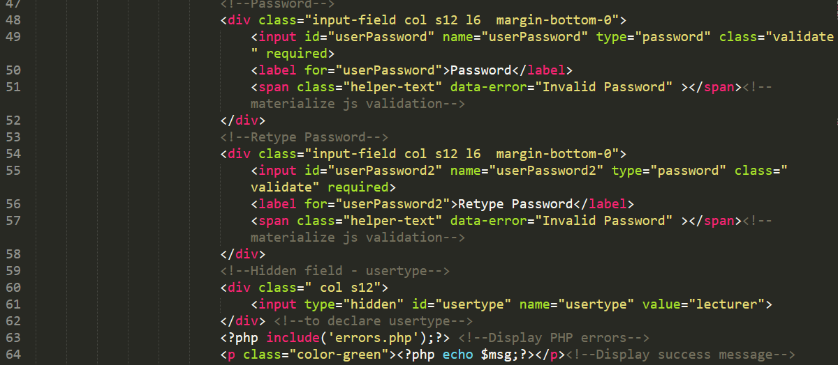

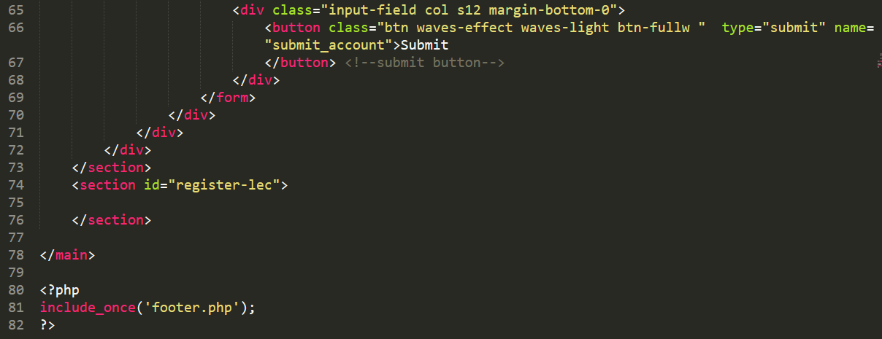

**Section 5. Lecturer Registration Success**

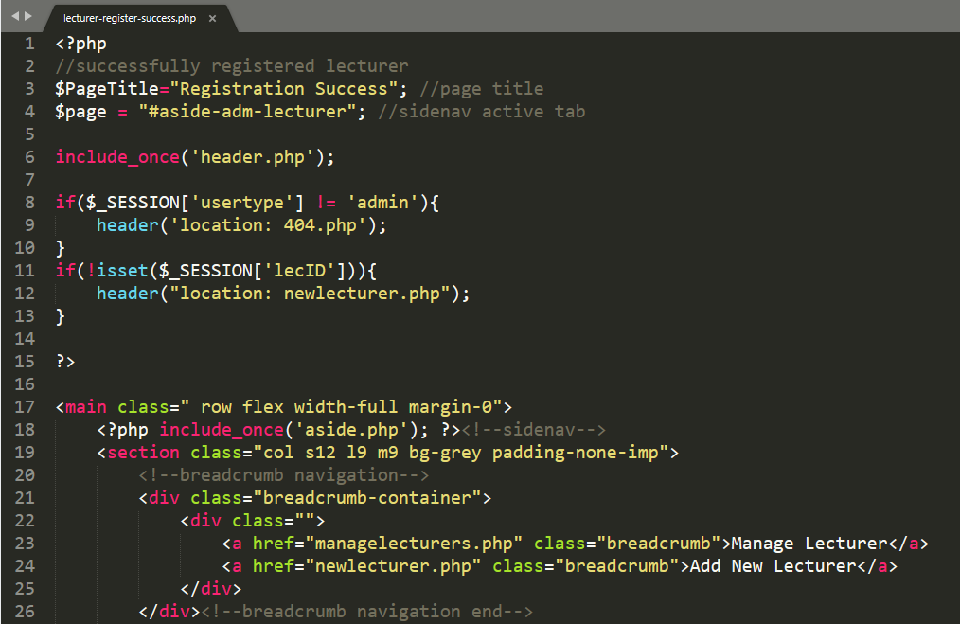

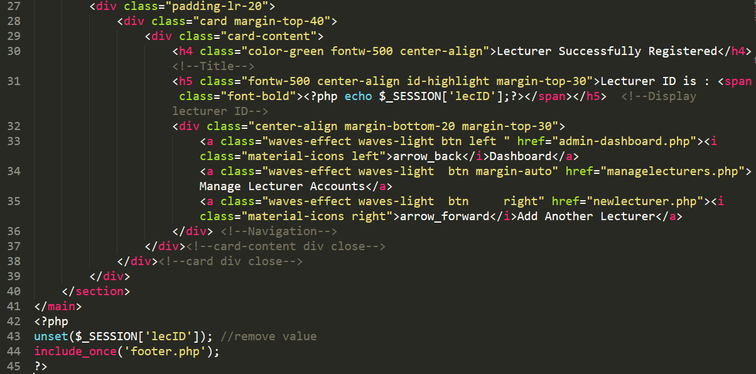

**Section 6. Manage Students**

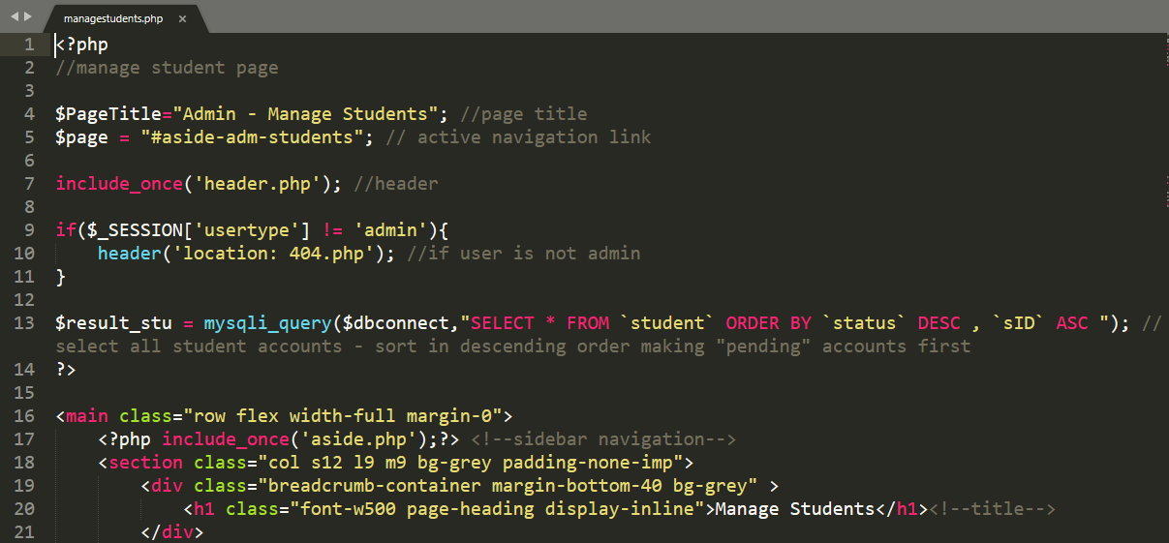 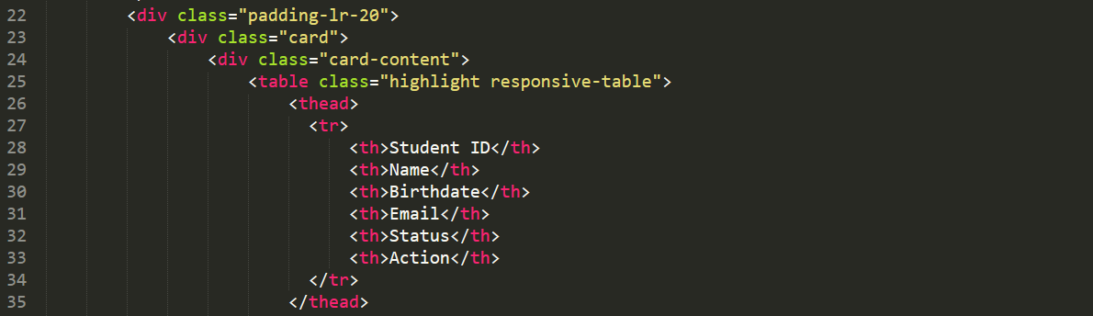

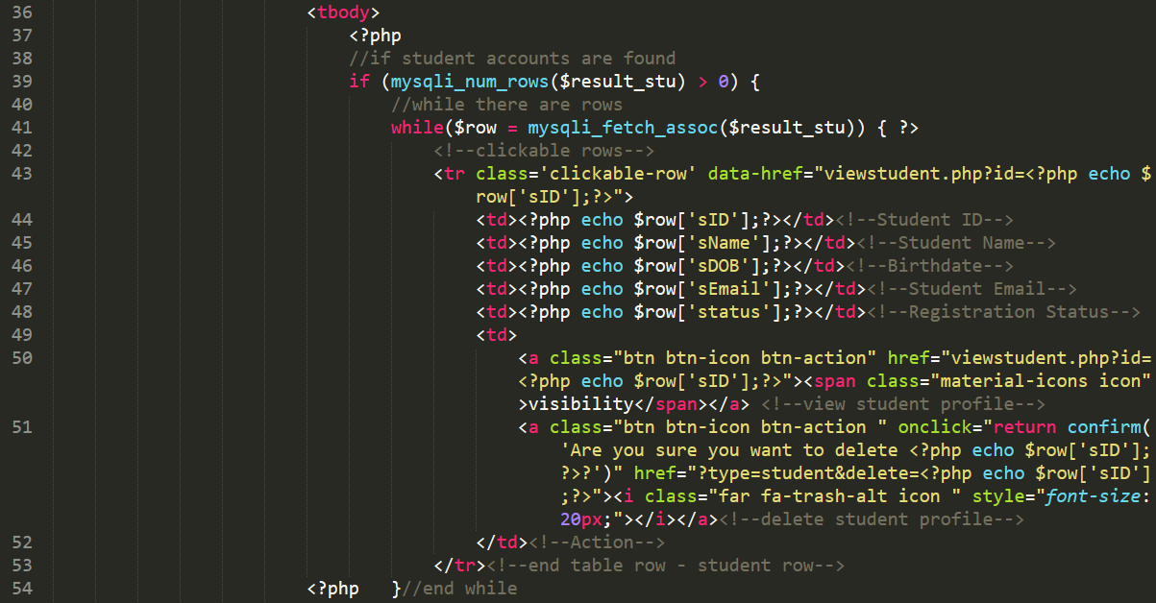 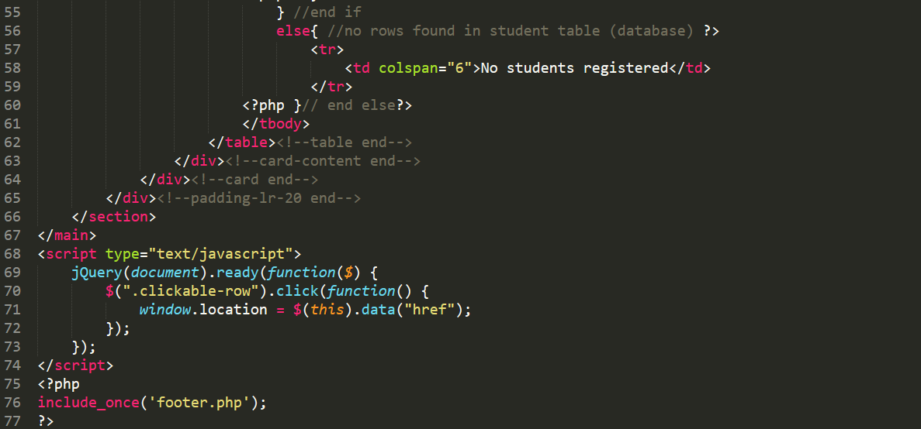

**Section 7. View Student (Admin)**

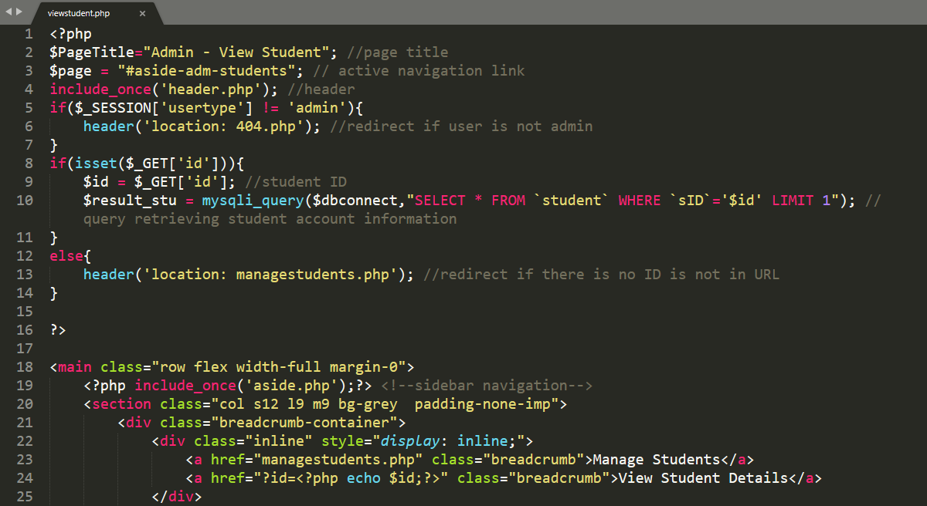

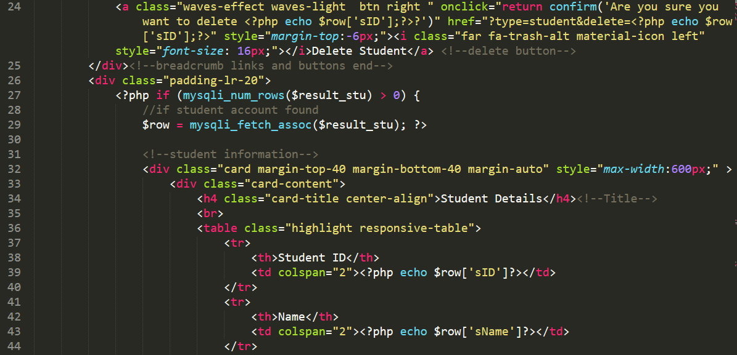

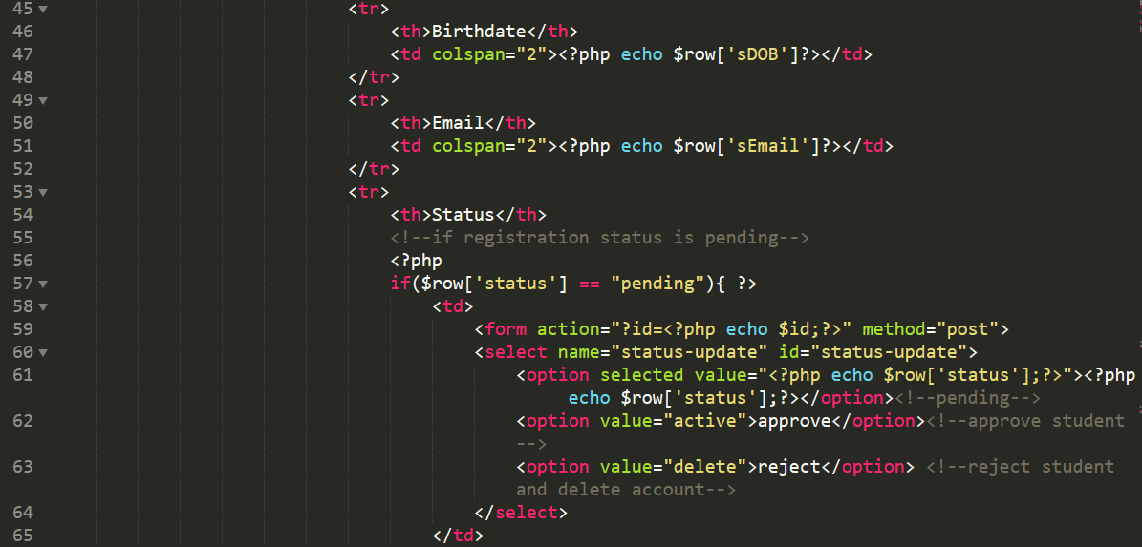

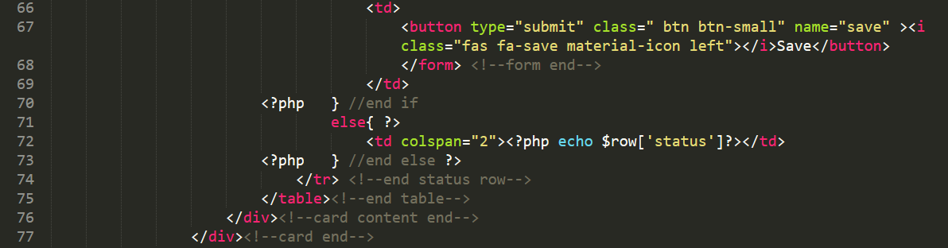

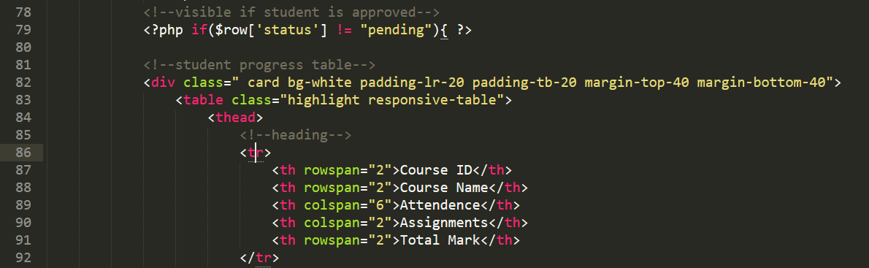

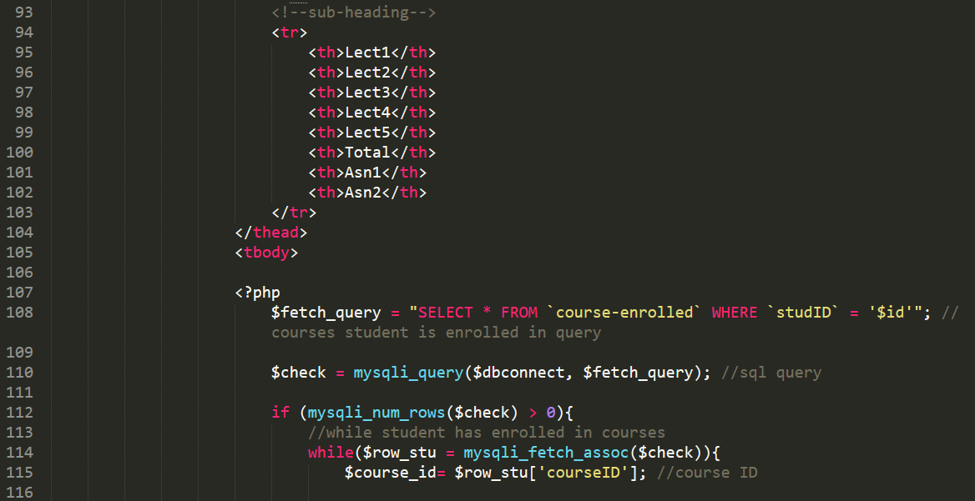

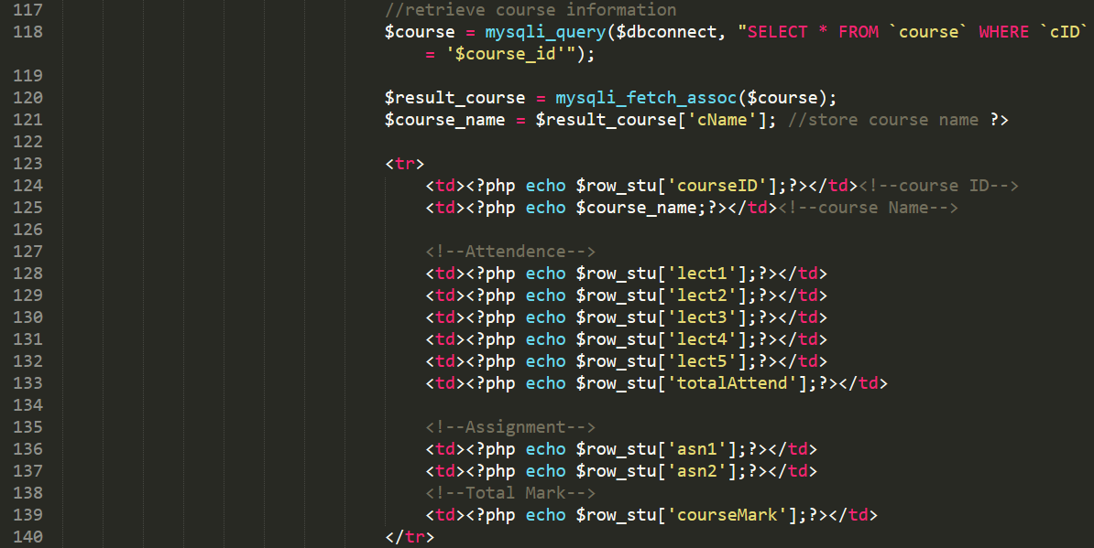

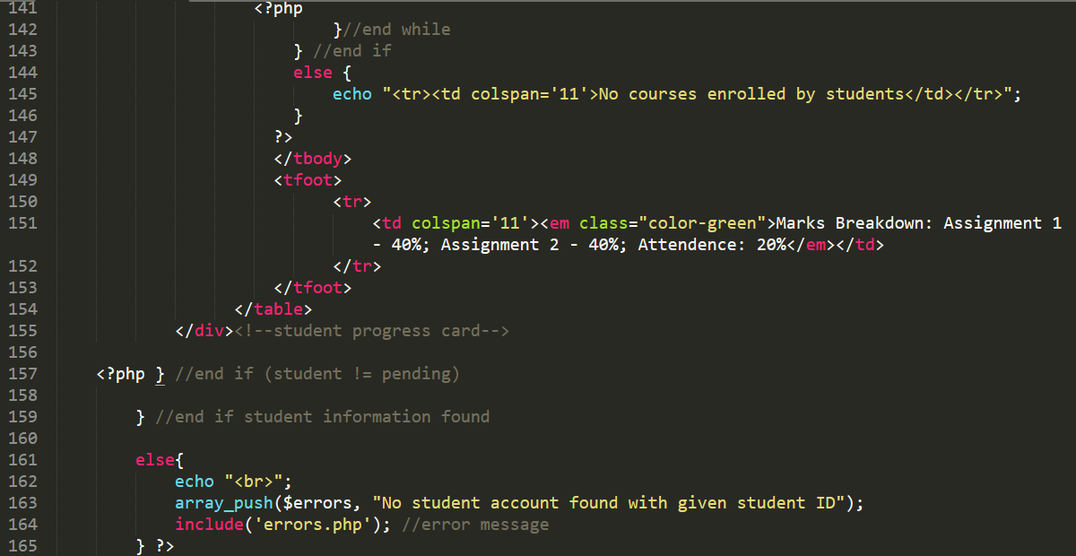

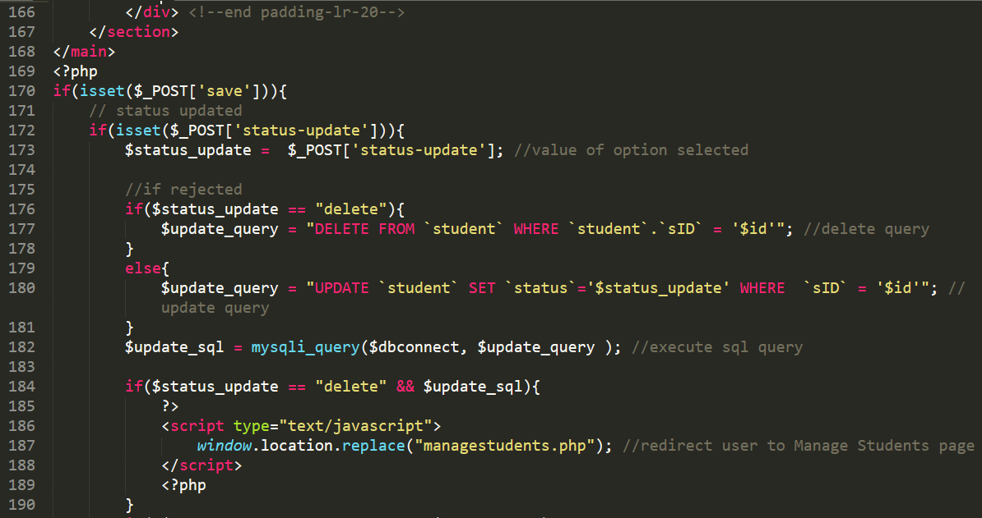

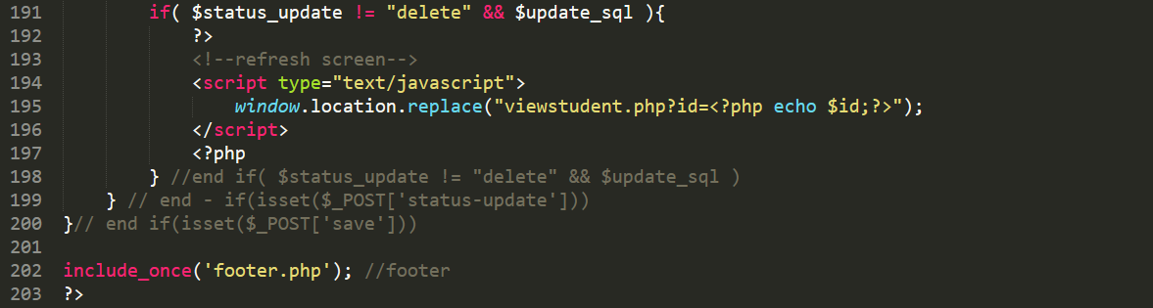

**Section 8. Manage Courses**

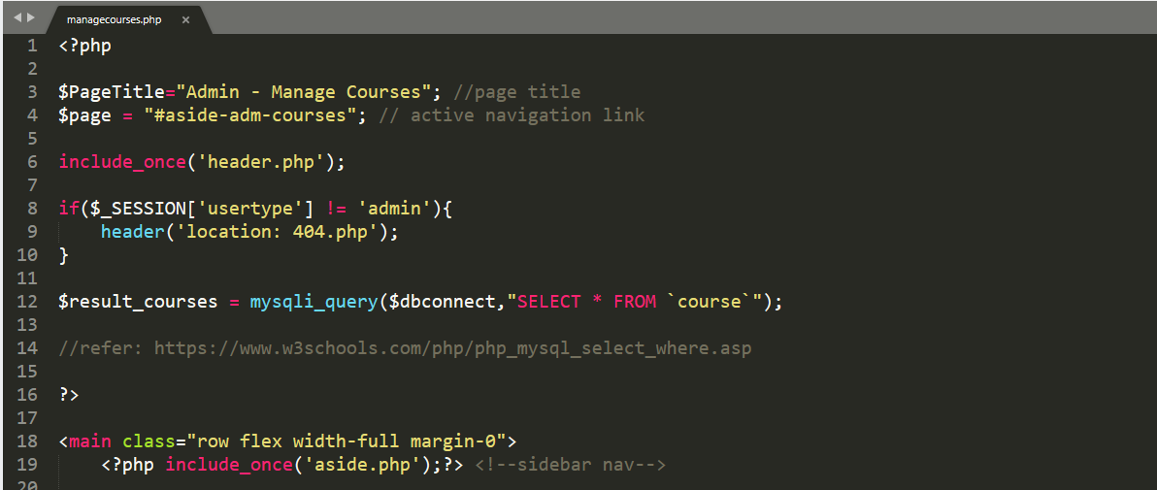 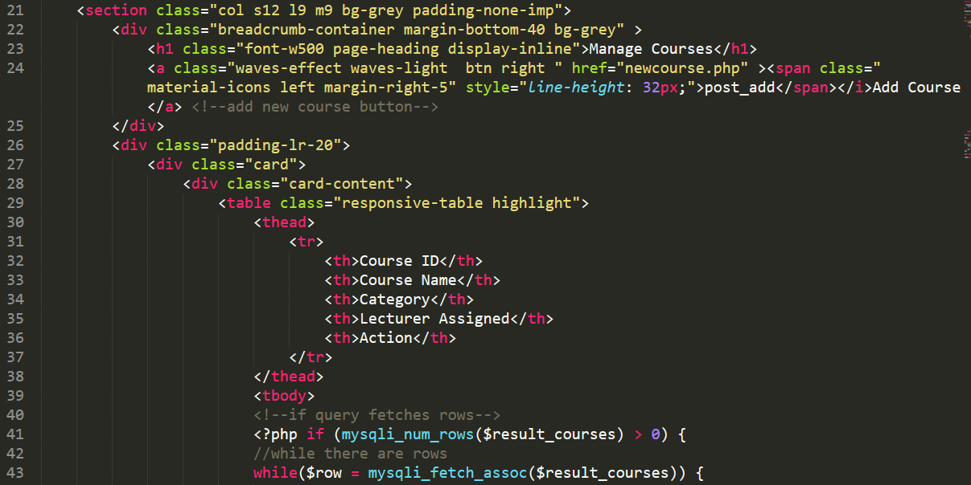 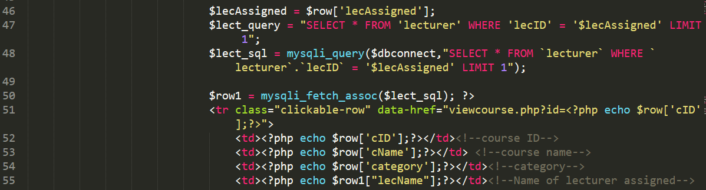

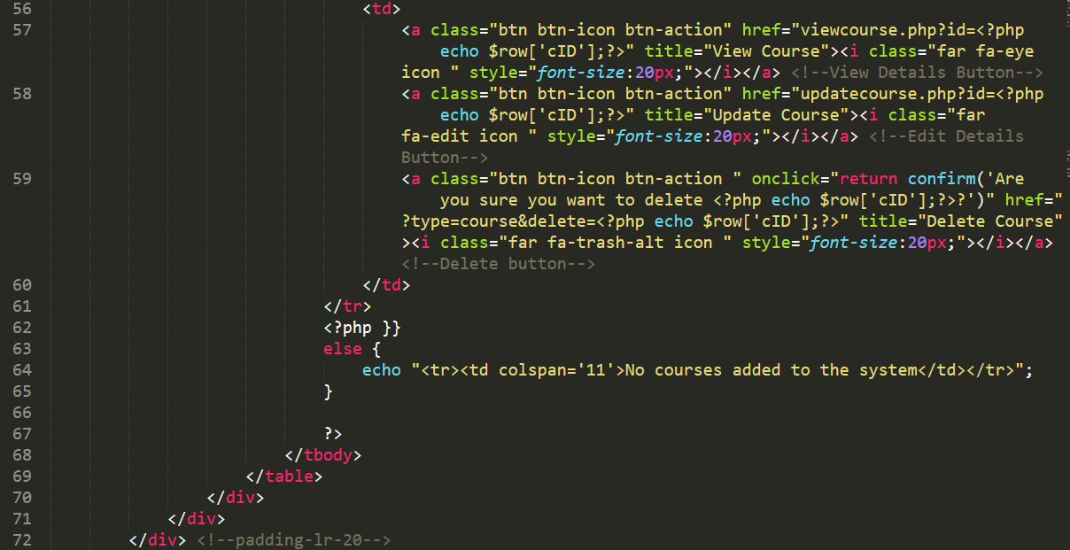

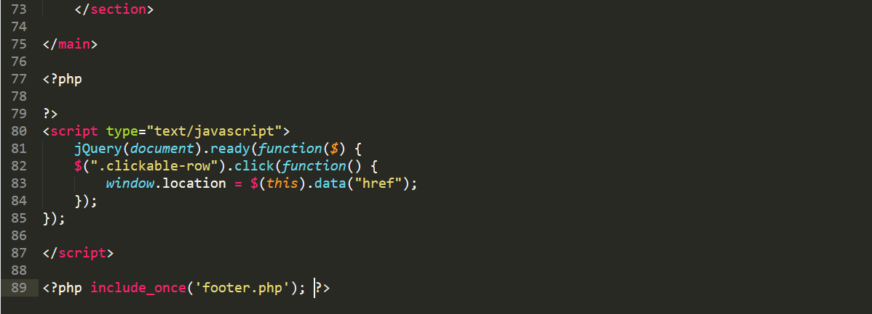

**Section 9 Add New Course**

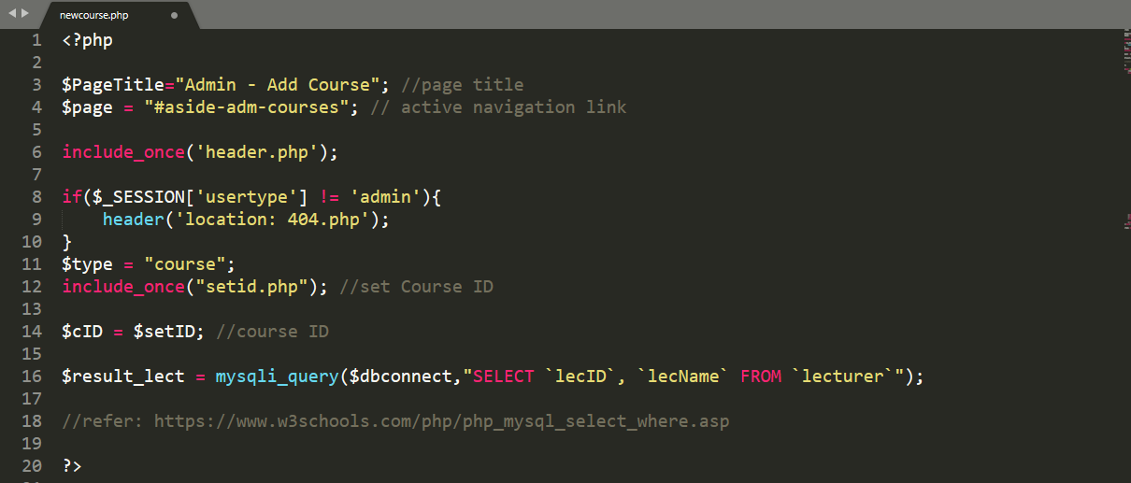

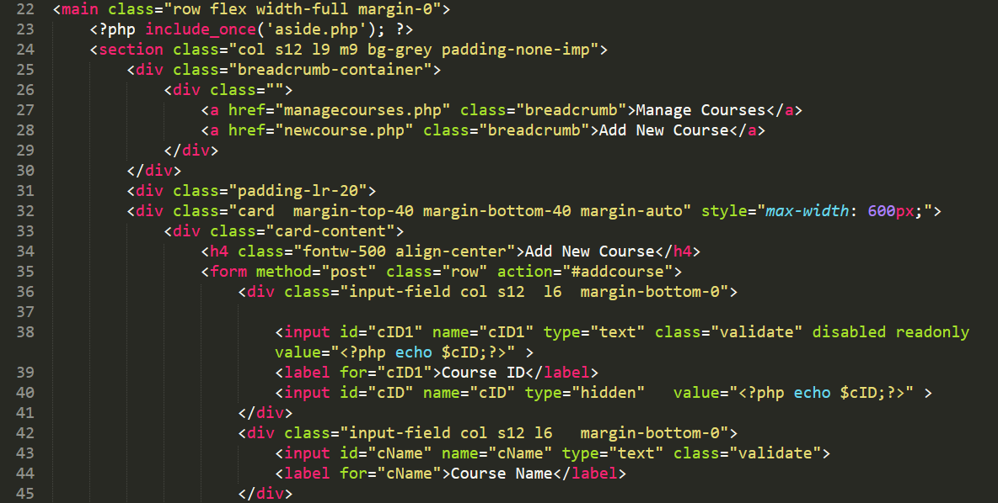

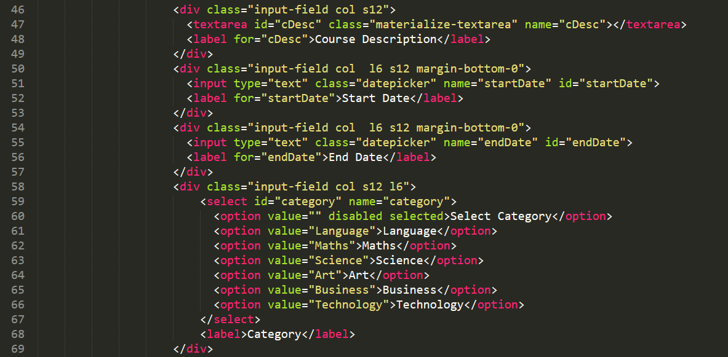

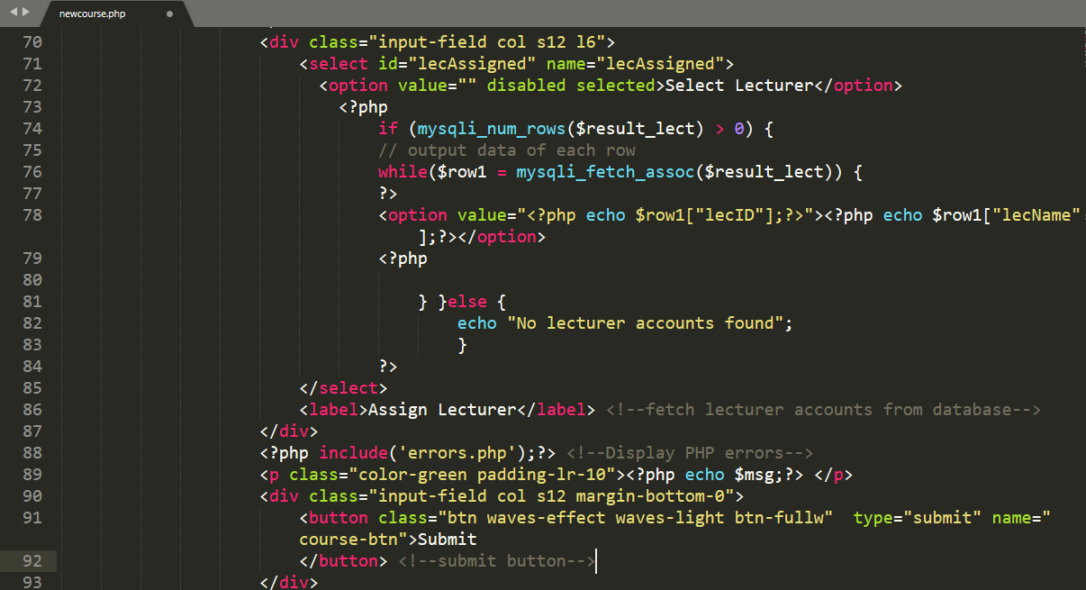

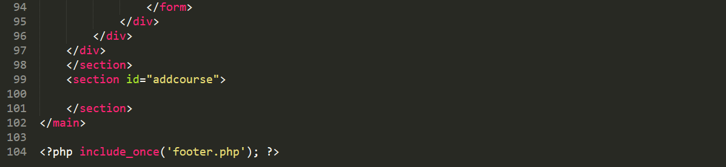

**Section 10 Update Course**

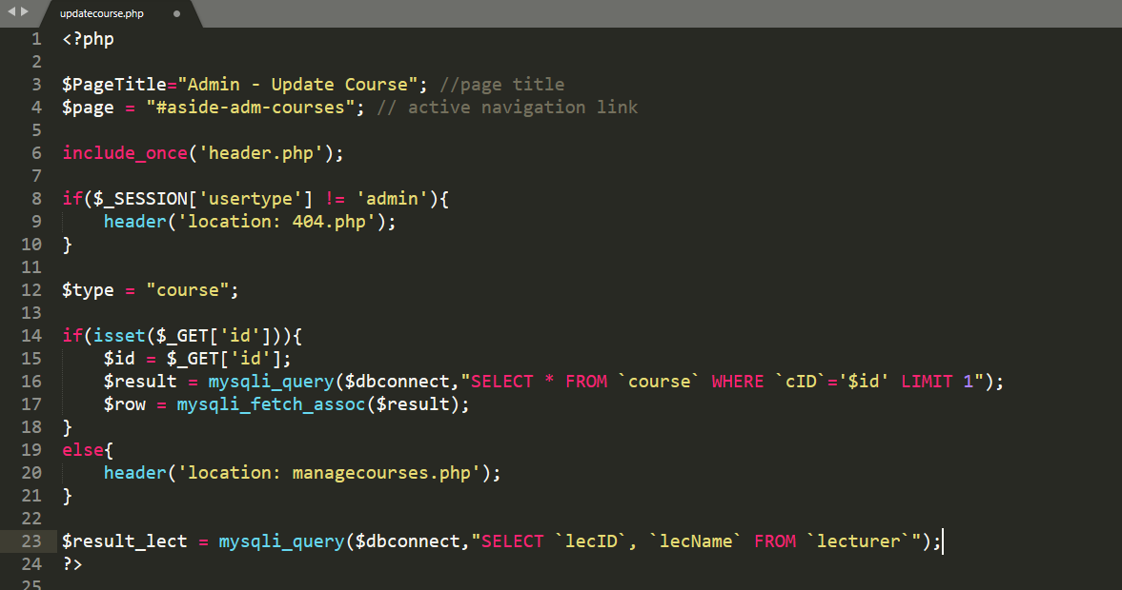

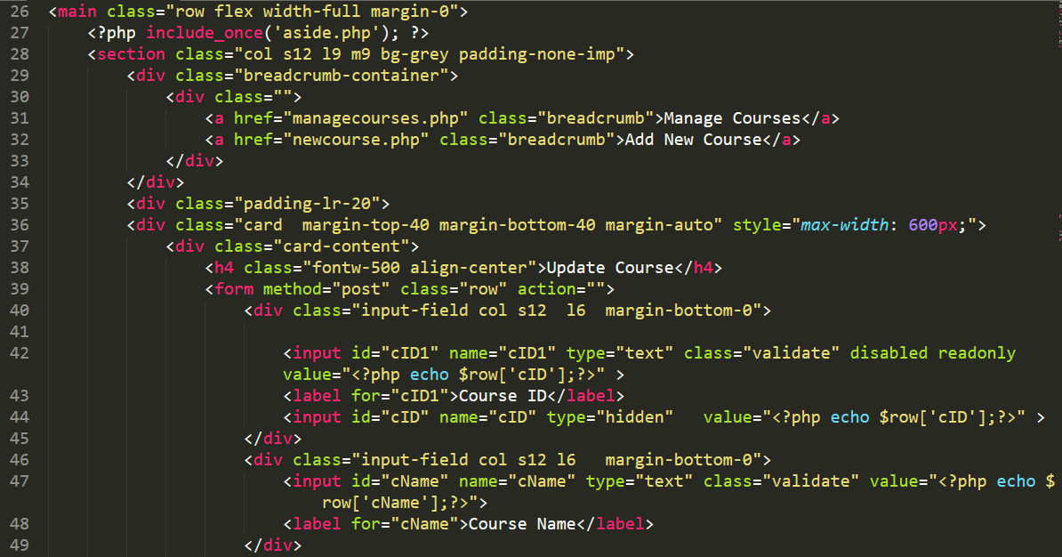

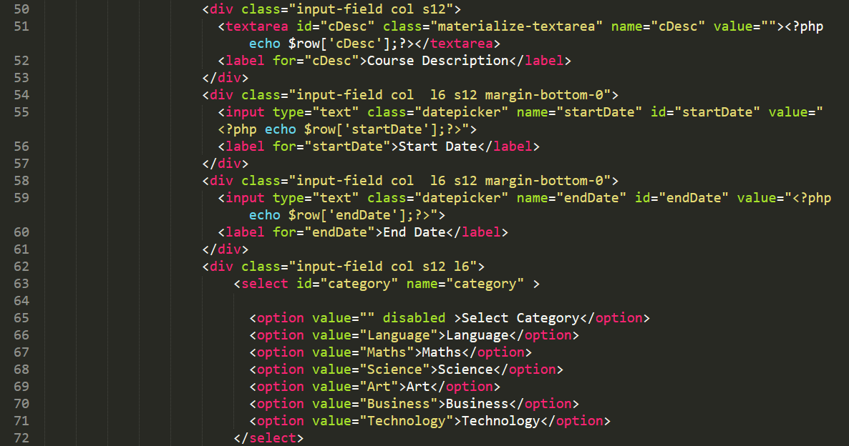 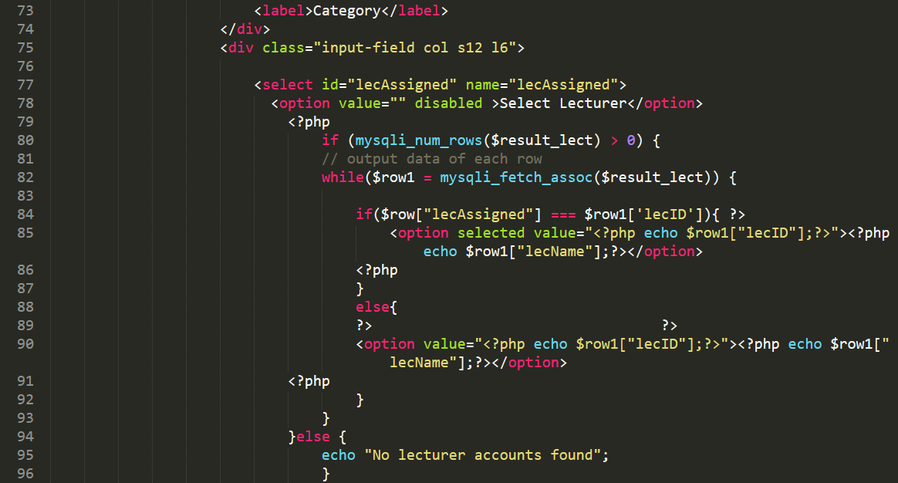

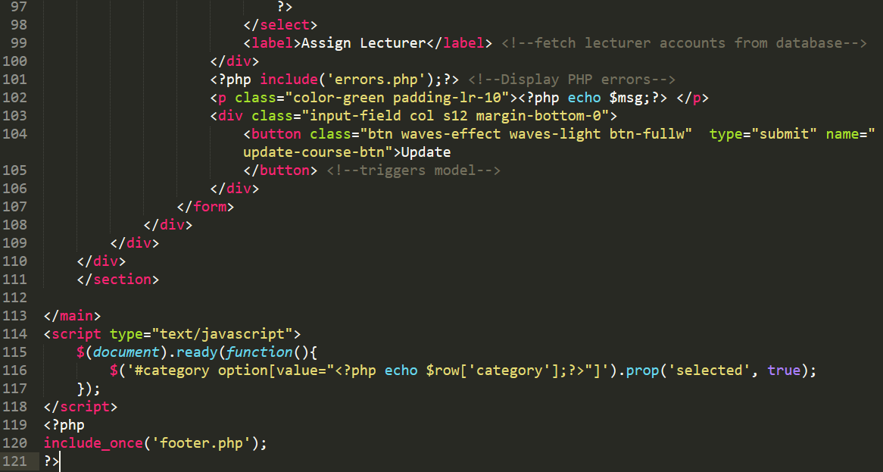

# Appendix J

All pages under the student portal will be provided in Appendix J

**Section 1. Student Dashboard**

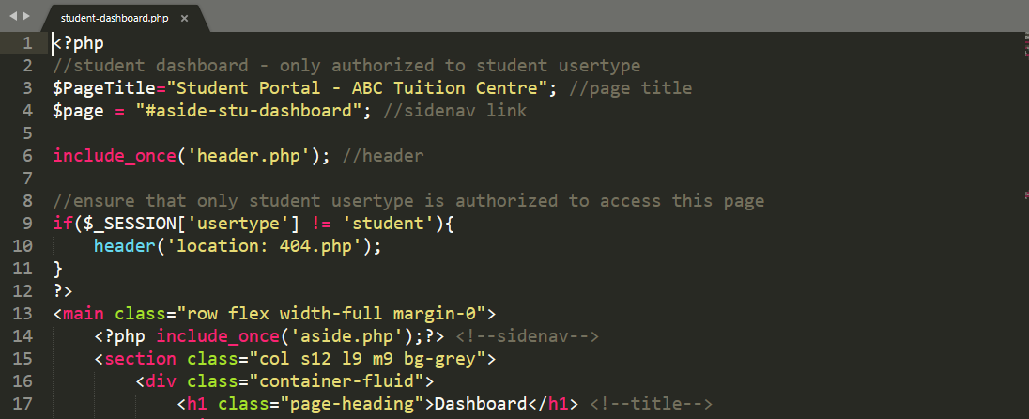

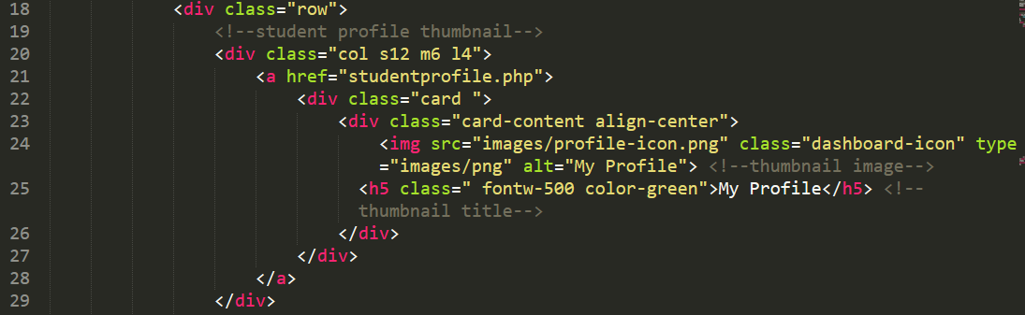

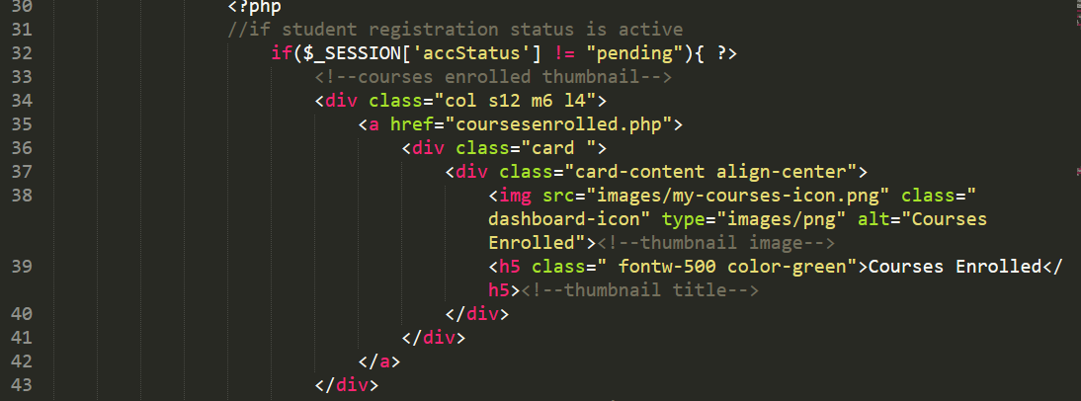

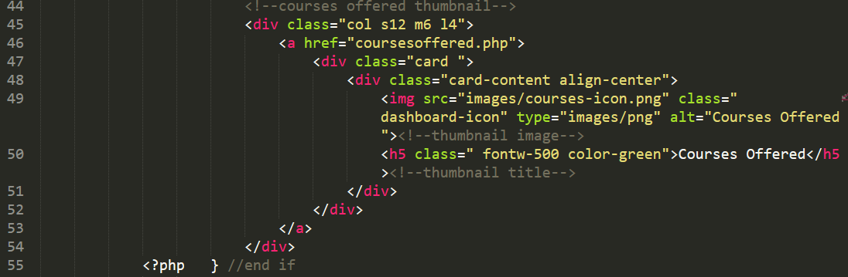

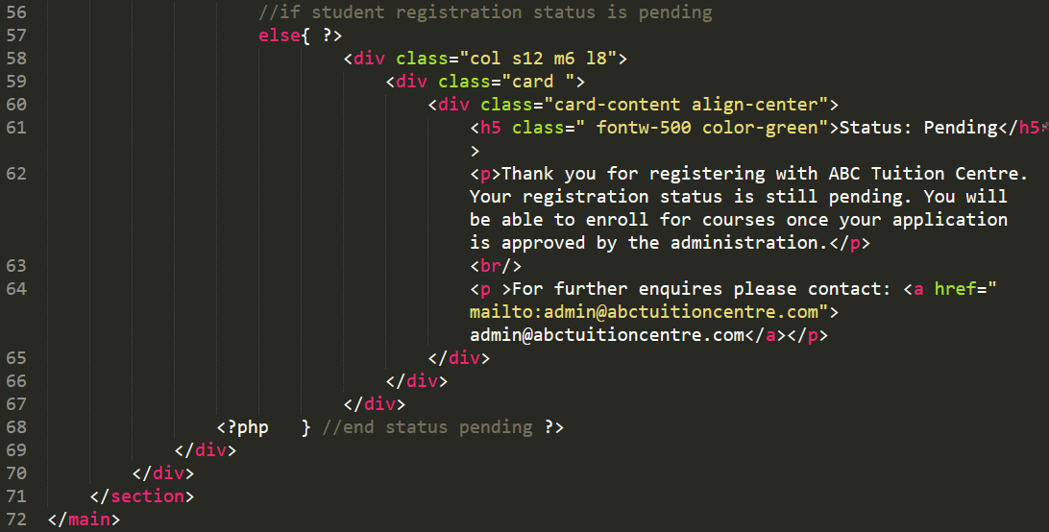



**Section 2 Student Profile**

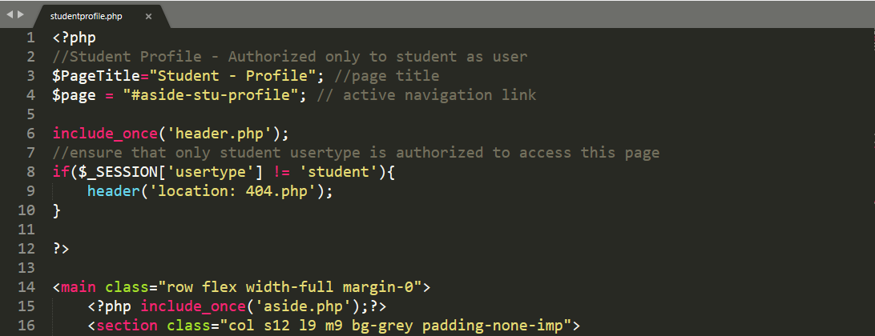

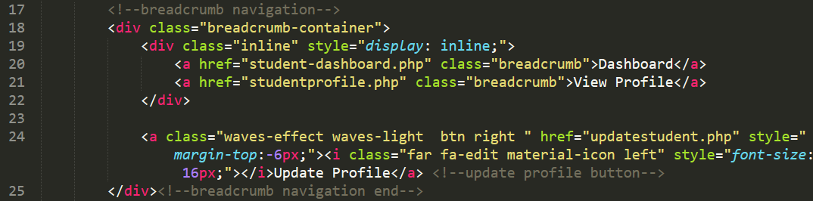

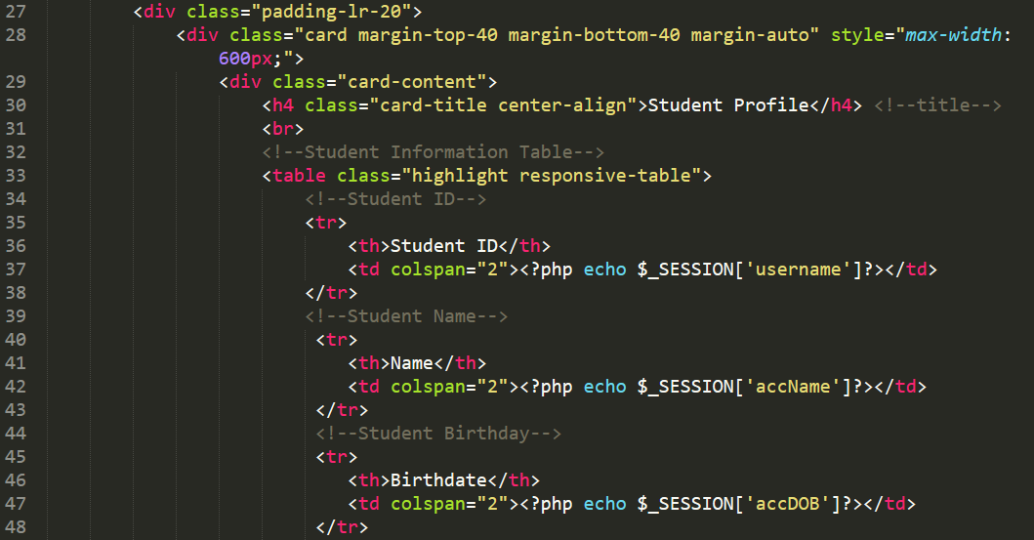

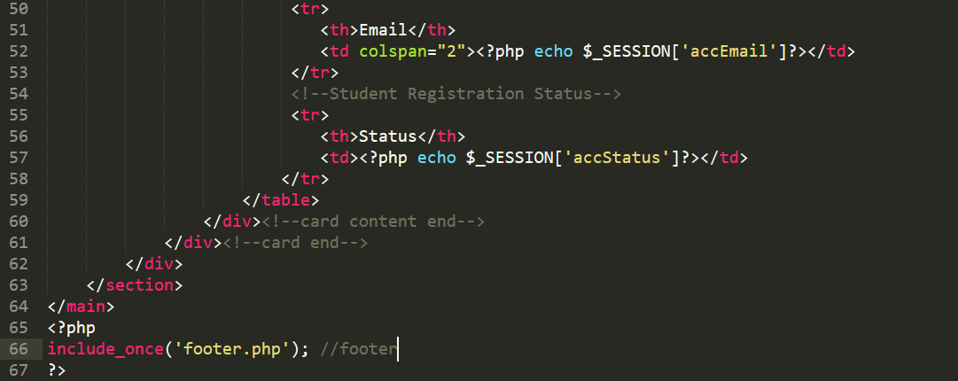

**Section 3. Update Profile**

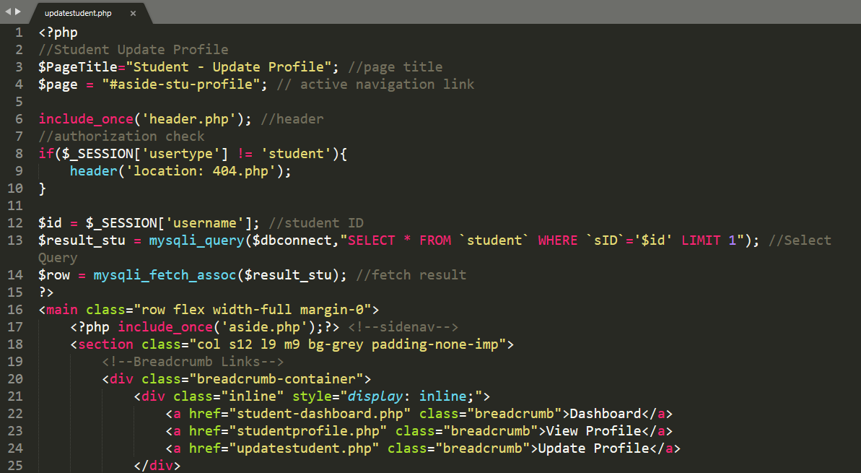

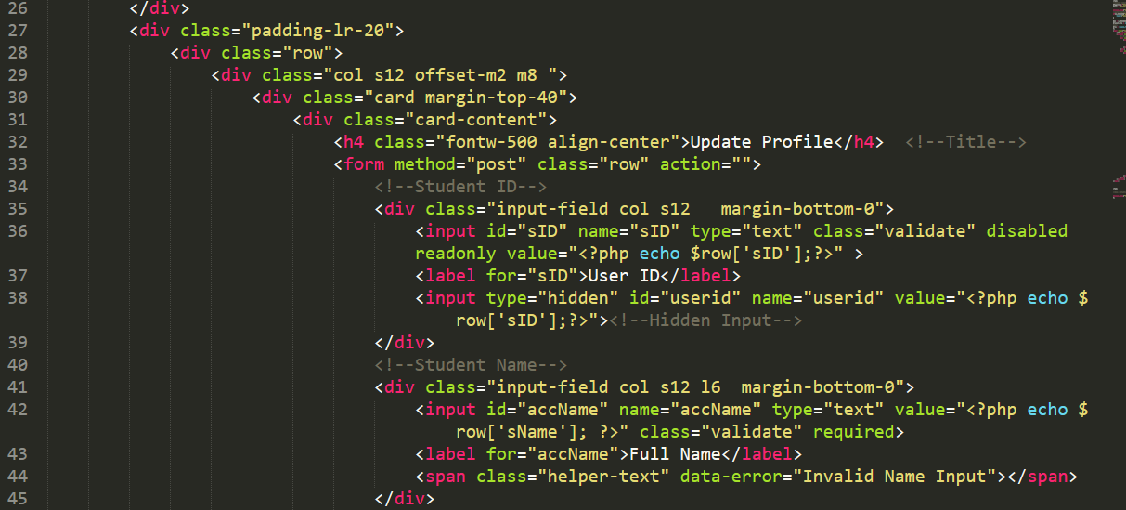

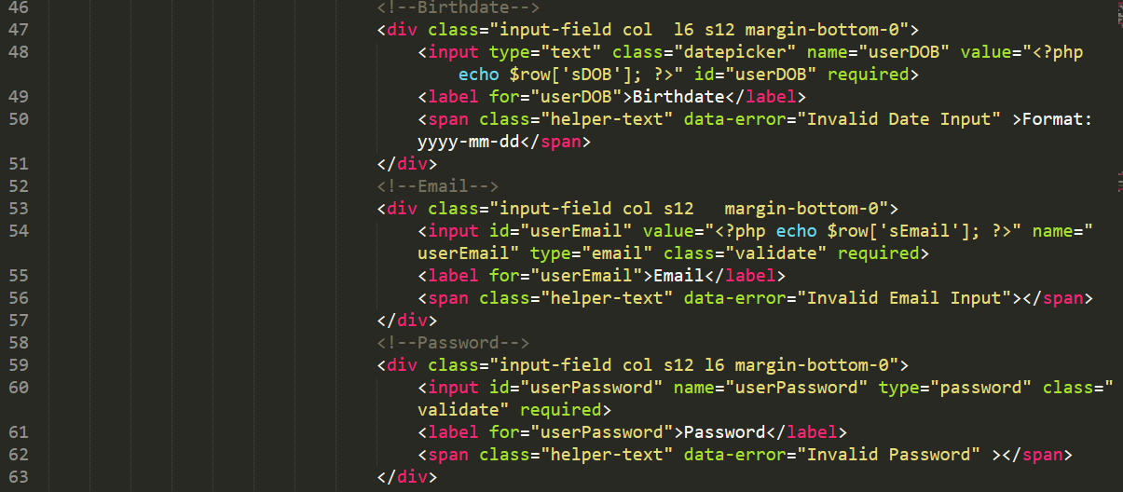

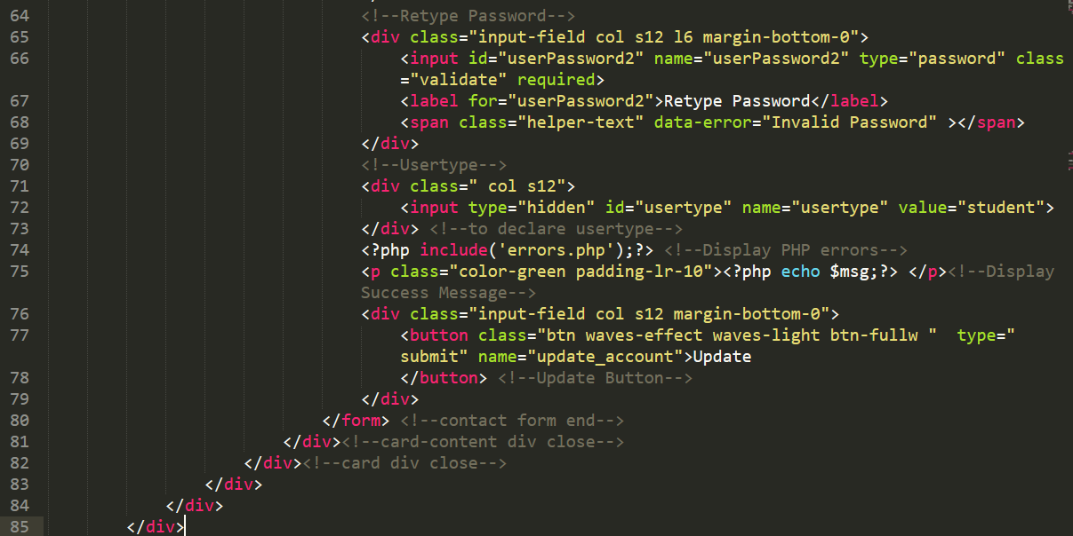

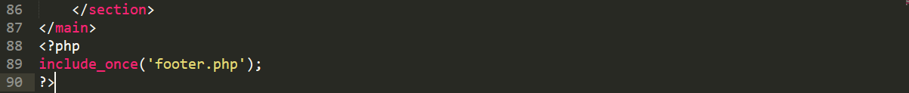

**Section 4. Courses Offered**

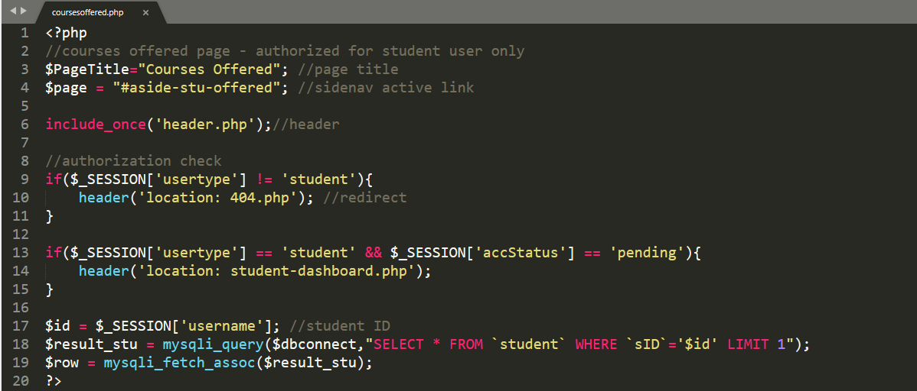

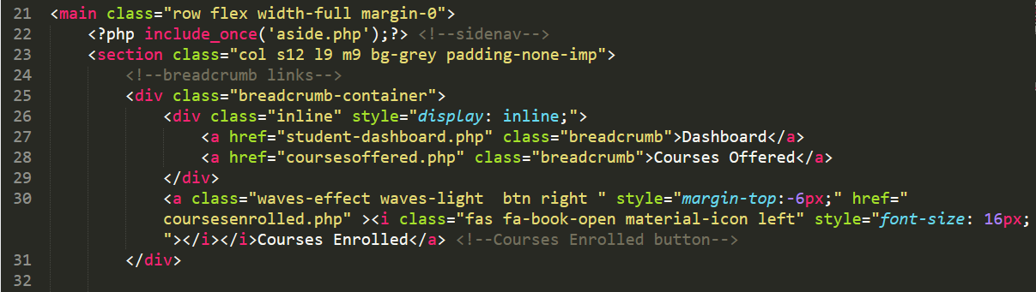

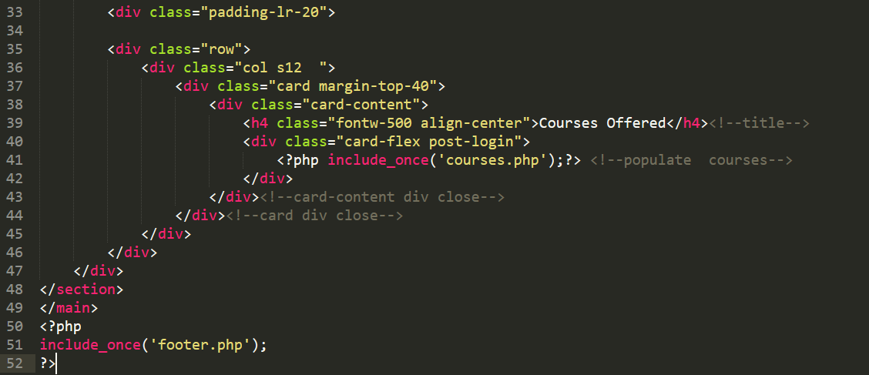

**Section 5 Courses Enrolled**

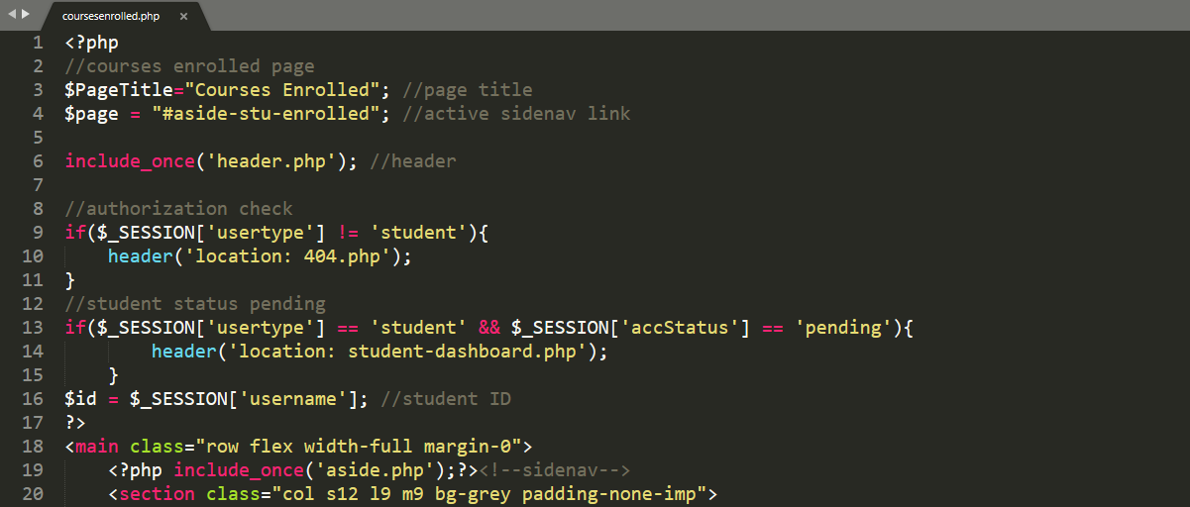

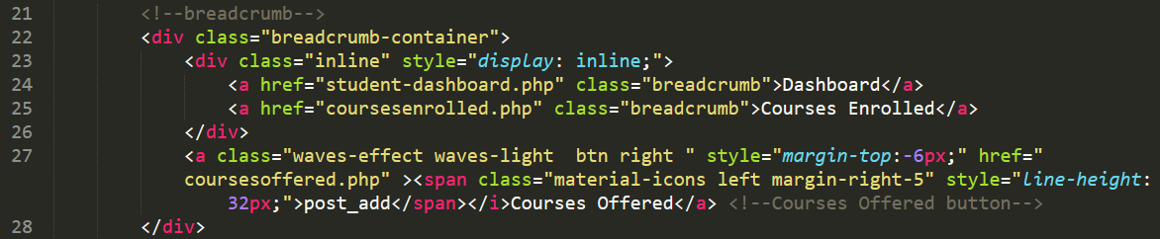

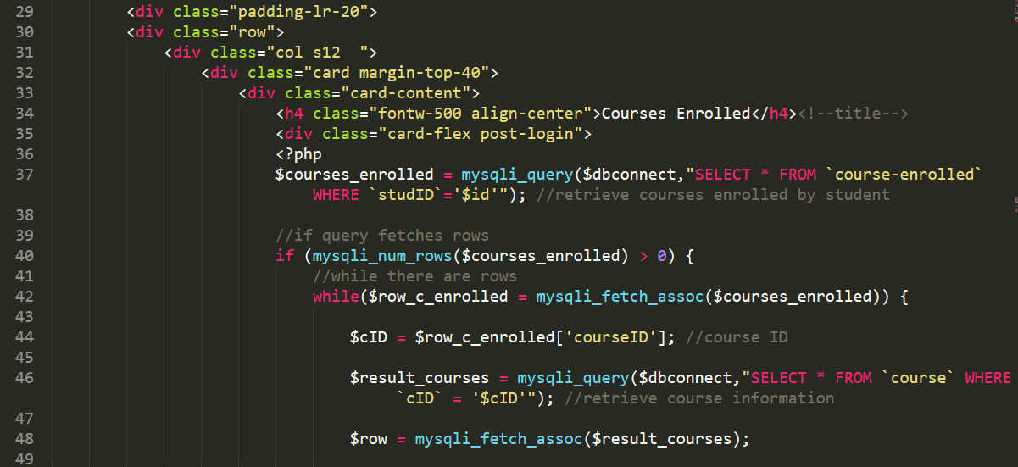

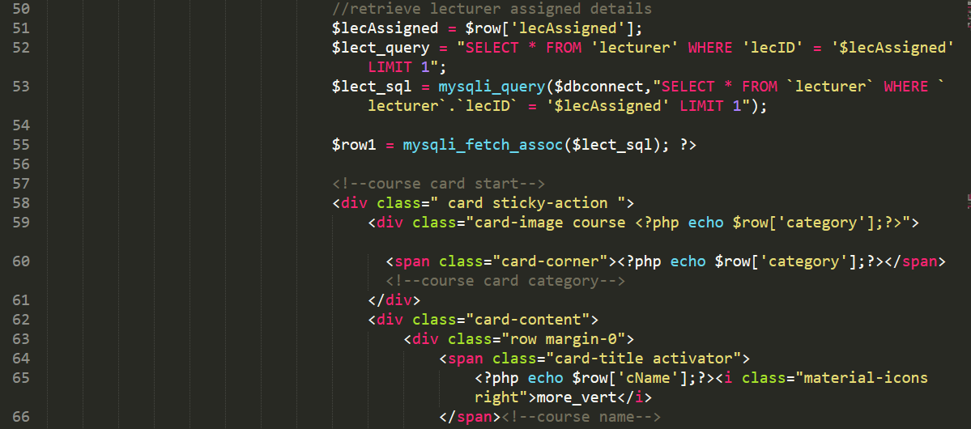

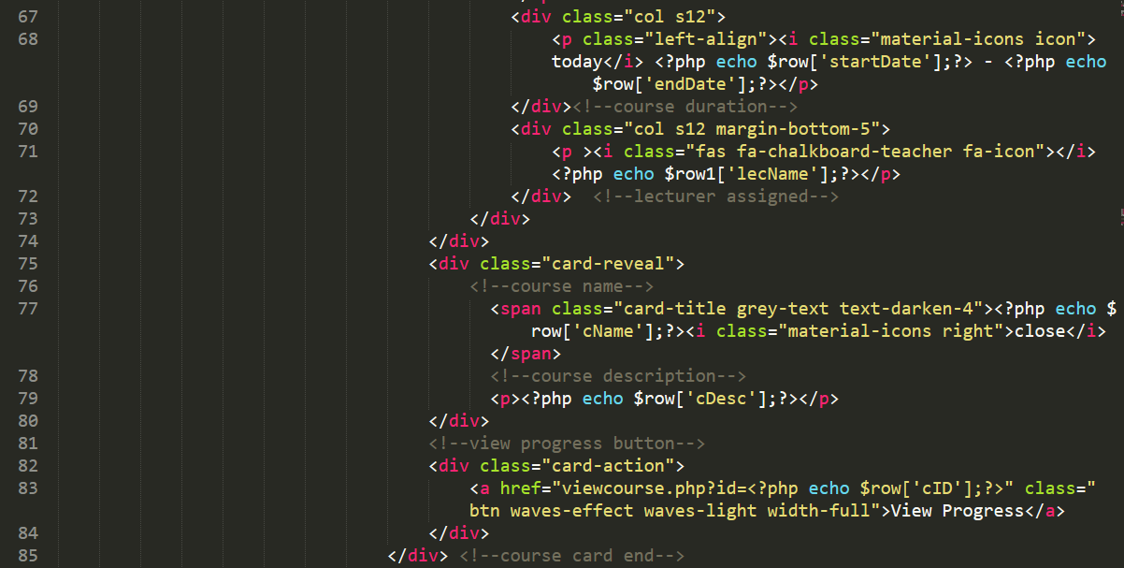

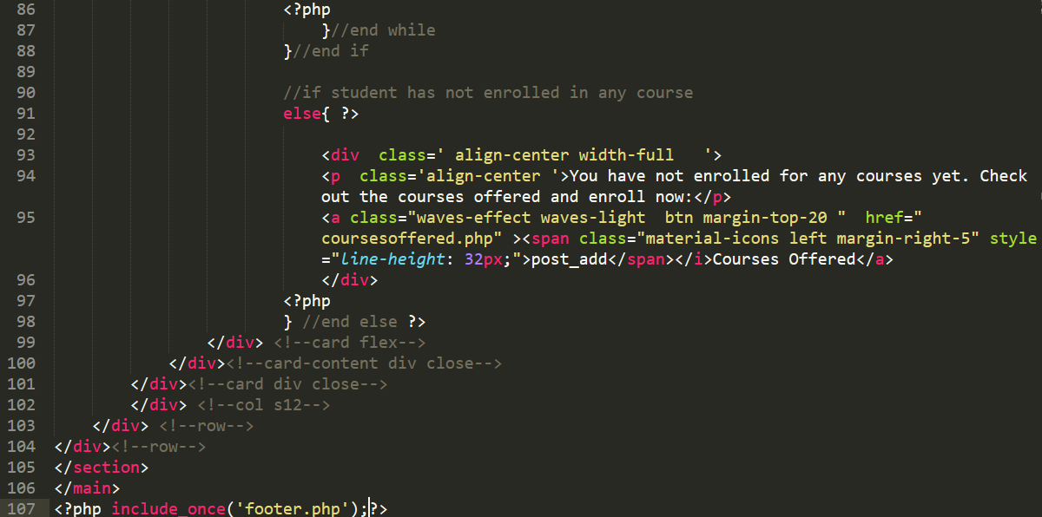

# Appendix K

**Lecturer Dashboard**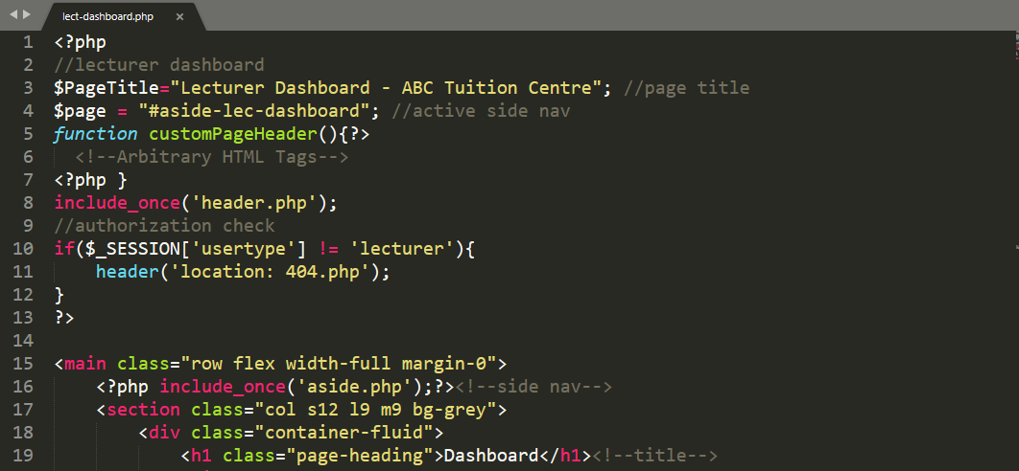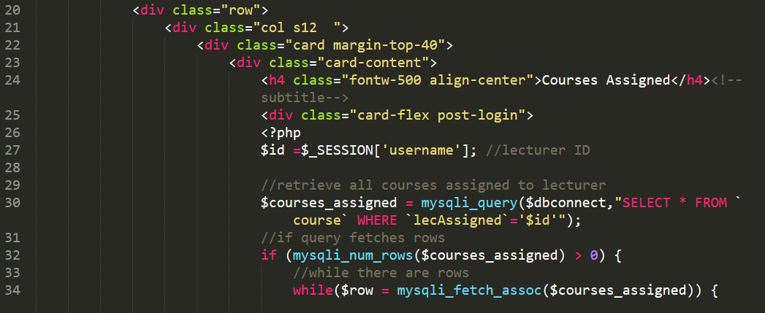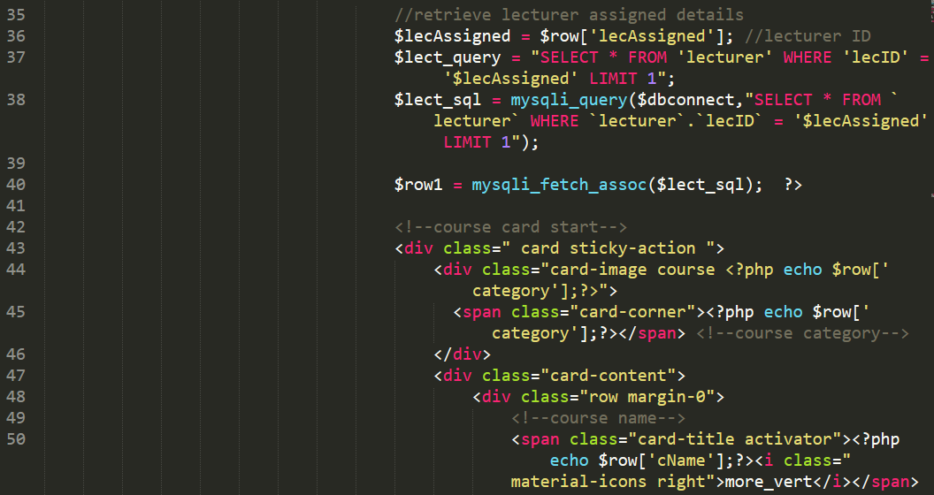

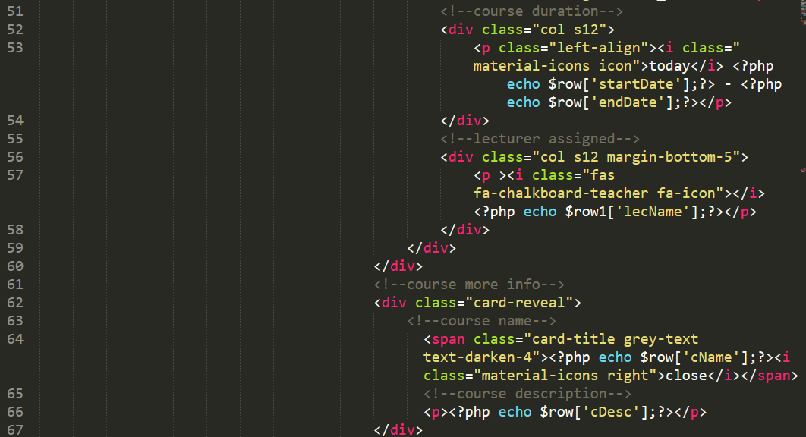

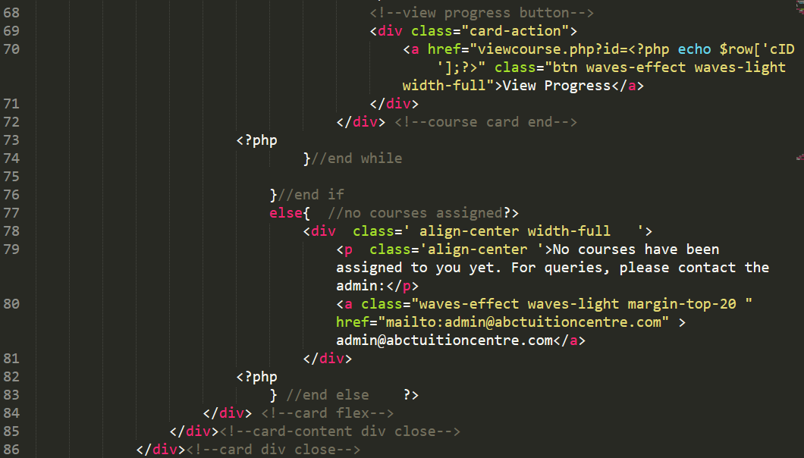 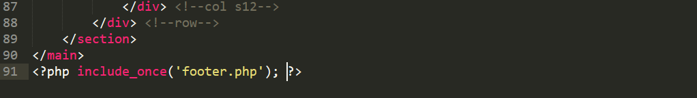

# References

*Biography*. (2016). Retrieved from https://www.biography.com/people/sachin-tendulkar-9503921

Christensson, P. (2016, February 17). *Web Application Definition*. Retrieved from TechTerms: https://techterms.com/definition/web_application

Cisco. (2019). Digitizing Higher Education. *Cisco*, 20.

Eboueya, M., & Uden, L. (2007, 1 1). *Benefits and Limitations of Portals.* Retrieved from https://www.researchgate.net/publication/240321078_Benefits_and_Limitations_of_Portals

Gibb, R. (2016, May 31). *What is a Web Application?* Retrieved from Stackpath: https://blog.stackpath.com/web-application/

Gladwell, M. (2008). Outliers. In *Outliers.* Little, Brown Company.

*Motivation Grid*. (2016, November). Retrieved from https://motivationgrid.com/hard-work-is-the-key-to-success/

*Quotefancy*. (n.d.). Retrieved from https://quotefancy.com/quote/1246150/Arianna-Huffington-Failure-is-a-stepping-stone-to-success

Rouse, M. (2007, April). *Digitization*. Retrieved from What Is: https://whatis.techtarget.com/definition/digitization

Singh, A. (2019, December 06). *What Is Rapid Application Development (RAD)?* Retrieved from Captera: https://blog.capterra.com/what-is-rapid-application-development/

Thoring, A., Rudolph, D. D., & Vogl, R. (2017). *Digitalization of Higher Education from a Student's point of view.* Munster: University of Munster, Germany.

Windsor, S. (2020, March). *What Is a Student Portal?* Retrieved from Classroom: https://classroom.synonym.com/student-portal-7331470.html

1. Progress: In this context, progress refers to student’s attendance and performance information